Think Like a Linux Network Engineer

From Packets and Sockets to the Linux Kernel: Debugging, Performance, and Advanced Networking
Reference kernel: Linux 6.6 LTS

Avinash Pal

2026

Copyright
No part of this book may be reproduced, distributed, or transmitted in any form or by any means, including photocopying, recording, or other electronic or mechanical methods, without the prior written permission of the author, except in the case of brief quotations embodied in critical reviews and certain other noncommercial uses permitted by copyright law.
This book is provided for educational purposes. The author has made every effort to ensure the accuracy of the information contained herein, but assumes no responsibility for errors or omissions. The Linux kernel and associated tools change over time; always consult the official documentation for your running kernel version.
Linux is a registered trademark of Linus Torvalds. All other trademarks referenced in this book are the property of their respective owners.

Dedication
To every engineer who has ever stared at a tcpdump and wondered, where exactly did this packet go?

About the Author
Avinash Pal is a systems engineer and technical writer focused on the Linux kernel, networking internals, and the practical concerns of engineers who have to ship, debug, and keep production running on real Linux systems.
Avinash has spent years reading and writing kernel code, building network drivers, debugging TCP retransmits at 3 a.m., and helping teams turn network incidents into lasting fixes instead of one-off patches. The writing in this book is grounded in the same source tree the reader is learning to navigate. The analogies come from systems that have actually shipped, broken, and been fixed in production.
This book is the natural next step after basic Linux use. Once you can work on Linux, the next question is: what is it really doing with your packets? That is what this book answers.
The book uses clear examples, everyday analogies that match how the kernel works, and diagrams you can sketch on a whiteboard in an interview.

Acknowledgments
To every Linux kernel developer who has written a clear comment, a clean commit message, or a focused documentation page. Your work makes books like this possible.
To the maintainers of bpftrace, bpftool, tcpdump, Wireshark, iproute2, nftables, ethtool, and the rest of the Linux networking toolkit. These tools turn guesswork into evidence.
To the readers of earlier drafts who pushed back on unclear explanations and missing diagrams. This book is better because of you.

Preface

Why This Book
Most networking books teach commands. This book teaches how to think.
When something breaks on a Linux machine, the engineer who fixes it fastest is not the one who memorized the most commands. It is the one who knows which layer to look at first, which tool answers which question, and how to read what the kernel is actually doing. That knowledge comes from understanding the system end to end: from the wire, through the driver, up the kernel stack, into the socket, and out to the application.
This book is built around that idea. Every concept is tied to a real packet you can capture, a command you can run, a source file you can read, and a lab you can break on purpose.

Who Should Read This Book
This book is for engineers who already know basic Linux and want to understand how Linux networking really works inside. Not “what command to run” but what happens, why it happens, where it happens, and how to debug it when it breaks.
The book is written primarily for:
- Linux engineers and embedded Linux engineers
- Software engineers moving into systems work
- Kernel and device driver developers
- Network engineers who want depth on the Linux side
- DevOps and SRE engineers
- Students preparing for Linux or kernel interviews

How to Use This Book
Read the chapters in order the first time. After that, use the book as a reference. Jump to the chapter you need, run the lab, read the source walkthrough, and look at the interview questions.
Every chapter follows the same eight-step learning pattern:
- What You Will Learn - concrete outcomes.
- Real-Life Analogy - an intuitive mental model.
- The Networking Concept - the formal understanding.
- Follow the Packet - a concrete walkthrough.
- Linux View - the commands and how to read them.
- Kernel View - where in the source, what to read.
- Source Code Walkthrough - focused excerpts with commentary.
- Hands-On Lab - run it, break it, debug it, extend it.
Each lab uses the 10-step structure: Goal, Setup, Commands, Expected Output, Explanation, Experiment, Break It, Debug It, Challenge, Solution.

Prerequisites
You need comfort with the Linux command line and basic C. You do not need kernel knowledge. Every kernel concept is built up from the ground.
You need a Linux system. Ubuntu 22.04 or later is recommended, but any modern distro works. The labs are designed to work in:
- A physical machine with a network connection
- A virtual machine
- A cloud instance
You will need root access (most labs need sudo). Many labs use network namespaces, so you do not need multiple physical machines.
To set up the lab environment:
sudo apt update
sudo apt install -y iproute2 tcpdump traceroute mtr iperf3 \
nftables conntrack ethtool \
bpftrace linux-headers-$(uname -r) \
clang llvm strace lsof netcat-openbsd
Some advanced chapters (XDP, eBPF) require a kernel with:
- CONFIG_BPF=y, CONFIG_BPF_SYSCALL=y
- CONFIG_BPF_JIT=y
- CONFIG_DEBUG_INFO_BTF=y (for CO-RE)
- CONFIG_NET_CLS_BPF=y, CONFIG_NET_ACT_BPF=y
- CONFIG_XDP_SOCKETS=y (for AF_XDP)
Most modern distro kernels (5.10 and later) ship with all of these.

How to Get the Most from This Book
When something does not work, walk the layer model. The book introduces this methodology in Chapter 1 and reinforces it through every chapter, culminating in the dedicated debugging chapter (Chapter 10). The short version:
- Did the application generate traffic?
- Did the socket send it?
- Did TCP/UDP process it?
- Did routing pick the right path?
- Did the firewall allow it?
- Did the packet reach the interface?
- Did the driver transmit it?
- Did the NIC transmit it?
- Did the peer receive?
- Did the reply come back?
Where exactly did the packet disappear? Apply that checklist before reaching for any other tool. It is almost always faster than random guessing.

Table of Contents

Chapter 1 - Networking Fundamentals: What Really Happens to a Packet? 13
What You Will Learn 41
Real-Life Analogy - The Postal System 14
The Networking Concept 16
Follow the Packet - The Complete Journey of a ping 22
Linux View 24
Kernel View 28
Source Code Walkthrough - Reading the IP Header Definition 28
Hands-On Lab - Trace Your First Packet 29
Interview Questions 33
Key Takeaways 36
Practice Challenges 36
Bonus Material: Common First-Time Mistakes 37
A Note on Reading tcpdump Output 40
Summary 40
Chapter 2 - Ethernet, MAC, ARP and the Local Network 41
What You Will Learn 57
Real-Life Analogy - The Last-Mile Delivery 42
The Networking Concept 43
Follow the Packet 48
Linux View 48
Kernel View 50
Source Code Walkthrough 50
Hands-On Lab - Watch ARP Happen 52
Interview Questions 54
Key Takeaways 56
Practice Challenges 56
Chapter 3 - IP Addressing, Routing and How Linux Chooses the Next Hop 57
What You Will Learn 74
Real-Life Analogy - The GPS and the Road Map 58
The Networking Concept 59
Follow the Packet 65
Linux View 66
Kernel View 67
Source Code Walkthrough 67
Hands-On Lab - Predict the Next Hop 69
Interview Questions 70
Key Takeaways 73
Practice Challenges 73
Chapter 4 - Sockets: How Applications Enter the Linux Network Stack 74
What You Will Learn 94
Real-Life Analogy - The Post-Office Counter, Revisited 75
The Networking Concept 76
Follow the Packet - A strace Trace of a TCP Client 81
Linux View 81
Kernel View 82
Source Code Walkthrough 83
Hands-On Lab - Build a TCP Echo Server and a UDP Probe 84
Interview Questions 90
Key Takeaways 94
Practice Challenges 94
Chapter 5 - TCP and UDP: What Actually Happens During Communication 94
What You Will Learn 113
Real-Life Analogy - Two People on a Phone Call 96
The Networking Concept 97
Follow the Packet - A TCP Session Captured 103
Linux View 103
Kernel View 104
Source Code Walkthrough 105
Hands-On Lab - Watch TCP and UDP Side by Side 106
Interview Questions 108
Key Takeaways 111
Practice Challenges 112
Chapter 6 - Inside the Linux Kernel Network Stack 113
What You Will Learn 136
Real-Life Analogy - The Envelope Inside the Sorting Office 114
The Networking Concept 115
Follow the Packet - The sk_buff’s Journey 123
Linux View 124
Kernel View 125
Source Code Walkthrough 125
Hands-On Lab - Inspect an skb at Runtime 129
Interview Questions 132
Key Takeaways 135
Practice Challenges 135
Chapter 7 - The Complete Linux Packet TX and RX Path 136
What You Will Learn 157
Real-Life Analogy - Outbound and Inbound Logistics 138
The Networking Concept 138
Follow the Packet - Tracing a Single TCP Send 147
Linux View 147
Kernel View 148
Source Code Walkthrough 148
Hands-On Lab - Trace the TX/RX Path 151
Interview Questions 153
Key Takeaways 156
Practice Challenges 157
Chapter 8 - Linux Virtual Networking: Bridges, VLANs, veth and Namespaces 157
What You Will Learn 173
Real-Life Analogy - Buildings, Tunnels, and Switchboards 158
The Networking Concept 159
Follow the Packet - Container to Internet 164
Linux View 164
Kernel View 165
Source Code Walkthrough 166
Hands-On Lab - Build a Four-NS Topology 167
Interview Questions 170
Key Takeaways 172
Practice Challenges 172
Chapter 9 - Netfilter, nftables, Conntrack and NAT 173
What You Will Learn 190
Real-Life Analogy - Customs Checkpoints 175
The Networking Concept 175
Follow the Packet - Inbound Web Request Through DNAT 180
Linux View 181
Kernel View 182
Source Code Walkthrough 182
Hands-On Lab - Build a Linux Router with Firewall and NAT 184
Interview Questions 187
Key Takeaways 189
Practice Challenges 189
Chapter 10 - Linux Network Debugging: Find Where the Packet Died 190
What You Will Learn 207
Real-Life Analogy - Tracing a Missing Package 191
The Networking Concept 192
Case Studies 194
Linux View 202
Kernel View 203
Source Code Walkthrough 203
Hands-On Lab - Build a Bug, Find It, Fix It 204
Interview Questions 205
Key Takeaways 206
Practice Challenges 206
Chapter 11 - Linux Network Performance and High-Speed Networking 10
What You Will Learn 207
Real-Life Analogy - Highway Engineering 208
The Networking Concept 192
Follow the Packet - A 64-byte UDP Flood 213
Linux View 202
Kernel View 203
Source Code Walkthrough 203
Hands-On Lab - Tune a veth Pair 217
Interview Questions 205
Key Takeaways 206
Practice Challenges 206
Chapter 12 - eBPF, XDP, AF_XDP and the Final Capstone Project 221
What You Will Learn 207
Real-Life Analogy - The Programmable Inspector 223
The Networking Concept 224
Follow the Packet - Where Programs Hook 227
Linux View 229
Kernel View 229
Source Code Walkthrough 230
Hands-On Lab - Six Mini-Projects 231
Load a program from an ELF object and pin it by name: 232
Attach the pinned XDP program to an interface: 232
Or, more simply, attach in one step from an ELF object: 232
Or use iproute2 (also widely used): 232
Final Capstone Project - Build a Mini Linux Network 235
Interview Questions 239
Key Takeaways 241
Practice Challenges 242
Afterword - Where to Go From Here 242
Appendix A - Common Linux Networking Pitfalls 242
Layer 1: Application 243
Layer 2: Sockets 243
Layer 3: Routing 243
Layer 4: Firewall 244
Layer 5: Neighbor / ARP 244
Layer 6: Interface / Driver / NIC 244
Layer 7: Application Protocol 244
Appendix B - Glossary 245
Appendix C - Tool Reference 248
Diagnostic Tools 234
State Inspection 266
Kernel Source Locations 249
Appendix D - Reading the Linux Network Source 249
Setting Up the Source 236
Useful Search Patterns 250
Source Tree Tour for Networking 250
Reading Strategy 251
Appendix E - Performance Tuning Recipes 251
Reality check — apply tuning recipes only after measuring. Do not blindly copy tuning knobs (ethtool -K, sysctl -w) into production: offloads and buffer sizes interact with the driver, the firmware, and the workload in ways that depend on the specific NIC and CPU generation. Profile with the methodology in Chapter 10 before, during, and after each change; roll back if a single-number metric regresses.
Recipe: Maximize Single-Stream Throughput on a 10 Gbps NIC 252
Recipe: Maximize PPS (Small Packets) 252
Recipe: Minimize Latency (Avoid Bufferbloat) 253
Recipe: Isolate the Bottleneck 253
Appendix F - Common Interview Answers 254
Q: How does a packet travel from one host to another? 240
Q: How does TCP ensure reliability? 272
Q: What’s the difference between TCP and UDP? 272
Q: How does NAT work? 255
Q: How does Linux decide which route to use? 255
Q: What is NAPI? 255
Q: How do you debug “ping works, TCP fails”? 255
Q: What is sk_buff? 255
Q: What is XDP? 255
Appendix G - Notes on Kernel Versions 256
Kernel 4.x 242
Kernel 5.x 274
Kernel 6.x 274
What This Means for the Reader 274
Appendix H - Recommended Reading Order 257
If you are new to networking 243
If you know networking but not Linux 243
If you know Linux but not networking 275
If you know kernel development but not networking 275
If you are preparing for interviews 275
If you are debugging a production issue 275
Appendix I - Acknowledgments and Contributions 258
Appendix J - Notation and Conventions 276
Commands 298
Code Blocks 245
File Paths 259
Network Notation 259
Cross-References 259
Glossary of Abbreviations 259

Chapter 1 - Networking Fundamentals: What Really Happens to a Packet?

What You Will Learn
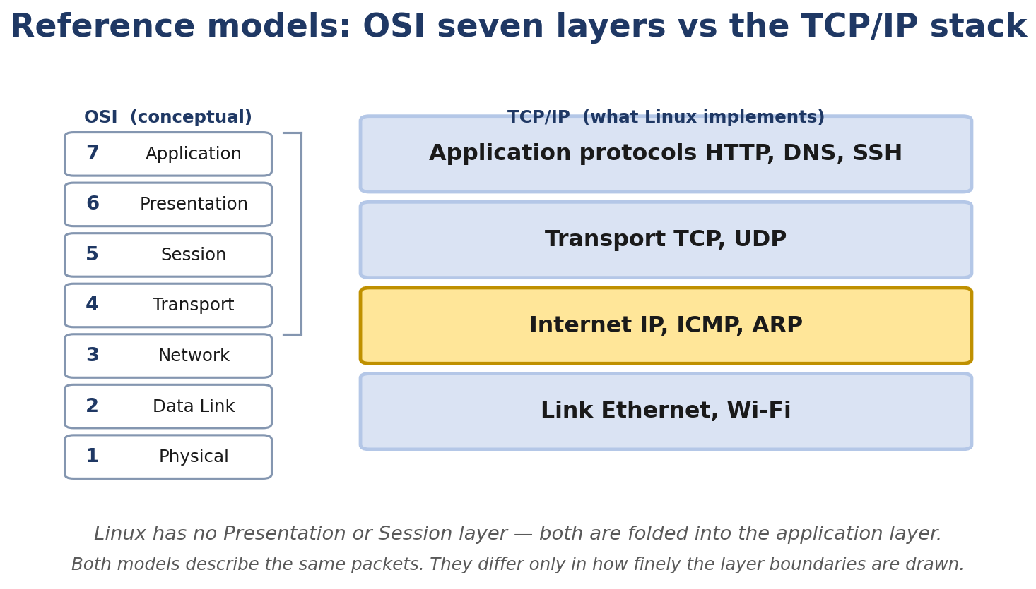
Figure 1.1. The two reference models describe the same packets; they differ only in how finely the layer boundaries are drawn.
By the end of this chapter you’ll be able to:
- Describe what a network actually is, and how a LAN, a WAN, and the Internet differ.
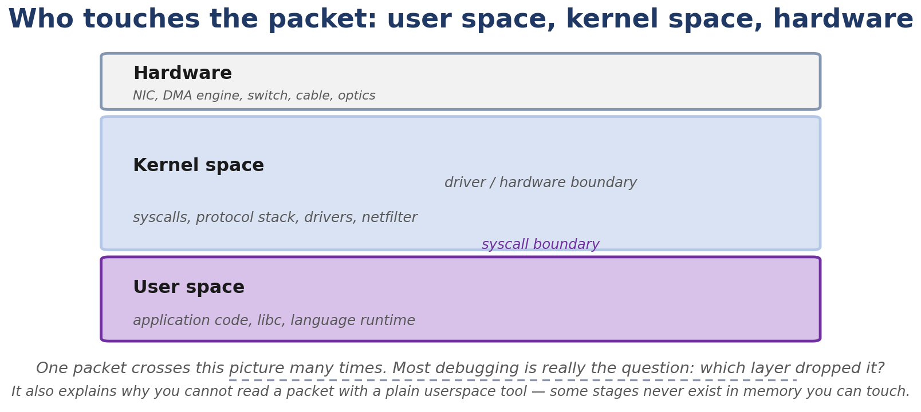
Figure 1.2. Who touches a packet: user space, kernel space, and hardware. Most debugging is really the question of which layer dropped it.
- Name the parts of a packet on the wire, and tell the difference between a packet, a frame, a segment, and a datagram.
- Read an Ethernet header, an IPv4 header, an ICMP header, a UDP header, and a TCP header.
- Look at any Linux machine and immediately know its interfaces, addresses, routes, and neighbors.
- Capture your first packet with tcpdump and explain every field you see.
- Predict, with confidence, where a packet will go before you run ping.
- Recognize the OSI seven-layer model and the TCP/IP four-layer model, and explain why both exist.
- Find your way around the Linux kernel’s network source tree.
This is a foundations chapter. We use a few small source excerpts here to anchor the concepts you have just read; the systematic kernel-source walkthroughs (sk_buff, the softnet path, the TX/RX layers) start properly in Chapter 6. By the end of Chapter 1 you should be able to look at a Linux box and a packet and feel, “ah, I see what’s happening here.”

Real-Life Analogy - The Postal System
Reality check — where the analogy breaks. The analogy above is a pedagogical tool for building a mental model. It is not a precise description of the kernel mechanism. The real implementation differs from the analogy in ways your interviews and lab work will surface; always reason from the kernel source when precision matters.
Imagine you want to send a birthday card to a friend in another city.
You write the letter. That’s your application data, a stream of bytes your program produced.
You put the letter in an envelope. On the envelope you write two things: your friend’s full postal address and your return address. The destination address is the destination IP: where in the world should this go. The return address is the source IP: where to send a reply if delivery fails.
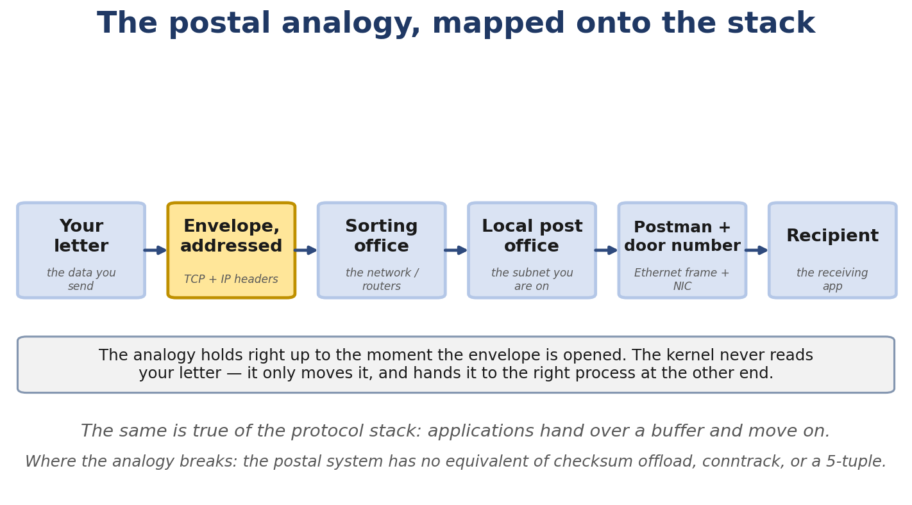
Figure 1.3. The postal analogy mapped onto the stack, and the point at which it stops being useful.
You hand the sealed envelope to the clerk at your local post office. That clerk is the socket: the agreed-upon counter between you (user space) and the postal service (the kernel). You don’t get to walk into the sorting facility. The clerk takes the envelope from you.
Now the postal service decides how to deliver it. It looks at the destination city and picks a route: maybe a truck to a regional hub, then a flight, then a local truck, then a walking postman. Each hop is a router. The set of all known routes is the routing table, the road map of the postal system.
When the envelope reaches the local post office nearest your friend’s house, a postman has to deliver it physically. The postman doesn’t carry envelopes to every house on the street. They walk to your friend’s specific house. For that last step, the postman needs a local address: the house number and street. In networking that local address is the MAC address, and the postman asking “which house is this” is the ARP process (covered in Chapter 2).
The postman’s bag is the NIC (the loading dock of your network building). The postman themselves is the network driver. The envelope, as it moves through the postal system, is the packet. Inside the postal system the envelope gets stamped, sorted, and routed. In Linux, the packet gets headers added and removed at each layer. That’s encapsulation and decapsulation.
Two more pieces matter:
TCP versus UDP. When you drop the envelope at the post office, you can choose regular mail (cheap, no confirmation) or registered mail (more expensive, signed for, retried on failure). Regular mail is UDP: fire-and-forget. Registered mail is TCP: acknowledged, retried, ordered. The clerk, the socket, lets you choose.
Port numbers. Your friend’s apartment building has hundreds of residents. The clerk needs a way to deliver to “your friend, apartment 5B,” not just “your friend.” The apartment number is the port number: it identifies which application on the destination machine should receive the data.
That’s the postal system. From here on, we replace it with the real thing.

The Networking Concept

What is a network?
A network is two or more devices that agree to exchange information over a shared medium using agreed rules. The rules are the protocols. The medium can be copper wire, fiber, radio waves, or even just RAM between two processes on the same machine (yes. 127.0.0.1 is a real network).
A LAN (Local Area Network) is small: your home, your office, one floor of a datacenter. A WAN (Wide Area Network) is large: connecting cities, countries, continents. The Internet is a global network of networks: thousands of independent networks agreeing to exchange traffic using TCP/IP.
A device attached to a network is a host. Hosts run applications. Some applications are clients (they initiate requests, your browser, your curl, your ping). Some are servers (they wait for requests, your web server, your DNS server, your SSH daemon). The same machine can run both.

Network interfaces
A network interface is the hardware (or virtual thing) that connects a host to a network. Physically, it’s the NIC: a PCIe card with a port. Virtually, it’s a lo (loopback), a veth (virtual ethernet), a br0 (bridge), or a tun0 (tunnel). Each interface has:
- A MAC address: its Layer-2 identity on the local link.
- An MTU: the maximum size of a single frame on that link.
- A state: UP/DOWN, and whether the link is actually live (LOWER_UP).
- One or more IP addresses: its Layer-3 identity.
- Queues: TX/RX rings (Chapter 7) and a qdisc (Chapter 11).

MAC addresses
A MAC address is 48 bits, written as six hex bytes: 52:54:00:12:34:56. The first 24 bits are the OUI (Organizationally Unique Identifier) assigned by the IEEE to the vendor; the lower 24 bits are assigned by the vendor. Locally administered MACs (the '02:' prefix is a common marker for KVM guests) override the OUI on the second-least-significant bit of the first byte. Modern kernel interfaces track 64-bit ifindex:8-bit addr_type combinations, and the IEEE 802 MAC-48 / EUI-48 is the form used on Ethernet; EUI-64 is used in other link layers.
MAC addresses are link-local. They only matter on the local segment. As soon as a router forwards your frame, your MAC is gone. The next hop rewrites the frame with its own MAC as source.
The lowest bit of the first byte is the I/G bit (Individual/Group). 0 means unicast (this specific device). 1 means multicast (a group; we’ll come back to this). The second-lowest bit is the U/L bit (Universal/Local). 1 means locally administered (you set it yourself; common in virtual interfaces and some privacy features).
The broadcast MAC is ff:ff:ff:ff:ff:ff. Every device on the local segment processes frames sent to it.

IPv4
An IPv4 address is 32 bits, written as four decimal octets: 192.168.1.10. Combined with a prefix length (e.g. /24), it identifies a network plus a host within that network. /24 means the first 24 bits identify the network; the remaining 8 bits identify the host.
Special addresses you’ll meet often:
- 127.0.0.0/8: the loopback range. 127.0.0.1 is “this machine.”
- 0.0.0.0: “any” or “no address yet” depending on context.
- 255.255.255.255: limited broadcast (rarely useful).
- 169.254.0.0/16: IPv4 link-local space. Linux may use it when DHCP or static address negotiation fails, but the exact behavior depends on the network manager, the distro configuration, and whether link-local autoconfiguration is enabled.
IPv4 is running out. That’s why IPv6 exists.

IPv6
An IPv6 address is 128 bits, written as eight colon-separated 16-bit hex groups: 2001:db8::1. The :: collapses one run of zero groups. fe80::/10 is link-local. fc00::/7 is unique local (private). 2000::/3 is global unicast.
IPv6 is not “IPv4 with more bits.” It changes many things: no broadcast (multicast only), mandatory Neighbor Discovery (replaces ARP), header is simpler and fixed at 40 bytes, fragmentation is discouraged (PMTUD is expected).
You’ll see IPv6 addresses on every modern Linux box, often as a fe80:: link-local one on every interface, even if you didn’t configure anything.

Ports
A port is a 16-bit number (0-65535) that identifies which transport-layer endpoint receives traffic. 0-1023 is the IANA 'well-known' range; binding to those on Linux requires CAP_NET_BIND_SERVICE (the kernel enforces this for IPv4 and IPv6 sockets since before Linux 1.0; modern systems keep it for backward-compatibility with the original BSD semantics — there is no actual security benefit beyond the convention). 1024-49151 are registered ports, often used without IANA registration. the range net.ipv4.ip_local_port_range, default 32768-60999 on Linux is the dynamic / ephemeral range used by clients.
The 5-tuple (src_ip, src_port, dst_ip, dst_port, protocol) is commonly used to identify a network flow. It does not necessarily imply an established connection — UDP is connectionless. Linux uses this tuple to demultiplex incoming packets back to the right socket.

Packets, frames, segments, datagrams
These words look similar but mean different things:
- Frame: the Layer-2 unit. Ethernet header + payload.
- Packet: usually means the Layer-3 unit. IP header + payload.
- Segment: a TCP header + payload. TCP is a “segment-oriented” protocol.
- Datagram: a UDP header + payload. UDP is a “datagram-oriented” protocol. The word is also used informally for any self-contained packet at any layer.
On the wire, all of these are nested:
+-------------------------+ <- outermost (first on wire)
| Ethernet header (14 B) |
+-------------------------+
| IP header (20+ B) |
+-------------------------+
| TCP header (20+ B) | or UDP header (8 B)
+-------------------------+
| Application data |
+-------------------------+
| Ethernet trailer (FCS (note: ordinary host packet captures do not always include the Ethernet FCS)) | <- innermost (last on wire)
+-------------------------+
You’ll hear people call this whole thing “a packet.” That’s fine for casual use. When you need to be precise, use the right word.

Bandwidth, throughput, latency, jitter
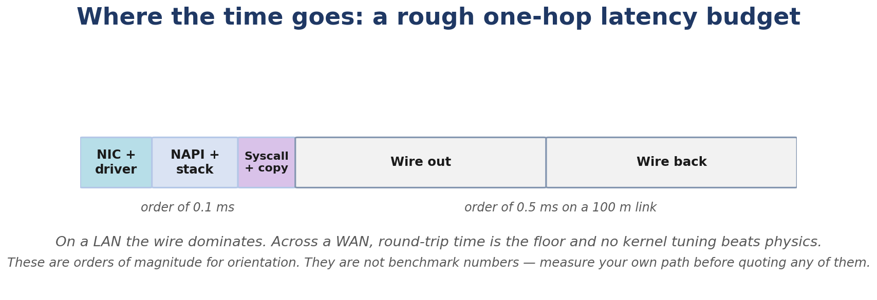
Figure 1.4. A rough one-hop latency budget, for orientation. These are orders of magnitude, not benchmark numbers.
- Bandwidth: the maximum rate the link can carry, in bits per second. A 1 Gbps Ethernet link has 1 Gbps of bandwidth.
- Throughput: what you actually achieve. Always less than bandwidth because of overhead, contention, and protocol behavior.
- Latency: how long a packet takes to get from A to B. Usually milliseconds for WANs, microseconds for LANs.
- Jitter: variation in latency. If latency is 10 ms plus or minus 0.1 ms, jitter is low. If latency is sometimes 10 ms and sometimes 80 ms, jitter is high. Matters for voice, video, gaming.

MTU
The Maximum Transmission Unit (MTU) is the maximum size of a Layer-3 packet that an interface can normally transmit over a link without fragmentation. For a traditional Ethernet interface with MTU 1500, an IPv4 packet can be up to 1500 bytes. The Ethernet header and the frame check sequence are additional Layer-2 overhead on top of that 1500-byte payload. This distinction matters whenever you reason about PMTUD, VLANs, tunnels, MSS, or hardware offloads. Ethernet’s classic MTU is 1500 bytes. Some paths support jumbo frames (typically 9000 bytes). Some tunnels have a lower effective MTU (e.g. 1450) because they wrap the original packet in their own headers.
If an IPv4 packet exceeds the outgoing MTU and fragmentation is permitted (DF=0), it may be fragmented. If fragmentation is prohibited (DF=1), the packet may be dropped and an ICMP Fragmentation Needed message generated. IPv6 routers do not fragment packets; the source is responsible for fragmentation when needed (IPv6 expects PMTUD). See Chapter 3 for details.

Unicast, broadcast, multicast, anycast
- Unicast: one sender to one receiver. The normal case.
- Broadcast: one sender to everyone on the local segment. Ethernet: ff:ff:ff:ff:ff:ff. IPv4: subnet-directed broadcast (e.g. 192.168.1.255) or limited broadcast (255.255.255.255).
- Multicast: one sender to a subscribed group. IPv4: 224.0.0.0/4. IPv6: ff00::/8. Used for things like OSPF, mDNS, IPTV.
- Anycast: multiple receivers share an address; the network delivers to the nearest one. Common in IPv6 DNS roots.

The OSI model
The OSI model is a teaching tool. It defines seven layers:
7 Application <- HTTP, DNS, SSH, SMTP
6 Presentation <- encoding, encryption (TLS lives here)
5 Session <- dialog management (mostly vestigial)
4 Transport <- TCP, UDP
3 Network <- IP, ICMP
2 Data Link <- Ethernet, ARP, switches
1 Physical <- cables, fiber, radio, voltages
It’s useful for vocabulary. Real networks don’t strictly follow it. There’s no separate “Session layer” in Linux, and TLS lives partly in user space and partly in the kernel depending on the version.

The TCP/IP model
The TCP/IP model is what the Internet actually uses. Four layers:
4 Application <- HTTP, DNS, SSH, ...
3 Transport <- TCP, UDP
2 Internet <- IP, ICMP
1 Link <- Ethernet, ARP, the actual wire
When you read kernel source, you’ll see names that map roughly to these. net/ipv4/ is “Internet layer.” net/ipv4/tcp.c is “Transport.” The socket layer is “the bridge between Application and Transport.”

Encapsulation and decapsulation
When your program calls send(), the data travels down the stack. Each layer adds its own header (and trailer, where applicable):
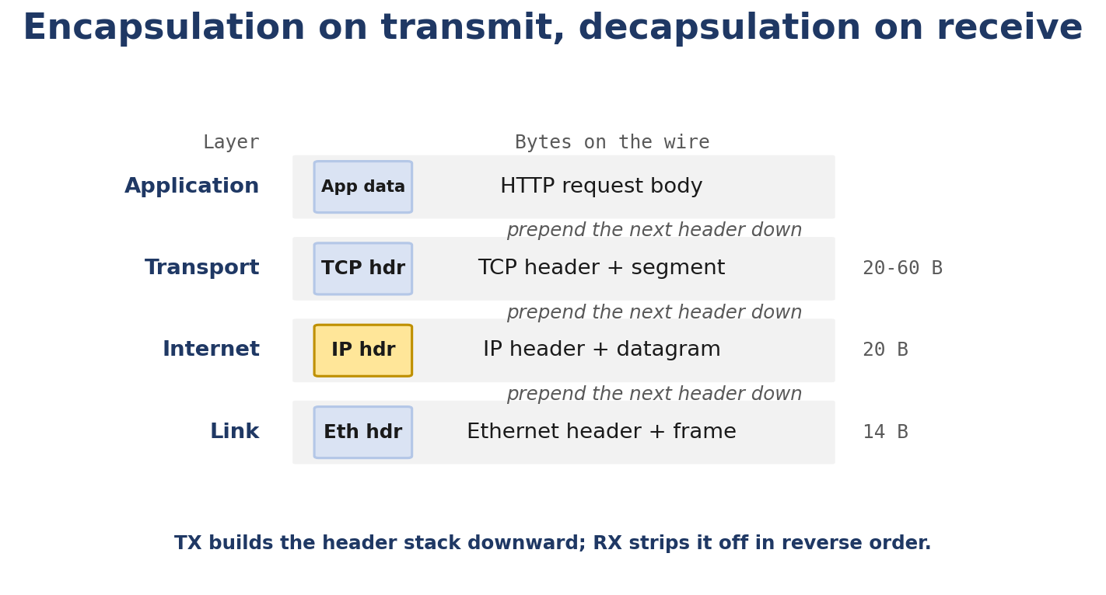
Figure 1.5. Encapsulation on transmit, decapsulation on receive. Headers are prepended by moving a pointer, not by copying the payload.
Application data
| (TCP adds its header)
v
TCP segment = TCP header + application data
| (IP adds its header)
v
IP packet = IP header + TCP segment
| (Ethernet adds its header + trailer)
v
Ethernet frame = Ethernet header + IP packet + Ethernet trailer (FCS (note: ordinary host packet captures do not always include the Ethernet FCS))
| (NIC converts to bits on the wire)
v
Bits on the wire
On the way up, each layer parses and consumes its own header. In Linux the bytes are typically kept in place inside the sk_buff data area and the layer advances via skb_pull rather than physically removing the bytes; the analogy below is a pedagogical mental model.
Bits on the wire
v
Ethernet frame (NIC + driver strip Ethernet header and trailer)
v
IP packet (IP layer strips IP header)
v
TCP segment (TCP strips TCP header)
v
Application data (delivered to the socket's receive queue)
This is the whole game. Everything else in this book is detail.

Follow the Packet - The Complete Journey of a ping
Let’s trace one packet end-to-end. You type:
$ ping -c1 8.8.8.8
Here’s what happens, layer by layer.
+----------------------------------------------------------+
| USER SPACE |
| |
| ping process |
| | |
| | sendto() / sendmsg() |
| | |
| v |
| +------------------------------------------+ |
| | Socket (ICMP socket, AF_INET; modern ping implementations typically use an ICMP datagram / 'ping' socket, falling back to a raw ICMP socket where needed) | |
| +------------------------------------------+ |
| | |
| | syscall into kernel |
| v |
+----------------------------------------------------------+
| KERNEL |
| |
| Socket layer (socket.c, net/socket.c) |
| | |
| v |
| Internet/network layer. ICMP provides control, error-reporting, and |
| diagnostic messaging associated with IP; it is not TCP/UDP. |
| ICMP lives in net/ipv4/icmp.c (lives at network layer, not transport) |
| | |
| | icmp_push_reply / icmp_echo are built |
| v |
| Internet layer (net/ipv4/ip_output.c) |
| | |
| | (IPv4 route lookup; modern kernels split this across fib_lookup + ip_route_output_key_hash and friends — exact helper depends on path) : determine the destination route and next hop |
| | ip_finish_output2 : neighbor lookup + hand-off |
| v |
| Netfilter (net/netfilter/) |
| | |
| | NF_INET_LOCAL_OUT : POSTROUTING hooks |
| v |
| Qdisc (net/sched/) |
| | |
| | dev_queue_xmit : qdisc decides when to send |
| v |
| Network device layer (net/core/dev.c) |
| | |
| v |
| Driver (drivers/net/ethernet/...) |
| | |
| | ndo_start_xmit : DMA-maps the frame |
| v |
| NIC |
| | |
| | bits on the wire |
| v |
+----------------------------------------------------------+
|
| 100,000 km of cable and radio
v
8.8.8.8 (Google's resolver)
|
| reply travels back
v
your machine, the path above in reverse
Each step in the diagram has a kernel function name. We won’t read those functions now. That’s Chapter 6 and 7. For now, just notice: the packet passes through well-defined checkpoints. When you debug a network problem, those checkpoints are exactly where you go look.

The packet on the wire, byte by byte
When ping sends an ICMP echo, the wire carries this (simplified):
Ethernet header (14 bytes)
dest MAC (6 bytes) <- neighbor cache gave us this (Chapter 2)
src MAC (6 bytes) <- our NIC's MAC
EtherType (2 bytes) 0x0800 (IPv4)
IPv4 header (20 bytes)
version/IHL (1 byte) 0x45
DSCP/ECN (1 byte) 0x00
total length (2 bytes) 0x0054 (84)
id (2 bytes) varies
flags/offset (2 bytes) 0x4000 (don't fragment, no offset)
TTL (1 byte) 0x40 (64)
protocol (1 byte) 0x01 (ICMP)
checksum (2 bytes) computed
src IP (4 bytes) 192.168.1.10
dst IP (4 bytes) 8.8.8.8
ICMP header (8 bytes)
type (1 byte) 0x08 (echo request)
code (1 byte) 0x00
checksum (2 bytes) computed
identifier (2 bytes) implementation-defined value (commonly the PID at socket-creation time)
seq (2 bytes) 1
ICMP payload
56 bytes of pattern data (typically 0x00..0x38)
Ethernet trailer (4 bytes)
FCS (note: ordinary host packet captures do not always include the Ethernet FCS) (4 bytes) CRC over the whole frame
Total: 14 + 20 + 8 + 56 + 4 = 102 bytes on the wire for one tiny echo. That’s the cost of headers: about half the bytes you see aren’t your data.
Now look at the same packet in a tcpdump capture:
$ sudo tcpdump -ni eth0 -c 1 icmp
tcpdump: verbose output suppressed, use -v or -vv for full protocol decode
listening on eth0, link-type EN10MB (Ethernet), capture size 262144 bytes
15:32:11.123456 IP 192.168.1.10 > 8.8.8.8: ICMP echo request, id 1234, seq 1, length 64
1 packet captured
2 packets received by filter
0 packets dropped by kernel
The length 64 is the IP payload length. For a standard ping: IPv4 header (20 bytes) + ICMP header (8 bytes) + ICMP data (56 bytes) = IPv4 total length 84, so the IP payload (which is what tcpdump prints) is 84 - 20 = 64 bytes.

Linux View
Time to look at a real Linux machine.

See your interfaces
$ ip link
1: lo: <LOOPBACK,UP,LOWER_UP> mtu 65536 qdisc noqueue state UNKNOWN mode DEFAULT group default qlen 1000
link/loopback 00:00:00:00:00:00 brd 00:00:00:00:00:00
2: eth0: <BROADCAST,MULTICAST,UP,LOWER_UP> mtu 1500 qdisc fq_codel state UP mode DEFAULT group default qlen 1000
link/ether 52:54:00:12:34:56 brd ff:ff:ff:ff:ff:ff
What you see:
- lo: the loopback interface. Always there. Always UP. MTU 65536 (a large default MTU; not literally unlimited).
- eth0: your real NIC. The flags <BROADCAST,MULTICAST,UP,LOWER_UP> mean: it supports broadcast and multicast, the interface is administratively UP, and the physical link is also UP.
- mtu 1500: classic Ethernet MTU.
- qdisc fq_codel: the queuing discipline. fq_codel (or fq) is the typical default on modern Ethernet interfaces in mainline kernels (Chapter 11).
- link/ether 52:54:00:12:34:56: the MAC address.
- brd ff:ff:ff:ff:ff:ff: the broadcast MAC.

See your addresses
$ ip addr
1: lo: <LOOPBACK,UP,LOWER_UP> mtu 65536 qdisc noqueue state UNKNOWN group default qlen 1000
inet 127.0.0.1/8 scope host lo
valid_lft forever preferred_lft forever
inet6 ::1/128 scope host
valid_lft forever preferred_lft forever
2: eth0: <BROADCAST,MULTICAST,UP,LOWER_UP> mtu 1500 qdisc fq_codel state UP group default qlen 1000
inet 192.168.1.10/24 brd 192.168.1.255 scope global (the address has global validity within the address-scoping model; this does not imply it is publicly routable on the Internet — RFC1918 addresses can have scope global) dynamic noprefixroute eth0
valid_lft 86316sec preferred_lft 86316sec
inet6 fe80::5054:ff:fe12:3456/64 scope link noprefixroute
valid_lft forever preferred_lft forever. (Note: 'scope global' is a kernel-internal scope, not a guarantee of global routability. RFC1918 10/8, 172.16/12, 192.168/16 are NOT routable on the public internet; the 'global' scope just means the kernel does not restrict their use to a single interface or subnet. On a host behind NAT, that 10.x.x.x address has 'scope global' inside the host but is masqueraded to a public IP on the wire.)
What you see:
- inet 127.0.0.1/8: IPv4 on loopback.
- inet6 ::1/128: IPv6 loopback (shorthand for 0:0:0:0:0:0:0:1).
- inet 192.168.1.10/24: your IPv4 on eth0. The /24 is the prefix length.
- brd 192.168.1.255: the subnet broadcast address.
- scope global (the address has global validity within the address-scoping model; this does not imply it is publicly routable on the Internet — RFC1918 addresses can have scope global): globally routable. (Note: 'scope global' is a kernel-internal scope, not a guarantee of global routability. RFC1918 10/8, 172.16/12, 192.168/16 are NOT routable on the public internet; the 'global' scope just means the kernel does not restrict their use to a single interface or subnet. On a host behind NAT, that 10.x.x.x address has 'scope global' inside the host but is masqueraded to a public IP on the wire.)
- dynamic: acquired from DHCP (its lifetime is 86316 seconds; it’ll renew).
- inet6 fe80::5054:ff:fe12:3456/64: a link-local IPv6 address. The host part is derived from the MAC address: insert ff:fe in the middle and flip bit 6 of the first byte (52 to 50 because we OR with 0x02). You’ll see the pattern.

See your routes
$ ip route
default via 192.168.1.1 dev eth0 proto dhcp src 192.168.1.10 metric 100
192.168.1.0/24 dev eth0 proto kernel scope link src 192.168.1.10 metric 100
Two routes:
- A connected route for 192.168.1.0/24. Anything in this subnet is reached directly through eth0.
- A default route. Anything not matched by a more specific route goes through 192.168.1.1 (your home router).
metric 100 is a tie-breaker: lower wins when two routes match equally. proto dhcp and proto kernel are bookkeeping tags (who installed the route). src 192.168.1.10 is the source address Linux will pick for traffic going out that route.

See your hostname’s IPs
$ ip addr show
2: eth0: <BROADCAST,MULTICAST,UP,LOWER_UP> mtu 1500
inet 192.168.1.10/24 brd 192.168.1.255 scope global eth0
$ ip route show
default via 192.168.1.1 dev eth0
192.168.1.0/24 dev eth0 proto kernel scope link src 192.168.1.10
(Use `ip addr` and `ip route` for the actual interface and route state. `hostname -I` is a hostname-resolution style output and is not a reliable inventory of every local interface address.)

See interface counters
$ cat /proc/net/dev
Inter-| Receive | Transmit
face |bytes packets errs drop fifo frame compressed multicast|bytes packets errs drop fifo colls carrier compressed
lo: 123456 1234 0 0 0 0 0 0 123456 1234 0 0 0 0 0 0
eth0: 98765432 123456 0 0 0 0 0 1234 87654321 123400 0 0 0 0 0 0
/proc/net/dev is the raw counter view. The columns you’ll care about most:
- bytes / packets: total counts.
- errs: driver-level errors.
- drop: packets dropped at the device/stack level represented by this interface counter. The counter alone does not identify the exact drop mechanism; correlate it with qdisc, driver, softnet, and kernel drop-reason statistics.
If drop is climbing while traffic is flowing, something is wrong (full ring, qdisc full, IRQ starvation). We’ll go deep on this in Chapter 11.

See your neighbors (the ARP cache)
$ ip neigh
192.168.1.1 dev eth0 lladdr a4:2b:b0:12:34:56 REACHABLE
This is the Layer-2-to-Layer-3 mapping for your local segment. You’ll understand exactly what REACHABLE means in Chapter 2. For now, notice: to send a packet to 192.168.1.1 (your default gateway), Linux uses the MAC a4:2b:b0:12:34:56.

Capture a packet
$ sudo tcpdump -ni eth0 -c 1 icmp
15:32:11.123456 IP 192.168.1.10 > 8.8.8.8: ICMP echo request, id 1234, seq 1, length 64
-n skips name resolution (faster, and DNS is one less thing to fail). -i eth0 selects the interface. -c 1 means capture exactly one packet then exit. icmp is a tcpdump filter expression.
Run ping 8.8.8.8 in another terminal while tcpdump runs. You’ll see the request and the reply.
Want more detail?
$ sudo tcpdump -ni eth0 -vv -c 1 icmp
tcpdump: listening on eth0, link-type EN10MB (Ethernet), capture size 262144 bytes
15:32:11.123456 IP (tos 0x0, ttl 64, id 12345, offset 0, flags [DF], proto ICMP (1), length 84)
192.168.1.10 > 8.8.8.8: ICMP echo request, id 1234, seq 1, length 64
Now tcpdump is showing you:
- tos 0x0: Type of Service (modern usage: DSCP/ECN).
- ttl 64: Time To Live. Each router decrements; if it hits 0 the packet is dropped and an ICMP “time exceeded” is sent back.
- id 12345: IP identification field. Used for fragmentation reassembly.
- flags [DF]: Don’t Fragment. PMTUD relies on this.
- proto ICMP (1): IP protocol number 1 is ICMP.
- length 84: IP total length.
You have just read an IP header by reading tcpdump. No fancy tools required.

Kernel View
Foundations chapter. We won’t open the kernel source yet, but you should know where the concepts live.
The kernel’s network stack lives in three top-level directories:
- net/: protocol implementations. net/ipv4/ is IPv4, ICMP, TCP, UDP, IPsec, netfilter IPv4 hooks. net/ipv6/ is IPv6. net/core/ is the framework (devices, sockets, neighbors).
- include/net/: headers. include/net/tcp.h is TCP internals. include/linux/skbuff.h is struct sk_buff (Chapter 6).
- drivers/net/: device drivers. drivers/net/ethernet/intel/e1000e/ is one example of a NIC driver.
A practical way to search:
# Look for a function definition
$ grep -RIn "^int tcp_sendmsg" net/
net/ipv4/tcp.c:1396:int tcp_sendmsg / tcp_sendmsg_locked (Linux 6.6 has both: tcp_sendmsg_locked is the held-socket-lock variant and tcp_sendmsg acquires the socket lock and calls into it)
# Look for callers
$ grep -RIn "tcp_sendmsg(" net/ drivers/ include/
Or, if you have the kernel source via git:
$ git grep "tcp_sendmsg"
If you don’t have the full kernel source, you can install it on Ubuntu:
$ sudo apt install linux-source
$ cd /usr/src/linux-source-$(uname -r)
$ tar xf linux-source-*.tar.xz
$ cd linux-source-*/
Then grep away.
That’s enough orientation for now. The serious source walkthroughs start in Chapter 6.

Source Code Walkthrough - Reading the IP Header Definition
Even at the foundations level, one source excerpt is worth seeing. The actual IPv4 header structure in the kernel. It anchors everything you’ve just learned.
File: include/uapi/linux/ip.h (the uapi part means “userspace API”. The layout matches what hits the wire):
struct iphdr {
__u8 ihl:4, // header length in 32-bit words
version:4; // IP version (4)
__u8 tos; // DSCP/ECN field
__be16 tot_len; // total length (header + payload)
__be16 id; // identification
__be16 frag_off; // flags + fragment offset
__u8 ttl; // time to live
__u8 protocol; // L4 protocol (6 = TCP, 17 = UDP, 1 = ICMP)
__sum16 check; // header checksum
__struct_group(..., // source and destination as 4-byte pair
__be32, saddr,
__be32, daddr);
}; Both TCP and UDP compute the checksum over their own header, the payload, and a pseudo-header built from the IP header (source/destination address, zero, protocol, and segment length). The pseudo-header is not transmitted on the wire; it is reconstructed by the receiver. A checksum mismatch is a symptom, not a diagnosis: it can be caused by corruption, a buggy checksum offload path, interrupted hardware processing, translation state, or a packet that changed while in flight. The capture may also show an apparently invalid checksum while the NIC has not yet completed its checksum-offload handling.
A few things worth noticing:
- The first byte packs version (4 bits) and ihl (4 bits). When tcpdump shows 0x45, the 4 is the version and the 5 is ihl (5 x 32-bit words = 20 bytes, the minimum header).
- __be16 and __be32 are big-endian types. IP is big-endian on the wire; x86 is little-endian. These tagged types make the endianness explicit so you don’t accidentally read garbage.
- __sum16 is a checksum type. IP’s checksum covers only the header (not the payload); TCP and UDP cover both.
- saddr/daddr are inside a __struct_group. This is a relatively new kernel pattern that lets the same struct be overlaid with another struct for checksum computation. Useful, but you don’t need to worry about it yet.
This single struct is the reason your tcpdump shows the fields it does. When tcpdump prints ttl 64, it’s reading the byte at offset 8 in the IP header. That’s iphdr->ttl. Same struct, same offset.

Hands-On Lab - Trace Your First Packet

Goal
You will run ping, capture the resulting packet, and explain every field. You’ll also observe what happens when you change the MTU.

Setup
- An Ubuntu 22.04 (or newer) VM or laptop.
- A working network connection (so ping 8.8.8.8 actually works).
- Install tools if missing:
- sudo apt update
sudo apt install -y iproute2 tcpdump traceroute
- iproute2 gives you ip and ss. tcpdump is the packet capture tool. traceroute we’ll use in Chapter 3.

Commands
Step 1. Inventory your machine:
ip link
ip addr
ip route
ip neigh
cat /proc/net/dev
Step 2. Capture a ping:
Open a terminal and start a capture:
sudo tcpdump -ni any -c 4 icmp
In another terminal:
ping -c2 8.8.8.8
You’ll see something like:
tcpdump: verbose output suppressed, use -v or -vv for full protocol decode
listening on any, link-type LINUX_SLL (Linux cooked v1), capture size 262144 bytes
15:32:11.123456 IP 192.168.1.10 > 8.8.8.8: ICMP echo request, id 1234, seq 1, length 64
15:32:11.156789 IP 8.8.8.8 > 192.168.1.10: ICMP echo reply, id 1234, seq 1, length 64
15:32:12.124567 IP 192.168.1.10 > 8.8.8.8: ICMP echo request, id 1234, seq 2, length 64
15:32:12.157890 IP 8.8.8.8 > 192.168.1.10: ICMP echo reply, id 1234, seq 2, length 64
4 packets captured
8 packets received by filter
0 packets dropped by kernel
Step 3. Verbose capture:
sudo tcpdump -ni eth0 -vv -c 2 icmp
Run ping -c2 8.8.8.8 again. You’ll see the same packets with full header decode (TTL, flags, ID, etc.).
Step 4. Hex dump:
sudo tcpdump -ni eth0 -vvv -X -c 1 icmp
-X adds hex + ASCII dump. You’ll see the actual bytes on the wire.

Expected Output
The key things you should observe:
- Two packets per ping round-trip: a request (192.168.1.10 > 8.8.8.8) and a reply (8.8.8.8 > 192.168.1.10).
- id 1234 is the same on both. That’s how the kernel matches requests to replies.
- seq increments per echo.
- The reply arrives about 30 ms later. That’s your latency to 8.8.8.8.

Explanation
ping opens an IPv4 ICMP socket (AF_INET, IPPROTO_ICMP). Modern ping(8) implementations typically use an ICMP datagram (“ping”) socket; a raw ICMP socket with SOCK_RAW is one of the supported mechanisms (used as a fallback or on older kernels)

Experiment
Try a few things:
- Capture only your own traffic. sudo tcpdump -ni lo -c 4 icmp. Run ping -c2 127.0.0.1. Notice: no Ethernet, no MACs, no real NIC. The packet never leaves your machine.
- Bigger payload. ping -c2 -s 1000 8.8.8.8. The IP total length goes up but the Ethernet frame is still well under MTU.
- Don’t fragment. ping -c2 -M do -s 1472 8.8.8.8. This sends an ICMP packet of 1500 bytes total (1472 + 8 ICMP header + 20 IP header), the maximum that fits a 1500-byte MTU without fragmentation. Try ping -c2 -M do -s 1473 8.8.8.8 and watch what happens. (We explore PMTUD in Chapter 3.)

Break It
Add a blackhole route:
sudo ip route add blackhole 8.8.8.8/32
ping -c2 8.8.8.8
Expected:
PING 8.8.8.8 (8.8.8.8) 56(84) bytes of data.
From 192.168.1.10 icmp_seq=1 Destination Host Prohibited
Wait. That’s not the right symptom. Let me give you a better one. Actually with a blackhole route you typically see 100% packet loss with no reply at all. To see a “destination unreachable” you need a different setup. Let’s do this instead:
sudo iptables -I OUTPUT -d 8.8.8.8 -j REJECT # needs root
ping -c2 8.8.8.8
Expected: an ICMP “destination unreachable (port unreachable)” coming back from your own machine. tcpdump will show it.
When you’re done:
sudo iptables -D OUTPUT -d 8.8.8.8 -j REJECT

Debug It
Now do a real diagnostic. Imagine a user reports: “ping works to 8.8.8.8, but curl https://google.com hangs.”
Walk through the methodology:
- Did the application generate traffic? curl -v shows you exactly what it’s doing. If you see Trying 142.250.x.x... and it hangs, the app generated the TCP SYN.
- Did the socket send it? sudo ss -tnp dst 142.250.x.x shows the connection in SYN-SENT. The kernel knows about it.
- Did routing pick the right interface? ip route get 142.250.x.x shows the chosen next hop.
- Did neighbor resolution succeed? ip neigh show should show the gateway MAC.
- Did the firewall allow it? sudo iptables -L OUTPUT -nv and sudo iptables -L INPUT -nv.
- Did the packet reach the interface? sudo tcpdump -ni eth0 host 142.250.x.x.
- Did the reply come back? Same capture.
- Where exactly did it disappear? That’s what you’re about to find out.
The most common cause of “ping works, TCP doesn’t” is a firewall dropping TCP while allowing ICMP. Run:
sudo iptables -L -nv
Look for a rule that drops outgoing TCP, or. more commonly. a stateful rule that allows outgoing but not established/related replies.
This kind of debugging is the whole point of Chapter 10. We’re previewing it here so the methodology starts to feel natural.

Challenge
Without running the commands, predict the output of each of these:
- ip route get 192.168.1.5
- ip route get 10.0.0.1
- ip neigh show
For #1, what does ip route get print if 192.168.1.5 is on your local /24? For #2, what if it’s outside, and there’s no specific route for it?

Solution
- 192.168.1.5 is on your local /24, so it’s reached directly:
- 192.168.1.5 dev eth0 src 192.168.1.10 uid 0
cache
- 10.0.0.1 doesn’t match any specific route, so the default wins:
- 10.0.0.1 via 192.168.1.1 dev eth0 src 192.168.1.10 uid 0
cache
- ip neigh show lists Layer-2 mappings. With nothing cached yet:
- 192.168.1.1 dev eth0 lladdr a4:2b:b0:12:34:56 REACHABLE
- (or INCOMPLETE if you just flushed it and haven’t talked to the gateway yet). The neighbor entry for your default gateway was probably populated the moment you first tried to reach anywhere off-subnet.
Notice the order of operations: to send to 10.0.0.1, Linux picked the default route. Then it needed to ARP 192.168.1.1 (the next hop), which gave it the MAC to put in the Ethernet header. That’s exactly the postal system in action.
The driver’s core job is to maintain a correct ownership boundary between the networking stack and the device. Probe establishes that boundary; open activates it; TX/RX move packet buffers across it; and stop/remove close it only after hardware and asynchronous kernel work are safely quiesced.
Q: Why can interface UP coexist with carrier DOWN? A: Administrative state and physical/logical link state are separate; the interface may be enabled without a usable link.
Q: What is the difference between NETDEV_TX_OK and NETDEV_TX_BUSY? A: OK transfers skb responsibility to the driver; BUSY says the skb was not consumed and must remain available for retry.
Q: When may a driver free an RX buffer? A: Only after the device can no longer DMA to it and the networking stack no longer owns or references it.
Q: What does register_netdev() mean? A: The interface is registered with the networking core and can be managed by userspace; it does not prove that the physical link is up.

Interview checkpoint
For a PCI NIC, use the reported driver name to locate its source under drivers/net/ethernet/ in a matching kernel source tree. Find its pci_driver declaration, probe callback, netdev_ops table, ndo_open, ndo_stop, and ndo_start_xmit. Then trace how the driver adds NAPI and manages DMA mappings. Compare the source to ethtool -S output and identify which counters can reveal a full RX ring, TX timeout, or reset. On a VM, the device may be virtio rather than a physical Ethernet controller; follow the driver actually bound to the device.
$ lspci -nnk # find the device and its in-use kernel driver
$ readlink -f "/sys/class/net/$IFACE/device/driver"
$ ethtool -i "$IFACE"
$ IFACE=eth0 # replace with an interface on this host

Hands-on lab: identify the driver and follow its lifecycle
A reset or MTU change can rebuild rings while the interface remains registered. These paths need the same discipline as close/open: serialize reconfiguration, quiesce users of the old configuration, establish the new one, and recover cleanly if hardware initialization fails. During PCI removal, unregister the net_device so userspace can no longer start new operations, stop active traffic, and release PCI mappings and allocations only after asynchronous activity is finished.
ndo_stop must prevent new work from entering the device and make in-flight work safe to reclaim. Drivers stop transmit queues, stop or detach link management as appropriate, mask device interrupts, synchronize with active IRQ handlers, disable NAPI, stop DMA engines, and then release IRQs, descriptors, and buffers. Exact ordering depends on the device protocol. The invariant is stable: no interrupt, poll callback, work item, or DMA transaction may still reference memory when that memory is freed.

Stop, reset, and device removal
The interface name alone does not identify the driver. Combine lspci -nnk (PCI binding), ethtool -i IFACE (driver and firmware information), ethtool -k IFACE (offloads), ethtool -l IFACE (channels), and ethtool -S IFACE (driver statistics). Not every device implements every ethtool operation, and counter names are driver-specific.
A network driver exposes capabilities through the networking core and, where appropriate, ethtool operations. These may include supported link modes, ring parameters, coalescing, channels, statistics, and offload settings. Userspace should use ethtool and netlink interfaces rather than writing device registers. Report counters with clear semantics: hardware missed packets, driver drops, queue stops, and software backlog drops point to different failure locations.

Link state, capabilities, and observability
NAPI is the scheduling mechanism for bounded receive work, not a guarantee that every driver has identical interrupt behavior. A poll callback processes no more than its budget for RX work, reports the work done, and completes polling only when its queue is drained according to the NAPI contract. Interrupt masking and re-enabling must be coordinated with that transition so a packet arriving at the boundary is not stranded. One edge case matters in drivers: the core can call poll with a zero budget for TX completions only. Do not process RX packets, use RX-only page-pool or XDP APIs, or call napi_complete_done() in that call.
The driver must not return a buffer to the allocator while the NIC can still DMA into it. Likewise, it must not hand a buffer to the stack and then reuse that same memory for another receive unless the ownership model explicitly supports that sharing. Page pools and recycling reduce allocation cost, but they make the lifetime rules more important, not less.
For receive, the driver prepares DMA-capable buffers and gives their DMA addresses to the NIC through RX descriptors. The device writes packet data and completion status, then the driver observes completed descriptors in its NAPI poll method. Depending on the driver and buffer strategy, it may synchronize or unmap DMA, build an skb around a page or fragment, pass the packet toward GRO, and replenish the ring with a replacement buffer.

Receive ownership and NAPI
A DMA mapping failure is different from temporary ring pressure: the driver has to handle the failure path correctly and return the right status to the stack. CPU virtual addresses, CPU physical addresses, and DMA/bus addresses are not interchangeable. The device sees bus addresses, not arbitrary CPU pointers. If the driver maps a buffer for DMA, it must unmap it when ownership returns, and it must not assume that a CPU pointer can be passed directly to the device. For a descriptor ring, a failure to map or enqueue a packet means the packet is not consumed by the device; the driver must either cleanly drop it or return a status that preserves the correct ownership rules.
Returning NETDEV_TX_OK means the driver accepted the skb and is now responsible for its eventual completion or drop. Ownership transfers to the driver at that point. The driver must release DMA mappings and free the skb exactly once. If the ring cannot accept the skb, NETDEV_TX_BUSY means the device did not consume it; the driver must not free or partially queue it. Drivers normally stop a queue before the ring is exhausted, then wake it after completions return enough space. Byte Queue Limits (BQL) can help keep software queueing aligned with actual device progress.
The core calls ndo_start_xmit with an skb and a selected transmit queue. The callback runs in a networking transmit context and must not sleep. A conventional driver checks ring space, maps the skb data and any fragments for DMA, fills the descriptor ring, applies the hardware ordering rules implied by the device, and then writes the doorbell or equivalent register to notify the device. Scatter-gather, checksum, and segmentation offloads change how many descriptors or metadata fields are needed; they do not remove the ownership rules.

Transmit ownership: ndo_start_xmit
The driver also connects link management to the networking core. A PHY may be managed through phylib, or a pluggable/complex link may use phylink. The driver reports carrier transitions with the appropriate networking APIs. A configured interface can be administratively UP while carrier is DOWN: the first describes software intent; the second describes link availability.
Initialization ordering is a correctness property. For example, the receive path must have valid buffers and polling state before the device is allowed to generate receive interrupts. On failure, ndo_open must unwind only what it successfully started. The driver then reports the failure so the interface does not appear operational when its queues are unusable.
When an administrator brings an interface up, the networking core invokes the driver’s ndo_open callback. This is where many drivers allocate or initialize RX/TX rings, populate receive buffers, request IRQ vectors, enable NAPI, program queue registers, and enable interrupts. Some resources are prepared earlier in probe; the driver’s design determines the exact split.

Opening the interface and starting hardware
Error paths matter as much as the happy path. If probe fails halfway through, every acquired resource must be released in reverse ownership order. Modern drivers commonly use managed device resources for suitable PCI allocations, but managed resources do not replace synchronization or hardware quiescing.
5. Register the interface only after callbacks and visible state are ready. register_netdev() makes it available to networking userspace; it does not mean the link is up.
4. Map device registers and initialize locks, work items, NAPI structures, and other software state required before registration.
3. Allocate a net_device and driver-private state; initialize netdev_ops, queue counts, features, address, and device relationships.
2. Set streaming and coherent DMA capabilities with the DMA API. The NIC uses DMA addresses, which are not necessarily CPU physical addresses.
1. Enable the PCI function and claim its resources. Do not access a BAR until it has been reserved and mapped.
A PCI driver declares the device IDs it supports and supplies callbacks through struct pci_driver. When the PCI core finds a matching function, it calls the driver’s probe callback. A typical probe enables the device, claims its MMIO BARs, sets an appropriate DMA mask, allocates and initializes a struct net_device, maps registers, and initializes private state. Real drivers differ: some allocate queue memory during probe, while others defer much of it until the interface is opened.

PCI probe and network-device registration
Think of probe as installing and registering a loading dock, open as starting a shift, and ndo_start_xmit as accepting one package for shipment. Once the driver reports that it accepted an skb, the driver owns the work needed to complete or drop it. Closing the interface is not just hiding the dock: hardware must stop touching memory before those buffers can be freed.
PCI enumeration
| vendor/device ID matches a pci_driver
v
probe()
| enable device, claim BARs, configure DMA, initialize net_device
| map registers, initialize queues/NAPI, configure hardware
v
register_netdev() ---> interface becomes visible to userspace
|
ndo_open() ---> allocate/start rings, IRQs, NAPI, PHY/link
|
ndo_start_xmit() ---> map skb data, publish TX descriptors, ring doorbell
|
ndo_stop() ---> stop traffic, quiesce DMA/IRQs, release run-time resources
|
remove() ---> unregister interface, release PCI and driver resources

The lifecycle at a glance
The packet-path sections above show where the driver sits. This section looks at the driver as a piece of Linux device software: how it binds to hardware, publishes a network interface, transfers packet-buffer ownership, reports link state, and shuts down without racing the NIC. The exact sequence varies by driver and kernel version; treat the lifecycle below as a map, then verify details in the driver you are studying.

Ethernet Driver Lifecycle: From PCI Probe to Unbind

Interview Questions
Detailed answers follow each question. No one-liners.
Q1.1 (Beginner). What is the difference between a packet, a frame, a segment, and a datagram?
A frame is the Layer-2 unit on a single link. Ethernet header + payload + trailer. A packet is the Layer-3 unit (IP header + payload) that survives across links. A segment is a TCP unit (TCP header + payload). A datagram is a UDP unit (UDP header + payload). On the wire, all four are nested inside each other. When someone says “packet,” they usually mean the IP-level unit, but in casual conversation it can mean “whatever’s on the wire at Layer 3 or below.” Be precise in technical contexts: the word you choose should match the layer you’re discussing.
Q1.2 (Beginner). What is a MAC address used for? Why isn’t it enough to use just IP addresses?
A MAC address identifies a network interface on the local link. The segment the host is physically attached to. Switches use MAC addresses to decide which port to forward a frame out of. IP addresses identify a host on the whole network. Routers use them to forward packets across links. You need both because they solve different problems: MAC is for “who on this wire receives this frame,” IP is for “how does this packet get across the Internet.” When a packet leaves your host, IP gets you to the next router; MAC gets you across the local segment to that router. Each hop rewrites the MAC headers but leaves the IP headers alone (with one exception: NAT, Chapter 9).
Q1.3 (Beginner). What does ping 127.0.0.1 actually test?
It tests whether your kernel’s network stack is functioning at all. 127.0.0.1 is the loopback address. Linux short-circuits traffic to it, never touching any real NIC. If ping 127.0.0.1 fails, your kernel is broken (or you’ve done something exotic like disable lo with ip link set lo down, which is a bad idea). If it works but ping 8.8.8.8 fails, the problem is downstream. Routing, NIC, link, firewall, or the wider network.
Q1.4 (Intermediate). What does an Ethernet switch do that a hub does not?
A hub repeats every electrical signal out every other port, so every device sees every frame and they all have to filter (a collision-prone shared medium). A switch learns which MAC address is on which port and forwards frames only to the correct port. Result: separate collision domains per port, higher effective throughput, and the ability for multiple conversations to happen simultaneously. Modern networks use switches; hubs are essentially extinct.
Q1.5 (Intermediate). Explain encapsulation. Why does each layer add its own header instead of one big header?
Encapsulation lets each layer be designed, implemented, and replaced independently. Ethernet could be replaced with Wi-Fi or PPP without touching IP. IP could be replaced with IPv6 without touching TCP. TCP could be replaced with QUIC without touching IP. The headers are stacked because the layers are stacked. One practical consequence: when a router forwards a packet, it strips the incoming Ethernet header at the link layer, processes the IP header at the network layer, and writes a new Ethernet header for the outgoing link. The IP and TCP headers above the link layer are not touched (except for TTL/checksum adjustments).
Q1.6 (Intermediate). Why is the IP identification field needed if every packet has source and destination addresses?
The identification field is used for fragment reassembly. If a packet is too big for a link’s MTU, IPv4 can split it into multiple fragments, each carrying the same id. The receiver uses (src_ip, dst_ip, protocol, id) to know which fragments belong together. Once all pieces arrive, they’re reassembled before being delivered up the stack. With IPv4’s “Don’t Fragment” flag widely set today (because PMTUD is preferred), fragmentation is rarer than it used to be. The field is still there for compatibility.
Q1.7 (Advanced). Why does the kernel expose so much networking state in /proc and /sys?
Two reasons. First, debugging: when something is broken, you need to read state and adjust behavior, often without recompiling or rebooting. /proc/net/*, /sys/class/net/*, and /proc/sys/net/* give you a stable-ish window into kernel data structures and tunables. Second, configuration: most networking settings (forwarding, neighbor timeouts, TCP buffers) have no business being compile-time constants; they need to be live-tunable to match real-world conditions. Modern Linux also adds per-namespace /proc and /sys mounts, so you can debug inside a container or netns as easily as on the host.
Q1.8 (Advanced). What’s the difference between bandwidth and throughput? Why is throughput always lower?
Bandwidth is the link’s rated capacity (e.g. 1 Gbps). Throughput is what you actually get. Throughput is always lower because of:
- Protocol overhead. Ethernet, IP, TCP headers are bytes that don’t carry your data.
- Retransmissions. Lost packets consume bandwidth on the way back.
- Congestion control. TCP deliberately doesn’t blast at line rate; it probes.
- CPU and memory limits. The host can’t always feed the NIC fast enough.
- Cross traffic. The link is shared with other flows.
For a single TCP stream over 1 Gbps Ethernet you might see roughly 700-940 Mbps of throughput in *illustrative* test conditions (modern x86 CPU, kernel TCP defaults, modest RTT, no packet loss). Real-world throughput varies with CPU generation, NIC, RSS, IRQ affinity, congestion control, socket buffers, MTU, and RTT — treat these numbers as examples, not expectations. depending on the path and tuning. For many small packets (high PPS), CPU becomes the bottleneck long before bandwidth does. (Chapter 11 explores this.)

Key Takeaways
- A network is a shared medium plus a set of agreed protocols. LANs are local; WANs span distance; the Internet is a federation of networks.
- A packet travels by being created at the application, encapsulated at each layer (TCP/UDP -> IP -> Ethernet), pushed to a NIC, transmitted as bits on a wire, received by another NIC, and decapsulated on the way up to the destination application.
- MAC addresses are link-local (Layer 2). IP addresses are end-to-end (Layer 3). Ports identify applications on a host. The 5-tuple (src_ip, src_port, dst_ip, dst_port, protocol) identifies a connection.
- Bandwidth is capacity; throughput is what you actually get; latency is one-way delay; jitter is the variation in latency. All matter, but for different workloads.
- MTU is the largest frame a link accepts. If your packet exceeds the path’s MTU, IPv4 fragments or PMTUD discovers the limit before sending.
- OSI is a teaching model (seven layers); TCP/IP is the operational model (four layers). Linux code lives somewhere between them.
- Encapsulation is the stacking of headers. Each layer adds its own header on the way out, removes it on the way in. This is the central abstraction of networking.
- On Linux: ip link for interfaces, ip addr for addresses, ip route for the routing table, ip neigh for the ARP cache, cat /proc/net/dev for counters, tcpdump for the wire. Run ping once while tcpdump runs, and you’ve seen the whole stack in action.

Practice Challenges
These have no immediate solution. work them out, then verify.
- Build a complete map. Pick any Linux machine. Write down: every interface, every IP address (v4 and v6), the default route, and the gateway’s MAC. Then trace ping 8.8.8.8 and identify which interface the packet goes out, what source IP is used, and what destination MAC is in the Ethernet header (look at the packet in tcpdump).
- Capture a TCP handshake. Start sudo tcpdump -ni any -c 6 'host 1.1.1.1 and tcp'. Then curl -s https://1.1.1.1 > /dev/null. Look at the three SYN/ACK packets and identify each one’s TCP flags. Why are there six packets total when a TCP handshake only has three?
- Compare capture with reality. Pick a host you can ping. Run sudo tcpdump -ni eth0 -vvv -X -c 1 icmp while pinging it. Identify: the byte offset of the IP TTL field, the byte offset of the ICMP type field, the byte offset of the source IP, and the byte offset of the destination IP. Verify by counting bytes in the hex dump.
- Make a blackhole. Use sudo ip route add blackhole 1.2.3.4 (or any unreachable IP). Ping it. What does the kernel say? Why doesn’t it send an ICMP error back to you? (Hint: blackhole routes drop the packet; they don’t generate a “destination unreachable” reply.)
- Find an MTU you can’t pass. On most home networks, the path MTU to the Internet is 1500 (Ethernet default). On some VPNs it’s 1400 or 1450. Find yours by running ping -M do -s 1472 8.8.8.8 (don’t fragment, payload 1472) and ping -M do -s 1473 8.8.8.8. What’s the largest size that gets through? That’s your path MTU minus 28 (20 IP + 8 ICMP).
- Read the kernel source. Without installing anything, search the kernel source online (e.g. on elixir.bootlin.com) for struct iphdr. Find the definition. How many bits is the version field? The ihl field? Why are they packed into a single byte?
- Look inside your neighbor cache. Run ip neigh show. Every entry is a Layer-3-to-Layer-2 mapping. Find an entry in STALE state. What does STALE mean? (Read man ip-neighbour.) Run ping <neighbor IP> and watch the state change.
You’re done with Chapter 1. You have the vocabulary, the basic commands, the encapsulation model, and you’ve seen a real packet on the wire. Chapter 2 zooms into the local segment: how Linux actually discovers the MAC address of the next hop, what ARP looks like, and how Ethernet switching works at a level the kernel cares about.

Bonus Material: Common First-Time Mistakes
This section collects mistakes that almost everyone makes the first time. If something doesn’t work, scan this list first.

Mistake 1: Forgetting to enable an interface
New interfaces start DOWN. Common when creating veth pairs or VLAN subinterfaces.
Wrong:
sudo ip link add veth-a type veth peer name veth-b
ip addr add 192.168.1.1/24 dev veth-a
ping 192.168.1.2
# fails: "connect: Network is unreachable"
Right:
sudo ip link set veth-a up
sudo ip link set veth-b up

Mistake 2: Forgetting to set up the peer end
Veth pairs need both ends configured.
Wrong: Configure only one end, leave the other in default namespace but DOWN.
Right: Move one end to a namespace, or set both ends up in the host namespace (less useful but possible).

Mistake 3: Asymmetric MTU
If one end of a veth pair has MTU 1500 and the other has MTU 9000, large packets are dropped silently on the side with the lower MTU. The kernel does not fragment for you across a veth pair unless GRO/GSO decide to.
Wrong: ping -s 8000 works on one side but fails from the other.
Right: Set the same MTU on both ends. ip link set veth-a mtu 9000 && ip link set veth-b mtu 9000.

Mistake 4: Forgetting the namespace when running a command
Wrong: sudo ip addr add 10.0.0.1/24 dev veth-a (but veth-a is in ns-a).
Right: sudo ip netns exec ns-a ip addr add 10.0.0.1/24 dev veth-a.

Mistake 5: Mixing up ip link set and ip link add
ip link set modifies an existing interface. ip link add creates a new one. Common confusion when typing fast:
Wrong: sudo ip link set veth-a type veth peer name veth-b (this errors out, set doesn’t take type).
Right: sudo ip link add veth-a type veth peer name veth-b, then sudo ip link set veth-a netns ns-a.

Mistake 6: Forgetting to flush conntrack when changing firewall rules
If you’ve added conntrack-tracked rules and then change them, existing conntrack entries still reflect the old rules. New flows use the new rules, but flows already established may keep using the old behavior.
Wrong: Add a DROP rule, but the connection still works because of an old ESTABLISHED entry.
Right: delete only the lab entries, for example `sudo conntrack -D -s 192.168.1.0/24`. If the lab runs in `ns-router`, use `sudo ip netns exec ns-router conntrack -F` to clear that namespace only. Do not flush the host table on a shared machine.

Mistake 7: Running iptables alongside nftables
Modern nftables has an iptables compatibility layer (xtables-nft), but mixing raw iptables commands with native nftables rules can produce unexpected results. Pick one.
Wrong: Use iptables -A INPUT ... for some rules, nft add rule ... for others.
Right: Use one or the other. Modern: nftables. Legacy: iptables (with the caveat that on newer kernels, iptables-translate converts to nftables anyway).

Mistake 8: Not waiting for DHCP
When an interface comes up via DHCP, the IP, route, and DNS don’t appear instantly. There’s a delay (typically a few seconds).
Wrong: ip link set eth0 up; ping 8.8.8.8 (fails because no default route yet).
Right: Wait a few seconds after bringing up a DHCP interface, or use dhclient eth0 to trigger the lease.

Mistake 9: Forgetting --noproxy for curl
By default, curl respects http_proxy and https_proxy environment variables. In a debugging session this can confuse you into thinking networking is broken when really curl is just hitting a proxy.
Wrong: curl https://google.com (uses proxy).
Right: curl --noproxy '*' https://google.com.

Mistake 10: Comparing IPv4 and IPv6 results
Many sites are dual-stack. ping google.com might resolve to an IPv4 address while ping6 google.com resolves to an IPv6. If you only test one, you miss issues with the other.
Wrong: “DNS works” (tested only IPv4).
Right: Test both: dig +short google.com A google.com AAAA, then ping each.

A Note on Reading tcpdump Output
tcpdump output is dense. This guide helps you read it.
15:32:11.123456 IP 192.168.1.10.54321 > 8.8.8.8.443: Flags [S], seq 1000000000, win 64240, options [mss 1460,sackOK,TS val 1000 ecr 0,nop,wscale 7], length 0
Breaking it down:
- 15:32:11.123456: timestamp (HH:MM:SS.microseconds).
- IP: protocol (could be IP6 for IPv6).
- 192.168.1.10.54321: source IP and port (54321 is the ephemeral port chosen by the kernel).
- >: direction (outgoing).
- 8.8.8.8.443: destination IP and port.
- Flags [S]: TCP flags. S = SYN, . = ACK, P = PSH, F = FIN, R = RST.
- seq 1000000000: TCP sequence number (randomized).
- win 64240: receive window size.
- options [mss 1460,sackOK,TS val 1000 ecr 0,nop,wscale 7]: TCP options. MSS = maximum segment size, SACK permitted, timestamps, window scale factor 7 (multiply window by 128).
- length 0: payload length (zero for SYN).
Once you can read this, you can read any packet capture.

Summary
This chapter set the foundation. You know the OSI and TCP/IP models. You understand encapsulation. You’ve seen a real packet on the wire. You can run the basic commands. The rest of the book builds on this.

Chapter 2 - Ethernet, MAC, ARP and the Local Network

What You Will Learn
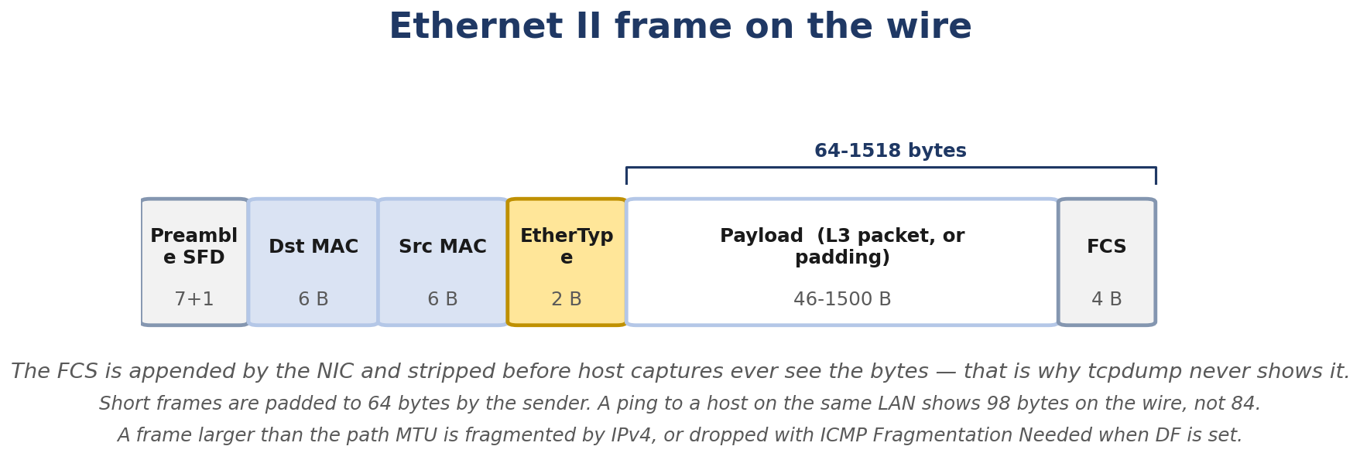
Figure 2.1. Ethernet II frame on the wire, including the parts a host capture never shows you.
- What an Ethernet frame looks like on the wire, byte by byte
- How MAC addresses identify hosts on the local link
- How ARP maps an IP address to a MAC address in real time
- How the kernel maintains the neighbor cache and what each state means
- How IPv6 Neighbor Discovery replaces ARP
- How VLAN tagging works (802.1Q)
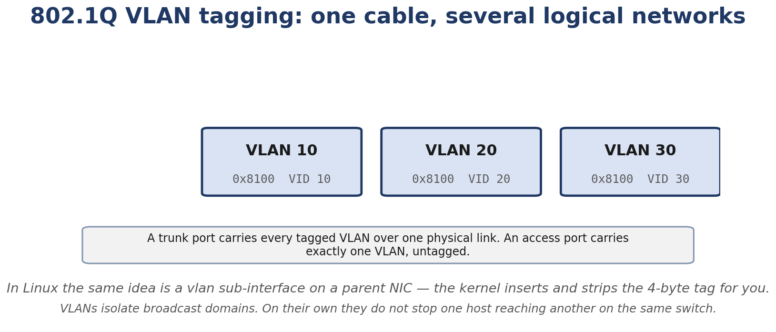
Figure 2.2. 802.1Q tagging: several logical layer-2 networks sharing one physical link.
- The difference between a switch and a router
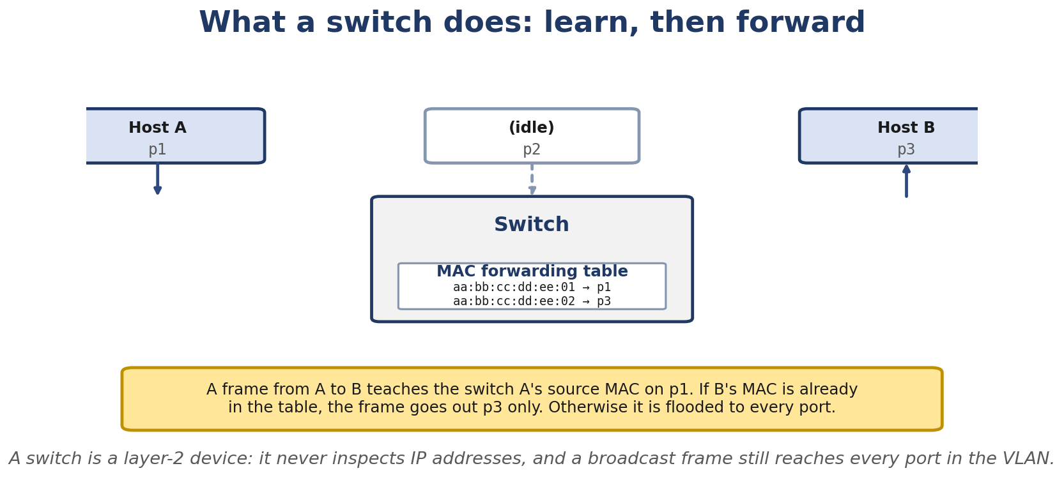
Figure 2.3. What a switch does: learn source MACs, then forward or flood based on the forwarding table.
- How Linux decides “is this destination on my link or do I need to send it to a gateway?”

Real-Life Analogy - The Last-Mile Delivery
Reality check — where the analogy breaks. The analogy above is a pedagogical tool for building a mental model. It is not a precise description of the kernel mechanism. The real implementation differs from the analogy in ways your interviews and lab work will surface; always reason from the kernel source when precision matters.
Chapter 1 left us at the post office. The letter has the right destination address (IP). Now it has to reach the specific house on the local street. That’s what this chapter covers.
Imagine a street with twenty houses. The postman (the NIC) carries the envelope (the packet). The envelope says “house 12” (the destination IP). The postman doesn’t know every house number by heart. They look at a clipboard (the neighbor cache) that says “house 12 is the blue door on the right.” If the clipboard is empty, the postman walks up to a loudspeaker in the middle of the street and shouts, “Hey, house 12, drop your mailbox!” (an ARP request, broadcast to every house on the street). House 12 yells back, “I’m the blue door!” (ARP reply). The postman updates the clipboard and delivers.
Two things matter here:
- The clipboard is cached, not perfect. If house 12 moves away, the entry becomes stale until the postman checks.
- The loudspeaker is shared. Every house on the street hears the shout. That’s the Ethernet broadcast MAC ff:ff:ff:ff:ff:ff.
This is ARP. Every time you send a packet to a host on your local segment, this is what happens.

The Networking Concept

Ethernet framing
Every Ethernet frame on the wire has the same structure:
+----------+----------+----------+----------+----------------+----------+
| Dst MAC | Src MAC | EtherType| Payload | Pad (if any) | FCS (note: ordinary host packet captures do not always include the Ethernet FCS) |
| 6 B | 6 B | 2 B | 46-1500 B | 0-? B | 4 B |
+----------+----------+----------+----------+----------------+----------+
Destination MAC (6 bytes) - who should receive this frame. The special value ff:ff:ff:ff:ff:ff means “everyone on this segment.” Source MAC (6 bytes) - who sent it. Always unicast (the lowest bit of the first byte is 0). EtherType (2 bytes) - what protocol is in the payload. Common values: - 0x0800 - IPv4 - 0x86DD - IPv6 - 0x0806 - ARP - 0x8100 - VLAN tag (802.1Q) - when this is present, a 4-byte VLAN tag is inserted between Source MAC and EtherType Payload - the encapsulated higher-layer packet. 46-byte minimum (so the frame is at least 64 bytes total, not counting preamble) and 1500-byte maximum (the MTU). FCS (note: ordinary host packet captures do not always include the Ethernet FCS) (4 bytes) - Frame Check Sequence, a CRC over the entire frame. The receiving NIC uses this to detect corruption. If the CRC fails, the frame is silently dropped - the receiver doesn’t even know it was sent.
The minimum frame size of 64 bytes exists for collision detection on shared media. Modern full-duplex switched networks don’t need it, but the standard still requires the minimum payload length.

MAC address format
A MAC address is 48 bits, conventionally written as six hex bytes:
52:54:00:12:34:56
The first three bytes (here 52:54:00) of a globally administered address are typically an IEEE-assigned organizationally unique identifier (OUI or OUI-36/MAC-24/MAC-36/MAC-40) - the IEEE-allocated block identifying the organization that owns this prefix. The remaining bytes (12:34:56) are assigned by the organization within that block. The historical “first three bytes = OUI” rule is not a universal truth on modern IEEE-allocated prefixes: IEEE now also assigns MA-L (24-bit, traditional OUI), MA-M (28-bit), and MA-S (20-bit + 4-bit extension) blocks, so the OUI portion may be shorter or longer than 24 bits depending on the allocation type. Treat “first three bytes = manufacturer” as a beginner mnemonic, not a precise statement.
Two special bits matter in the first byte:
I/G bit (bit 0 of byte 0) - Individual/Group. 0 means unicast (this one device). 1 means multicast (a group of devices). U/L bit (bit 1 of byte 0) - Universal/Local. 0 means globally unique (assigned by manufacturer). 1 means locally administered (you set it yourself, often for virtual interfaces).
Examples:
52:54:00:12:34:56 - first byte 0x52 = 0101 0010. I/G=0, U/L=0. Globally unique, unicast. ff:ff:ff:ff:ff:ff - first byte 0xff = 1111 1111. I/G=1. Broadcast (multicast used as broadcast). 33:33:00:00:00:01 - first byte 0x33 = 0011 0011. I/G=1. This is an IPv6 multicast MAC (IPv6 multicast addresses map to 33:33:xx:xx:xx:xx).

Ethernet broadcast
A frame with destination MAC ff:ff:ff:ff:ff:ff is delivered to every device on the same Layer-2 segment. Switches flood it out every port (except the one it came in on). Every NIC checks the destination and accepts it.
IPv4 also has broadcast IPs (e.g. 192.168.1.255 for a /24), but IPv6 does not - IPv6 uses multicast only.

Switches (briefly, from the kernel’s perspective)
A switch is a Layer-2 device. It learns which MAC is on which port by inspecting incoming frames and builds a forwarding table (the FDB, Forwarding Database). When a frame arrives:
- The switch reads the source MAC and associates it with the ingress port. If it didn’t already know that MAC, it learns it.
- The switch looks up the destination MAC in its FDB.
- If found, it forwards the frame out only that port.
- If not found, it floods the frame out every port except the ingress (unknown unicast flood).
- If the destination is ff:ff:ff:ff:ff:ff (broadcast) or a multicast MAC, it floods.
This means: a switch isolates conversations between different pairs of devices. Two simultaneous conversations between four hosts can use the full link speed on each port. (A hub, the old shared-media device, cannot - it just repeats everything everywhere.)
For the rest of this book, assume the network is switched. Almost every modern network is.

ARP - Address Resolution Protocol
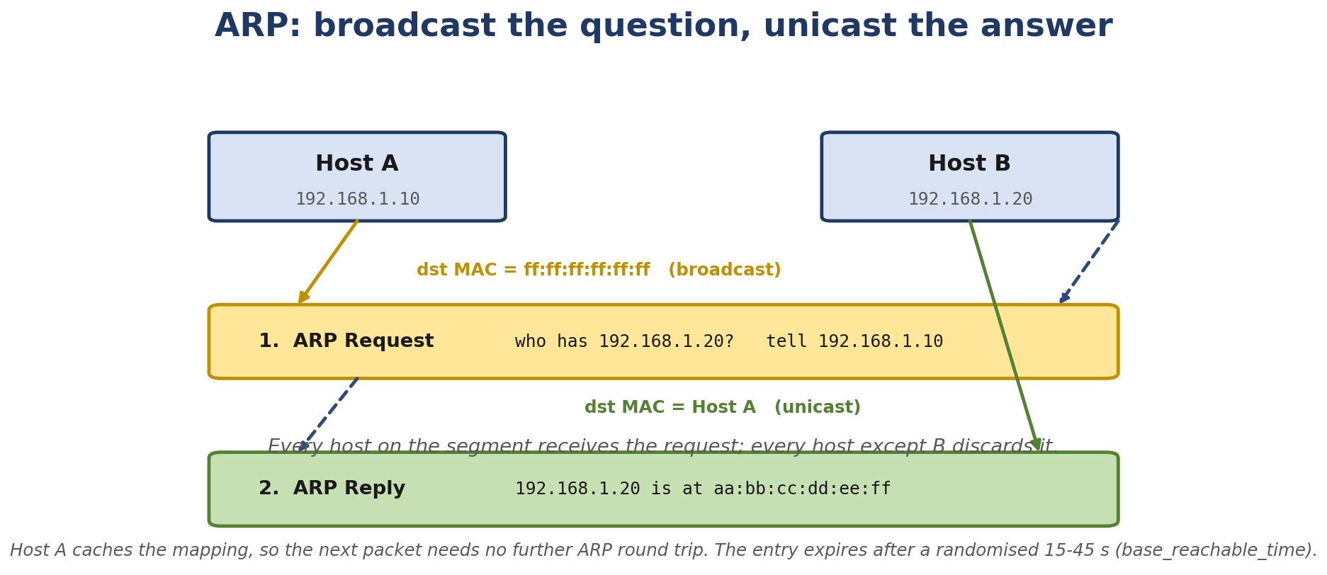
Figure 2.4. ARP: the request is broadcast, the reply is unicast. Host A caches the result.
ARP exists to bridge Layers 2 and 3. The kernel knows it wants to send an IP packet to 192.168.1.5. It also knows 192.168.1.5 is on the local link (from the routing table). But to actually transmit the Ethernet frame, it needs the MAC address of the host that owns 192.168.1.5. ARP provides that mapping.

ARP request
The kernel broadcasts:
Ethernet header
Dst MAC: ff:ff:ff:ff:ff:ff (broadcast)
Src MAC: 52:54:00:11:11:11 (our MAC)
EtherType: 0x0806 (ARP)
ARP payload
Hardware type: 1 (Ethernet)
Protocol type: 0x0800 (IPv4)
Hardware size: 6
Protocol size: 4
Opcode: 1 (request)
Sender MAC: 52:54:00:11:11:11
Sender IP: 192.168.1.10
Target MAC: 00:00:00:00:00:00 (unknown)
Target IP: 192.168.1.5
Every device on the segment receives this. Only the one whose IP matches 192.168.1.5 responds. The others drop it.

ARP reply
That device sends back:
Ethernet header
Dst MAC: 52:54:00:11:11:11 (unicast back to requester)
Src MAC: 52:54:00:22:22:22
EtherType: 0x0806
ARP payload
Hardware type: 1
Protocol type: 0x0800
Hardware size: 6
Protocol size: 4
Opcode: 2 (reply)
Sender MAC: 52:54:00:22:22:22
Sender IP: 192.168.1.5
Target MAC: 52:54:00:11:11:11
Target IP: 192.168.1.10
The requester now knows 192.168.1.5 is at MAC 52:54:00:22:22:22. It updates the neighbor cache and sends the originally intended IP packet.

Gratuitous ARP
A host can also send an ARP request for its own IP - that is, Sender IP = Target IP = my IP. This is gratuitous ARP, and it has two main uses:
- Announce a move. When a host gets a new IP (e.g. via DHCP or failover), it sends gratuitous ARP so any switches that receive the frame update their forwarding database (FDB) for the sender’s source MAC (this is normal bridge learning, not GARP-specific); hosts on the segment may update their ARP/neighbor caches for the announced IP-to-MAC mapping; GARP does not actively push to switches that do not see the frame and other hosts update their ARP caches.
- Detect IP conflicts. If another host replies, you know your IP is already in use.

ARP and IPv6
IPv6 doesn’t use ARP. It uses Neighbor Discovery (ND), which runs over ICMPv6. The functionality is the same - map an IPv6 address to a MAC - but the mechanism is different:
Neighbor Solicitation (NS) - the IPv6 equivalent of ARP request, sent to the solicited-node multicast address (which only the target should be listening on, not the whole segment). Neighbor Advertisement (NA) - the IPv6 equivalent of ARP reply, sent unicast back.
Solicited-node multicast is clever. Every IPv6 unicast address has a corresponding solicited-node multicast address in the ff02::1:ffxx:xxxx range. The host joins that multicast group on each interface. NS goes to that multicast, so only the target processes it - not every host on the link.
ND also provides router discovery (find the default gateway), prefix discovery (what’s the on-link prefix), and duplicate address detection (is anyone else using my tentative address?).

The neighbor cache
Linux keeps ARP/ND results in the neighbor cache (also called the ARP table on IPv4 hosts). Each entry has:
The Layer-3 address (IPv4 or IPv6) The Layer-2 address (MAC) The interface it’s on A state machine
The state machine is the subtle part:
INCOMPLETE - we sent an ARP request and are waiting for a reply. REACHABLE - we recently confirmed the host is reachable (we got a reply, or we got an upper-layer confirmation within the reachable time). STALE - the entry is in the cache but we haven’t confirmed reachability lately. The next packet will trigger a confirmation. DELAY - a packet was sent to a STALE entry, but we’re giving the upper layer a brief window to confirm reachability before sending an ARP probe. PROBE - actively probing (sending ARP requests) to confirm reachability before declaring STALE→REACHABLE. FAILED - probing didn’t get a reply. The neighbor is considered unreachable.
Default timers (tunable via sysctl):
base_reachable_time_ms - typically a randomized interval around the default base_reachable_time of 30 s (typically 15-45 s). After this much time without confirmation, REACHABLE → STALE. gc_stale_time / delay_first_probe_time - when to first probe a STALE entry. retransmit_time_ms - how long to wait between ARP probes before declaring FAILED.

Switches vs routers
A switch operates at Layer 2. It forwards frames based on MAC addresses. It cannot move traffic between different IP subnets.
A router operates at Layer 3. It forwards packets based on IP addresses. It connects different subnets and rewrites the MAC headers at each hop.
In Linux, a host with multiple interfaces and IP forwarding enabled acts as a router. The kernel forwards packets between interfaces. (Chapter 8 covers bridging vs routing in detail.)

Default gateway
When the kernel wants to send to 8.8.8.8 but the routing table says 8.8.8.8 is not on any local subnet, the kernel looks for a route with a gateway. The route entry might say default via 192.168.1.1. So the kernel needs to ARP 192.168.1.1 (not 8.8.8.8) and send the frame to the gateway’s MAC. The gateway then takes responsibility for forwarding the packet onward.
This is the key insight: on a local Ethernet, you only ever ARP for the next hop, not for the final destination.

Follow the Packet
Let’s trace ping 192.168.1.5 from 192.168.1.10 (same subnet, no router involved):
- Application: ping opens an ICMP socket, builds an echo request.
- Kernel routing: ip route get 192.168.1.5 returns 192.168.1.5 dev eth0 src 192.168.1.10 - directly reachable, no gateway.
- Neighbor lookup: kernel checks ip neigh show. If 192.168.1.5 is in the cache in REACHABLE state, use that MAC. If not, trigger ARP.
- ARP request: kernel broadcasts an ARP request for 192.168.1.5.
- ARP reply: 192.168.1.5 replies. Kernel adds an entry to the neighbor cache.
- Frame build: kernel wraps the ICMP packet in an IP header, then in an Ethernet frame:
- Dst MAC = 192.168.1.5’s MAC
- Src MAC = our MAC
- EtherType = 0x0800
- Transmit: the NIC sends the frame on the wire.
- Receive: 192.168.1.5’s NIC receives it, decapsulates up to ICMP, sends an echo reply.
- Reply arrives on our NIC, decapsulates, matches the pending socket, delivers to ping.

Linux View

Inspect the neighbor cache
$ ip neigh
192.168.1.1 dev eth0 lladdr a4:2b:b0:12:34:56 REACHABLE
192.168.1.5 dev eth0 lladdr 52:54:00:22:22:22 STALE
fe80::1 dev eth0 lladdr a4:2b:b0:12:34:56 REACHABLE
The lladdr is the MAC. The state matters for understanding what happens next.

Force a fresh ARP
$ sudo ip neigh flush all
$ ping -c1 192.168.1.5
$ ip neigh show 192.168.1.5
192.168.1.5 dev eth0 lladdr 52:54:00:22:22:22 REACHABLE

Capture ARP exchanges
$ sudo tcpdump -nei eth0 arp
15:32:11.123456 ARP, Request who-has 192.168.1.5 tell 192.168.1.10, length 28
15:32:11.123890 ARP, Reply 192.168.1.5 is-at 52:54:00:22:22:22, length 28
-e shows the link-layer (MAC) addresses. -n skips DNS.

Capture the full ping
$ sudo tcpdump -nei eth0 -c 4 icmp
15:32:11.123456 52:54:00:11:11:11 > 52:54:00:22:22:22, IPv4, length 98: 192.168.1.10 > 192.168.1.5: ICMP echo request
Notice: at the link layer, the frame shows the MACs, not IPs. The IPs are in the IPv4 payload.

Inspect VLAN subinterfaces
$ ip link add link eth0 name eth0.10 type vlan id 10
$ ip link set eth0.10 up
$ ip addr add 192.168.10.10/24 dev eth0.10
$ ip -d link show eth0.10
vlan id 10 <REORDER_HDR> ...
eth0.10 is a VLAN subinterface on eth0. Frames sent out of it will have an 802.1Q tag inserted (if the underlying driver supports hardware VLAN offload; otherwise the kernel does it).
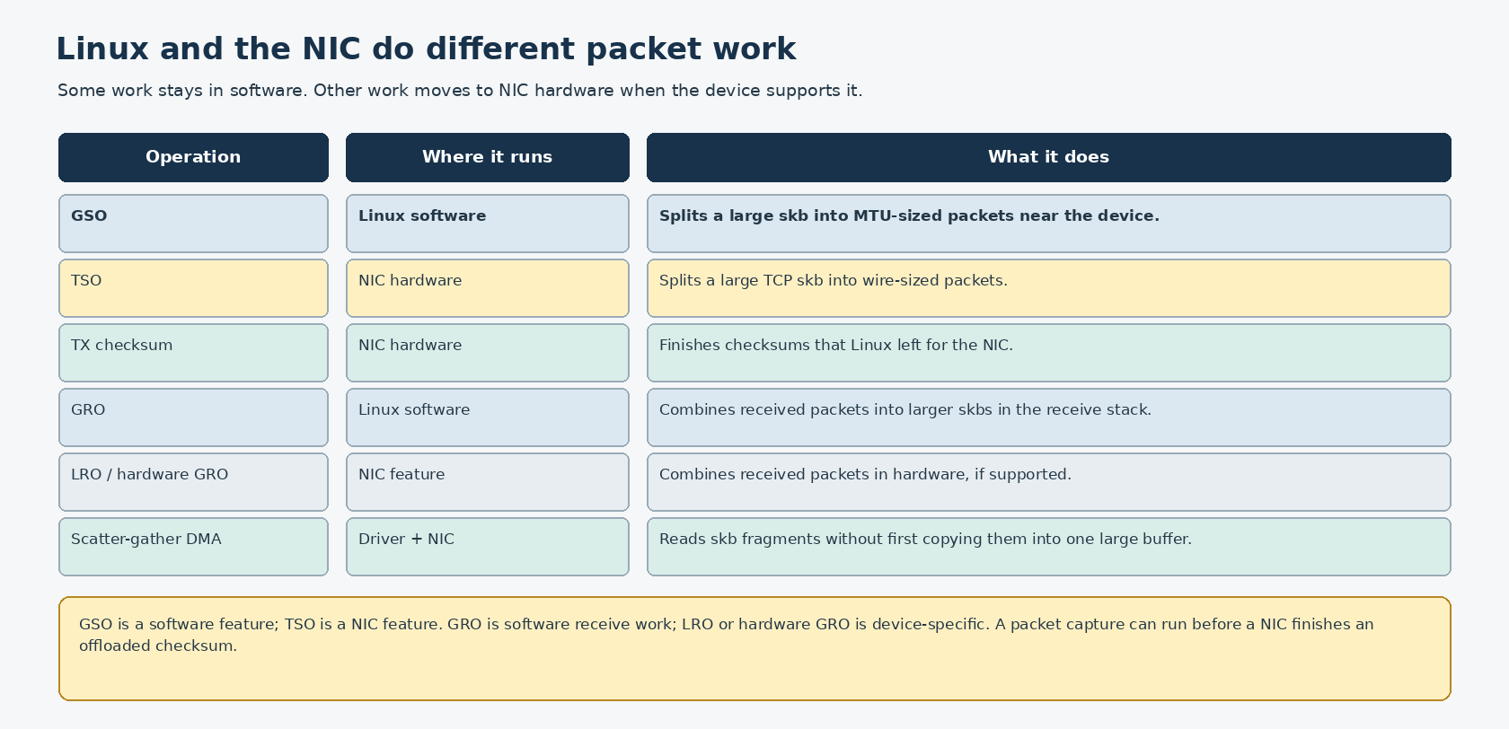
Figure 2.5. GSO and GRO are software features; TSO and checksum offload use NIC hardware when supported.

Kernel View
The relevant kernel files:
net/ipv4/arp.c - IPv4 ARP request/reply handling net/ipv6/ndisc.c - IPv6 Neighbor Discovery net/core/neighbour.c - the generic neighbor cache (shared by ARP, ND, and DECnet) drivers/net/ethernet/* - drivers handle the actual frame TX/RX net/8021q/ - VLAN subinterface
Key functions:
arp_solicit - send an ARP request for a target neigh_resolve_output - given an skb with a Layer-3 destination, resolve the MAC (or queue the skb while ARP is in progress) neigh_event_ns - process an incoming ARP or NA ndisc_solicit / ndisc_recv_na - IPv6 ND functions __neigh_create / neigh_destroy - entry lifecycle neigh_timer_handler - state machine transitions
The neighbor cache is implemented as a hash table indexed by (dev, protocol, address). Each entry has a neighbour struct with the MAC, state, timer, and queues for waiting skbs.

Source Code Walkthrough

Excerpt 1: arp_solicit (net/ipv4/arp.c)
static void arp_solicit(struct neighbour *neigh, struct sk_buff *skb)
{
__be32 saddr = 0;
u8 dst_ha[MAX_ADDR_LEN], *dst_hw = NULL;
if (IN_DEV(neigh->dev)->arp_parms &&
!(IN_DEV(neigh->dev)->arp_parms->no_neigh))
saddr = inet_select_addr(neigh->dev, 0, RT_SCOPE_LINK);
neigh_probe(neigh, skb);
...
}
neigh_probe is what actually sends the broadcast ARP request. Note the IP source address selection - inet_select_addr picks the address on neigh->dev that’s in the same subnet as the target.

Excerpt 2: neigh_resolve_output (net/core/neighbour.c, abbreviated)
int neigh_resolve_output(struct neighbour *neigh, struct sk_buff *skb)
{
if (!neigh || !(neigh->nud_state & NUD_VALID)) {
...
}
if (neigh->nud_state & NUD_CONNECTED) {
/* Fast path: have a valid MAC, just write it. */
return dev_hard_header(skb, dev, ETH_P_IP, ...);
}
...
}
NUD_VALID includes REACHABLE, STALE, DELAY, PROBE - i.e. states where we have a MAC we can try. NUD_CONNECTED is the subset that are confirmed-recent (REACHABLE, PERMANENT, NOARP). Fast path writes the MAC straight into the skb header; otherwise the skb is queued for later transmission when the ARP completes.

Excerpt 3: VLAN tag insertion
In net/8021q/vlan_dev.c:
static int vlan_dev_hard_header(struct sk_buff *skb, struct net_device *dev,
unsigned short type, const void *dst_addr,
const void *src_addr, unsigned len)
{
return dev_hard_header(skb, vlan_dev_priv(dev)->real_dev,
ETH_P_8021Q, dst_addr, src_addr, len);
}
The VLAN device is essentially a thin shim that inserts the 4-byte 802.1Q tag before passing the skb to the real device. The VLAN ID lives in vlan_dev_priv(dev)->vlan_id.

Hands-On Lab - Watch ARP Happen

Goal
You’ll create two network namespaces connected by a veth pair and watch the ARP exchange that lets them communicate.

Setup
A single Linux VM or machine. No special hardware. Need iproute2 (which provides ip, ip netns, etc.).

Commands
# Create two namespaces
sudo ip netns add ns-a
sudo ip netns add ns-b
# Create a veth pair
sudo ip link add veth-a type veth peer name veth-b
# Move each end into a namespace
sudo ip link set veth-a netns ns-a
sudo ip link set veth-b netns ns-b
# Configure IPs and bring them up
sudo ip netns exec ns-a ip addr add 192.168.100.1/24 dev veth-a
sudo ip netns exec ns-a ip link set veth-a up
sudo ip netns exec ns-b ip addr add 192.168.100.2/24 dev veth-b
sudo ip netns exec ns-b ip link set veth-b up

Capture the ARP exchange
In one terminal:
sudo ip netns exec ns-a tcpdump -nei veth-a -c 2 arp
In another:
sudo ip netns exec ns-a ping -c1 192.168.100.2

Expected Output
listening on veth-a, link-type EN10MB (Ethernet), capture size 262144 bytes
15:32:11.123456 ARP, Request who-has 192.168.100.2 tell 192.168.100.1, length 28
15:32:11.123890 ARP, Reply 192.168.100.2 is-at <MAC>, length 28
2 packets captured

Explanation
Before ping could send its ICMP packet, the kernel in ns-a needed the MAC of 192.168.100.2. The neighbor cache was empty. So it broadcast an ARP request. ns-b received it, recognized its own IP, replied unicast. ns-a cached the result, built the ICMP frame, and sent it.

Experiment
- Run sudo ip netns exec ns-a ip neigh show. Note the REACHABLE entry for 192.168.100.2.
- Wait 30+ seconds. Run ip neigh show again - the entry may have moved to STALE.
- Send another packet. Watch it briefly enter DELAY, then return to REACHABLE.

Break It
sudo ip netns exec ns-a ip neigh flush all
sudo ip netns exec ns-a ping -c1 192.168.100.2
Flushing the cache forces a fresh ARP. Notice this happens transparently - ping works fine, just one extra ARP exchange.
WARNING: iptables -A INPUT -p arp -j DROP does NOT actually drop ARP frames. The ip tables family in iptables matches only IPv4 protocols, and ARP is link-layer - it never traverses the IPv4 netfilter hooks. To make the experiment work, use one of the following instead:
# Option A: nftables with the arp family (works on the host, not namespace-internal)
sudo ip netns exec ns-a nft add table arp filter
sudo ip netns exec ns-a nft 'add chain arp filter input { type filter hook input priority 0; policy accept; }'
sudo ip netns exec ns-a nft 'add rule arp filter input arp op request drop'
sudo ip netns exec ns-a ping -W1 -c1 192.168.100.2
# Option B: ebtables (bridge family), which DOES see ARP frames
sudo ip netns exec ns-a ebtables -A INPUT -p ARP -j DROP
To see what happens with ARP completely blocked, use one of the methods above. The original iptables command was technically broken and would not actually filter ARP traffic.
Now ping fails with From 192.168.100.1 icmp_seq=1 Destination Host Unreachable after the ARP times out.

Debug It
Apply the layer-by-layer methodology: can ping 127.0.0.1 in ns-a work? (Tests loopback.) Can ns-b see its own veth? (ip netns exec ns-b ip link show.) Is the ARP reply actually returning? (tcpdump on the veth in ns-b.) Is the neighbor cache in ns-b populated?

Challenge
Without running the commands, predict: what state will ip neigh show show for 192.168.100.2 exactly 35 seconds after a successful ping, with default Linux timers?

Solution
After about a randomized interval around the default base_reachable_time of 30 s (typically 15-45 s) of inactivity, REACHABLE transitions to STALE. So you’d see STALE. The next packet sent will enter DELAY for a short window (5 seconds by default) and then PROBE if no upper-layer confirmation arrives.

Interview Questions
Q2.1 (Beginner) - What is the difference between a MAC address and an IP address?
A MAC address identifies a network interface on the local physical (or virtual) link. An IP address identifies a host on a logical network. MACs are 48 bits, used at Layer 2 by switches; IPs are 32 or 128 bits, used at Layer 3 by routers. A packet keeps the same IP across hops but its MAC changes at every hop.
Q2.2 (Beginner) - What does ARP do, and why is it needed?
ARP maps an IP address to the MAC address of the device that owns it on the local segment. Without it, the kernel knows the destination IP but cannot build a valid Ethernet frame, because the frame needs a destination MAC. The kernel broadcasts an ARP request asking “who has IP X?” and the device with that IP responds with its MAC.
Q2.3 (Beginner) - What is the broadcast MAC address, and what is it used for?
ff:ff:ff:ff:ff:ff. Every NIC on the segment accepts frames with this destination. Used for ARP requests and certain other protocols (DHCP discovery, for example). IPv4 also has IP-layer broadcast addresses, but IPv6 does not - IPv6 uses multicast.
Q2.4 (Intermediate) - Explain the neighbor cache state machine. Why does Linux not just keep entries forever?
The state machine balances correctness and efficiency. REACHABLE means “we recently confirmed this MAC.” After a timeout (default ~30s), the entry goes STALE because we can’t be sure the host is still there. The next packet sent triggers DELAY/PROBE to reconfirm. Without this, we’d send packets to stale MACs forever after a host moved or vanished. The cost is occasional ARP probes - the benefit is correctness.
Q2.5 (Intermediate) - How does IPv6 Neighbor Discovery differ from ARP?
ND runs over ICMPv6 (so it can be extended, secured with IPsec, etc.), uses solicited-node multicast instead of broadcast (more efficient, no need to wake every host), and combines multiple functions: address resolution, router discovery, prefix discovery, and duplicate address detection. ARP is IPv4-only and broadcast-based.
Q2.6 (Intermediate) - Why is gratuitous ARP useful?
It’s used to announce an IP-to-MAC mapping change to the segment. After a host gets a new IP (DHCP, failover, NIC swap), gratuitous ARP tells switches to update their FDBs and other hosts to update their ARP caches. Without it, traffic would continue to go to the old MAC until cache entries aged out.
Q2.7 (Intermediate) - How does a switch decide which port to forward a frame out of?
It consults its Forwarding Database (FDB), which maps MAC addresses to ports. The FDB is built by learning: every time a frame comes in on a port, the source MAC is associated with that port. If the destination MAC is unknown, the switch floods the frame out all ports except the ingress.
Q2.8 (Advanced) - What is ARP spoofing, and how is it mitigated?
ARP spoofing is when a host sends ARP replies claiming that some IP (often the gateway) is at its own MAC. Other hosts update their caches and start sending traffic through the attacker. Mitigations: static ARP entries (work but don’t scale), DAI (Dynamic ARP Inspection on managed switches - verifies ARP packets against a DHCP snooping database), ARPwatch/IDS, network segmentation, or simply using IPv6 with Secure Neighbor Discovery (SEND).
Q2.9 (Advanced) - What is VLAN hopping, and how do switches prevent it?
VLAN hopping is sending frames tagged for a VLAN you shouldn’t have access to, getting frames into another VLAN’s broadcast domain. Two flavors: switch spoofing (a host impersonates a switch and negotiates a trunk) and double-tagging (a frame carries two 802.1Q tags, the first is stripped by the first switch, the second is interpreted by the next). Mitigation: explicitly configure trunk ports (switchport mode trunk on the right ports only, all others access), disable auto-negotiation of trunks, and in some cases use a native VLAN that’s not used for data.
Q2.10 (Advanced) - What happens when a host with no default gateway tries to send to an off-link IP?
The kernel’s routing table lookup returns “no route to host.” The kernel returns EHOSTUNREACH to the application; no packet is ever transmitted. This is one of the most common misconfigurations in container/VM setups.

Key Takeaways
An Ethernet frame is destination MAC, source MAC, EtherType, payload, FCS (note: ordinary host packet captures do not always include the Ethernet FCS). The minimum payload length keeps the frame above 64 bytes; the maximum (MTU) is typically 1500. A MAC address is 48 bits. The I/G and U/L bits tell you whether it’s unicast/multicast and global/local. ARP exists to bridge Layers 2 and 3: it maps an IP to a MAC on the local segment. The neighbor cache has a state machine - REACHABLE, STALE, DELAY, PROBE, FAILED. Entries don’t live forever because hosts move. IPv6 replaces ARP with Neighbor Discovery (NS/NA over ICMPv6), uses multicast instead of broadcast, and combines several link-local functions. 802.1Q VLAN tagging lets a single physical link carry multiple logical Layer-2 segments. On a local Ethernet, you ARP only for the next hop, never for the final destination.

Practice Challenges
- Find your gateway’s MAC. On your machine, run ip route to find the default gateway’s IP, then ip neigh to find its MAC. Now run sudo tcpdump -nei eth0 -c 1 arp and try to trigger an ARP - what do you see?
- Watch a state transition. After pinging a host, immediately run ip neigh show repeatedly (e.g. in a loop). Observe the state transitions over time.
- Add a static ARP entry. sudo ip neigh replace 192.168.1.5 lladdr 52:54:00:22:22:22 dev eth0 nud permanent. Now try to ping 192.168.1.5. What happens if the real MAC is different?
- Build a VLAN. On your machine (if you have control of the switch), create ip link add link eth0 name eth0.10 type vlan id 10. Configure an IP on it. Capture traffic with tcpdump -nei eth0 -vv - you should see 802.1Q tags.
- IPv6 ND. Run ping6 fe80::1%eth0 to ping a link-local IPv6 address. Use sudo tcpdump -nei eth0 -vv 'icmp6' to observe the NS/NA exchange.
- Find the kernel files. On your Ubuntu VM, apt install linux-source then explore net/ipv4/arp.c and net/core/neighbour.c. Find the function that handles an incoming ARP packet.
- Force a failure. Use nft 'add rule arp filter input arp op request drop' (after creating an arp filter table and chain) or ebtables -A INPUT -p ARP -j DROP in a namespace and observe how neighbor resolution fails. Note: iptables -A INPUT -p arp -j DROP does NOT actually drop ARP - iptables’ IPv4 family doesn’t match ARP. What’s the timeout?

Chapter 3 - IP Addressing, Routing and How Linux Chooses the Next Hop

What You Will Learn
- The IPv4 and IPv6 header layouts, field by field
- How subnetting works - how to read a prefix and find network/broadcast
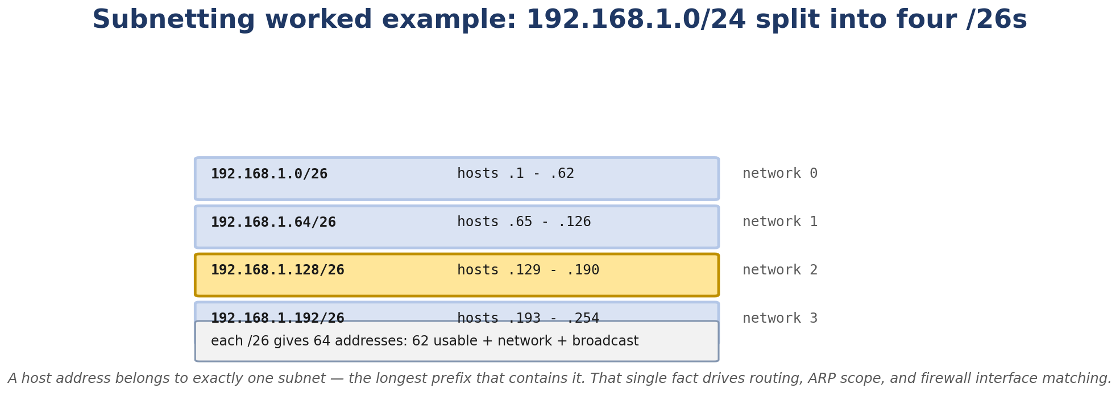
Figure 3.1. Splitting 192.168.1.0/24 into four /26 subnets.
- CIDR notation and prefix lengths
- How the kernel’s routing table is structured
- Longest-prefix match - what it is and how Linux implements it
- The full set of route types: unicast, local, broadcast, blackhole, prohibit, throw, anycast, multicast
- Policy routing with multiple tables and ip rule
- How to predict a route with ip route get before sending the packet
- ICMP types and codes, TTL and hop limit, fragmentation
- Path MTU Discovery and what happens when it breaks

Real-Life Analogy - The GPS and the Road Map
Reality check — where the analogy breaks. The analogy above is a pedagogical tool for building a mental model. It is not a precise description of the kernel mechanism. The real implementation differs from the analogy in ways your interviews and lab work will surface; always reason from the kernel source when precision matters.
The postal system gave us IPs as addresses. Now we need a way to figure out which way to send the letter. That’s routing.
Imagine a national postal network. Every sorting office has a giant book of directions: “if the destination city is in the Northeast, put it on Truck A. If it’s the Midwest, Truck B. If it’s international, Truck C.” That book is the routing table.
When an envelope arrives, the clerk reads the destination city and finds the matching rule. If multiple rules apply (say, “all of New England” and “specifically Boston”), the clerk uses the most specific rule. That’s longest-prefix match.
Sometimes the routing book has multiple sections for different kinds of traffic. Section A is for letters from local residents. Section B is for letters from the corporate office. Section C is for foreign mail. Each section has its own rules. The clerk flips to the right section based on the envelope’s origin or some other criterion. That’s policy routing.
When no rule matches, the envelope goes to the “default” sorting office - the one that handles anything we don’t recognize. That’s the default route.

The Networking Concept

IPv4 header
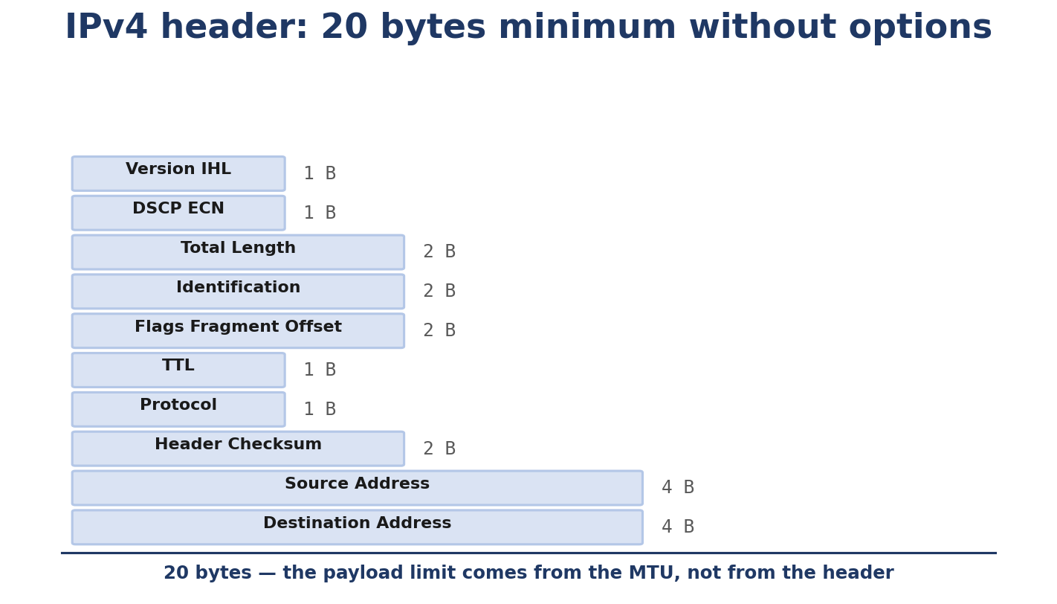
Figure 3.2. IPv4 header: 20 bytes minimum without options. The payload limit comes from the MTU, not the header.
0 1 2 3
0 1 2 3 4 5 6 7 8 9 0 1 2 3 4 5 6 7 8 9 0 1 2 3 4 5 6 7 8 9 0 1
+-+-+-+-+-+-+-+-+-+-+-+-+-+-+-+-+-+-+-+-+-+-+-+-+-+-+-+-+-+-+-+-+
|Version| IHL |Type of Service| Total Length |
+-+-+-+-+-+-+-+-+-+-+-+-+-+-+-+-+-+-+-+-+-+-+-+-+-+-+-+-+-+-+-+-+
| Identification |Flags| Fragment Offset |
+-+-+-+-+-+-+-+-+-+-+-+-+-+-+-+-+-+-+-+-+-+-+-+-+-+-+-+-+-+-+-+-+
| Time to Live | Protocol | Header Checksum |
+-+-+-+-+-+-+-+-+-+-+-+-+-+-+-+-+-+-+-+-+-+-+-+-+-+-+-+-+-+-+-+-+
| Source Address |
+-+-+-+-+-+-+-+-+-+-+-+-+-+-+-+-+-+-+-+-+-+-+-+-+-+-+-+-+-+-+-+-+
| Destination Address |
+-+-+-+-+-+-+-+-+-+-+-+-+-+-+-+-+-+-+-+-+-+-+-+-+-+-+-+-+-+-+-+-+
| Options | Padding |
+-+-+-+-+-+-+-+-+-+-+-+-+-+-+-+-+-+-+-+-+-+-+-+-+-+-+-+-+-+-+-+-+
Version (4 bits) - 4 for IPv4, 6 for IPv6. IHL (4 bits) - Internet Header Length, in 32-bit words. Minimum 5 (= 20 bytes header), maximum 15 (= 60 bytes with options). Type of Service (8 bits) - modern usage: DSCP (6 bits) for QoS class, ECN (2 bits) for congestion signaling. Total Length (16 bits) - entire IP packet size in bytes, header included. Max 65535. Identification (16 bits) - used for fragment reassembly. Flags (3 bits) - bit 0 reserved, bit 1 = Don’t Fragment (DF), bit 2 = More Fragments (MF). Fragment Offset (13 bits) - where this fragment fits in the original packet, in 8-byte units. TTL (8 bits) - decremented by each router. When it hits 0, the packet is dropped and an ICMP Time Exceeded is sent back. Prevents routing loops from keeping packets alive forever. Protocol (8 bits) - what’s in the payload. 1=ICMP, 6=TCP, 17=UDP, 41=IPv6-encapsulated, 47=GRE, 50=ESP, etc. Header Checksum (16 bits) - covers only the header (TCP/UDP cover their own + payload). Source/Destination Address (32 bits each). Options - rarely used today. Source routing, record route, timestamp.

IPv6 header
0 1 2 3
0 1 2 3 4 5 6 7 8 9 0 1 2 3 4 5 6 7 8 9 0 1 2 3 4 5 6 7 8 9 0 1
+-+-+-+-+-+-+-+-+-+-+-+-+-+-+-+-+-+-+-+-+-+-+-+-+-+-+-+-+-+-+-+-+
|Version| Traffic Class | Flow Label |
+-+-+-+-+-+-+-+-+-+-+-+-+-+-+-+-+-+-+-+-+-+-+-+-+-+-+-+-+-+-+-+-+
| Payload Length | Next Header | Hop Limit |
+-+-+-+-+-+-+-+-+-+-+-+-+-+-+-+-+-+-+-+-+-+-+-+-+-+-+-+-+-+-+-+-+
| |
+ +
| |
+ Source Address (128 bits) +
| |
+ +
| |
+-+-+-+-+-+-+-+-+-+-+-+-+-+-+-+-+-+-+-+-+-+-+-+-+-+-+-+-+-+-+-+-+
| |
+ +
| |
+ Destination Address (128 bits) +
| |
+ +
| |
+-+-+-+-+-+-+-+-+-+-+-+-+-+-+-+-+-+-+-+-+-+-+-+-+-+-+-+-+-+-+-+-+
Simpler than IPv4: fixed 40-byte header, no fragmentation fields (IPv6 routers don’t fragment; the sender uses PMTUD or accepts that large packets fail), no header checksum (assumed handled by lower and upper layers). Extension headers (if needed) follow the main header and are chained via the “Next Header” field.

Subnetting and CIDR
An IPv4 address has two parts: the network portion (the prefix) and the host portion (what’s left). The prefix length tells you where to split:
192.168.1.10/24 - first 24 bits are the network. The network is 192.168.1.0/24. The host is 0.0.0.10 within that network. 10.0.0.5/8 - first 8 bits are the network. The network is 10.0.0.0/8. The host is 0.0.0.5. 192.168.1.0/30 - only 2 host bits. Possible hosts: 192.168.1.1 and 192.168.1.2 (with .0 as network and .3 as broadcast).
CIDR replaced the old classful addressing (A/B/C/D/E). It lets you use any prefix length instead of being stuck with /8, /16, /24.
Special addresses in any subnet:
Network address - all host bits zero. 192.168.1.0/24. Broadcast address - all host bits one. 192.168.1.255/24. Gateway - by convention, often the .1 (e.g. 192.168.1.1), but it’s not enforced - the gateway can be any host in the subnet.

The IPv6 prefix
IPv6 has no broadcast. The first address in a /64 (...::0) is just an address, not “the network address.” The convention for routers is ...::1.
There are several reserved prefixes:
::/0 - default route. ::1/128 - loopback. fe80::/10 - link-local. Every IPv6 interface has one automatically. fc00::/7 - unique local (RFC 4193, the IPv6 equivalent of RFC 1918 private space). 2000::/3 - global unicast. ff00::/8 - multicast.

The routing table
The routing table is a set of routes. Each route says “to reach this prefix, send via this gateway (or directly), out this interface, with this metric.”
default via 192.168.1.1 dev eth0 proto dhcp src 192.168.1.10 metric 100
192.168.1.0/24 dev eth0 proto kernel scope link src 192.168.1.10 metric 100
10.0.0.0/8 via 10.0.0.1 dev tun0 metric 50
blackhole 192.168.100.0/24
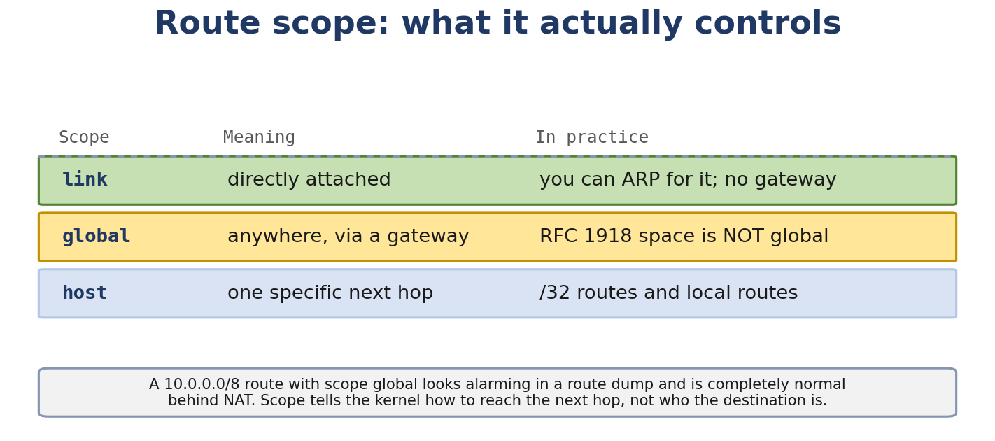
Figure 3.3. Route scope controls how the next hop is reached, not who the destination is.
Types of routes you’ll meet:
unicast - normal route, with a gateway or device. local - destination is one of our own IPs. Handled locally, never sent. broadcast - destination is a broadcast address on a directly-attached subnet. local (the kernel auto-adds these for every IP). blackhole - drop the packet silently. unreachable / prohibit - return ICMP “destination unreachable” / “administratively prohibited” to the sender. throw - go back to the previous routing table (used in policy routing).

Longest-prefix match
When the kernel looks up a destination, it picks the most specific matching route. Example:
default via 192.168.1.1 dev eth0
192.168.1.0/24 dev eth0 scope link
192.168.100.0/24 via 192.168.1.1 dev eth0 metric 10
A packet for 192.168.100.5 matches both the default and the /24. The kernel picks the /24 - more bits, more specific. A packet for 192.168.200.5 matches only the default.

Routing metrics
When two routes have the same prefix length, metric (lower wins) breaks the tie. Also, in Linux, route type matters: locally-added routes typically beat dynamically-learned ones.

Policy routing
Most setups use a single routing table called main. But Linux supports multiple tables and rules that say “for traffic from source X, look in table Y first.”
# Create a custom table
echo "200 vpn" | sudo tee /etc/iproute2/rt_tables
# Add a default route to that table
sudo ip route add default via 10.8.0.1 dev tun0 table vpn
# Tell the kernel to use the vpn table for traffic from 192.168.50.10
sudo ip rule add from 192.168.50.10 lookup vpn
sudo ip rule add to 192.168.50.10 lookup vpn
# Default - use the main table
sudo ip rule add lookup main priority 32766
This is how VPN “split-tunnel” setups work, and how multi-homed hosts steer traffic.

ip route get
This command does the actual lookup the kernel would do and tells you what would happen. It’s invaluable for debugging:
$ ip route get 8.8.8.8
8.8.8.8 via 192.168.1.1 dev eth0 src 192.168.1.10 uid 0
cache
The output tells you:
The route was found via 192.168.1.1. Out interface is eth0. Source address that will be used is 192.168.1.10. The uid 0 means the lookup was performed as UID 0 (root).
You can also test with a from-address:
$ ip route get 8.8.8.8 from 10.0.0.5
That walks the policy routing rules first.

ICMP
ICMP is the network’s diagnostic and error-reporting protocol. It’s not “user data” - it’s infrastructure.
Common types:
0 - Echo Reply (the response to ping). 3 - Destination Unreachable. Codes 0=net, 1=host, 2=protocol, 3=port, 4=fragmentation needed (PMTUD), 5=source route failed. 5 - Redirect. Tells the sender “you should use a different gateway next time.” 8 - Echo Request (ping). 11 - Time Exceeded. Sent when TTL hits 0 (used by traceroute).
ICMP packets have a small header:
Type (1) | Code (1) | Checksum (2) | Rest-of-header (4) | Payload
For echo request/reply, “rest of header” is identifier + sequence. For other types, it varies.

TTL and hop limit
IPv4’s TTL and IPv6’s hop limit do the same job: prevent packets from living forever in routing loops. Each router decrements. At 0, the packet is dropped and ICMP Time Exceeded (IPv4) or ICMPv6 Hop Limit Exceeded (IPv6) is sent back.
Common starting values:
Linux: 64 (default) Windows: 128 Many routers: 255
ping lets you set it: ping -t 1 8.8.8.8 sends with TTL 1 - useful to see the first router.

Fragmentation
When a packet is larger than the outgoing interface’s MTU, IPv4 can fragment it. Each fragment has the same Identification, a different Fragment Offset, and the MF flag set on all but the last.
IPv6 doesn’t allow router fragmentation. The sender is expected to use PMTUD to discover the path MTU. If the packet is too big for the outgoing interface, the sender is expected to drop it (or the kernel may generate an ICMPv6 Packet Too Big back to itself for loopback, but this doesn’t help across the network).

Path MTU Discovery
PMTUD is how the sender learns the smallest MTU along a path. Process:
- Sender sets DF (Don’t Fragment) and sends.
- If a router on the path can’t forward (next-hop MTU is smaller), it drops the packet and sends back ICMP Type 3 Code 4 (“Fragmentation Needed and DF set”), including the MTU of its outgoing interface.
- Sender receives the ICMP, records the MTU, and reduces its packet size.
- Repeat until the packet gets through.
If the ICMP is blocked (firewall dropping it), PMTUD breaks - the sender keeps sending big packets that get dropped silently. This is “PMTUD black hole” and is one of the classic “why does my big upload fail” issues.

Follow the Packet
ping 8.8.8.8 from 192.168.1.10:
- Kernel routing: ip route get 8.8.8.8 → 8.8.8.8 via 192.168.1.1 dev eth0 src 192.168.1.10.
- Next-hop is 192.168.1.1. Look up its MAC in the neighbor cache (or ARP for it).
- Build Ethernet frame: Dst MAC = gateway’s MAC, Src MAC = our MAC, EtherType = IPv4.
- Build IPv4 packet: Src = 192.168.1.10, Dst = 8.8.8.8, TTL = 64, Protocol = ICMP, Identification = some kernel-chosen number.
- Encapsulate ICMP Echo Request inside.
- Send.
- Router receives, decrements TTL to 63, looks up 8.8.8.8 in its own routing table, sends to next hop.
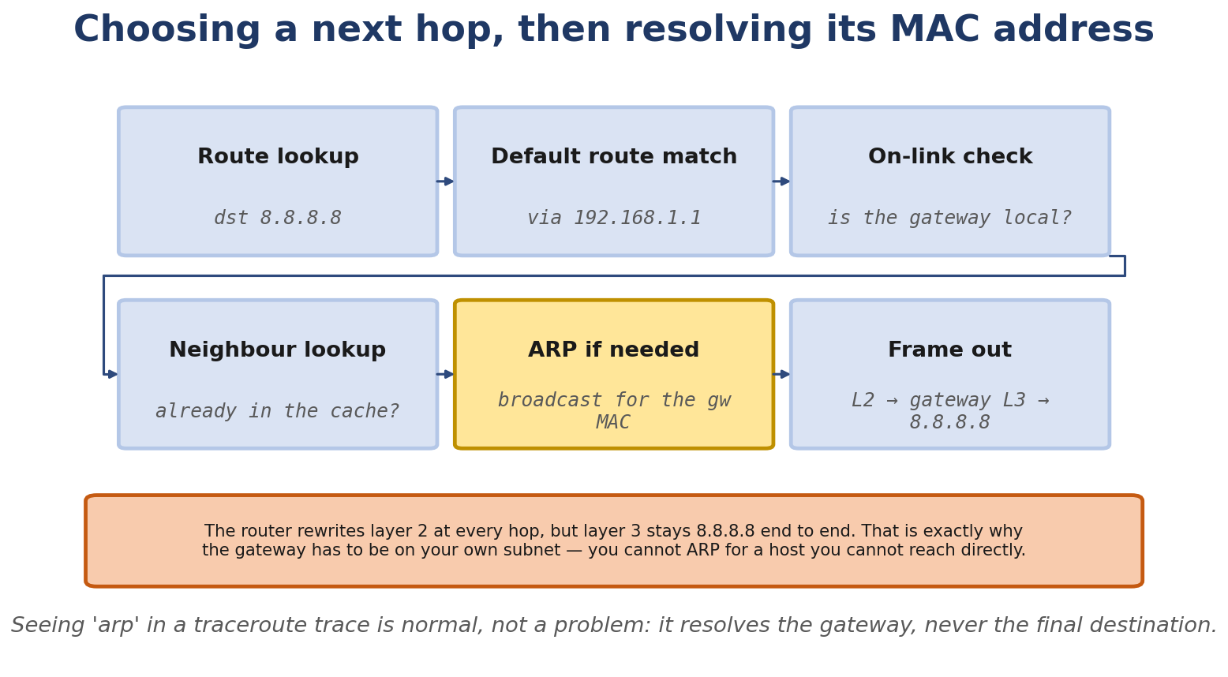
Figure 3.4. Choosing a next hop, then resolving its MAC address. The gateway has to be on your own subnet.
- Eventually reaches 8.8.8.8, which sends an Echo Reply back through the same process.

Linux View

Inspect the routing table
$ ip route show
default via 192.168.1.1 dev eth0 proto dhcp src 192.168.1.10 metric 100
192.168.1.0/24 dev eth0 proto kernel scope link src 192.168.1.10 metric 100

Predict a route
$ ip route get 8.8.8.8
8.8.8.8 via 192.168.1.1 dev eth0 src 192.168.1.10 uid 0
cache
$ ip route get 192.168.1.5
192.168.1.5 dev eth0 src 192.168.1.10 uid 0
cache
$ ip route get 10.99.99.99
10.99.99.99 via 192.168.1.1 dev eth0 src 192.168.1.10 uid 0
cache

traceroute
$ traceroute -n 8.8.8.8
traceroute to 8.8.8.8 (8.8.8.8), 30 hops max
1 192.168.1.1 0.412 ms 0.401 ms 0.391 ms
2 10.0.0.1 8.122 ms 8.099 ms 8.110 ms
3 ...
...
Each hop is a TTL=1, 2, 3, … packet. The router at that hop decrements to 0, drops, and sends back ICMP Time Exceeded (revealing its IP).

Policy routing
$ ip rule show
0: from all lookup local
32766: from all lookup main
32767: from all lookup default
local is a special kernel table that handles local and broadcast addresses. main is the user-managed table. default is empty and used as a fallback.

Routing cache
Modern Linux doesn’t have a routing cache anymore (it was removed in 3.6). fib_lookup walks the trie directly each time. There’s a per-CPU cached route for the most recent lookup, but no global cache. The “cache” you see in ip route get output means “this result came from the per-CPU cache.”

Path MTU test
$ ping -M do -s 1472 8.8.8.8 # should work (1500 - 28 = 1472 payload + IP+ICMP headers)
$ ping -M do -s 1473 8.8.8.8 # may fail if path MTU is 1500
PING 8.8.8.8 (8.8.8.8) 1473(1501) bytes of data.

Force PMTUD black hole
sudo iptables -I OUTPUT -p icmp --icmp-type fragmentation-needed -j DROP
Now PMTUD is broken on your host. Try sending big packets - they’ll fail.

Kernel View
The kernel’s IPv4 routing code lives in:
net/ipv4/fib_trie.c - the trie data structure (replaced fib_hash in 2.6). net/ipv4/fib_semantics.c - route semantics, fib_rules, fib_info. net/ipv4/fib_lookup.h - the lookup interface. net/ipv4/route.c - high-level routing decisions for input/output. net/ipv4/ip_output.c - output path. net/ipv4/icmp.c - ICMP handling.
Key functions:
fib_lookup - given a flow, find the route. ip_route_input - input-side lookup (used for incoming packets). __ip_route_output_key_hash - output-side lookup. ip_finish_output2 - neighbor-resolution output (the function called after MTU check; ip_finish_output calls ip_fragment -> ip_finish_output2 if fragmentation is needed; otherwise it goes directly to neighbor lookup). ip_rt_acct - route accounting.
The trie structure: each node has up to two children (bit 0 or bit 1) and a list of routes that match at that prefix length. The lookup walks from the longest possible prefix down, returning the most specific match.

Source Code Walkthrough

Excerpt 1: fib_lookup contract
include/net/ip_fib.h declares:
struct fib_result {
__be32 prefix;
unsigned char prefixlen;
struct fib_info *fi;
struct fib_rule *r;
struct fib_nh_common *nhc;
...
};
int fib_lookup(struct net *net, struct flowi4 *flp,
struct fib_result *res, unsigned int flags);
flowi4 is the lookup key: source/destination address, tos, scope, protocol, sport/dport (if known), iif (input interface). fib_lookup walks the trie, fills in fib_result with the matched route and next-hop.

Excerpt 2: ip_route_input and rp_filter
In net/ipv4/route.c, ip_route_input is called early in packet receive. One of its jobs is the reverse-path filter:
if (IN_DEV_OR_NET(in_dev, rp_filter)) {
if (fib_validate_source(...)) {
...
goto drop;
}
}
rp_filter checks: if I sent a packet from my IP and routed it back to the same source, would it arrive on the same interface? If not, drop. This catches spoofed source IPs. Three modes: 0 = off, 1 = strict (drop if route lookup for source doesn’t go back via same interface), 2 = loose (drop only if source is unreachable at all).

Excerpt 3: ip_finish_output2 (does NOT fragment; ip_finish_output does)
[Linux 6.6] The IP output path is: ip_finish_output (MTU check + fragmentation decision) -> [ip_fragment -> ip_finish_output2] OR [direct -> ip_finish_output2]. So ip_finish_output2 itself handles the neighbor lookup and final hand-off; it does NOT decide whether to fragment. The actual MTU-vs-length decision lives in ip_finish_output:
In net/ipv4/ip_output.c:
static int ip_finish_output2(struct net *net, struct sock *sk, struct sk_buff *skb)
{
struct dst_entry *dst = skb_dst(skb);
struct net_device *dev = dst->dev;
...
if (neigh_output(neigh, skb) == 0)
return 0;
...
}
neigh_output calls neigh_resolve_output (Chapter 2). The skb now has a destination MAC and is ready for dev_queue_xmit.

Hands-On Lab - Predict the Next Hop

Goal
You’ll set up a host with two interfaces and predict routing decisions before sending packets.

Setup
A single Linux VM. Need iproute2.

Commands
If you have only one real interface, simulate a second by creating a veth pair where one end stays in the host and the other goes into a namespace. The host side is “eth1”:
sudo ip netns add ns-test
sudo ip link add veth-host type veth peer name veth-ns
sudo ip link set veth-ns netns ns-test
sudo ip link set veth-host up
sudo ip addr add 10.50.0.1/24 dev veth-host
sudo ip netns exec ns-test ip addr add 10.50.0.2/24 dev veth-ns
sudo ip netns exec ns-test ip link set veth-ns up
Now your host has eth0 (default route via 192.168.1.1) and veth-host (10.50.0.1/24).

Predict routes
$ ip route get 192.168.1.5
192.168.1.5 dev eth0 src 192.168.1.10 uid 0
cache
$ ip route get 10.50.0.2
10.50.0.2 dev veth-host src 10.50.0.1 uid 0
cache
$ ip route get 10.50.0.99
10.50.0.99 via 10.50.0.2 dev veth-host src 10.50.0.1 uid 0
cache ← note: there's no /24 connected route for 10.50.0.0/24 on the host side, so it falls through to default
(Adjust based on what your actual routes show.)

Add a more specific route
sudo ip route add 10.50.0.0/26 via 10.50.0.2 dev veth-host
ip route get 10.50.0.50 # in this /26, goes via 10.50.0.2
ip route get 10.50.0.200 # not in /26, falls through to default

Break It
sudo ip route add blackhole 10.50.0.0/24
ping 10.50.0.2 # fails with no response
To see the kernel drop:
sudo ip route get 10.50.0.5
10.50.0.5 dev lo scope host src 10.50.0.5 blackhole
A blackhole route is local to the box - the kernel drops the packet without sending ICMP. Different from “unreachable” which sends ICMP back.

Debug It
Use traceroute -n 8.8.8.8. If it stops at your default gateway, your gateway doesn’t know how to forward - the problem is on that device, not you. If it stops halfway through, the problem is further upstream. If it works fine, your routing is OK; the problem must be application-layer.

Challenge
Without running, predict: in ns-test, what does ip route get 192.168.1.5 return? Does it work? Why?

Solution
ns-test only has a veth to the host. It has no default route. So the kernel in ns-test returns “network is unreachable” - there’s no route for 192.168.1.5 and no default. The kernel never sends a packet. Add sudo ip netns exec ns-test ip route add default via 10.50.0.1 dev veth-ns and it works (assuming the host forwards).

Interview Questions
Q3.1 (Beginner) - What’s the difference between a default route and a more specific route?
A default route (0.0.0.0/0 for IPv4, ::/0 for IPv6) catches everything that doesn’t match a more specific route. A specific route like 192.168.1.0/24 only catches that subnet. When multiple routes match a destination, the most specific (longest prefix) wins.
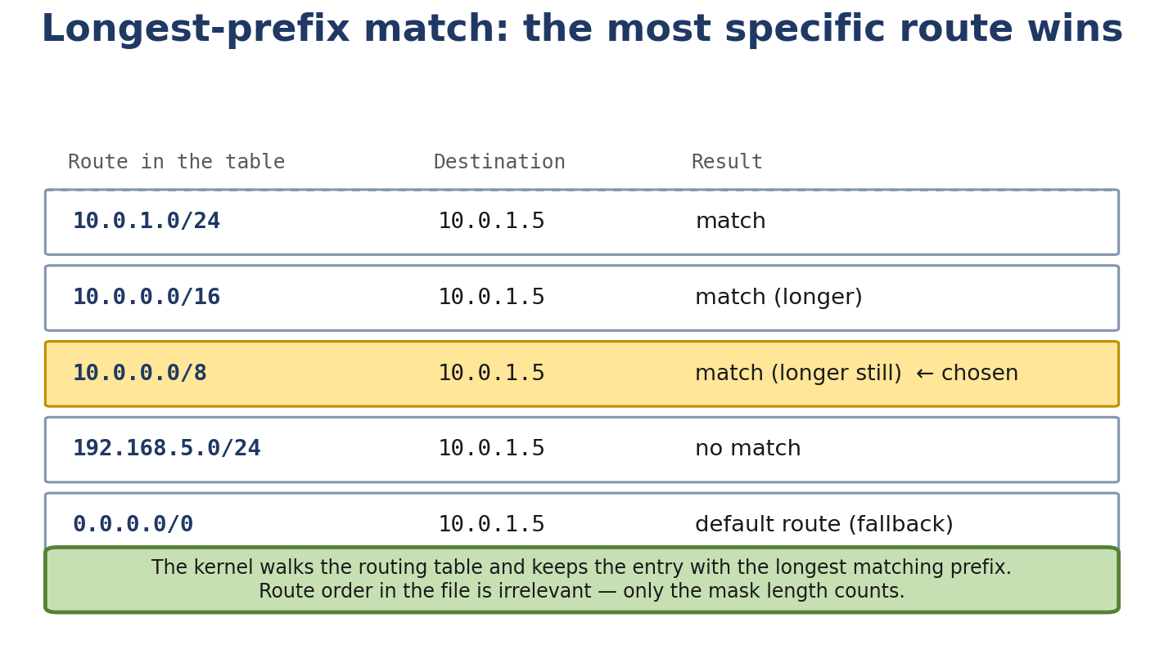
Figure 3.5. Longest-prefix match: the most specific matching route wins, regardless of the order routes appear in.
Q3.2 (Beginner) - Why does the TTL field exist?
To prevent packets from looping forever between misconfigured routers. Each hop decrements; at 0 the packet is dropped and an ICMP Time Exceeded is sent back. This bounds the damage from routing loops.
Q3.3 (Beginner) - What is the kernel’s routing table, conceptually?
A list of rules that say “to reach this prefix, send the packet via this gateway (or directly), out this interface, with this metric and source.” The kernel does a longest-prefix match for each outgoing packet.
Q3.4 (Intermediate) - How does Linux implement longest-prefix match?
With a trie (the fib_trie). Each node represents a bit position and has up to two children (bit 0 and bit 1). The lookup walks from the longest possible prefix toward shorter ones, returning the first route that matches. The structure is efficient (256KiB for the IPv4 root node alone but it’s a flat array, cache-friendly).
Q3.5 (Intermediate) - Explain policy routing. When would you use it?
Policy routing lets you use multiple routing tables. Rules say “for traffic from source X (or to destination Y, or with mark Z), look in table W first.” Common use cases: VPN split-tunnel (some traffic via VPN, some direct), source-based routing on multi-homed hosts, and isolating management traffic.
Q3.6 (Intermediate) - What is rp_filter, and what does it protect against?
Reverse-path filter. On input, the kernel checks that the source IP would route back out the same interface (strict mode) or to anywhere at all (loose mode). If not, the packet is dropped. Protects against IP spoofing. Asymmetric routing can cause false positives with strict mode.
Q3.7 (Intermediate) - Explain the difference between fragmentation and PMTUD.
Fragmentation splits a too-large packet into smaller pieces that are reassembled at the destination. PMTUD discovers the smallest MTU along a path before sending so you can size packets to fit without fragmenting. Fragmentation is generally avoided today (security concerns, complexity, performance cost); PMTUD is the preferred approach.
Q3.8 (Advanced) - Why is PMTUD fragile in practice?
Because it relies on ICMP Fragmentation Needed messages coming back. Firewalls and ACLs frequently drop ICMP. When that happens, the sender has no idea its packets are too big, so it keeps sending them and they keep being dropped. Result: small transfers work, large transfers hang. Common mitigation: clamp MSS at the VPN/TCP layer (advertise a smaller MSS in the SYN so the connection never tries to send a too-big packet).
Q3.9 (Advanced) - How does Linux handle route cache invalidation?
There’s no global route cache anymore (since 3.6). The kernel invalidates routes by bumping a generation counter (the fnhe_genid on the FIB next-hop exception cache). When the counter changes, lookups re-walk the trie. This means cache invalidation is essentially free - no cache to flush.
Q3.10 (Advanced) - Describe IPv6’s approach to routing differently from IPv4.
IPv6 has link-local addresses by default on every interface (used for NDP and as source for routing protocols), uses Router Advertisements to learn the default route (instead of DHCP-only), and supports multiple addresses per interface natively (useful for renumbering). The routing table structure is essentially the same - IPv6 has its own fib_trie (net/ipv6/ip6_fib.c) but the trie algorithm is shared.
Q3.11 (Advanced) - What happens when you ip route add while traffic is using that route?
The route is added atomically. New lookups will see it. Existing flows with the old route cached (in the per-CPU next-hop exception cache) will continue to use the old route until their cached entry expires or the route is invalidated. With ip route replace, the kernel bumps the genid to invalidate existing cached entries immediately.
Q3.12 (Advanced) - How does Linux decide between an IPv4 and IPv6 route when both exist for the same destination?
It doesn’t, at the routing table level - the addresses are in separate tables. The address-family choice happens earlier: in getaddrinfo (controlled by AI_ADDRCONFIG, RFC 6724 rules, and /etc/gai.conf) the application (or the kernel’s resolver helper) decides whether to try A or AAAA records. Once a destination family is chosen, only that family’s routing table is consulted. The kernel can be configured to prefer IPv6 over IPv4 (/etc/gai.conf) for getaddrinfo lookups.

Key Takeaways
IPv4 is 32-bit, IPv6 is 128-bit. CIDR uses prefix lengths (/n) to mark the network portion. The routing table is a list of (prefix, gateway, interface, metric) tuples. Lookups use longest-prefix match. Linux’s routing table is built from a trie for O(prefix_length) lookups instead of O(N) table scans. Policy routing via multiple tables and ip rule lets you steer different traffic through different paths. ip route get <dest> is the fastest way to see what the kernel would do without actually sending. ICMP carries error and diagnostic info; ICMP Type 3 Code 4 is the PMTUD signal. TTL/hop limit prevents routing loops. Fragmentation is discouraged in favor of PMTUD.

Practice Challenges
- Find your prefix. On your machine, compute the network and broadcast addresses for every IP. Use ipcalc or python3 -c 'import ipaddress; print(ipaddress.ip_network("192.168.1.10/24"))'.
- Add a more-specific route. Create two default routes with different metrics. Use ip route get to see which one wins.
- Break PMTUD. Use iptables to drop outgoing ICMP Type 3 Code 4. Try to send a 1500-byte ping. Observe the failure.
- traceroute with -f and -m. Set the first TTL to 5 and max hops to 8. See what you learn about the path.
- Policy routing. Set up a custom table and rule. Confirm with ip rule show and ip route get 8.8.8.8 from <your IP>.
- Read fib_trie.c. Look at trie_get_next or similar. Find the loop that walks down from root to leaf. Why is it efficient?
- Find your router’s hops. Run mtr 8.8.8.8 if available. Compare with traceroute - what’s different?

Chapter 4 - Sockets: How Applications Enter the Linux Network Stack

What You Will Learn
- What a socket really is - the bridge between your program and the kernel
- The syscall interface: socket, bind, listen, accept, connect, send, recv, and friends
- Blocking vs non-blocking I/O and when to use each
- Socket options you should know (SO_REUSEADDR, TCP_NODELAY, SO_KEEPALIVE, SO_LINGER, SO_RCVBUF/SO_SNDBUF)
- The select, poll, and epoll mechanisms and why epoll scales
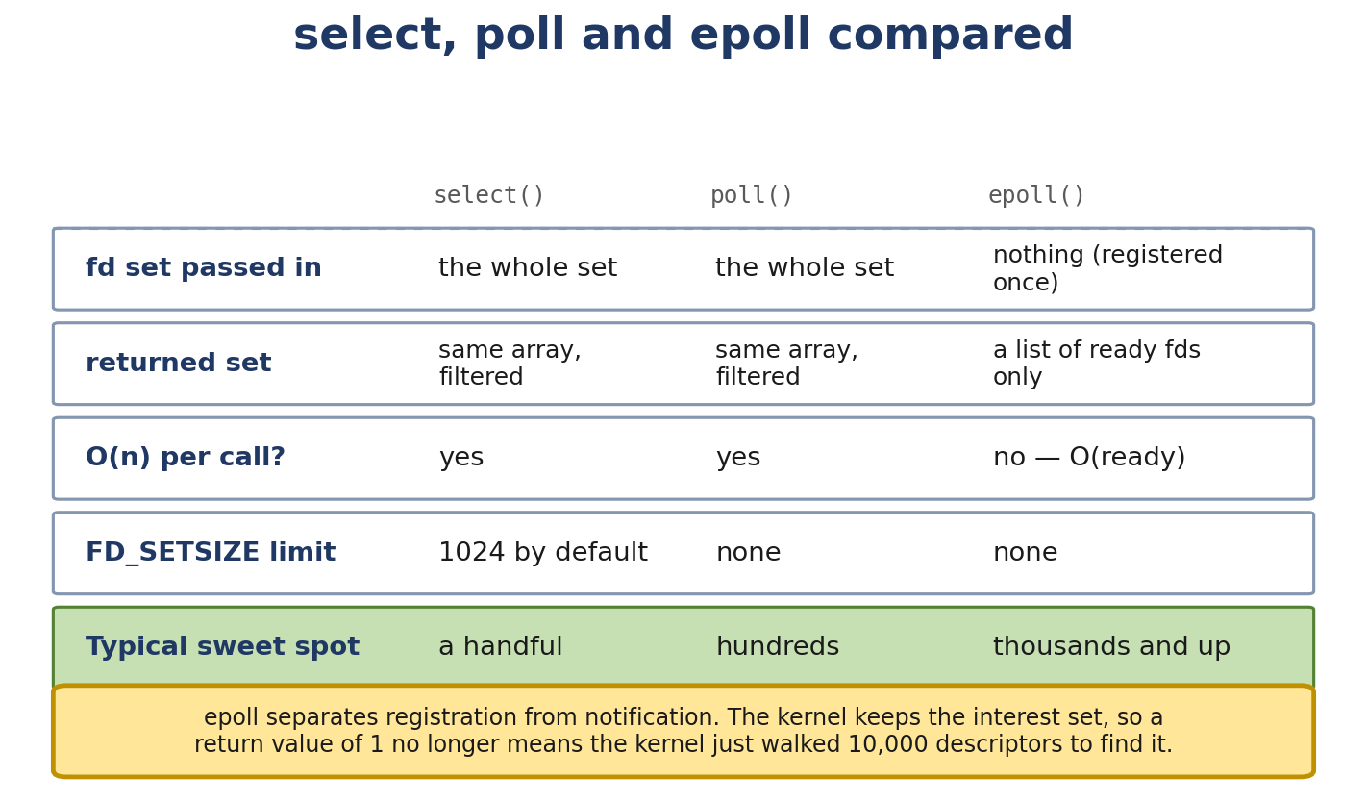
Figure 4.1. select, poll and epoll compared. epoll separates registration from notification.
- The difference between TCP and UDP from the syscall perspective
- How strace lets you watch your program talk to the kernel
- How to write a working TCP echo server and a UDP probe in C
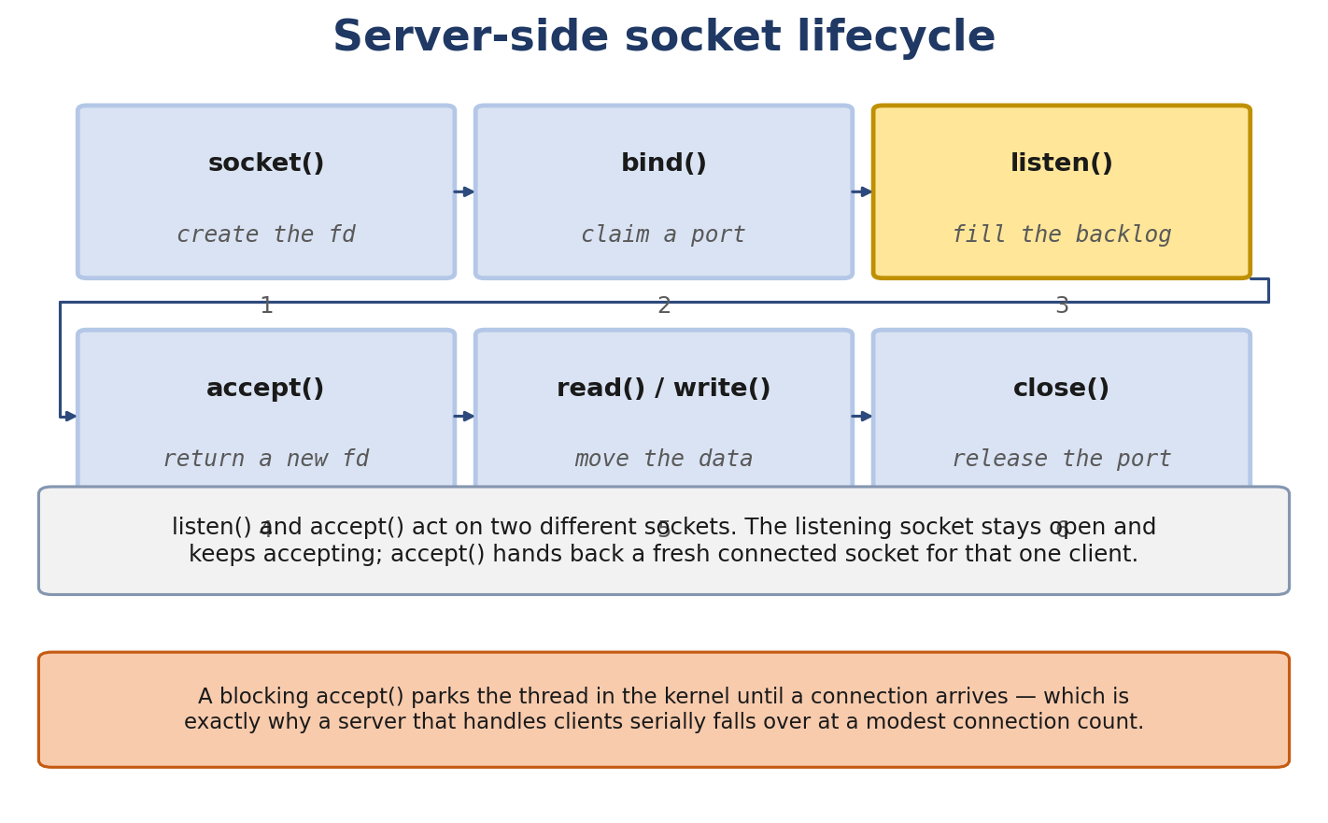
Figure 4.2. The server-side socket lifecycle. listen() and accept() act on two different sockets.

Real-Life Analogy - The Post-Office Counter, Revisited
Reality check — where the analogy breaks. The analogy above is a pedagogical tool for building a mental model. It is not a precise description of the kernel mechanism. The real implementation differs from the analogy in ways your interviews and lab work will surface; always reason from the kernel source when precision matters.
The post office has a counter. You stand on the user side; the postal worker stands on the kernel side. To use the service, you fill out a form (the syscall arguments) and hand it across the counter. The worker stamps it, files it, and gives you back a receipt (the file descriptor).
The receipt is your ticket number. Every time you want to do something - send a letter, receive one, ask about delivery status - you present your ticket. The counter knows your service type (TCP vs UDP) and your addressing details (which ports you’ve claimed).
The key thing about this counter: it’s not magic. The worker on the other side is following a procedure. You can watch the procedure by standing near the counter with a clipboard - that’s strace. Every syscall your program makes is a paper form handed across.

The Networking Concept

What is a socket?
A socket is a kernel object representing one end of a network conversation. It bundles:
The protocol family (AF_INET for IPv4, AF_INET6 for IPv6, AF_UNIX for local sockets). The socket type (SOCK_STREAM for TCP, SOCK_DGRAM for UDP, SOCK_RAW for raw protocols). The local address and port (if bound). The remote address and port (if connected). Send and receive buffers. A queue of pending connections (for listening TCP sockets). A backpointer to the struct file so the socket is accessible via standard file descriptor syscalls (read, write, close, poll, etc.).
In user space, you have an integer file descriptor (fd) that refers to the socket. In kernel space, there’s a struct socket and (for AF_INET) a struct sock underneath.
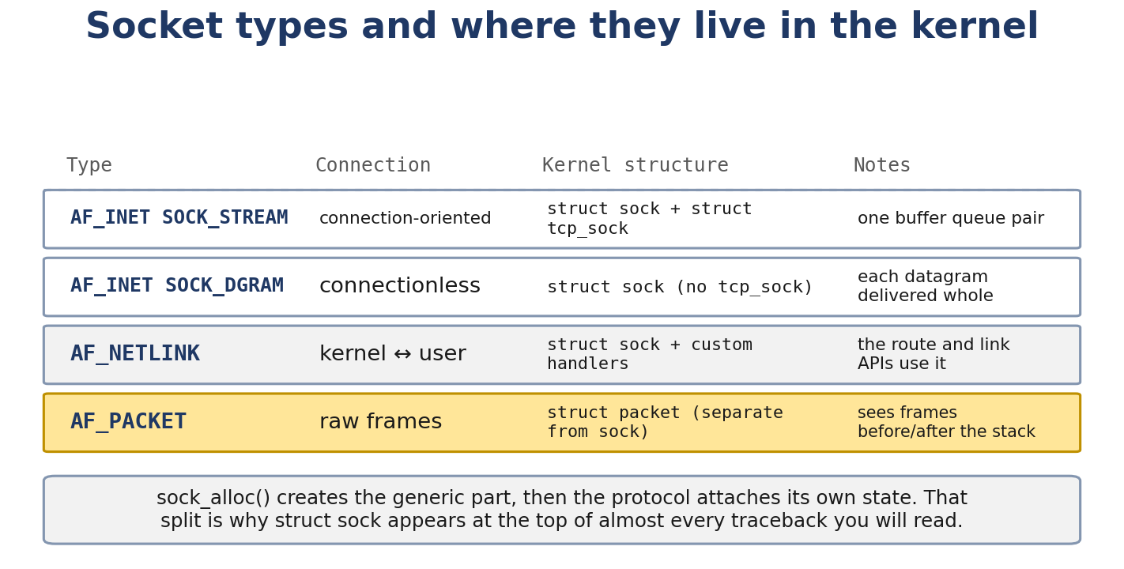
Figure 4.3. Socket families and the kernel structures behind them. struct sock appears at the top of most networking tracebacks.

The syscall interface
All of these are POSIX (or Linux-specific) syscalls. They look like normal C functions:
#include <sys/socket.h>
#include <netinet/in.h>
#include <arpa/inet.h>
#include <unistd.h>
int fd = socket(AF_INET, SOCK_STREAM, 0);
That’s the counter - “I want a TCP over IPv4 service, give me a ticket.”
struct sockaddr_in addr = {
.sin_family = AF_INET,
.sin_port = htons(8080),
.sin_addr.s_addr = htonl(INADDR_ANY)
};
bind(fd, (struct sockaddr *)&addr, sizeof(addr));
That’s “I claim port 8080 on all my interfaces.” htons and htonl convert host byte order to network byte order (big-endian).
listen(fd, 128); // backlog: how many pending connections queue before refuse
“Tell incoming callers to wait; I’ll accept them in turn.”
int client_fd = accept(fd, NULL, NULL);
// or accept4(fd, NULL, NULL, SOCK_NONBLOCK) for non-blocking directly
“Give me the next waiting caller.” If none waiting, this blocks (default). With SOCK_NONBLOCK, returns EAGAIN.
// Server side, after accept:
char buf[1024];
ssize_t n = recv(client_fd, buf, sizeof(buf), 0);
send(client_fd, buf, n, 0);
close(client_fd);
// Client side:
struct sockaddr_in srv = { ... };
connect(fd, (struct sockaddr *)&srv, sizeof(srv));
send(fd, "hello", 5, 0);
char buf[1024];
ssize_t n = recv(fd, buf, sizeof(buf), 0);
close(fd);
For UDP, no connect/listen/accept needed:
int fd = socket(AF_INET, SOCK_DGRAM, 0);
bind(fd, (struct sockaddr *)&addr, sizeof(addr));
// To send:
sendto(fd, msg, len, 0, (struct sockaddr *)&peer, sizeof(peer));
// To receive:
recvfrom(fd, buf, sizeof(buf), 0, NULL, NULL);

Blocking vs non-blocking
By default, sockets are blocking: accept, recv, send, connect will wait until they can do their job (or fail). For a server, you typically want this - a thread or process per connection is fine up to a point, but doesn’t scale to thousands of connections.
Non-blocking sockets return immediately. If they can’t do their job, they set errno to EAGAIN or EWOULDBLOCK and you’re expected to do something else.
Set a socket non-blocking with:
int flags = fcntl(fd, F_GETFL, 0);
fcntl(fd, F_SETFL, flags | O_NONBLOCK);
Then you need a way to know when the socket is “ready” (data available, write buffer drained, etc.). That’s where select, poll, and epoll come in.

Socket options
Some common ones:
SO_REUSEADDR - allows binding to an address that’s in TIME_WAIT. Essential for restarting servers quickly. SO_REUSEPORT - since Linux 3.9, multiple sockets can bind to the same address/port; the kernel load-balances connections across them. Since 4.5/4.6 you can attach an eBPF program for custom selection. TCP_NODELAY - disables Nagle’s algorithm. Sends small packets immediately instead of buffering. Important for low-latency interactive traffic. TCP_CORK - the opposite: hold small writes and send them together. Good for bulk senders. SO_KEEPALIVE - enable TCP keepalives (default off). Periodically probes the peer. SO_LINGER - controls close() behavior on unsent data. Default: disabled (no wait); closing the socket returns immediately. SO_RCVBUF / SO_SNDBUF - buffer sizes. Linux autotunes; you usually shouldn’t override. SO_BINDTODEVICE - bind to a specific interface. Useful for multihomed hosts. IP_TRANSPARENT - used for transparent proxies (TPROXY). TCP_CONGESTION - set the congestion control algorithm (cubic, bbr, …). SO_TIMESTAMP* - receive timestamps with each packet.
Use setsockopt:
int yes = 1;
setsockopt(fd, SOL_SOCKET, SO_REUSEADDR, &yes, sizeof(yes));

select, poll, epoll
When you have multiple sockets (or other file descriptors) and want to know which are ready, you need a readiness notification mechanism.
select(fd_set *readfds, *writefds, *exceptfds, timeout) - old, simple, O(N) per call (kernel scans the full bitmask). You pass three bitmasks of fds you care about. The kernel updates them to show which are ready. Scales poorly past a few thousand fds because the bitmask is copied in and out each call.
poll(struct pollfd *fds, nfds_t nfds, timeout) - same idea, but uses an array of structs (no fixed size limit). Still O(N) per call.
epoll - the scalable solution. You create an epoll instance, add fds to it with epoll_ctl, then epoll_wait blocks until any of them is ready. The kernel does the bookkeeping in O(1) and only returns fds that are ready. Crucially, it supports edge-triggered (ET) mode where you only get notified on a state change (must drain the fd), and level-triggered (LT) mode where you’re notified as long as the fd is ready.
int ep = epoll_create1(0);
struct epoll_event ev = { .events = EPOLLIN, .data.fd = fd };
epoll_ctl(ep, EPOLL_CTL_ADD, fd, &ev);
struct epoll_event events[MAX];
int n = epoll_wait(ep, events, MAX, -1); // blocks
for (int i = 0; i < n; i++) {
if (events[i].data.fd == fd && (events[i].events & EPOLLIN)) {
// fd is readable
}
}
Most high-performance servers (Nginx, HAProxy, Redis) use epoll in level-triggered (LT) mode.

TCP vs UDP from the syscall perspective
TCP (SOCK_STREAM) is connection-oriented:
- socket → bind (server) → listen → accept (loop)
- connect (client) → blocks until 3-way handshake completes
- send/recv - byte stream, no message boundaries
- close → 4-way FIN exchange
The kernel handles the three-way handshake, retransmissions, ordering, flow control, and congestion control. You just get a reliable byte stream.
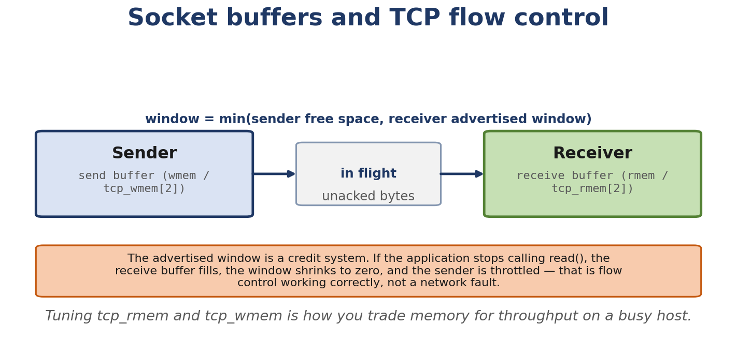
Figure 4.4. Socket buffers and the advertised window: TCP flow control as a credit system.
UDP (SOCK_DGRAM) is connectionless:
- socket → optional bind
- sendto / recvfrom per message - each is one packet
- close
The kernel adds a UDP header (8 bytes), IP header, and ships the packet. No handshake, no retransmission, no ordering. If you want reliability, you implement it yourself (or use QUIC, which is UDP underneath).

Socket buffers
Every socket has a send buffer and a receive buffer (in kernel memory). When your program calls send, the data goes into the send buffer; the kernel transmits asynchronously. When the NIC receives data, it goes into the receive buffer; your program calls recv to drain it.
Default sizes are autotuned in Linux. You can see them with ss -m:
$ ss -tm
State Recv-Q Send-Q Local:Port Peer:Port
ESTAB 0 0 192.168.1.10:22 192.168.1.5:54321
skmem:(r0,rb87380,t0,tb2097152) ...
r/t are byte counters; rb/tb are buffer sizes. The buffer sizes are also visible in /proc/sys/net/ipv4/tcp_rmem and tcp_wmem.
If the receive buffer fills (peer is faster than you), TCP will signal zero window. If the send buffer fills (network is slower than you), send will block (or return EAGAIN in non-blocking mode).

Follow the Packet - A strace Trace of a TCP Client
$ strace -e trace=network,read,write ./tcp_client 192.168.1.5 8080
socket(AF_INET, SOCK_STREAM, IPPROTO_TCP) = 3
connect(3, {sa_family=AF_INET, sin_port=htons(8080), sin_addr=inet_addr("192.168.1.5")}, 16) = 0
sendto(3, "hello\n", 6, 0, NULL, 0) = 6
recvfrom(3, "hi\n", 1024, 0, NULL, NULL) = 3
close(3) = 0
What the kernel did:
socket → allocated a struct socket and struct sock, returned fd 3. connect → looked up the route, built a SYN, sent it, waited for SYN-ACK, completed the handshake. Returns 0 on success. sendto → copied the data into the socket’s send buffer. The kernel transmitted it as a TCP segment. The return value (6) is bytes copied into the buffer - not bytes acked. recvfrom → blocked until the reply arrived, then copied it out. Returned 3 bytes. close → sent FIN, eventually freed the socket.

Linux View

strace a network program
$ strace -e trace=network,read,write,connect,bind,listen,accept,sendto,recvfrom ./my_program
Add -f to follow forks. Add -ttt for microsecond timestamps relative to previous call.

ss - socket statistics
The modern replacement for netstat.
$ ss -tnp # all TCP sockets with process info
$ ss -ltnp # listening TCP
$ ss -unp # UDP
$ ss -m # show memory (buffer sizes)
$ ss -tin # internal TCP info (retransmits, cwnd, rtt)
$ ss -s # summary counts
Example:
$ ss -tin 'dst :443'
State Recv-Q Send-Q Local:Port Peer:Port
ESTAB 0 0 192.168.1.10:54321 142.250.190.78:443
cubic wscale:7,7 rto:204 rtt:11.5/2.5 ato:40 mss:1388 pmtu:1500 rcvmss:1388 advmss:1388 cwnd:10 ssthresh:7 bytes_sent:1234 bytes_acked:1234 bytes_received:5678 segs_out:23 segs_in:30 segs_pending:0 send 0.0Mbps lastsnd:1200 lastrcv:1300 lastack:1300 pacing_rate 0.0Mbps rcv_space:14600 rcv_ssthresh:64000 minrtt:9.5
This single line tells you almost everything: congestion control (cubic), window scales, RTT (11.5 ms), MSS (1388), PMTU (1500), cwnd (10 segments), etc.

lsof
$ sudo lsof -i :8080
Shows which processes have sockets on port 8080.

File descriptor basics
$ ls -la /proc/self/fd/
Each fd is a symlink to the actual file or socket. readlink /proc/1234/fd/5 might give socket:[12345]. The number in brackets is the inode of the socket in the kernel’s socket filesystem.

Kernel View
The kernel’s socket layer is split across many files:
net/socket.c - generic BSD socket API (socket, bind, listen, accept, sendmsg, recvmsg). net/ipv4/af_inet.c - AF_INET family. Ties BSD socket API to IPv4-specific code. net/ipv4/tcp.c - TCP protocol implementation. net/ipv4/udp.c - UDP protocol implementation. net/ipv4/tcp_input.c, tcp_output.c, tcp_timer.c - TCP state machine, output, retransmission. include/net/sock.h - struct sock definition (the common base for all protocol sockets). include/net/tcp.h - TCP-specific extensions to struct sock.
Key functions:
__sys_socket - the actual syscall. Calls sock_create to allocate, sock_map_fd to attach to a file descriptor. __sys_bind / __sys_listen / __sys_connect / __sys_accept - family-specific. inet_stream_connect - TCP connect: builds SYN, blocks waiting for handshake. sock_sendmsg → inet_sendmsg → tcp_sendmsg (TCP) or udp_sendmsg (UDP). sock_recvmsg → inet_recvmsg → tcp_recvmsg / udp_recvmsg. ep_poll_callback - what epoll uses to wake waiters when data arrives.
The data flow for a TCP packet arrival:
NIC IRQ
→ driver → napi_gro_receive() (Linux 6.6 signature: gro_result_t napi_gro_receive(struct napi_struct *napi, struct sk_buff *skb))
→ ip_local_deliver
→ tcp_v4_rcv
→ tcp_v4_do_rcv
→ sock_queue_rcv_skb (push skb into socket backlog)
→ sk_data_ready (wake up waiters: epoll, blocked recv, etc. - the precise wakeup chain is `sk_data_ready` -> `sock_def_readable` -> `wake_up_interruptible_sync_poll` on the socket's wait queue; any `epoll`/`poll`/`select` waiter registered there is then marked ready and returns to userspace.)

Source Code Walkthrough

Excerpt 1: __sys_socket (net/socket.c, simplified)
int __sys_socket(int family, int type, int protocol)
{
struct socket *sock;
int flags, fd;
flags = type & ~SOCK_TYPE_MASK;
type &= SOCK_TYPE_MASK;
sock = sock_create(family, type, protocol, &sock);
if (IS_ERR(sock))
return PTR_ERR(sock);
fd = sock_map_fd(sock, flags & O_CLOEXEC);
if (fd < 0)
sock_release(sock);
return fd;
}
sock_create allocates the socket and calls the family’s create function (e.g. inet_create). sock_map_fd allocates a file descriptor and a struct file pointing to the socket.

Excerpt 2: inet_stream_connect (net/ipv4/af_inet.c, abbreviated)
static int inet_stream_connect(struct socket *sock, struct sockaddr *uaddr,
int addr_len, int flags)
{
...
err = sk->sk_prot->connect(sk, uaddr, addr_len);
if (err < 0)
goto out;
sock->state = SS_CONNECTING;
...
timeo = sock_sndtimeo(sk, flags & O_NONBLOCK);
if (!timeo || !inet_wait_for_connect(sk, timeo, writebias))
goto out;
...
}
For TCP, sk->sk_prot->connect is tcp_v4_connect, which initiates the three-way handshake. Then the function waits (blocking) until the connection is established or times out.

Excerpt 3: tcp_sendmsg_locked (net/ipv4/tcp.c, Linux 6.6)
int tcp_sendmsg_locked(struct sock *sk, struct msghdr *msg, size_t size)
{
struct tcp_sock *tp = tcp_sk(sk);
/* ... address setup, flags handling ... */
while (msg_data_left(msg)) { /* copy from user / build skb chain */ }
/* ... TSO / wait for memory / queue to qdisc ... */
return sent;
}
/* Source: net/ipv4/tcp.c, Linux 6.6 LTS (abbreviated; key branches shown).
Important: tcp_sendmsg() in Linux 6.6 is a *wrapper* that holds the
socket lock and calls tcp_sendmsg_locked(). The substantive send logic
(skb allocation, sk_stream_wait_memory, MSG_FASTOPEN handling,
send-side TSO/GSO, queue-to-qdisc) lives in the _locked variant. If you
grep 'tcp_sendmsg' in 6.6 you will be redirected to tcp_sendmsg_locked
by the file's #define alias — verify with:
git grep -nE 'tcp_sendmsg(|_locked)\(' net/ipv4/tcp.c */
sk_stream_wait_memory blocks (or returns EAGAIN) if the send buffer is full. Otherwise it allocates an skb, copies the user’s data into it (or references user pages with zero-copy), and queues it for transmission.

Excerpt 4: epoll
static int ep_poll_callback(wait_queue_entry_t *wait, unsigned mode,
int sync, void *key)
{
struct epitem *epi = ep_item_from_wait(wait);
struct eventpoll *ep = epi->ep;
if (ep_events_available(ep))
wake_up(&ep->wq);
...
}
This is what gets called when a socket becomes readable. It checks if any events are ready and wakes the epoll_wait sleeper.

Hands-On Lab - Build a TCP Echo Server and a UDP Probe

Goal
You’ll compile a small TCP echo server and client, and a UDP probe. You’ll observe them with strace and ss.

Setup
A single Linux VM with GCC. No special hardware needed.

Programs
Save these three files.
tcp_echo_server.c:
#include <stdio.h>
#include <stdlib.h>
#include <string.h>
#include <unistd.h>
#include <signal.h>
#include <errno.h>
#include <sys/socket.h>
#include <netinet/in.h>
#include <arpa/inet.h>
static int server_fd = -1;
static void on_sigint(int sig) {
(void)sig;
if (server_fd >= 0) close(server_fd);
_exit(0);
}
int main(void) {
signal(SIGINT, on_sigint);
signal(SIGTERM, on_sigint);
server_fd = socket(AF_INET, SOCK_STREAM, 0);
if (server_fd < 0) { perror("socket"); return 1; }
int yes = 1;
setsockopt(server_fd, SOL_SOCKET, SO_REUSEADDR, &yes, sizeof(yes));
struct sockaddr_in addr = {
.sin_family = AF_INET,
.sin_port = htons(8080),
.sin_addr.s_addr = htonl(INADDR_ANY)
};
if (bind(server_fd, (struct sockaddr *)&addr, sizeof(addr)) < 0) {
perror("bind"); return 1;
}
if (listen(server_fd, 16) < 0) {
perror("listen"); return 1;
}
fprintf(stderr, "listening on 0.0.0.0:8080\n");
for (;;) {
struct sockaddr_in peer;
socklen_t peerlen = sizeof(peer);
int client = accept(server_fd, (struct sockaddr *)&peer, &peerlen);
if (client < 0) {
if (errno == EINTR) continue;
perror("accept");
continue;
}
char ipstr[INET_ADDRSTRLEN];
inet_ntop(AF_INET, &peer.sin_addr, ipstr, sizeof(ipstr));
fprintf(stderr, "connection from %s:%d\n", ipstr, ntohs(peer.sin_port));
char buf[4096];
ssize_t n;
while ((n = recv(client, buf, sizeof(buf), 0)) > 0) {
send(client, buf, n, 0);
}
if (n < 0) perror("recv");
close(client);
}
}
tcp_client.c:
#include <stdio.h>
#include <stdlib.h>
#include <string.h>
#include <unistd.h>
#include <sys/socket.h>
#include <netinet/in.h>
#include <arpa/inet.h>
int main(int argc, char **argv) {
if (argc != 3) { fprintf(stderr, "usage: %s IP PORT\n", argv[0]); return 1; }
int fd = socket(AF_INET, SOCK_STREAM, 0);
if (fd < 0) { perror("socket"); return 1; }
struct sockaddr_in addr = {
.sin_family = AF_INET,
.sin_port = htons(atoi(argv[2])),
};
inet_pton(AF_INET, argv[1], &addr.sin_addr);
if (connect(fd, (struct sockaddr *)&addr, sizeof(addr)) < 0) {
perror("connect"); return 1;
}
char *msg = "hello\n";
if (send(fd, msg, strlen(msg), 0) < 0) { perror("send"); return 1; }
char buf[4096];
ssize_t n = recv(fd, buf, sizeof(buf) - 1, 0);
if (n > 0) {
buf[n] = 0;
printf("got: %s", buf);
}
close(fd);
return 0;
}
udp_probe.c:
#include <stdio.h>
#include <stdlib.h>
#include <string.h>
#include <unistd.h>
#include <sys/socket.h>
#include <netinet/in.h>
#include <arpa/inet.h>
int main(int argc, char **argv) {
if (argc != 3) { fprintf(stderr, "usage: %s IP PORT\n", argv[0]); return 1; }
int fd = socket(AF_INET, SOCK_DGRAM, 0);
if (fd < 0) { perror("socket"); return 1; }
struct sockaddr_in addr = {
.sin_family = AF_INET,
.sin_port = htons(atoi(argv[2])),
};
inet_pton(AF_INET, argv[1], &addr.sin_addr);
const char *msg = "ping\n";
if (sendto(fd, msg, strlen(msg), 0, (struct sockaddr *)&addr, sizeof(addr)) < 0) {
perror("sendto"); return 1;
}
struct timeval tv = { .tv_sec = 2 };
setsockopt(fd, SOL_SOCKET, SO_RCVTIMEO, &tv, sizeof(tv));
char buf[4096];
ssize_t n = recvfrom(fd, buf, sizeof(buf) - 1, 0, NULL, NULL);
if (n > 0) {
buf[n] = 0;
printf("got: %s", buf);
} else if (n < 0) {
perror("recvfrom");
}
close(fd);
return 0;
}

Commands
gcc -Wall -O2 -o tcp_echo_server tcp_echo_server.c
gcc -Wall -O2 -o tcp_client tcp_client.c
gcc -Wall -O2 -o udp_probe udp_probe.c
# Terminal 1 - server
./tcp_echo_server
# Terminal 2 - observe
strace -e trace=network,read,write -f ./tcp_client 127.0.0.1 8080
# In another terminal
ss -tnp 'sport = :8080'
ss -tin '( sport = :8080 )'

Expected Output
$ ./tcp_client 127.0.0.1 8080
got: hello
ss -tnp shows the connection in ESTABLISHED state with both endpoints.
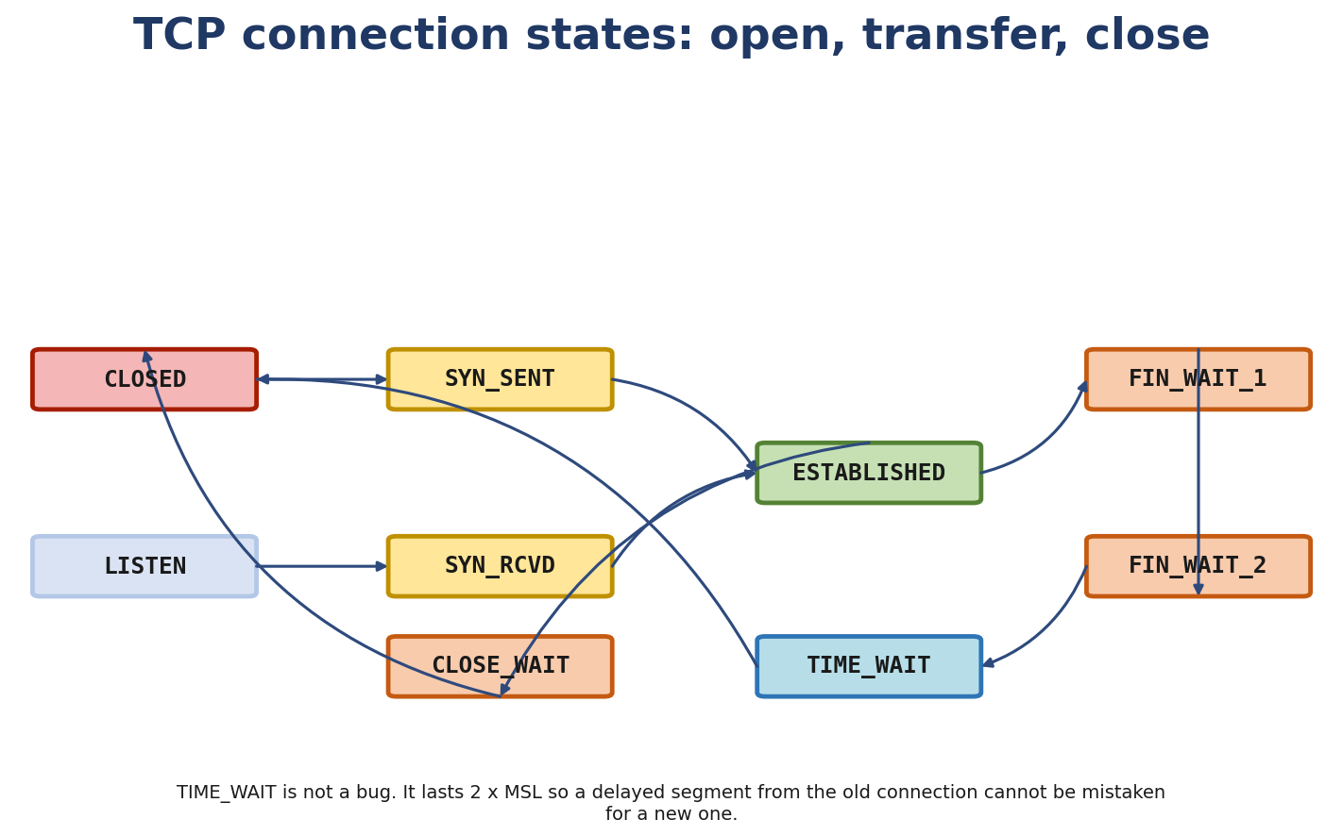
Figure 4.5. TCP connection states, and why TIME_WAIT exists rather than being a bug.

Explanation
- The client called connect(), the kernel sent a SYN.
- The server’s kernel received the SYN, sent SYN-ACK back, and added the connection to the accept queue.
- The server’s accept() returned with a new fd.
- Both sides exchanged data.
- Both sides called close(), FIN exchange, both sides tear down.

Experiment
- Vary buffer size. Set SO_RCVBUF to 1024 in the server. Watch ss -m reflect the change.
- Enable TCP_NODELAY. In the client, add setsockopt(fd, IPPROTO_TCP, TCP_NODELAY, &(int){1}, sizeof(int)). Capture with tcpdump -ni lo -ttt and observe that “hello” goes out in one packet instead of being buffered.

Break It
# Start the server, then start it again - fails:
./tcp_echo_server &
./tcp_echo_server
bind: Address already in use
The second one fails because the first is still listening on port 8080. To fix, add SO_REUSEADDR:
int yes = 1;
setsockopt(server_fd, SOL_SOCKET, SO_REUSEADDR, &yes, sizeof(yes));
With SO_REUSEADDR, the second instance can bind even though the first holds the port. (Useful for restarting the server without waiting for TIME_WAIT.)

Debug It
Imagine the client times out (no response). Apply the methodology:
- Is the server running? (ps aux | grep tcp_echo)
- Is it bound to the right port? (ss -ltnp)
- Is there a firewall? (sudo iptables -L INPUT -nv, sudo nft list ruleset)
- Does tcpdump -ni lo -c 4 'port 8080' show the SYN?
- Does ss -tn 'sport = :8080' show the half-open connection in SYN-SENT?

Challenge
Convert the blocking TCP echo server to use epoll in edge-triggered mode. Hint: set each accepted socket to non-blocking and use EPOLLIN | EPOLLET.

Solution sketch
// After listen:
int ep = epoll_create1(0);
struct epoll_event ev = { .events = EPOLLIN, .data.fd = server_fd };
epoll_ctl(ep, EPOLL_CTL_ADD, server_fd, &ev);
for (;;) {
struct epoll_event events[64];
int n = epoll_wait(ep, events, 64, -1);
for (int i = 0; i < n; i++) {
if (events[i].data.fd == server_fd) {
// Accept all available (loop until EAGAIN)
for (;;) {
int client = accept4(server_fd, NULL, NULL, SOCK_NONBLOCK);
if (client < 0) break;
struct epoll_event cev = { .events = EPOLLIN | EPOLLET, .data.fd = client };
epoll_ctl(ep, EPOLL_CTL_ADD, client, &cev);
}
} else {
// Read all available (loop until EAGAIN)
int fd = events[i].data.fd;
for (;;) {
char buf[4096];
ssize_t r = recv(fd, buf, sizeof(buf), 0);
if (r > 0) {
send(fd, buf, r, 0);
} else if (r == 0 || (r < 0 && errno == EAGAIN)) {
break;
} else {
close(fd);
epoll_ctl(ep, EPOLL_CTL_DEL, fd, NULL);
break;
}
}
}
}
}
Edge-triggered means: you get notified only on a state transition (data went from empty to non-empty). After notification, you must drain the fd until EAGAIN - otherwise, if more data arrives, you won’t get notified again until something else happens.

Interview Questions
Q4.1 (Beginner) - What is the difference between bind, connect, and listen?
bind assigns a local address/port to a socket. listen marks a bound TCP socket as accepting incoming connections. connect initiates a connection from a client to a remote address. A typical TCP server: socket → bind → listen → accept. A typical TCP client: socket → connect.
Q4.2 (Beginner) - What is a file descriptor?
An integer that refers to an open file, socket, pipe, or other kernel object managed by the file table. Every process has its own fd table. 0 is stdin, 1 is stdout, 2 is stderr; subsequent fds are returned by open/socket/pipe/etc. When you create a socket, the kernel gives you an fd; everything you do (read, write, send, recv, close, poll) uses that fd.
Q4.3 (Beginner) - What’s the difference between TCP and UDP from the application’s perspective?
TCP gives you a byte stream: send N bytes, the kernel decides how to chop them into segments. You get back N bytes in order, no loss. UDP gives you datagrams: send a message of N bytes, it goes as one packet. You get back individual datagrams, may arrive out of order or not at all. TCP does the work; UDP pushes the work to you.
Q4.4 (Intermediate) - When would you use UDP instead of TCP?
When low latency matters more than reliability: DNS (small requests, fast retries on app level), video/audio streaming (drop a frame rather than lag), gaming (state updates where stale data is useless), and QUIC (which needs UDP to avoid middlebox interference with TCP). Also when you’re building your own reliability layer on top.
Q4.5 (Intermediate) - Why does epoll scale better than select or poll?
select and poll both copy the set of fds into the kernel on every call and back out on every return - O(N) work even if only one fd is ready. epoll keeps the set in the kernel and only returns fds that are ready. Adding an fd is O(1). With thousands of connections, epoll is dramatically faster.
Q4.6 (Intermediate) - Explain level-triggered vs edge-triggered epoll.
Level-triggered (default): you’re notified as long as the fd is in the ready state. If you don’t read all data, you’ll be notified again next time you call epoll_wait. Edge-triggered: you’re notified only when the fd transitions from not-ready to ready. If you don’t drain the fd until EAGAIN, you may miss notifications. Edge-triggered requires non-blocking fds and is used in some high-performance servers.
Q4.7 (Intermediate) - What is Nagle’s algorithm and when do you disable it?
Nagle buffers small writes and combines them with previously-acked data to reduce the number of small packets on the wire. Good for bulk senders, bad for interactive applications with small request-response patterns (you wait 40-200 ms for the ACK before your small write goes out). Disable with TCP_NODELAY when latency matters more than packet count.
Q4.8 (Intermediate) - What is SO_REUSEADDR, and why is it commonly set?
It loosens bind() rules so a socket can bind to an address/port that has another socket in a non-LISTEN state (commonly TIME_WAIT). It does NOT delete TIME_WAIT entries, change TIME_WAIT duration, or globally disable TIME_WAIT. Whether “restarting a server fails for ~60 seconds” depends on the local/remote address matrix - see the socket(7) man page for the exact cases. Note: SO_REUSEPORT goes further, allowing multiple sockets to bind to the same port simultaneously (kernel load-balances).
Q4.9 (Advanced) - How does send() know when the data has been transmitted?
It doesn’t - and shouldn’t. send returns when the data has been copied into the kernel’s send buffer. From there, the kernel transmits it asynchronously. For TCP, transmission involves the three-way handshake, segment building, retransmissions, etc. - all invisible to the application. If you need to know when the peer actually received the data, you need an application-level acknowledgment.
Q4.10 (Advanced) - Describe what happens between accept() returning and the client seeing data.
In the server’s kernel:
- accept removes the next entry from the accept queue and returns a new fd.
- The new fd is backed by a socket with state = SS_CONNECTED and a struct sock with sk_state = TCP_ESTABLISHED.
- When the client sends data, the kernel receives the segment, queues the payload into the socket’s receive queue.
- When recv is called, the kernel copies bytes from the receive queue into user space and returns.
In the client’s kernel:
- send copies bytes from user space into the send buffer.
- The TCP layer builds a segment (depending on Nagle, TSO, etc.) and pushes it to the IP layer.
- The IP layer routes and sends it.
- Eventually the server’s kernel sees the segment.
Q4.11 (Advanced) - What is SO_REUSEPORT? When is it useful?
SO_REUSEPORT (Linux 3.9+) lets multiple sockets bind to the exact same address/port combination - each socket must set the option. The kernel load-balances incoming connections across the group; the default selector is a hash on the 4-tuple, so a given connection is consistently steered to the same socket within the group (good for cache locality). Since Linux 4.5/4.6 you can attach an eBPF program via SO_ATTACH_REUSEPORT_EBPF for custom selection; since Linux 4.19, BPF_MAP_TYPE_REUSEPORT_SOCKARRAY + BPF_PROG_TYPE_SK_REUSEPORT allow BPF-driven selection from a map. Primary use case: multi-process / multi-thread listener scaling for performance - one worker per CPU, each accept()ing from the same port. It is NOT a generic “hot-upgrade without dropping connections” mechanism; that requires separate drain/rolling-restart logic.
Q4.12 (Advanced) - How does the kernel wake a blocked recv() call when data arrives?
The recv() syscall uses an internal wait queue. The kernel puts the calling process to sleep on that queue. When data arrives in the socket’s receive queue, the TCP receive path calls sk_data_ready → sock_def_readable → wake_up_interruptible on the wait queue. The process becomes runnable; the scheduler picks it up; the syscall returns.
Q4.13 (Advanced) - Describe sendmsg/recvmsg vs send/recv.
sendmsg/recvmsg take a struct msghdr that bundles the data (possibly multiple buffers via iov), control messages (msg_control - used for SCM_RIGHTS, IP_PKTINFO, etc.), flags, and the address (for sendmsg). send/recv are convenience wrappers that fill in most of these from simple arguments. For most code, send/recv is enough; for advanced uses (passing file descriptors, ancillary data), you need sendmsg/recvmsg.
Q4.14 (Kernel internals) - Walk through what happens in the kernel between socket(AF_INET, SOCK_STREAM, 0) returning and the user being able to call send.
socket calls sock_create → __sock_create → pf->create (PF_INET family, so inet_create). inet_create:
- Allocates a struct socket and a struct sock (via sk_alloc).
- Sets sk->sk_net to the current network namespace.
- Looks up the protocol by type (SOCK_STREAM → TCP) and assigns sk->sk_prot to tcp_prot (the struct proto for TCP).
- Calls sk->sk_prot->init (which is tcp_init_sock) to set up TCP-specific state.
sock_map_fd then:
- Allocates a struct file.
- Sets file->f_op = &socket_file_ops.
- Allocates an fd in the current process’s fd table.
- Returns the fd.
At this point the socket exists but has no address, isn’t connected or listening. bind and connect/listen/accept follow.

Key Takeaways
A socket is a kernel object exposed to user space as a file descriptor. TCP: socket → bind → listen → accept (server) or socket → connect (client). UDP: socket → optional bind → sendto/recvfrom. Non-blocking + epoll is how scalable servers are built. Socket options (SO_REUSEADDR, TCP_NODELAY, etc.) tweak behavior at specific points. strace shows you exactly what your program is asking the kernel to do. ss is the modern tool for inspecting sockets.

Practice Challenges
- strace your favorite CLI tool. strace -e trace=network,connect,read,write curl https://example.com. See the socket creation, DNS resolution (which uses connect to a nameserver), TLS handshake (which uses read/write on the socket).
- Compare TCP and UDP behavior. Write a UDP server that just receives and discards. Use iperf3 -u -c <addr> to send a flood. Watch ss -u -m - observe receive buffer behavior.
- Implement a chat server. Multi-client broadcast over TCP using epoll.
- Watch socket buffer autotuning. Start an iperf3 test. In another terminal, watch cat /proc/net/sockstat and ss -tm to see buffer sizes change.
- Use SO_REUSEPORT. Modify the echo server to create N child processes, each accepting connections. Verify with ss -ltnp that you see multiple sockets on the same port.
- TCP_NODELAY vs default. With Nagle enabled, type characters one at a time into a nc session. With TCP_NODELAY, watch the difference in tcpdump - the first mode sends pairs of segments; the second sends one segment per character.
- Read tcp.c. Find tcp_sendmsg. How does it know when to return? When does it block?

Chapter 5 - TCP and UDP: What Actually Happens During Communication

What You Will Learn
- The TCP three-way handshake and four-way close, in detail
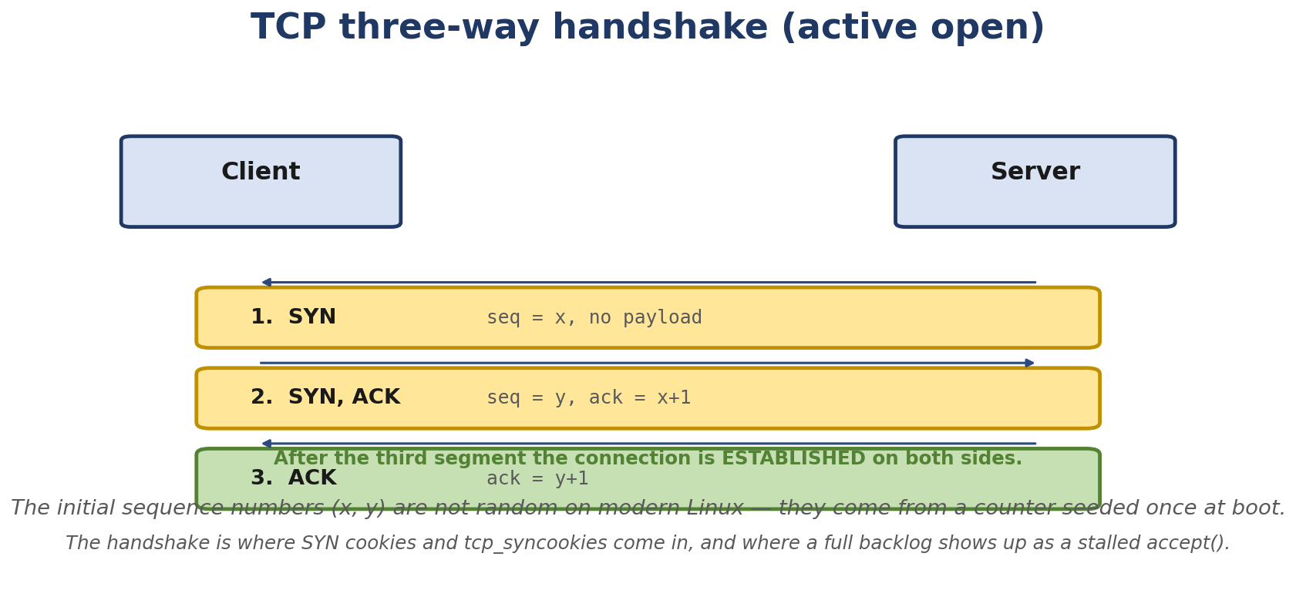
Figure 5.1. The TCP three-way handshake. After the third segment the connection is ESTABLISHED on both sides.
- Every TCP state in the state machine and when transitions happen
- TCP sequence numbers, acknowledgments, and the sliding window
- The receive window, the congestion window, and how they interact
- Slow start, congestion avoidance, fast retransmit, fast recovery
- TCP retransmissions, RTO, and duplicate ACKs
- FIN vs RST, half-close, and TIME_WAIT
- UDP’s datagram model - and when it’s the right tool
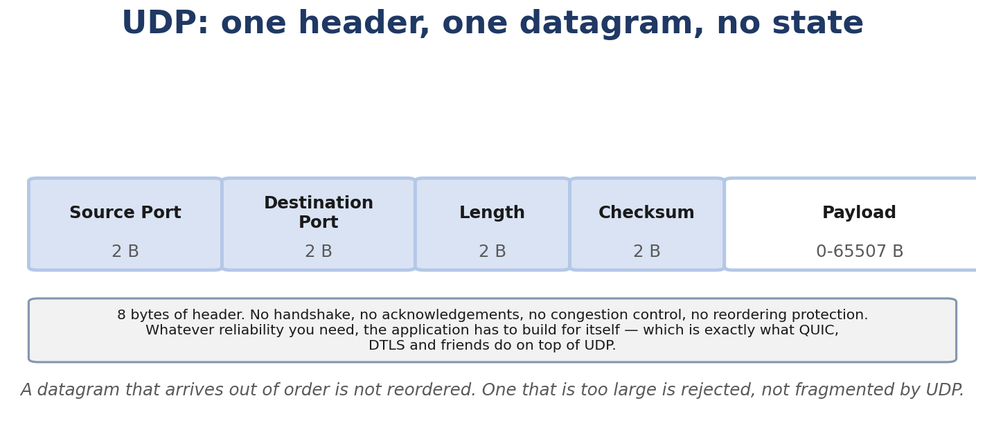
Figure 5.2. UDP: an eight-byte header and no state. All reliability has to be built above it.
- How to recognize TCP problems in a packet capture

Real-Life Analogy - Two People on a Phone Call
Reality check — where the analogy breaks. The analogy above is a pedagogical tool for building a mental model. It is not a precise description of the kernel mechanism. The real implementation differs from the analogy in ways your interviews and lab work will surface; always reason from the kernel source when precision matters.
Imagine a phone call between two people. TCP works like a really meticulous phone call:
- Alice calls Bob. SYN - “Are you there?”
- Bob picks up and says “Yes, I’m here.” SYN-ACK - “I see you, I’m ready.”
- Alice says “Great, let’s start.” ACK - “OK, go.”
Now they’re connected. Alice talks. Bob periodically tells Alice how much of the byte stream he has received in order — not one acknowledgement per sentence, but a cumulative position counter, often thinned by delayed ACK. If Bob doesn’t confirm progress, Alice repeats what she thinks is missing. If Bob is overwhelmed, he tells Alice to slow down (“congestion window”). If Bob’s connection is fine but Alice is talking too fast, Bob says “wait” (“flow control”). If Bob stops responding for too long, Alice assumes he’s gone and hangs up.
When done:
- Alice says “I’m done talking.” FIN
- Bob says “OK, I’ll wait while you finish.” ACK
- Bob says “I’m done too.” FIN
- Alice says “OK, goodbye.” ACK
If one side wants to bail out instantly (corrupt data, security), they hang up with a “RST” - like slamming the phone down. RST doesn’t wait for acknowledgment.
UDP is more like shouting across a room. You send the message. If someone hears it, fine. If not, you don’t know. No setup, no acknowledgment, no closing ceremony.

The Networking Concept

TCP header layout
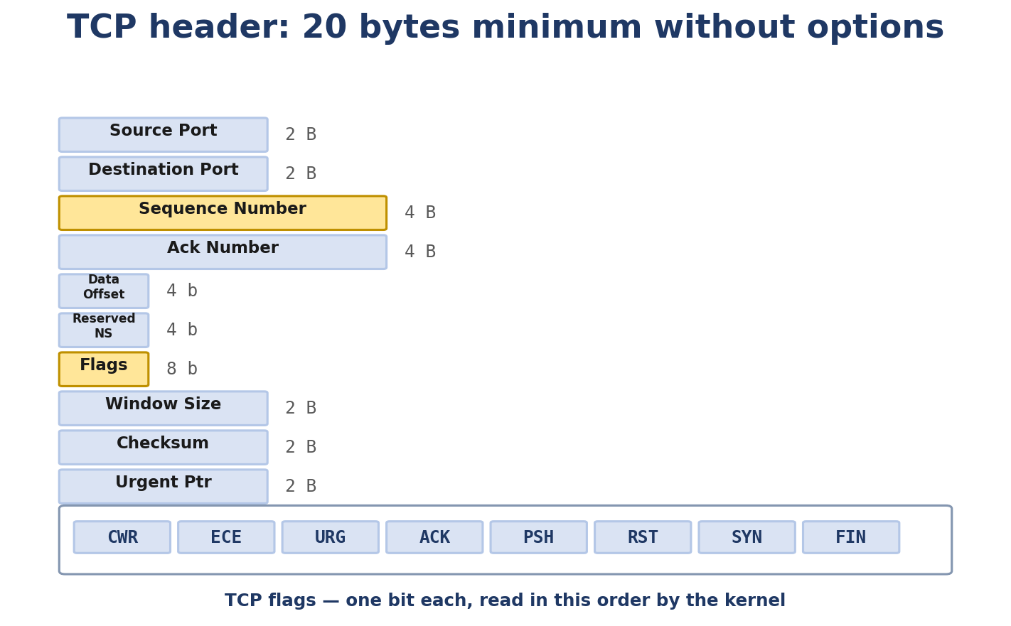
Figure 5.3. TCP header fields and the flag bits, in the order the kernel reads them.
0 1 2 3
0 1 2 3 4 5 6 7 8 9 0 1 2 3 4 5 6 7 8 9 0 1 2 3 4 5 6 7 8 9 0 1
+-+-+-+-+-+-+-+-+-+-+-+-+-+-+-+-+-+-+-+-+-+-+-+-+-+-+-+-+-+-+-+-+
| Source Port | Destination Port |
+-+-+-+-+-+-+-+-+-+-+-+-+-+-+-+-+-+-+-+-+-+-+-+-+-+-+-+-+-+-+-+-+
| Sequence Number |
+-+-+-+-+-+-+-+-+-+-+-+-+-+-+-+-+-+-+-+-+-+-+-+-+-+-+-+-+-+-+-+-+
| Acknowledgment Number |
+-+-+-+-+-+-+-+-+-+-+-+-+-+-+-+-+-+-+-+-+-+-+-+-+-+-+-+-+-+-+-+-+
| Data | |U|A|P|R|S|F| |
| Offset| Reserved |R|C|S|S|Y|I| Window |
| | |G|K|H|T|N|N| |
+-+-+-+-+-+-+-+-+-+-+-+-+-+-+-+-+-+-+-+-+-+-+-+-+-+-+-+-+-+-+-+-+
| Checksum | Urgent Pointer |
+-+-+-+-+-+-+-+-+-+-+-+-+-+-+-+-+-+-+-+-+-+-+-+-+-+-+-+-+-+-+-+-+
| Options | Padding |
+-+-+-+-+-+-+-+-+-+-+-+-+-+-+-+-+-+-+-+-+-+-+-+-+-+-+-+-+-+-+-+-+
Source/Destination Port (16 bits each) - the 5-tuple key. Sequence Number (32 bits) - the byte offset of the first byte of payload. So if a sender sends “hello” starting at sequence 1000, the next byte will be 1005. Acknowledgment Number (32 bits) - the next byte expected from the other side. ACK = N means “I’ve received everything up to N-1.” Data Offset (4 bits) - TCP header length in 32-bit words. Min 5 (= 20 bytes), max 15 (= 60 bytes with options). Flags (8 bits) - URG, ACK, PSH, RST, SYN, FIN, plus ECE and CWR for ECN, and NS for nonce sum. Window (16 bits) - receive window in bytes (before window scaling). Tells the peer how much data you can buffer. Checksum (16 bits) - covers TCP header + payload + pseudo-header (source/dest IP, protocol, length). Urgent Pointer - points to the end of urgent data; only meaningful with URG. Options - MSS, window scale, SACK, timestamps, etc.

The three-way handshake
Client Server
| |
| SYN, seq=x |
| (SYN=1, ACK=0, seq=x, win=W, options=[MSS,WS]) |
|-------------------------------------------------->|
| |
| SYN-ACK, seq=y, ack=x+1 |
| (SYN=1, ACK=1, seq=y, ack=x+1, win=W) |
|<--------------------------------------------------|
| |
| ACK, seq=x+1, ack=y+1 |
| (ACK=1, seq=x+1, ack=y+1) |
|-------------------------------------------------->|
| |
| (ESTABLISHED - both sides ready) |
Why three? Because each side needs to confirm: the other side received my initial SYN (or SYN-ACK), AND I know what sequence number they chose. Three packets establish both directions of communication.
Initial sequence numbers (ISNs) are randomized per connection (security: prevents off-path guessing).

The state machine
TCP has these states (simplified):
+---------+ ---------+ +---------+
| LISTEN | | | CLOSED |
+---------+ | +---------+
| | |
| SYN | | listen()
v | v
+-----------+ | +-----------+
| SYN_SENT |-------|------->| SYN_RECV |
+-----------+ +-----------+
| |
| ACK of SYN | ACK
v v
+-----------+ +-----------+
| ESTABLISHED| <----------> | ESTABLISHED|
+-----------+ +-----------+
| |
close() / FIN FIN
v v
+----------+ +-----------+
| FIN_WAIT_1| | CLOSE_WAIT|
+----------+ +-----------+
| |
| ACK close()
v v
+----------+ +-----------+
| FIN_WAIT_2| | LAST_ACK |
+----------+ +-----------+
| |
| FIN | ACK
v v
+-----------+ +-----------+
| TIME_WAIT | | CLOSED |
+-----------+ +-----------+
| (Linux 6.6: ~60s; protocol-level MSL is implementation-defined)
v
+---------+
| CLOSED |
+---------+
Each transition corresponds to a specific event:
LISTEN → SYN_RECV (server): received a SYN. SYN_SENT → ESTABLISHED (client): received a SYN-ACK. ESTABLISHED → FIN_WAIT_1 (active closer): called close(). FIN_WAIT_1 → FIN_WAIT_2 (active closer): received ACK of FIN. ESTABLISHED → CLOSE_WAIT (passive closer): received FIN from peer. CLOSE_WAIT → LAST_ACK (passive closer): called close(). TIME_WAIT → CLOSED (after 2*MSL on the implementation): enough time has passed that no more packets from this connection will arrive. TIME_WAIT exists for protocol correctness — it gives the network time to drain delayed segments and lets the active closer retransmit the final ACK if it is lost.

Sequence numbers and acknowledgments
Each byte in a TCP stream has a unique sequence number. The seq field in the header is the seq of the first byte in this segment. The ack field is the next byte expected.
Example: client sends “hello world” (11 bytes) starting at seq=1000.
Segment 1: seq=1000, len=11, ack=1 (or whatever). Bytes 1000-1010. Server receives. Sends ACK: seq=1, ack=1011 (next expected). Client sends “foo” starting at seq=1011. Server: ACK ack=1014.
If a segment is lost, the receiver keeps ACKing the last contiguous byte received (cumulative ACK). When the sender sees three duplicate ACKs (the classic fast-retransmit trigger; modern Linux also uses additional loss-recovery heuristics such as TLP and RACK-style timers on top of this) (or its RTO fires), it retransmits.

Sliding window
The receive window is the size of the receiver’s buffer. It tells the sender “you can have at most this many bytes in flight.” The congestion window is the sender’s estimate of how much the network can hold without dropping.
The actual number of bytes in flight is min(receive_window, congestion_window).
Early TCP had fixed window sizes (max 64 KB). Modern TCP uses window scaling (RFC 7323) - a window scale option in the SYN that multiplies the window field by 2^N for up to N=14, giving a 1 GB window.

Congestion control
Modern TCP uses congestion control to avoid overrunning the network. The Linux defaults:
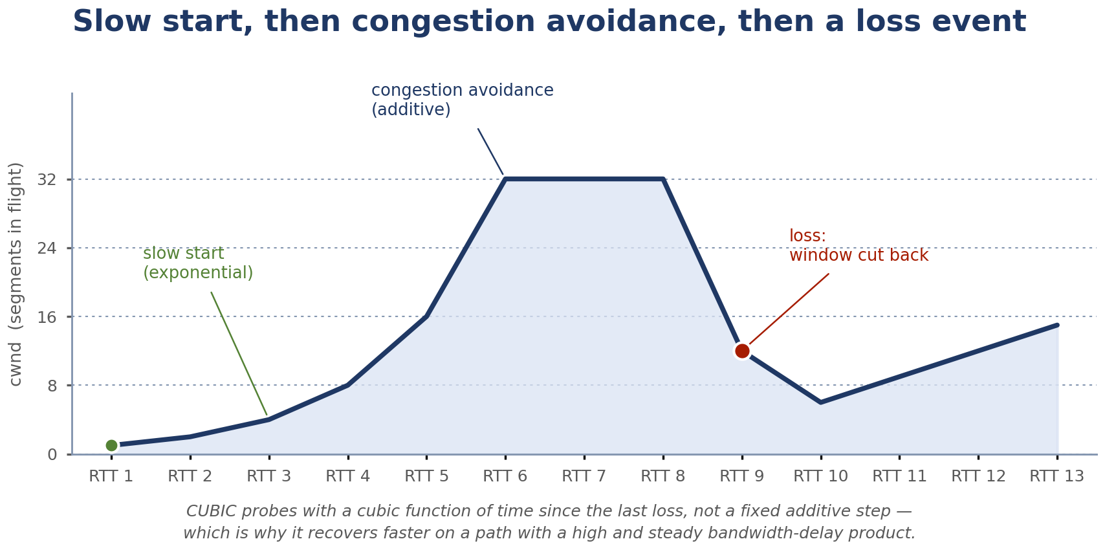
Figure 5.4. Slow start, congestion avoidance, and what a loss event does to the window.
cubic (default for many years) - uses a cubic function to find the available bandwidth. bbr (Bottleneck Bandwidth and Round-trip propagation time) - newer, models the bottleneck explicitly. Used by Google, Cloudflare, and increasingly as default in newer distros. reno - classic, fast retransmit + fast recovery, less aggressive than cubic.
Basic behavior (cubic-like):
Slow start - cwnd grows exponentially (doubles per RTT) until first loss or until ssthresh. Congestion avoidance - cwnd grows linearly (adds ~1 MSS per RTT). Loss detected (duplicate ACK or timeout) - cwnd is cut. With cubic, cwnd drops to cwnd * 0.7 on a loss event.

Retransmission
When a segment is lost, TCP retransmits. Two triggers:
RTO (retransmission timeout) - based on RTT estimates (SRTT + variance). If the sender doesn’t get an ACK within RTO, retransmit. Fast retransmit - if the sender receives 3 duplicate ACKs (the same ACK repeated 3 times), it assumes the next segment was lost and retransmits immediately, without waiting for RTO.
The retransmission can be the original segment, or if SACK (selective acknowledgment) is negotiated, just the missing byte range.

TIME_WAIT
After actively closing, the side that sent the FIN first enters TIME_WAIT. The protocol-level purpose is twofold:
- If the final ACK is lost, the other side will retransmit the FIN. The active closer must still be around to ACK it.
- Old packets from this connection (delayed duplicates) must not be confused with new packets from a new connection that reuses the same 5-tuple.
TIME_WAIT causes practical issues for servers handling many short connections - the server’s ephemeral-port table fills up, which limits outbound (client-side) connections and may also surface as EADDRNOTAVAIL. The fixes are nuanced, and the right one depends on whether you are the active closer (typically the client) or the passive closer (typically the server):
- Active closer (client side): enable net.ipv4.tcp_tw_reuse=1 so that the kernel may reuse a 5-tuple still in TIME_WAIT when the peer’s recent timestamp is fresh enough to be safe. This is a Linux-specific safety mechanism, not a TIME_WAIT timer change. WARNING: do not enable this as a generic TIME_WAIT fix without first understanding the workload. tcp_tw_reuse is gated by PAWS-style timestamp checks (RFC 1323), and the safety property depends on the peer’s behavior. It is appropriate when you are the active closer (e.g. an outbound HTTP client making many connections to the same set of peers), not as a global “make TIME_WAIT go away” knob. On the server (passive closer) side, prefer SO_REUSEPORT, widening ip_local_port_range, or keep-alive.
- Passive closer (server side): use SO_REUSEADDR (and, when supported, SO_REUSEPORT) to allow bind() to succeed even if the 5-tuple is still in TIME_WAIT. This affects the bind rules, not the TIME_WAIT timer.
- Capacity, not duration: widen net.ipv4.ip_local_port_range, add more server sockets behind a load balancer, or use HTTP keep-alive.
- What does NOT work: do not change net.ipv4.tcp_fin_timeout thinking it controls TIME_WAIT. That sysctl governs FIN_WAIT_2, not TIME_WAIT. TIME_WAIT’s duration is hardcoded in the kernel as TCP_TIMEWAIT_LEN (60 seconds on mainline Linux) and is not directly user-tunable as a general solution.

UDP header
UDP is gloriously simple:
0 1 2 3
0 1 2 3 4 5 6 7 8 9 0 1 2 3 4 5 6 7 8 9 0 1 2 3 4 5 6 7 8 9 0 1
+-+-+-+-+-+-+-+-+-+-+-+-+-+-+-+-+-+-+-+-+-+-+-+-+-+-+-+-+-+-+-+-+
| Source Port | Destination Port |
+-+-+-+-+-+-+-+-+-+-+-+-+-+-+-+-+-+-+-+-+-+-+-+-+-+-+-+-+-+-+-+-+
| Length | Checksum |
+-+-+-+-+-+-+-+-+-+-+-+-+-+-+-+-+-+-+-+-+-+-+-+-+-+-+-+-+-+-+-+-+
| |
+ +
| Payload |
+ +
| |
+-+-+-+-+-+-+-+-+-+-+-+-+-+-+-+-+-+-+-+-+-+-+-+-+-+-+-+-+-+-+-+-+
8 bytes total header. The length is the UDP header + payload. The checksum is optional in IPv4 (but commonly computed); required in IPv6.
UDP is connectionless. Each sendto is one packet. The kernel doesn’t retransmit, doesn’t acknowledge, doesn’t reorder. The receiver gets the datagram (or doesn’t). End of story.

When UDP is right
DNS - small queries, the application handles retries. UDP is faster than TCP. Voice/video (RTP) - drops are fine; delays are not. UDP avoids TCP’s retransmission delays. Gaming - state updates where stale data is useless; better to drop than retransmit. QUIC - built on UDP to avoid middlebox interference with TCP and to integrate TLS at the transport layer. Tunneling (WireGuard, VXLAN, GUE) - UDP packets tunnel other protocols.

Follow the Packet - A TCP Session Captured
Here’s what curl https://example.com actually does at the TCP level (simplified):
12:00:00.000 IP 192.168.1.10.54321 > 93.184.216.34.443: Flags [S], seq 1000000000, win 64240, options [mss 1460,sackOK,TS val 1000 ecr 0,nop,wscale 7], length 0
12:00:00.020 IP 93.184.216.34.443 > 192.168.1.10.54321: Flags [S.], seq 2000000000, ack 1000000001, win 64240, options [mss 1460,sackOK,TS val 2000 ecr 1000,nop,wscale 7], length 0
12:00:00.020 IP 192.168.1.10.54321 > 93.184.216.34.443: Flags [.], ack 2000000001, win 502, options [nop,nop,TS val 1001 ecr 2000], length 0
12:00:00.040 IP 192.168.1.10.54321 > 93.184.216.34.443: Flags [.], seq 1000000001:1000000141, ack 2000000001, win 502, length 140
...
12:00:01.000 IP 192.168.1.10.54321 > 93.184.216.34.443: Flags [F.], seq 1000001000, ack 2000000500, win 502, length 0
12:00:01.020 IP 93.184.216.34.443 > 192.168.1.10.54321: Flags [F.], seq 2000000500, ack 1000001001, win 502, length 0
12:00:01.020 IP 192.168.1.10.54321 > 93.184.216.34.443: Flags [.], ack 2000000501, win 502, length 0
Read the flags:
[S] - SYN. Handshake start. [S.] - SYN-ACK. Handshake response. [.] - ACK (no payload). Acknowledging something. [P.] - PSH-ACK. Push data; flush buffers. [F.] - FIN-ACK. Closing. [R] - RST. Reset, no ceremony.

TCP state observed via ss
$ ss -tnp
ESTAB 0 0 192.168.1.10:54321 93.184.216.34:443
SYN-SENT 0 1 192.168.1.10:54322 142.250.190.78:80
TIME-WAIT 0 0 192.168.1.10:54320 1.1.1.1:443
States you can see: ESTAB, SYN-SENT, SYN-RECV, FIN-WAIT-1, FIN-WAIT-2, CLOSE-WAIT, CLOSING, LAST-ACK, TIME-WAIT, CLOSED, LISTEN, UNCONN.

Linux View

Watch a TCP handshake
$ sudo tcpdump -ni any -S -ttt 'host 8.8.8.8 and tcp[tcpflags] & (tcp-syn|tcp-fin) != 0'
In another terminal:
nc -zv 8.8.8.8 80 2>&1
You’ll see SYN, SYN-ACK, ACK. The -S flag tells tcpdump to print absolute sequence numbers instead of relative; -ttt shows delta from previous packet.

Watch retransmissions
$ sudo ss -tin 'dst :443'
Look for retrans:1 or higher. That tells you TCP has retransmitted. For a deeper view:
$ sudo ss -tin '( retrans > 0 )'

Inject loss
sudo tc qdisc add dev eth0 root netem loss 10%
curl https://example.com # will be slower
sudo ss -tin '( sport = :443 )' # see retrans counts climb
sudo tc qdisc del dev eth0 root

Watch slow start
$ iperf3 -c 192.168.1.5 -t 5
While running, capture and look at the cwnd growth:
$ sudo tcpdump -ni eth0 -c 10000 'host 192.168.1.5' -w /tmp/cap.pcap
# Open in Wireshark, look at TCP Stream Graphs -> Window Scaling / cwnd
You’ll see cwnd ramp up rapidly (exponential) until it hits a plateau (likely the receiver’s window or the bottleneck bandwidth).

TIME_WAIT storm
ss -s
# Or:
ss -tan state time-wait | wc -l
If you have many TIME_WAIT entries, your server is creating lots of short-lived connections. Consider: HTTP keep-alive, SO_REUSEPORT to spread load across multiple listening sockets, widening ip_local_port_range, or tcp_tw_reuse if the workload is mostly outbound. Do not confuse tcp_fin_timeout (FIN_WAIT_2) with TIME_WAIT duration.

Kernel View
The TCP code is split across many files:
net/ipv4/tcp.c - top-level TCP API and state machine. net/ipv4/tcp_input.c - packet reception, ACK processing, state transitions. net/ipv4/tcp_output.c - segment construction and sending. net/ipv4/tcp_timer.c - retransmission timer, keepalive, TIME_WAIT timer. net/ipv4/tcp_minisocks.c - TIME_WAIT and SYN_RECV bookkeeping. net/ipv4/tcp_fastopen.c - TFO (TCP Fast Open). net/ipv4/tcp_cong.c - congestion control framework. net/ipv4/tcp_bic.c, tcp_cubic.c, tcp_bbr.c - specific CC algorithms. net/ipv4/tcp_recovery.c - loss recovery. net/ipv4/tcp_metrics.c - cached connection metrics.
Key functions:
tcp_v4_connect - initiate connection from client. tcp_conn_request - handle incoming SYN (server side). tcp_rcv_state_process - the state machine. Handles every incoming segment. tcp_fin - initiate close. tcp_ack - process ACK. tcp_retransmit_skb - retransmit one segment. tcp_retransmit_timer - RTO handler. tcp_transmit_skb - send a TCP segment. tcp_write_timer - push data. tcp_keepalive_timer - keepalive handler.

Source Code Walkthrough

Excerpt 1: tcp_v4_connect (net/ipv4/tcp_ipv4.c, beginning)
int tcp_v4_connect(struct sock *sk, struct sockaddr *uaddr, int addr_len) — simplified pseudocode, not a verbatim source excerpt
What the real Linux 6.6 tcp_v4_connect() does, in order: (1) ip_route_output_ports() picks the outgoing interface and the next hop. (2) inet_sk_state_load() reads the cached source address. (3) tcp_v4_connect() builds the SYN with tcp_make_synack() NOT being called — tcp_make_synack() is the server-side path. (4) The actual SYN is queued via inet_csk_route_xmit() / tcp_transmit_skb() with a freshly-generated ISN from tcp_generate_timestamps() + secure_seq(). The simplified walkthrough above shows the shape of those calls, not the real function bodies — read net/ipv4/tcp_ipv4.c for the actual implementation.

Excerpt 2: tcp_fin (net/ipv4/tcp_input.c, abbreviated)
static void tcp_fin(struct sock *sk)
{
struct tcp_sock *tp = tcp_sk(sk);
...
switch (sk->sk_state) {
case TCP_ESTABLISHED:
/* Passive close */
sk->sk_state = TCP_CLOSE_WAIT;
...
break;
case TCP_FIN_WAIT1:
/* Simultaneous close */
...
break;
case TCP_FIN_WAIT2:
/* Send ACK, then enter TIME_WAIT */
...
break;
...
}
}
When the peer sends a FIN, this function handles the state transition. Note that the side that received the FIN does NOT immediately close - it must wait for the local application to call close(), which triggers the matching FIN.

Excerpt 3: tcp_retransmit_skb (net/ipv4/tcp_output.c)
int tcp_retransmit_skb(struct sock *sk, struct sk_buff *skb, int flag)
{
...
if (skb->sk == sk) {
/* Our own skb, can retransmit */
...
}
...
err = tcp_transmit_skb(sk, skb_clone(skb, GFP_ATOMIC), 0);
...
}
Note GFP_ATOMIC - retransmission can happen in softirq context.

Hands-On Lab - Watch TCP and UDP Side by Side

Goal
You’ll capture a TCP handshake, a UDP exchange, and observe retransmissions under loss.

Setup
Two namespaces connected by a veth pair, or two VMs. For namespaces:
sudo ip netns add ns-a
sudo ip netns add ns-b
sudo ip link add veth-a type veth peer name veth-b
sudo ip link set veth-a netns ns-a
sudo ip link set veth-b netns ns-b
sudo ip netns exec ns-a ip addr add 192.168.100.1/24 dev veth-a
sudo ip netns exec ns-a ip link set veth-a up
sudo ip netns exec ns-b ip addr add 192.168.100.2/24 dev veth-b
sudo ip netns exec ns-b ip link set veth-b up
Start a netcat listener in ns-b (TCP on port 8080):
sudo ip netns exec ns-b nc -l -p 8080
Capture in another terminal:
sudo ip netns exec ns-a tcpdump -ni veth-a -S -ttt -vv
In a third terminal:
sudo ip netns exec ns-a nc 192.168.100.2 8080 < /etc/hostname

Expected output
You’ll see:
SYN (SYN=1, seq=X) SYN-ACK (SYN=1, ACK=1, seq=Y, ack=X+1) ACK (ACK=1, seq=X+1, ack=Y+1) PSH-ACK with payload FIN-ACK FIN-ACK (the reverse) ACK

UDP side
# ns-b:
sudo ip netns exec ns-b nc -u -l -p 8081
# ns-a:
sudo ip netns exec ns-a nc -u 192.168.100.2 8081 < /etc/hostname
You’ll see one or more datagrams each way, no handshake, no FIN.

Inject loss
sudo tc qdisc add dev veth-a root netem loss 30%
sudo ip netns exec ns-a nc 192.168.100.2 8080 < /etc/hostname
Watch tcpdump -S -ttt - you’ll see retransmissions (same sequence number repeated). With ss -tin 'sport = :8080' you’ll see retrans counts climb.

Break It
Kill the listener mid-stream:
sudo ip netns exec ns-b pkill nc
If the client was still sending, it gets an EPIPE / RST. If the client had just opened the connection and the server was still in CLOSE_WAIT, you’ll see FIN exchange, not RST.

Debug It
Imagine the connection is hanging in SYN_SENT. Apply the methodology:
- ss -tnp '( state syn-sent )' - does the kernel see the SYN?
- tcpdump - does the SYN go out on the wire?
- Is the peer reachable? ping
- Is there a firewall dropping it?

Challenge
You’re given this tcpdump snippet:
12:00:00.000 IP A > B: S 1000:1000(0) win 64240
12:00:00.020 IP B > A: S 2000:2000(0) ack 1001 win 64240
12:00:00.020 IP A > B: . ack 2001 win 502
12:00:00.040 IP A > B: P 1001:1015(14) ack 2001 win 502
12:00:00.060 IP B > A: . ack 1015 win 502
12:00:05.000 IP A > B: P 1001:1015(14) ack 2001 win 502
12:00:10.000 IP A > B: P 1001:1015(14) ack 2001 win 502
What’s happening? Why is A retransmitting the same segment?

Solution
A sent 14 bytes starting at seq 1001. B acknowledged them with ack 1015. But A didn’t see the ack. After 5 seconds (RTO), A retransmitted. After another 5 seconds (RTO doubled), again. This is the classic retransmission pattern - the ACK is being lost or the path is dropping it. With tcpdump -ni any you might see a duplicate ack being sent, indicating the receiver got the retransmission.

Interview Questions
Q5.1 (Beginner) - Describe the TCP three-way handshake.
Client sends SYN with random ISN. Server sends SYN-ACK with its own ISN and acknowledgment of client’s ISN+1. Client sends ACK acknowledging server’s ISN+1. After this, both sides are ESTABLISHED.
Q5.2 (Beginner) - What does FIN mean?
“I’m done sending data.” The sender will not send any more application data, but can still receive. The peer acknowledges with ACK and can continue sending until they too send FIN.
Q5.3 (Beginner) - What’s the difference between a connectionless and connection-oriented protocol?
Connection-oriented (TCP): both sides establish a connection (handshake), agree on initial sequence numbers, exchange data with reliability and ordering guarantees, then close cleanly. Connectionless (UDP): each message stands alone, no setup, no acknowledgment, no ordering, no closing.
**Q5.4 (Intermediate) - Why does TIME_WAIT last 2*MSL?**
To handle two protocol-correctness cases: (1) If the final ACK is lost, the peer will retransmit the FIN; the active closer must still be around to ACK it. (2) Old packets from this connection might still be in flight; waiting 2*MSL ensures they all expire before the same 5-tuple is reused. On Linux, MSL defaults to 30s, so the resulting TIME_WAIT is hardcoded at TCP_TIMEWAIT_LEN = 60s; that is a Linux implementation choice, not a property of TCP itself. The interview trap is calling TIME_WAIT “tunable via tcp_fin_timeout”: that sysctl controls FIN_WAIT_2, not TIME_WAIT.
Q5.5 (Intermediate) - Explain the difference between fast retransmit and timeout-based retransmission.
Fast retransmit is triggered by 3 duplicate ACKs - the receiver is telling the sender “I got everything up to X, three times, but I’m missing the segment after X.” The sender retransmits immediately, before RTO. Timeout-based retransmit waits for RTO, which is much longer. Fast retransmit recovers quickly from single-segment losses; timeout retransmit handles worse cases.
Q5.6 (Intermediate) - What is SACK and why is it useful?
Selective acknowledgment. Instead of cumulative ACK only (“got up to X”), the receiver can ACK non-contiguous ranges. So if segments 1000-1500 and 2000-2500 arrived but 1500-2000 was lost, the receiver can ACK [1001-1501, 2001-2501]. The sender knows exactly what was lost and retransmits just that. Without SACK, it would retransmit 1500-2000 (the right thing) but also potentially retransmit things already received.
Q5.7 (Intermediate) - What’s the congestion window, and how does it differ from the receive window?
The receive window is how much the receiver can buffer. The congestion window is the sender’s estimate of how much the network can hold without dropping. The actual in-flight is min(receive_window, congestion_window). Receive window is a local resource constraint; congestion window is a network constraint.
Q5.8 (Intermediate) - Describe the slow start algorithm.
Start with cwnd = 1 MSS (or a few MSS). On each successful ACK, increase cwnd by 1 MSS. The result is exponential growth (cwnd doubles per RTT). When cwnd hits ssthresh (or a loss happens), switch to congestion avoidance.
Q5.9 (Intermediate) - Why do some applications disable Nagle?
Nagle’s algorithm (RFC 896) is a sender-side rule: while there is unacknowledged data in flight, TCP holds back small writes until either the previous data is ACKed or enough buffered data fills a full segment (MSS). The goal is to reduce small-packet overhead. For interactive applications (SSH, RPC, games, request/response protocols with small messages), the interaction with delayed ACK on the receiver can add visible latency: Linux’s delayed ACK timer (TCP_DELACK_MIN=40ms, TCP_DELACK_MAX=200ms) parks the ACK hoping to piggyback on response data, while Nagle parks the next write hoping for the ACK; for write-write-read patterns, the latency is bounded by the receiver’s delayed-ACK timer (~40 ms on Linux), NOT a Nagle-specific value. TCP_NODELAY disables Nagle. Setting it is appropriate for interactive workloads, but it can also increase small-packet overhead - so “always on” is wrong too.
Q5.10 (Advanced) - Explain BBR’s approach to congestion control.
BBR (Bottleneck Bandwidth and Round-trip propagation time) models the network as a bottleneck with a bandwidth and a propagation delay. It tries to operate at bandwidth * RTT - the bandwidth-delay product - which is the maximum the pipe can hold. It uses probe RTT and probe bandwidth cycles to keep its estimates fresh. Unlike cubic, it doesn’t react to packet loss as the primary signal (loss-based) but to observed RTT and delivery rate (model-based). BBR can achieve higher throughput with less queueing delay in many scenarios.
Q5.11 (Advanced) - What is TCP Fast Open? What problem does it solve?
TFO lets the client include data in the SYN, eliminating one round-trip from the handshake. The server caches a cookie derived from the client’s IP/port; subsequent connections can use it to send data in the first SYN. Useful for HTTP requests where saving a round-trip matters. Security concern: amplification if spoofed; mitigated by the cookie.
Q5.12 (Advanced) - Explain how TCP handles out-of-order delivery.
Each segment carries a sequence number. The receiver tracks the highest contiguous byte received. Out-of-order segments are buffered (in the out-of-order queue). The receiver ACKs the highest contiguous byte (cumulative ACK) regardless. When the missing segment arrives, the receiver coalesces and re-ACKs. The sender’s fast retransmit triggers on 3 duplicate ACKs (3 ACKs with the same ack number).
Q5.13 (Advanced) - What happens if you close() a TCP socket but there’s still unsent data in the send buffer?
close() is not immediate - it transitions to FIN_WAIT_1. The kernel continues to drain the send buffer. The peer sees the data, then the FIN. The active closer transitions FIN_WAIT_1 → FIN_WAIT_2 → TIME_WAIT → CLOSED.
Q5.14 (Advanced) - What is the difference between a half-close and a full close?
Half-close: one direction is shut down (sender sends FIN, can still receive). Implemented as shutdown(fd, SHUT_WR) - sends FIN but leaves the receive direction open. Useful for protocols where the client sends a request, the server streams a response, and the client might want to abort the response mid-stream. Full close: both directions shut down (close() or shutdown(fd, SHUT_RDWR)).
Q5.15 (Kernel) - What function does the kernel call when a FIN arrives?
tcp_fin (in net/ipv4/tcp_input.c). It handles the state transition based on the current state (ESTABLISHED → CLOSE_WAIT, etc.).
Q5.16 (Kernel) - How does the kernel decide when to retransmit?
Two timers: the retransmission timer (RTO, derived from RTT measurements) and the delayed ACK timer. If RTO fires, retransmit. If 3 duplicate ACKs arrive, retransmit via fast retransmit (without waiting for RTO).

Key Takeaways
TCP is a connection-oriented, reliable, byte-stream protocol. UDP is a connectionless, unreliable, datagram protocol. The three-way handshake establishes both directions; the four-way close tears them down. The state machine tracks where each end is in the connection lifecycle. Sequence numbers identify every byte; cumulative ACKs acknowledge everything up to a point. Window scaling lets modern connections use large buffers (up to 1 GB). Congestion control (cubic, bbr, or whatever the running kernel/distribution has configured - check with sysctl net.ipv4.tcp_congestion_control) prevents the sender from overwhelming the network. Retransmission happens on RTO or 3 duplicate ACKs. TIME_WAIT is necessary but can cause issues at high connection rates.
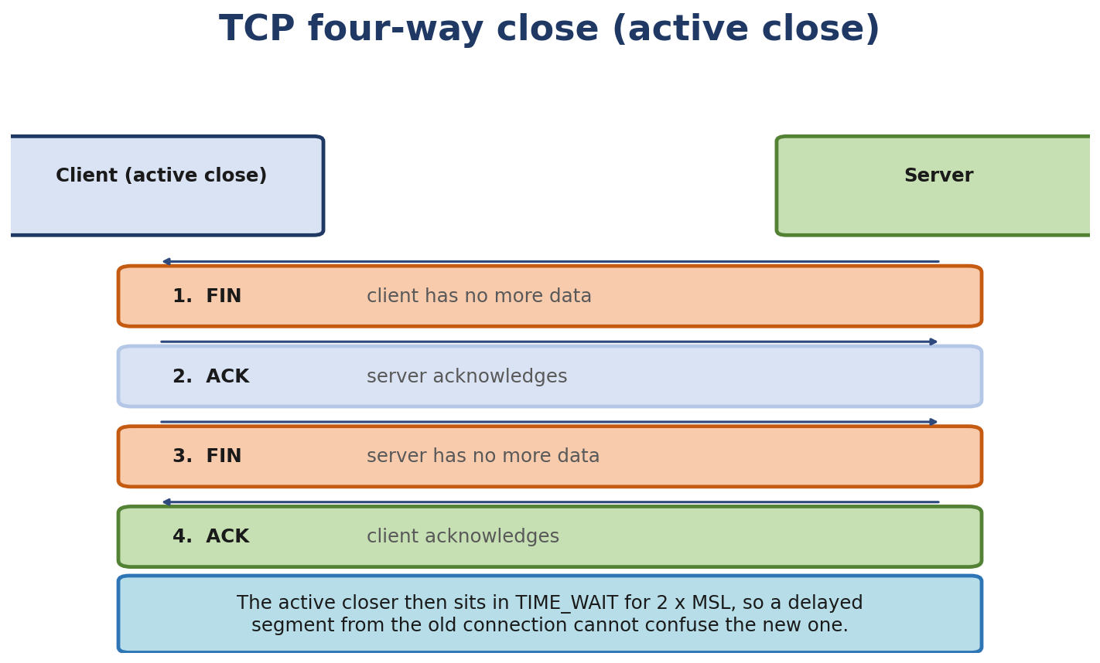
Figure 5.5. The TCP four-way close, and the TIME_WAIT state the active closer enters afterwards.

Practice Challenges
- Capture your own TCP session. Use tcpdump -w /tmp/cap.pcap while doing curl https://example.com. Open in Wireshark, examine the SYN/SYN-ACK/ACK, options (MSS, SACK, window scale), and follow the TCP stream.
- Force retransmits. Use tc netem loss 5% on your outgoing interface. Run iperf3 -c <server>. Observe retransmits in ss -tin.
- Measure cwnd growth. Use Wireshark’s TCP Stream Graphs (Window Scaling) to see cwnd over time during a slow start.
- TIME_WAIT tuning. Create a server that handles many short connections. ab -n 10000 -c 100 http://localhost/. Watch TIME_WAIT count grow.
- Switch congestion-control algorithms by writing net.ipv4.tcp_congestion_control. Check the current value first with 'sysctl net.ipv4.tcp_congestion_control'; the kernel default is CUBIC, but a workload-tuned system may run BBR, DCTCP, or another CC. Re-run iperf3 to see the difference.
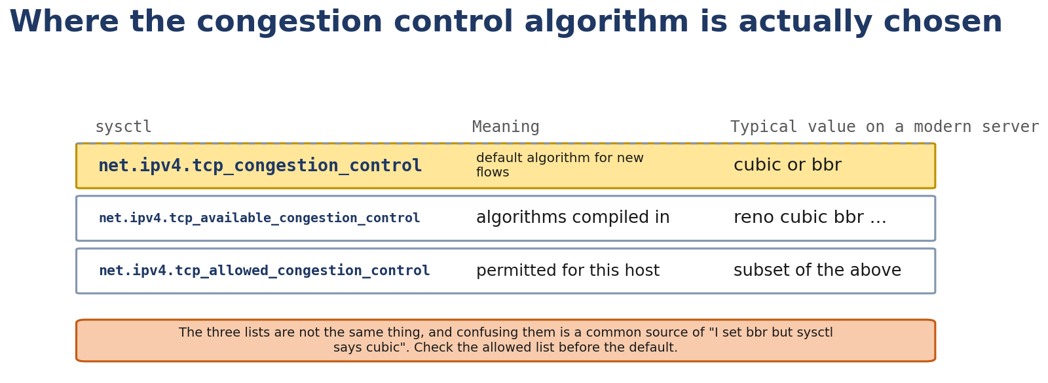
Figure 5.6. Where the congestion control algorithm is actually chosen, and why the three sysctls are not interchangeable.
- Examine RST. Use tcpdump -ttt 'tcp[tcpflags] & tcp-rst != 0' and find RSTs. Why each one?
- Read tcp_input.c. Find tcp_rcv_state_process. Follow the switch statement for each state. Understand each transition.

Chapter 6 - Inside the Linux Kernel Network Stack

What You Will Learn
- The architecture of the Linux network stack - every layer, every boundary
- The five key structures: struct socket, struct sock, struct sk_buff, struct net_device, struct napi_struct
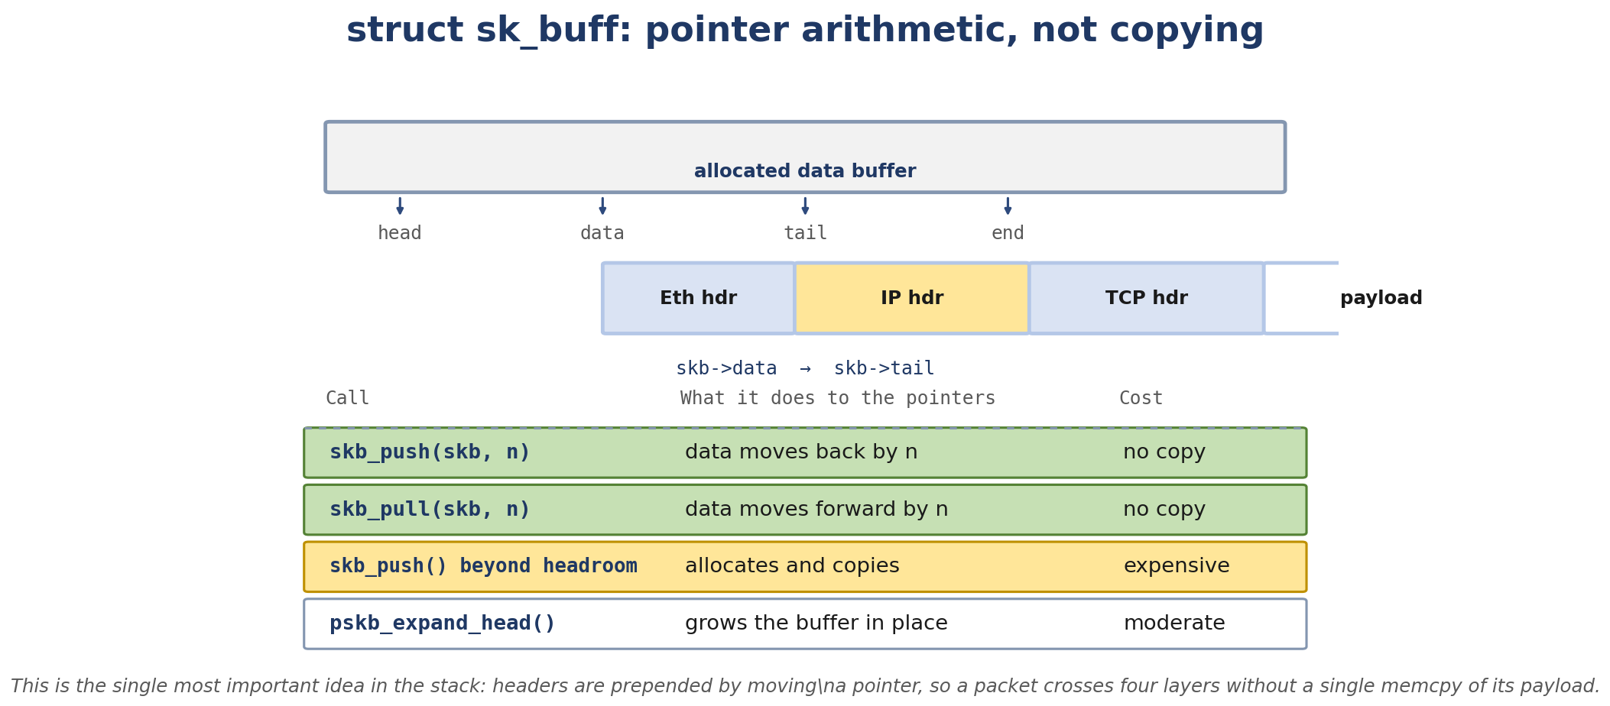
Figure 6.1. struct sk_buff is pointer arithmetic: headers are prepended without copying the payload.
- The sk_buff in depth: head/data/tail/end, headroom, tailroom, fragments, cloning, reference counting
- The sk_buff mutator functions: skb_put, skb_push, skb_pull, skb_trim
- Where to find all of this in the kernel source tree
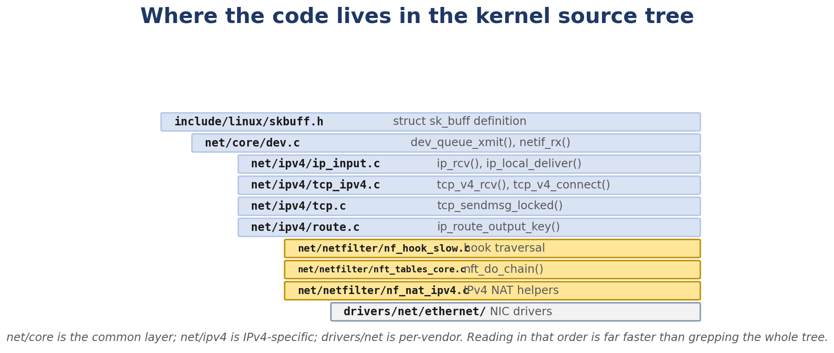
Figure 6.2. Where the code lives in the kernel source tree, in the order worth reading it.
- How to write a tiny bpftrace program that observes sk_buffs at runtime

Real-Life Analogy - The Envelope Inside the Sorting Office
Reality check — where the analogy breaks. The analogy above is a pedagogical tool for building a mental model. It is not a precise description of the kernel mechanism. The real implementation differs from the analogy in ways your interviews and lab work will surface; always reason from the kernel source when precision matters.
The postal system gave us packets as envelopes. The kernel doesn’t have envelopes - it has a single, flexible container called the sk_buff that plays every role.
Think of an envelope in a sorting office. As it moves through the system, the office doesn’t open the envelope and re-pack it at every station. Instead, the envelope stays the same, and the office just stamps and labels it differently at each point. The “where next” marker on the envelope (skb->cb[]) is rewritten; the contents (skb->data) are mutated in place.
A few clever things about the envelope:
Headroom and tailroom. The envelope has space above and below the address - empty padding the office can use later for new stamps without re-sealing. skb_push adds to the front; skb_put adds to the back. Cloning. When the office needs to send two copies of the same letter (e.g. for retransmission), it doesn’t duplicate the letter - it stamps “duplicate” on the envelope and gives it a reference. Both copies share the same content; only when both copies are gone is the actual data freed. Fragments. A long letter might not fit in one envelope. The office splits it into a list of envelopes, all tied together. The kernel does the same with skb->next, skb->prev, and the frag_list.

The Networking Concept

The architecture
+-----------------------------------+
| USER SPACE |
| |
| application (curl, nginx, etc) |
| | |
| v |
| libc / glibc (wrappers) |
| | |
+--------|--------------------------+
| syscall
+--------v--------------------------+
| KERNEL |
| |
| Socket layer |
| struct socket, struct file |
| sock_read, sock_write, |
| sock_poll, etc. |
| | |
| v |
| Protocol layer (struct sock) |
| AF_INET: tcp_prot, udp_prot |
| BSD-style ops |
| | |
| v |
| Transport layer |
| TCP, UDP |
| sendmsg/recvmsg handlers |
| | |
| v |
| Network layer |
| IPv4/IPv6 |
| routing, fragmentation, |
| ICMP |
| | |
| v |
| Netfilter |
| hooks: PREROUTING, INPUT, |
| FORWARD, OUTPUT, POSTROUTING |
| | |
| v |
| Device layer |
| net_device, qdisc |
| dev_queue_xmit, dev_hard_start|
| | |
| v |
| Driver layer |
| ndo_start_xmit |
| DMA mapping, TX ring |
| | |
| v |
| NIC (hardware) |
| |
+-----------------------------------+
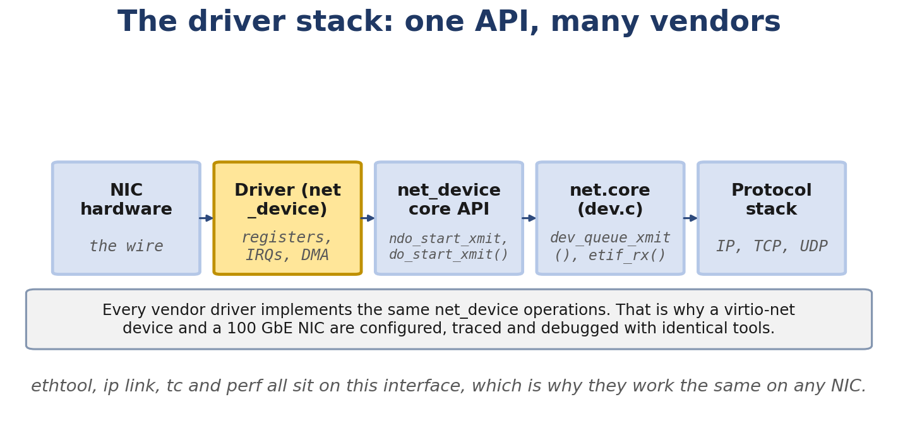
Figure 6.3. The driver stack: one net_device API, and why ethtool works on any NIC.
The reverse path (RX) goes NIC → driver → device layer → Netfilter → IP → TCP/UDP → socket → user.

struct socket - the BSD-style VFS entry
struct socket is in include/linux/net.h (and include/uapi/linux/socket.h for the parts visible to user space). It represents one end of a network connection from user space’s perspective. Key fields:
struct socket {
socket_state state; /* SS_CONNECTED, etc. */
short type; /* SOCK_STREAM, SOCK_DGRAM */
unsigned long flags; /* SOCK_NOSPACE, etc. */
struct file *file; /* backptr to struct file */
struct sock *sk; /* the protocol-level socket */
const struct proto_ops *ops; /* protocol-specific operations */
struct socket_wq *wq; /* wait queue for blocking */
};
struct file is the VFS file object (every fd points to one). The socket is connected to VFS through file->f_op = &socket_file_ops and file->private_data = socket. When you read() or write() an fd, VFS dispatches to the socket’s ops.
struct proto_ops is the family-specific operations table: bind, connect, sendmsg, recvmsg, accept, etc. For AF_INET SOCK_STREAM, it’s inet_stream_ops. For SOCK_DGRAM, inet_dgram_ops. These dispatch to the protocol’s specific functions.
struct socket_wq is the wait queue for poll/select/epoll. When the socket becomes ready, waiters are woken here.

struct sock - the protocol-level socket
struct sock is in include/net/sock.h. It’s the common base for all protocol implementations. TCP and UDP each have their own wrapper (struct tcp_sock and struct udp_sock) that embed struct sock and add protocol-specific fields.
Key fields of struct sock:
struct sock {
struct sk_buff_head sk_receive_queue; /* RX data waiting for user */
struct sk_buff_head sk_write_queue; /* TX data not yet sent */
...
u32 sk_drops; /* drops */
int sk_rcvbuf; /* RX buffer size */
int sk_sndbuf; /* TX buffer size */
...
struct socket *sk_socket; /* backptr */
void *sk_user_data; /* BPF attach point */
...
};
sk_receive_queue is where the kernel queues incoming data. When the user calls recv, the kernel dequeues from here.
For TCP, struct tcp_sock adds:
struct tcp_sock {
struct sock sk;
u32 snd_una; /* oldest unacked seq */
u32 snd_nxt; /* next seq to send */
u32 rcv_nxt; /* next expected seq */
u32 snd_wnd; /* peer's receive window */
u32 snd_cwnd; /* congestion window */
u32 snd_ssthresh;/* slow start threshold */
...
};

struct sk_buff - the packet container
This is the most important structure in the entire network stack. Every packet is an sk_buff from the moment it leaves the application to the moment it reaches the wire (and reverse on receive).
Layout (simplified, in memory):
linear data area
+------+--------------------+------+------+
| head | data | tail | end |
+------+--------------------+------+------+
| len bytes |
|<-- data_len bytes-->|
| |
v v
payload end of buffer
|<-- headroom -->|<-- payload -->|<-- tailroom -->|
The sk_buff struct itself looks like:
struct sk_buff {
union {
struct {
/* These two members must be first. */
struct sk_buff *next;
struct sk_buff *prev;
...
};
struct rb_node rbnode; /* used in some queues (TCP retransmit) */
};
struct sock *sk; /* owning socket */
struct net_device *dev; /* device */
...
__u16 protocol; /* ETH_P_IP, etc. */
__u16 transport_header;
__u16 network_header;
__u16 mac_header;
...
void (*destructor)(struct sk_buff *skb);
...
/* Headroom, data, tail, end pointers */
unsigned char *head;
unsigned char *data;
unsigned char *tail;
unsigned char *end;
...
u32 len; /* bytes in main area */
u16 data_len; /* bytes in fragments */
u16 mac_len;
u16 hdr_len;
...
refcount_t users; /* refcount */
unsigned char cloned:1,
nohdr:1,
fclone:2,
peeked:1,
head_frag:1,
pfmemalloc:1,
...
__u8 pkt_type:3,
...
struct skb_shared_info *shinfo; /* end of allocated block */
};
shinfo lives at skb->end and contains the frag_list and frag array (used for non-linear data). The skb_shared_info is allocated as part of the same kmem block as the data buffer.

Linear vs non-linear
A linear skb has all its data in a single contiguous buffer (between head and end). A non-linear skb has some data in the linear area and the rest in fragments. Fragments are stored in the skb_shared_info.frags[] array (up to MAX_SKB_FRAGS = 17 on typical kernels) and the skb_shared_info.frag_list (a list of additional skbs, used for GSO segmentation and recvmmsg-style accumulation).
Non-linear skbs are created when:
GRO combines multiple incoming skbs into one (a chain in frag_list). TCP receives a frame whose payload is split across multiple pages. The user provides data via sendmsg with multiple iovecs (the kernel might build a non-linear skb).

Cloning and refcount
skb_clone(skb, GFP_ATOMIC) creates a new sk_buff that shares the data buffer with the original. Both skbs point to the same memory; the original’s cloned flag is set. To actually copy the data, use skb_copy.
users is the reference count. When it drops to 0 and cloned is unset, the buffer can be freed.
kfree_skb (or its wrapper consume_skb) decrements the refcount and frees the buffer if it hits 0. kfree_skb is called on the drop path; consume_skb is called on the success path (they differ in their tracepoint and accounting).

skb_put, skb_push, skb_pull, skb_trim
These four functions mutate the data, tail, and len pointers to add or remove data.
unsigned char *skb_put(struct sk_buff *skb, unsigned int len)
{
/* Extend the data at the tail */
skb->tail += len;
skb->len += len;
...
return skb->data + skb->len - len;
}
skb_put adds len bytes of space at the end of the data area. Returns a pointer to the start of the new space. Used to add payload.
unsigned char *skb_push(struct sk_buff *skb, unsigned int len)
{
/* Extend the data at the head */
skb->data -= len;
skb->len += len;
...
return skb->data;
}
skb_push adds len bytes of space at the start. Used to add a protocol header (e.g. when TCP hands the skb to IP, IP does skb_push(skb, sizeof(struct iphdr)) to add the IP header).
unsigned char *skb_pull(struct sk_buff *skb, unsigned int len)
{
/* Remove data from the head */
skb->len -= len;
skb->data += len;
...
return skb->data;
}
skb_pull removes len bytes from the start. Used during decapsulation: when IP receives an skb, it does skb_pull(skb, ip_hdrlen(skb)) to strip the IP header and reveal the TCP segment.
void skb_trim(struct sk_buff *skb, unsigned int len)
{
/* Truncate data to len bytes */
if (skb->len > len)
__skb_trim(skb, len);
}
skb_trim shrinks the skb to len bytes. Used to remove padding or trim excess.
Visualization of an skb’s lifecycle (TX of a TCP segment):
Application does send().
|
v
TCP allocates skb, copies user data into linear area:
[data ............]
^- tail
TCP builds TCP header and pushes it:
[TCP| data ............]
^- data ^- tail
TCP passes to IP. IP pushes IP header:
[IP | TCP | data ............]
^- data ^- tail
IP passes to dev_queue_xmit. Driver writes the skb's data to a DMA descriptor.
|
v
NIC transmits bytes from data to data+len.
On RX:
NIC delivers bytes to driver.
Driver allocates skb, populates data with received bytes:
[eth header | IP | TCP | data ............]
^- tail
IP strips Ethernet header (skb_pull):
[IP | TCP | data ............]
TCP strips IP header (skb_pull):
[TCP | data ............]
Application calls recv(). TCP copies data out (or into a page) and frees skb.

struct net_device
struct net_device is in include/linux/netdevice.h. It represents one network interface - physical or virtual. Hundreds of fields, but the important ones:
struct net_device {
char name[IFNAMSIZ]; /* "eth0", "lo", "veth-a", ... */
...
unsigned int mtu; /* max transmission unit */
...
unsigned int flags; /* IFF_UP, IFF_RUNNING, IFF_BROADCAST, ... */
...
const struct net_device_ops *netdev_ops; /* driver callbacks */
const struct header_ops *header_ops; /* header cache */
...
struct netdev_queue *_tx; /* TX queues (multiqueue) */
unsigned int num_tx_queues;
struct Qdisc *qdisc; /* traffic control */
...
struct net_device_stats stats; /* packet/byte/error counters */
...
unsigned char *dev_addr; /* MAC address */
...
struct net *nd_net; /* network namespace */
...
};
netdev_ops is the driver’s table of operations: ndo_start_xmit, ndo_open, ndo_stop, ndo_set_mac_address, ndo_select_queue, ndo_get_stats64, etc.
qdisc is the per-device queuing discipline. Default is pfifo_fast for legacy compatibility but modern distros use fq or fq_codel.
stats is the old-style statistics. Modern drivers expose per-queue stats via ethtool -S.

struct napi_struct
NAPI is Linux's standard polling framework for network packet reception. The name originally stood for 'New API' when introduced in Linux 2.4, but NAPI is now simply the established name and no longer stands for anything in particular. struct napi_struct represents one polling context. Drivers register a NAPI instance, schedule it from the interrupt handler, and the kernel polls it in softirq context.
(*poll)(struct napi_struct *, int); /* driver's napi->poll callback (function pointer, not the symbol napi_poll) */
The NAPI state machine:
- NIC raises interrupt (or MSI-X).
- Driver ISR disables the IRQ, calls napi_schedule(&napi). This adds the napi to sd->poll_list and raises NET_RX softirq.
- napi->poll (driver-implemented callback)
- The driver's napi->poll callback processes RX ring entries, calling napi_gro_receive for each packet.
- the napi->poll callback returns the
This is the “interrupt coalescence” model: take a burst of packets in one softirq, then go back to interrupts.

Source tree orientation
net/
├── core/ # dev.c, skbuff.c, neighbour.c, filter.c
├── ipv4/ # IP, TCP, UDP, ICMP, ARP, routing
├── ipv6/ # IPv6, ICMPv6, NDP
├── netfilter/ # nf_conntrack, nftables, etc.
├── bridge/ # Linux bridge
├── sched/ # qdisc implementations
├── xfrm/ # IPsec
└── ...
include/
├── net/ # protocol-internal headers
└── linux/ # generic, including skbuff.h, netdevice.h, sock.h
drivers/net/
├── ethernet/ # most physical NIC drivers
│ ├── intel/ # e1000e, igb, ixgbe, i40e
│ ├── mellanox/ # mlx4, mlx5
│ └── ...
├── virtio_net.c # virtio-net (VMs)
├── veth.c # veth pair
├── loopback.c # loopback
├── tun.c # TUN/TAP
├── bond/ # bonding
└── ...
Useful search patterns:
# Find a function definition
grep -RIn "^int tcp_sendmsg" net/
# Find a function's callers
grep -RIn "tcp_sendmsg(" net/ drivers/ include/
# Find a struct definition
grep -RIn "^struct sk_buff {" include/linux/
# Find all uses of a field
git grep "sk_buff->protocol"

Follow the Packet - The sk_buff’s Journey
For a TCP send of “hello” (5 bytes) from 192.168.1.10:12345 to 192.168.1.5:8080:
1. Application calls send("hello", 5).
2. TCP allocates an skb. headroom is reserved (enough for ETH + IP + TCP headers).
3. TCP copies "hello" into the skb's data area via skb_put. skb->len = 5.
4. TCP builds TCP header at skb->data - 20 via skb_push(skb, 20). skb->len = 25.
5. TCP passes to ip_queue_xmit, which calls skb_push(skb, sizeof(struct iphdr)) = 20. skb->len = 45.
6. IP does skb->dev = route->dst.dev; passes to dev_queue_xmit.
7. dev_queue_xmit enqueues into qdisc, then calls dev_hard_start_xmit.
8. Driver ndo_start_xmit: DMA-maps the skb's data, writes descriptors, doorbell.
9. NIC transmits.
On RX (return path):
1. NIC receives, allocates skb, populates data.
2. Driver ISR: napi_schedule.
3. Softirq: napi_poll -> napi_gro_receive.
4. Protocol demux: eth_type_trans sets protocol, then __netif_receive_skb_core dispatches to ip_rcv.
5. IP: skb_pull(skb, ip_hdr_len). len -= 20.
6. ip_local_deliver -> tcp_v4_rcv. TCP: skb_pull(skb, tcp_hdr_len). len -= 20.
7. tcp_v4_do_rcv -> sock_queue_rcv_skb. skb sits in sk->sk_receive_queue.
8. Application's recv() returns 5 bytes. skb freed.

Linux View

Inspect /proc/net/
$ cat /proc/net/sockstat
sockets: used 312
TCP: inuse 14 orphan 0 tw 2 alloc 18 mem 4
UDP: inuse 5 mem 2
...
$ cat /proc/net/tcp
sl local_address rem_address st tx_queue rx_queue tr tm->when retrnsmt ...
0: 0100007F:0277 00000000:0000 0A 00000000:00000000 00:00000000 00000000 ...
$ cat /proc/net/udp
...
$ ss -s

Inspect per-device
$ ls /sys/class/net/eth0/
$ cat /sys/class/net/eth0/mtu
1500
$ cat /sys/class/net/eth0/address
52:54:00:12:34:56
$ cat /sys/class/net/eth0/ifindex
2

Drop monitoring
$ sudo perf trace -e skb:kfree_skb
$ sudo bpftrace -e 'kprobe:kfree_skb_reason { @[arg0->dev->name] = count(); }'

Kernel View
Key files:
include/linux/skbuff.h - struct sk_buff definition, all the helper inline functions. net/core/skbuff.c - __alloc_skb, kfree_skb , skb_put, skb_push, skb_pull, skb_trim, skb_clone, skb_copy, __pskb_copy, skb_orphan. include/net/sock.h - struct sock, common socket infrastructure. include/net/tcp.h - struct tcp_sock definition. include/linux/netdevice.h - struct net_device, struct napi_struct, netdev_ops. net/core/dev.c - device layer: dev_queue_xmit, __dev_queue_xmit, dev_hard_start_xmit, netif_receive_skb, __netif_receive_skb_core, napi_schedule, net_rx_action, napi_complete_done.
Key functions in skbuff.c:
__alloc_skb - allocate and initialize. Reserves headroom. kfree_skb / kfree_skb_reason - drop with reason. consume_skb - success path, no tracepoint with reason. skb_put, skb_push, skb_pull, skb_trim - mutators (often inlined). skb_clone - new skb sharing data. skb_copy - full copy. __pskb_copy - copy head but reference data (used for non-linear skbs). pskb_expand_head - grow the headroom. skb_orphan - detach from socket (used when going to driver).

Source Code Walkthrough

Excerpt 1: struct sk_buff core (include/linux/skbuff.h, abbreviated)
The actual definition is hundreds of lines. Here’s the essential layout:
struct sk_buff {
union {
struct {
/* These two members must be first. */
struct sk_buff *next;
struct sk_buff *prev;
union {
struct net_device *dev;
unsigned long dev_scratch;
};
};
struct rb_node rbnode;
};
struct sock *sk;
__u16 protocol;
__u16 transport_header;
__u16 network_header;
__u16 mac_header;
__u16 inner_transport_header;
__u16 inner_network_header;
__u16 inner_mac_header;
sk_buff_data_t tail;
sk_buff_data_t end;
unsigned char *head,
*data;
unsigned int truesize;
refcount_t users;
/* ... many more fields ... */
};
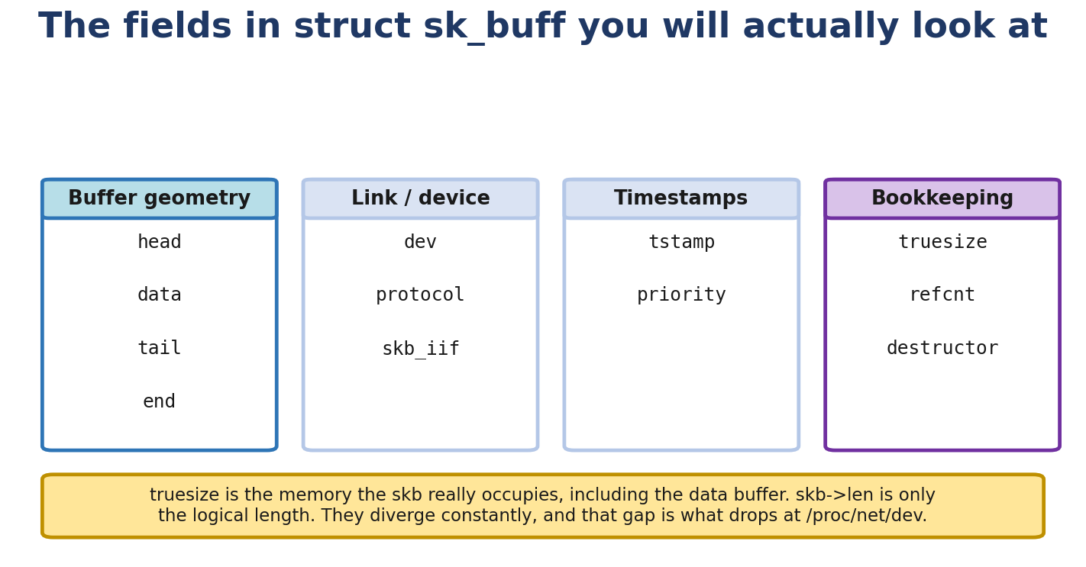
Figure 6.4. The sk_buff fields you will actually look at when debugging a packet path.
tail, end, head, data are sk_buff_data_t (typically unsigned char *, but on some 64-bit systems it’s a 32-bit offset for cache locality). The *head is the start of the allocated buffer; *data is where the payload starts; *tail is where the payload ends; *end is the end of the allocated buffer.

Excerpt 2: skb_put, skb_push (include/linux/skbuff.h, inlined)
static inline unsigned char *skb_put(struct sk_buff *skb, unsigned int len)
{
unsigned char *tmp = skb_tail_pointer(skb);
skb->tail += len;
skb->len += len;
if (unlikely(skb->tail > skb->end))
skb_over_panic(skb, len, __builtin_return_address(0));
return tmp;
}
static inline unsigned char *skb_push(struct sk_buff *skb, unsigned int len)
{
skb->data -= len;
skb->len += len;
if (unlikely(skb->data < skb->head))
skb_under_panic(skb, len, __builtin_return_address(0));
return skb->data;
}
Note the bounds checks: skb_put panics if you exceed the tailroom; skb_push panics if you exceed the headroom. This is why headroom is reserved at allocation.

Excerpt 3: __alloc_skb (net/core/skbuff.c, abbreviated)
struct sk_buff *__alloc_skb(unsigned int size, gfp_t gfp_flags, int flags,
int node)
{
struct kmem_cache *cache;
struct skb_shared_info *shinfo;
struct sk_buff *skb;
u8 *data;
/* Choose slab cache based on size */
cache = kmem_cache_alloc(skbuff_head_cache, gfp_flags & ~__GFP_DMA);
if (!cache)
return NULL;
skb = (struct sk_buff *)cache;
...
/* Allocate data buffer (size + sizeof(shinfo)) */
size = SKB_DATA_ALIGN(size);
size += sizeof(struct skb_shared_info);
data = kmalloc_reserve(size, gfp_flags, node, &pfmemalloc);
if (!data)
goto nodata;
/* Initialize pointers */
memset(skb, 0, offsetof(struct sk_buff, tail));
skb->truesize = SKB_TRUESIZE(size);
refcount_set(&skb->users, 1);
skb->head = data;
skb->data = data;
skb->tail = data;
skb->end = data + size;
skb->mac_header = (typeof(skb->mac_header))~0U;
skb->transport_header = (typeof(skb->transport_header))~0U;
skb->network_header = (typeof(skb->network_header))~0U;
...
return skb;
}
__alloc_skb is the central allocator. It uses the skbuff_head_cache slab for the skb struct itself and kmalloc for the data buffer. The skb_shared_info is allocated as part of the data buffer (at the end), so the total allocation is data_size + sizeof(skb_shared_info).

Excerpt 4: kfree_skb_reason (net/core/skbuff.c, Linux 6.6, abbreviated)
static __always_inline
bool __kfree_skb_reason(struct sk_buff *skb, enum skb_drop_reason reason)
{
if (unlikely(!skb_unref(skb)))
return false;
if (reason == SKB_CONSUMED)
trace_consume_skb(skb, __builtin_return_address(0));
else
trace_kfree_skb(skb, __builtin_return_address(0), reason);
return true;
}
void kfree_skb_reason(struct sk_buff *skb, enum skb_drop_reason reason)
{
if (__kfree_skb_reason(skb, reason))
__kfree_skb(skb);
}
In Linux 6.6, kfree_skb() is an inline wrapper that calls kfree_skb_reason() with SKB_DROP_REASON_NOT_SPECIFIED. When the caller knows the cause, it can pass a specific reason to kfree_skb_reason(). consume_skb() marks normal packet release and uses a different tracepoint.

Hands-On Lab - Inspect an skb at Runtime

Goal
Use the tracepoint to count drop reasons. Use a kprobe when you also need fields from the skb, such as its length or device.

Setup
A single Linux VM with bpftrace installed:
sudo apt install -y bpftrace linux-headers-$(uname -r)

Commands
Lab 1 - count skb drops by reason:
$ sudo bpftrace -e 'tracepoint:skb:kfree_skb { @[args->reason] = count(); }'
Generate test traffic. Normal traffic may create no drop events. The output groups drop events by reason; the numeric reason values depend on the kernel.
Tracepoint fields depend on the kernel version. Check them with `sudo cat /sys/kernel/tracing/events/skb/kfree_skb/format`. On Linux 6.6, the event includes skbaddr, location, protocol, and reason. skbaddr is an opaque address; it is not a device pointer.
To count drops by device, inspect the skb in kfree_skb_reason. Some skbs have no device, so check for a null pointer:
$ sudo bpftrace -e '
kprobe:kfree_skb_reason {
$skb = (struct sk_buff *)arg0;
if ($skb->dev) {
@drops[str($skb->dev->name)] = count();
}
}'
Lab 2 - group dropped skb lengths by process:
$ sudo bpftrace -e '
kprobe:kfree_skb_reason /arg0/ {
Lab 3 - write a kernel module (more involved).
For now, bpftrace is the easier path. If you want to write a kmod:
// kmod-skb-trace.c
#include <linux/module.h>
#include <linux/skbuff.h>
static int __init my_init(void)
{
pr_info("skb-trace loaded\n");
return 0;
}
static void __exit my_exit(void)
{
pr_info("skb-trace unloaded\n");
}
module_init(my_init);
module_exit(my_exit);
MODULE_LICENSE("GPL");
Build with a Makefile:
obj-m += kmod-skb-trace.o
all:
make -C /lib/modules/$(shell uname -r)/build M=$(PWD) modules
clean:
make -C /lib/modules/$(shell uname -r)/build M=$(PWD) clean
make
sudo insmod kmod-skb-trace.ko
sudo rmmod kmod-skb-trace
dmesg | tail
This Linux 6.6 module example counts skb drop events. The callback runs for each drop, so it only updates a counter; it does not print per packet.
#include <linux/atomic.h>
#include <linux/module.h>
#include <linux/skbuff.h>
#include <trace/events/skb.h>
static atomic64_t drop_count = ATOMIC64_INIT(0);
static void probe_kfree_skb(void *data, struct sk_buff *skb,
void *location,
enum skb_drop_reason reason)
{
atomic64_inc(&drop_count);
}
static int __init skb_trace_init(void)
{
return register_trace_kfree_skb(probe_kfree_skb, NULL);
}
static void __exit skb_trace_exit(void)
{
unregister_trace_kfree_skb(probe_kfree_skb, NULL);
tracepoint_synchronize_unregister();
}
module_init(skb_trace_init);
module_exit(skb_trace_exit);
MODULE_LICENSE("GPL");
Unload the module to print the total drop count in dmesg.

Example Output (reason values vary)
Attaching 1 probe...
@[2]: 12
@[7]: 5

Explanation
A kprobe on kfree_skb_reason receives the skb pointer as arg0 and the drop reason as arg1. The skb:kfree_skb tracepoint provides the reason as args->reason. Use the tracepoint for a reason count. Use a kprobe when you also need skb fields.

Experiment
Use a test namespace with a temporary drop rule if you need to create drop events. Do not expect normal traffic to make drop counters rise.

Break It
Force a drop with iptables -I INPUT -p tcp - dport 22 -j DROP. Watch the drop counter for eth0 increase as you try to SSH in.

Debug It
If a bpftrace script fails with “Could not resolve symbol”, the kernel might not have the symbol exported, or the field offset might differ. Try bpftrace -d -e '...' to dump the generated BPF program and look at the field accesses.

Challenge
Extend the bpftrace script to bucket drops by skb->len and skb->protocol. Generate UDP and TCP traffic; see which protocols have which length distributions.

Solution
sudo bpftrace -e '
kprobe:kfree_skb_reason /arg0/ {
$skb = (struct sk_buff *)arg0;
@[comm, $skb->protocol, $skb->len] = count();
}
'

Interview Questions
Q6.1 (Beginner) - What is a socket, conceptually?
An endpoint of a network conversation, represented in user space as a file descriptor. The kernel maintains a struct socket (BSD-style VFS) and a struct sock (protocol-specific state). User space accesses it through standard fd operations.
Q6.2 (Beginner) - What is an sk_buff?
The kernel’s representation of a network packet. It points to a buffer of bytes (the packet data) plus metadata (length, headers, owning socket, device, protocol). Every packet is an sk_buff from the time it leaves (or arrives at) the NIC to the time it’s delivered to (or from) user space.
Q6.3 (Beginner) - What’s the difference between struct socket and struct sock?
struct socket is the BSD-style interface to VFS - what user space sees. struct sock is the protocol-level state - what the kernel manipulates. For AF_INET SOCK_STREAM, struct sock is wrapped in struct tcp_sock which adds TCP state (sequence numbers, cwnd, etc.).
Q6.4 (Intermediate) - Why does the kernel use sk_buff instead of copying packet data between layers?
Because copying is expensive. The sk_buff lets the kernel add and remove headers in place (via skb_push and skb_pull) without moving the data. The actual byte buffer stays put; only the data and len pointers change.
Q6.5 (Intermediate) - Explain sk_buff cloning vs copying.
Cloning (skb_clone) creates a new sk_buff that shares the data buffer with the original. The original’s cloned flag is set. Both skbs point to the same memory; the data is only copied when one of them tries to write. Cloning is used for things like TCP retransmission (the retransmit skb shares with the original). Copying (skb_copy) creates a new sk_buff with a new data buffer. Used when both skbs will modify the data.
Q6.6 (Intermediate) - What is headroom, and why does the kernel reserve it?
Headroom is the space at the front of the sk_buff’s data buffer (between head and data). The kernel reserves it so it can use skb_push to add a header (e.g. when IP receives an skb, it can push down to add an IP header before sending to the driver). Without reserved headroom, every push would require a buffer reallocation.
Q6.7 (Intermediate) - What is the difference between kfree_skb and consume_skb?
kfree_skb() uses the default reason NOT_SPECIFIED. Use kfree_skb_reason() when the caller knows the cause. consume_skb() marks a normal release. Linux uses different tracepoints for these paths.
Q6.8 (Intermediate) - What is the role of struct net_device?
It represents one network interface in the kernel. Holds the device name, MTU, MAC, flags, queues, qdisc, driver callbacks (netdev_ops), and per-namespace linkage. Every NIC (physical, virtual) has one.
Q6.9 (Intermediate) - What is NAPI?
Polled RX framework (originally 'New API' in Linux 2.4; the acronym is no longer authoritative). Instead of one IRQ per packet, NAPI drivers disable the IRQ when a packet arrives, schedule a poll, and the kernel processes the entire RX ring in softirq. Reduces IRQ overhead.
Q6.10 (Advanced) - Why is cloning safer than copying for retransmission?
Because cloning is “free” until someone writes to the data. TCP retransmission is read-only - you just want to send the same bytes again. With cloning, you avoid the cost of copying. With copying, you allocate and fill a new buffer every time. Cloning is O(1); copying is O(n).
Q6.11 (Advanced) - What happens during TCP retransmission to the sk_buff?
tcp_transmit_skb is called. It builds the segment (with the right seq, ack, window, flags) by pushing a TCP header onto the skb, computes the checksum, and passes to the IP layer. The skb is cloned if it’s still in the send queue, or copied if it’s been modified.
Q6.12 (Advanced) - How does the kernel handle out-of-order skb fragments during reassembly?
Each fragment carries the same IP identification. The kernel has a hash table (ip4_frags) indexed by (src, dst, id, protocol). When fragments arrive, they’re added to a list. As contiguous fragments appear, they’re coalesced. When the full packet is reassembled, the original skb is passed up. If reassembly doesn’t complete in 60s, the fragments are dropped.
Q6.13 (Kernel internals) - Walk through what happens between skb_put and the NIC transmitting the bytes.
skb_put updates tail and len, returns a pointer to the new space. The caller fills that space with data. Then the skb is passed up the stack (to the next layer). Each layer calls skb_push to add its header in front, and skb_put to add its trailer (rare). When the skb reaches the driver, ndo_start_xmit is called. The driver DMA-maps the skb’s data buffer and writes descriptors. The NIC reads from those DMA addresses and transmits.
Q6.14 (Kernel internals) - How does the kernel choose whether to allocate a linear or non-linear skb?
__alloc_skb always allocates a linear skb. The caller decides whether to make it non-linear. For example, skb_append_pagefrags adds page-fragments to make a non-linear skb. Most TX skbs are linear; some RX skbs (especially from GRO) are non-linear.
Q6.15 (Kernel internals) - How do you find the IP header inside an skb?
ip_hdr(skb) is a macro that returns (struct iphdr *)(skb->data + skb->network_header). The network_header is an offset into the data buffer. It was set by the layer that created the header (or the NIC’s receive path). Similarly, tcp_hdr(skb) returns the TCP header at skb->data + skb->transport_header.

Key Takeaways
The Linux network stack has clear layers: socket → transport → network → device → driver. The five key structures are socket, sock, sk_buff, net_device, napi_struct. sk_buff is the packet container; understanding its layout (head, data, tail, end) and mutators (put, push, pull, trim) is essential. Cloning and refcounting let the kernel share skb data efficiently. Headroom and tailroom are reserved at allocation to allow in-place header manipulation. The kernel source is organized: net/ for protocols, include/net/ for internal headers, drivers/net/ for device drivers.

Practice Challenges
- Read include/linux/skbuff.h. Find the definition of sk_buff_data_t and the __skb_data accessors. Why are they optimized for cache?
- Find skb_put and skb_push callers. git grep "skb_put(" net/ | head -20. What kinds of data are being added?
- Trace a real drop. Use bpftrace to hook kfree_skb and find a packet that was dropped. Find its dev and protocol.
- Inspect /proc/net/sockstat. Watch it while running iperf3. See counters move.
- Compare kfree_skb and consume_skb rates. With bpftrace, count both. The ratio tells you about drops vs normal completions.
- Read net/core/skbuff.c. Find __alloc_skb. Trace the cache selection logic. Why is the slab cache used for skbs?
- Build a kmod that counts skbs per protocol. Add to the lab above.

Chapter 7 - The Complete Linux Packet TX and RX Path

What You Will Learn
- The full TX path from send() to the wire, with kernel function names at every step
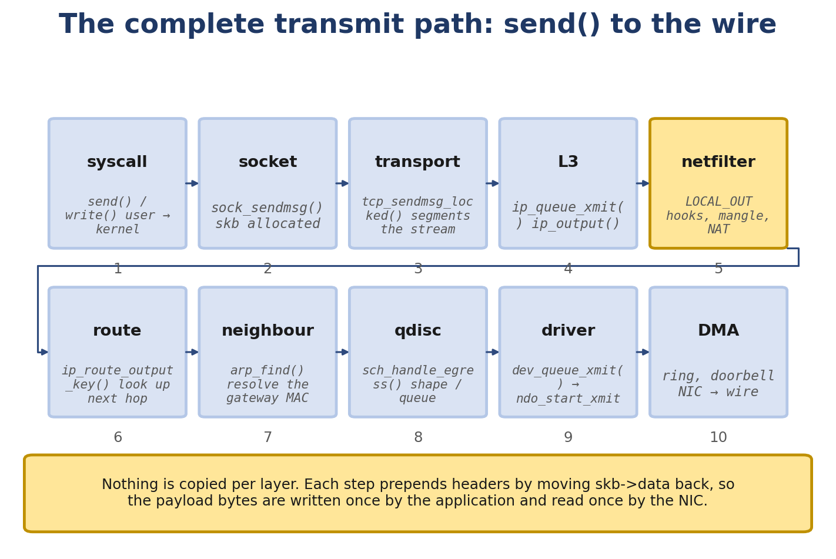
Figure 7.1. The complete transmit path, from the send() syscall to the wire.
- The full RX path from the wire to recv(), with kernel function names at every step
- MSI vs MSI-X interrupts
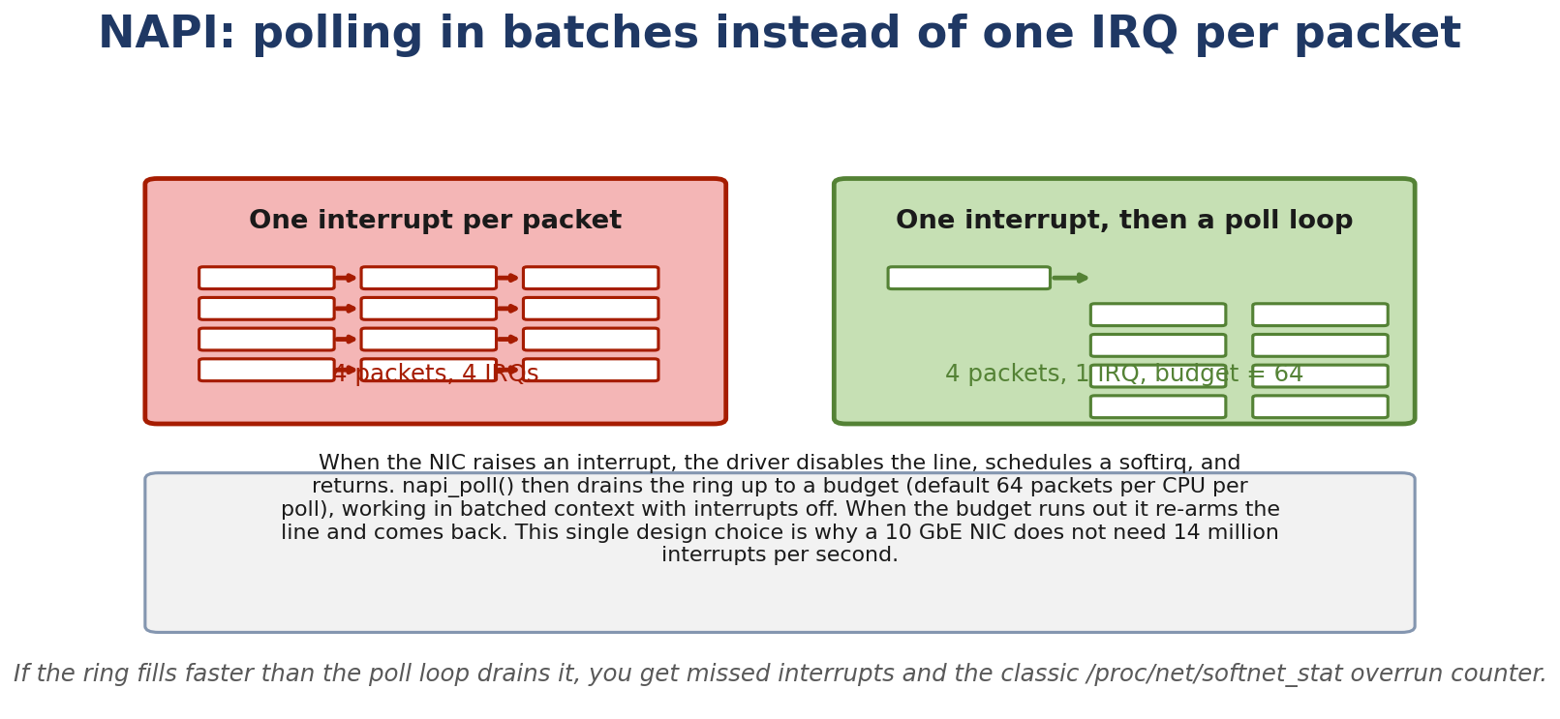
Figure 7.2. NAPI replaces one interrupt per packet with one interrupt and a budgeted poll loop.
- NAPI in detail: schedule, poll, complete
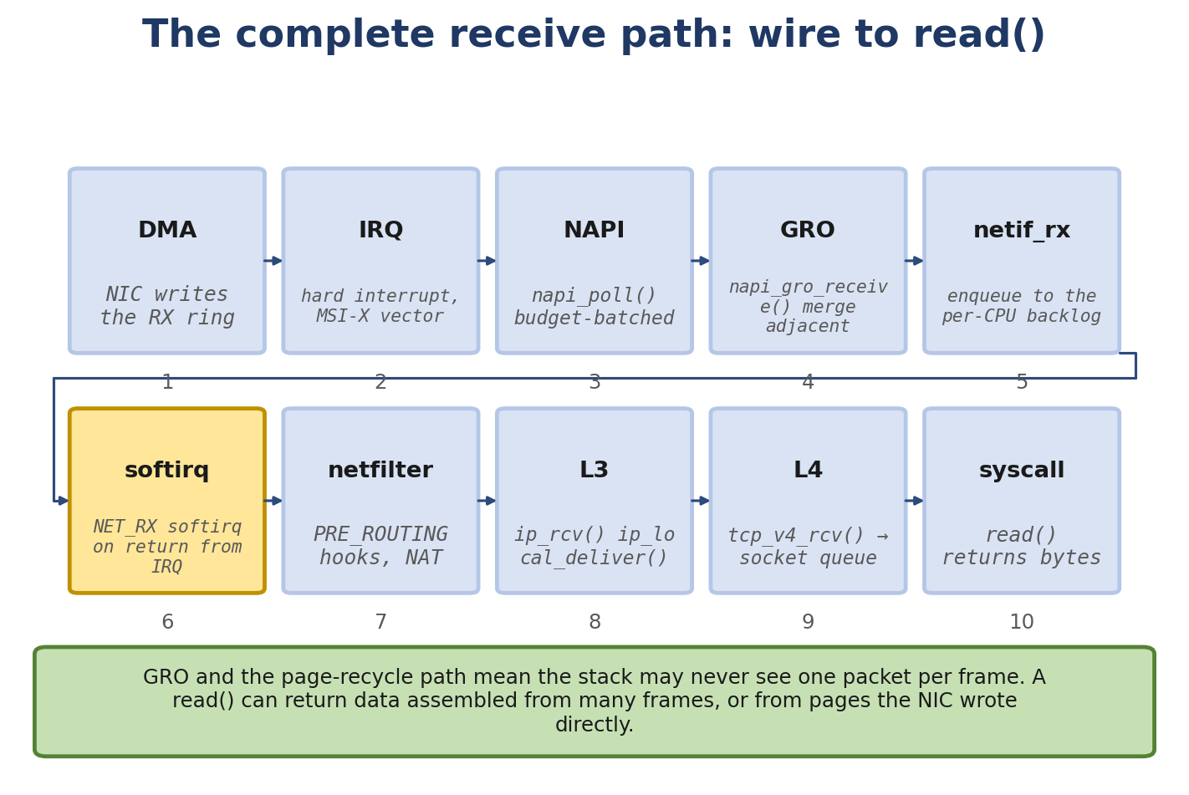
Figure 7.3. The complete receive path, from DMA in the NIC to the read() that returns it.
- RX and TX rings, DMA descriptors, and how the NIC uses them
- Offloads: GRO, GSO, TSO, checksum, VLAN, RSS
- How to trace the path with ftrace and bpftrace

Real-Life Analogy - Outbound and Inbound Logistics
Reality check — where the analogy breaks. The analogy above is a pedagogical tool for building a mental model. It is not a precise description of the kernel mechanism. The real implementation differs from the analogy in ways your interviews and lab work will surface; always reason from the kernel source when precision matters.
Outbound. You write a letter and hand it to the post office. The clerk (socket) takes it. They put it in a sorting bin (TCP segment). The sorter adds an address label (IP header). A customs officer checks it (Netfilter). It lands on a queue (qdisc). A worker carries it to the truck (driver), which drives it onto the loading dock (DMA ring). The dock has slots for trucks waiting to depart (TX ring). The dock manager (NIC) sends each truck out when the dock is clear.
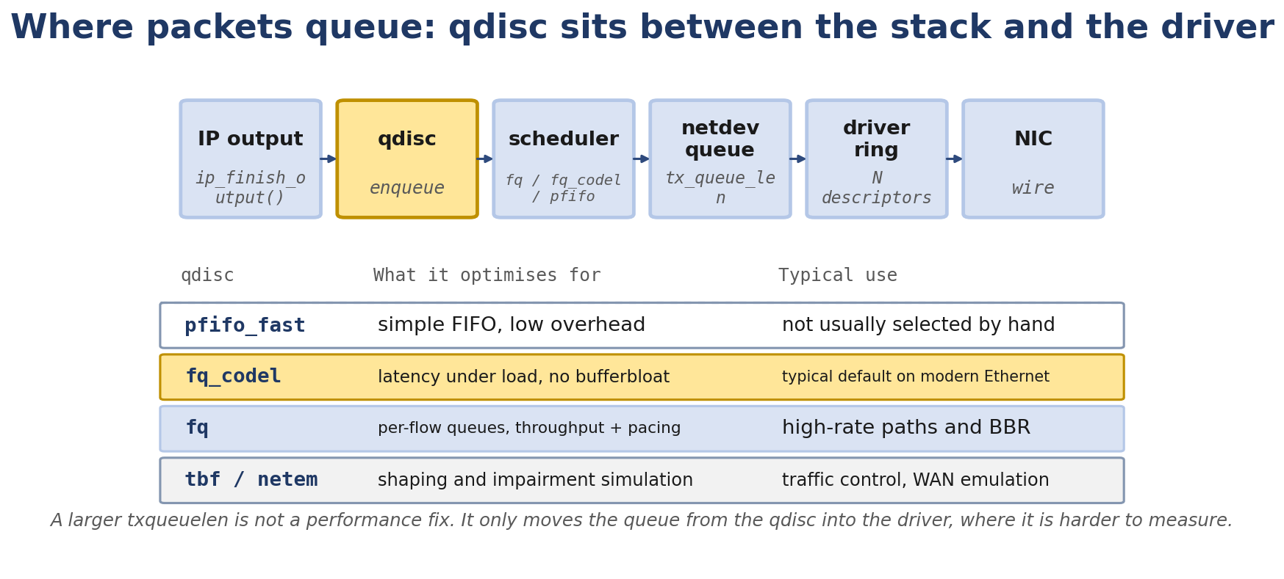
Figure 7.4. Where packets queue between the stack and the driver, and what each qdisc optimises for.
Inbound. A truck arrives at the loading dock (NIC). The dock manager signals the receiving worker (interrupt). The worker pulls the truck in and unloads packages (DMA, RX ring). They carry each package to a receiving counter (skb, NAPI), where a scanner reads the address (GRO). Customs inspects it (Netfilter). The sorter routes it (IP). The clerk delivers it (TCP) to the recipient (application).

The Networking Concept

The TX path (full, with kernel functions)
Application: send(fd, buf, len, 0)
|
v
libc: send -> sendto -> sendmsg
|
v
SYSCALL: __sys_sendmsg
|
v
sock_sendmsg
|
v
inet_sendmsg (AF_INET)
|
v
Protocol layer:
TCP: tcp_sendmsg
UDP: udp_sendmsg
|
v
TCP builds segment in skb:
- allocate skb with appropriate headroom
- copy user data via skb_put
- compute TCP checksum (or offload)
- call ip_queue_xmit
|
v
ip_queue_xmit
|
v
__ip_queue_xmit (cached route lookup)
|
v
ip_finish_output2
|
v
Netfilter: NF_INET_LOCAL_OUT, NF_INET_POST_ROUTING
|
v
__dev_queue_xmit
|
v
qdisc_enqueue (e.g. fq, fq_codel, pfifo_fast)
|
v
dev_hard_start_xmit
|
v
Driver: ndo_start_xmit
|
v
Driver: DMA-map the skb, write TX descriptors
|
v
Driver: write doorbell (memory-mapped register)
|
v
NIC: reads descriptors, fetches data via DMA, transmits bits
|
v
Wire

The RX path (full, with kernel functions)
Wire
|
v
NIC: receives bits, writes RX descriptor with packet info
|
v
NIC: raises MSI-X interrupt
|
v
Driver ISR: napi_schedule(&napi)
|
v
NET_RX softirq raised
|
v
net_rx_action (softirq handler)
|
v
Driver napi_poll(napi, budget):
- process up to `weight` RX descriptors
- for each, allocate skb, copy data into skb
- call napi_gro_receive (for GRO aggregation)
|
v
napi_gro_receive -> netif_receive_skb
|
v
__netif_receive_skb_core:
- deliver to taps (packet sockets, AF_PACKET, etc.)
- check for XDP (already handled before this)
- protocol demux: eth_type_trans -> ip_rcv
|
v
Netfilter: NF_INET_PRE_ROUTING, NF_INET_LOCAL_IN
|
v
ip_rcv -> ip_local_deliver
|
v
Protocol layer:
TCP: tcp_v4_rcv -> tcp_v4_do_rcv
UDP: udp_rcv -> __udp4_lib_rcv
|
v
sock_queue_rcv_skb (push into sk_receive_queue)
|
v
sk_data_ready -> wake waiters (epoll, blocked recv, etc.)
|
v
Application: recv() returns
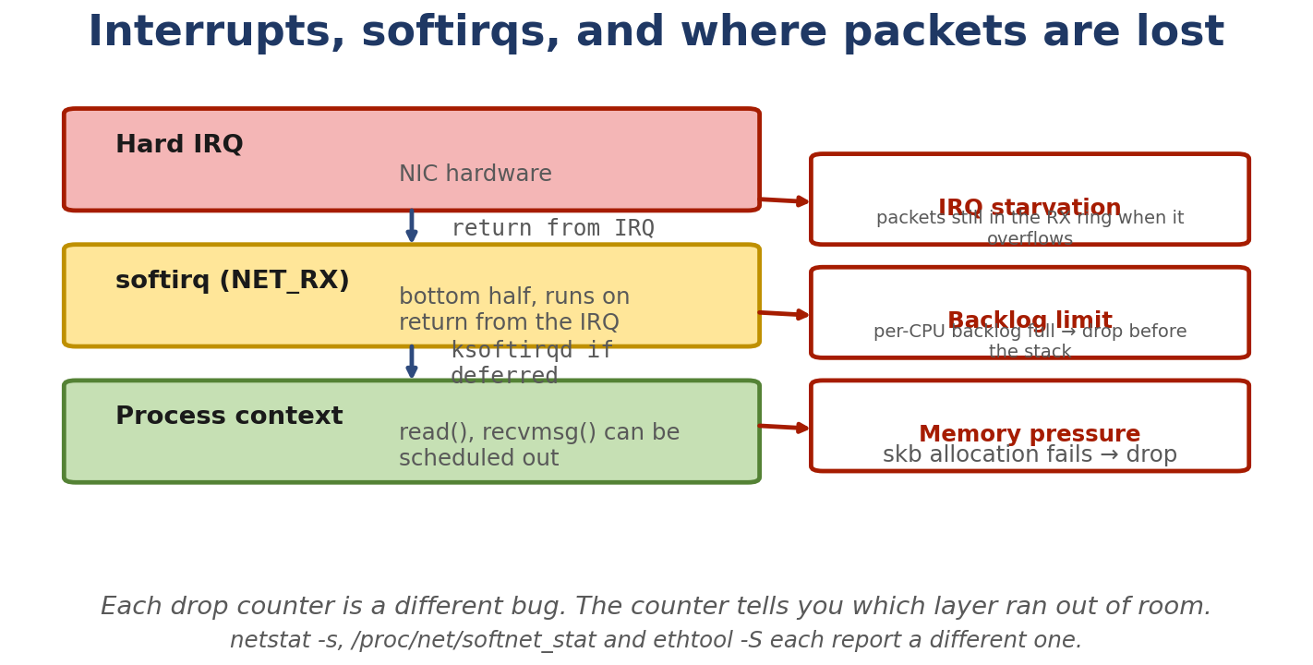
Figure 7.5. Interrupts, softirqs, and the three different counters that report where a packet was dropped.

Interrupts: legacy IRQ, MSI, MSI-X
Three ways the NIC can signal “I have a packet”:
Legacy interrupts use a shared hardware line. MSI uses one or more messages. MSI-X supports many independently routed vectors, so a driver can often give each queue its own vector. The number of vectors and queues depends on the device and driver.
/proc/interrupts shows the mapping:
$ cat /proc/interrupts
CPU0 CPU1 CPU2 CPU3
24: 1234567 0 0 0 IR-PCI-MSI 524288-edge eth0-TxRx-0
25: 0 123456 0 0 IR-PCI-MSI 524289-edge eth0-TxRx-1
26: 0 0 123456 0 IR-PCI-MSI 524290-edge eth0-TxRx-2
27: 0 0 0 123456 IR-PCI-MSI 524291-edge eth0-TxRx-3
Here eth0 has 4 queues, each with its own IRQ, each pinned to a different CPU.

NAPI
NAPI — Linux's polled RX framework — is the modern RX model:
- Driver allocates a napi_struct for each RX queue.
- On IRQ, driver’s ISR calls napi_schedule(&napi). This adds the napi to the per-CPU poll list and raises NET_RX_SOFTIRQ.
- The softirq handler net_rx_action runs in softirq context (atomic, not process context). Softirq handlers must NOT sleep. Code in this context uses GFP_ATOMIC allocations (which do not block), spinlocks, and other primitives that work without sleeping. Anything that might block (e.g. GFP_KERNEL allocation, mutex acquisition, schedule()) must be deferred to process context - typically via a workqueue or ksoftirqd.
- For each NAPI on the list, invoke napi->poll (the driver's callback pointer) up to budget times. The driver's poll callback processes up to budget packets.
- The driver's napi->poll callback returns the amount of work actually done (work_done). If the budget is exhausted and more work remains, the NAPI stays on the list for another pass; otherwise napi_complete_done() removes it and re-enables the IRQ.
The benefit: instead of one IRQ per packet (overhead), the NIC triggers one IRQ for a burst, and the kernel drains the burst in softirq (faster, no IRQ overhead per packet).
The trade-off: latency. If you set weight too low, you process too few packets per softirq. If too high, you starve other tasks. Typical values: 64.
/proc/net/softnet_stat shows per-CPU NAPI stats:
$ cat /proc/net/softnet_stat
01adbe44 00000000 00000000 00000000 00000000 00000000 00000000 00000000 00000000 00000000 00000000
00000000 ...
Columns: total packets, dropped (per-CPU queue full), squeezing (budget exhausted), etc.

RX and TX rings
A ring is a circular buffer of descriptors. Each descriptor describes one packet’s location in memory.
RX ring:
[desc 0] -> DMA address of buffer, length
[desc 1] -> DMA address of buffer, length
[desc 2] -> DMA address of buffer, length
...
[desc N-1]
^ ^
| |
next_to_use next_to_clean
(driver fills) (NIC writes here)
- Driver allocates a buffer for each descriptor (typically 2 KiB page or 4 KiB page).
- Driver writes the buffer’s DMA address into the descriptor.
- Driver sets next_to_use to the next descriptor to allocate.
- NIC receives a packet, writes it into the buffer at next_to_use, updates the descriptor (length, status flags), advances its own next_to_use.
- Driver’s poll function reads descriptors from next_to_clean to next_to_use, processes each packet, then refills the descriptor with a new buffer.
TX ring:
[desc 0] -> DMA address of buffer, length, flags
[desc 1] -> DMA address of buffer, length, flags
...
^ ^
| |
next_to_clean next_to_use
(NIC frees) (driver fills)
- The driver constructs an sk_buff for the frame. For DMA-capable NICs the typical path is page-recycle / page-pool reuse (or build_skb()): the NIC DMA-buffers the frame and the driver attaches the page buffer to a fresh sk_buff without copying the bytes; on simpler NICs the driver does memmove() into a freshly-allocated sk_buff. Both paths produce the same sk_buff abstraction.
- Driver writes the DMA address and flags into the descriptor.
- Driver sets next_to_use and writes the doorbell.
- NIC reads descriptors from next_to_use, transmits the packet.
- After transmission, NIC writes a completion status, advances its next_to_use.
- Driver’s TX completion (often a separate IRQ or polled in the same NAPI context) frees the buffer at next_to_clean and advances.

DMA
The NIC uses DMA (Direct Memory Access) to read/write packet buffers directly in host memory. This is what makes high-throughput NICs possible - the CPU doesn’t copy packets to/from the NIC.
For DMA, modern Linux NIC drivers rely on a few key properties:
Mapped via the kernel DMA API. A single DMA mapping does not necessarily require physically contiguous memory. NICs use scatter/gather DMA: each descriptor in the RX/TX ring points to a separate DMA-mapped segment (page, page fragment, or page-pool buffer). The kernel builds linear sk_buffs by concatenating these fragments at allocation time. The DMA API (dma_map_single, dma_map_page, dma_map_sg) handles IOMMU translation, cache coherency, and architecture-specific alignment requirements for you.
Cache-coherent with the device. Modern systems provide cache-coherent DMA; older or specific architectures require explicit flushing via dma_sync_* calls.
Aligned to the device’s requirements. There is no generic “64-byte minimum” rule. The DMA API enforces the alignment required by the underlying architecture and device.
The driver calls dma_map_single (or dma_map_page for fragments) to set up the mapping. After DMA is done, the driver calls dma_unmap_single.

Offloads

GRO - Generic Receive Offloading
GRO combines multiple incoming packets into one large skb. The kernel then processes one skb up the stack instead of N small ones. Saves CPU.
Example: if 10 small TCP segments arrive back-to-back, GRO can coalesce them into one skb with the combined payload. The TCP layer sees one segment with the correct seq/ack.
GRO is enabled by default. Check:
$ ethtool -k eth0 | grep generic-receive-offload
generic-receive-offload: on

GSO - Generic Segmentation Offload
GSO (Generic Segmentation Offload) lets Linux carry a large skb through much of the stack and split it into smaller packets in software near the device. TSO (TCP Segmentation Offload) lets a capable NIC split TCP data in hardware. If TSO is not available or is turned off, Linux can use GSO in software. GSO itself does not mean that the NIC does the work.
This saves CPU for large sends.

TSO - TCP Segmentation Offload
TSO is the TCP-specific form of GSO. With TSO enabled, the kernel builds one large TCP segment and the NIC’s hardware does the segmentation.
ethtool -k eth0:
tcp-segmentation-offload: on
udp-fragmentation-offload: off # usually off
generic-segmentation-offload: on

UFO - UDP Fragmentation Offload (Modern Linux uses USO — UDP Segmentation Offload; UFO is deprecated/legacy on current kernels.)
Like TSO but for UDP. Rare in practice (mainly used for VXLAN/GENEVE offloads).

LRO - Large Receive Offload
LRO was an older driver-side aggregation mechanism. It’s been largely replaced by GRO (kernel-side). Avoid using LRO when GRO is available - they can interact badly.

Checksum offload
The NIC can compute IPv4 header checksums and TCP/UDP checksums on TX (and verify on RX). Saves CPU.
$ ethtool -k eth0
tx-checksumming: on
rx-checksumming: on
tcp-checksumming: on
udp-checksumming: on

VLAN offload
The NIC can insert/remove 802.1Q tags. Useful for VLAN-aware applications.
$ ethtool -k eth0
tx-vlan-offload: on
rx-vlan-offload: on

RSS - Receive Side Scaling
RSS (Receive Side Scaling) is hardware-side distribution: the NIC hashes each packet’s network/transport header (typically a 4-tuple hash using Toeplitz or similar) and uses an indirection table to choose one of several RX queues. IRQ affinity then determines which CPUs service those queues - this is configured in the kernel via /proc/irq/*/smp_affinity, not by RSS itself. RSS is therefore the hardware mechanism for distributing flows across queues; which CPU processes a queue is a separate configuration step. RPS, RFS, and XPS are software mechanisms that work alongside (or in place of) RSS.
$ ethtool -x eth0
RX flow hash indirection table for ...

RPS, RFS, Accelerated RFS - software receive-side steering
[Linux 6.6] When the NIC has only one RX queue (so RSS cannot help) or when you want finer-grained control, the kernel provides software-side alternatives:
RPS (Receive Packet Steering) is a software implementation of RSS. After the IRQ has run on the CPU servicing the queue, RPS computes the same kind of 4-tuple hash and enqueues the packet onto the backlog of the target CPU, then IPI-wakes that CPU. This lets you spread softirq work across CPUs even on a single-queue NIC. Configuration: /sys/class/net/<dev>/queues/rx-<n>/rps_cpus is a CPU mask per RX queue.
RFS (Receive Flow Steering) attempts to steer receive processing toward the CPU where the application thread consuming the flow is running. The motivation is data-cache locality: socket data structures, kernel sk_buff metadata, and application buffers are hot on that CPU, so processing the packet there avoids cross-CPU cache-line bouncing. RFS is implemented as an additional layer on top of the RPS mechanism: it uses the same hash-to-CPU lookup but adds a flow-to-CPU table that records the most recent consumer CPU for each flow. Configuration: /proc/sys/net/core/rps_sock_flow_entries (global flow table size) and /sys/class/net/<dev>/queues/rx-<n>/rps_flow_cnt (per-queue entries).
Accelerated RFS is the hardware-accelerated version of RFS: drivers that implement ndo_rx_flow_steer can let the NIC do the same steering using hardware filters, so the steering happens before the IRQ instead of after.
The four mechanisms complement each other: - RSS: hardware queue selection. - RPS: software CPU steering after RSS (or replacing it). - RFS: software application-CPU steering on top of RPS. - Accelerated RFS: hardware-accelerated RFS.

XPS - Transmit Packet Steering
XPS is the TX counterpart: a configurable CPU-to-TX-queue mapping that lets you ensure the TX completion for a packet runs on a CPU close to where the packet was generated. See the description in the TX path above.

Follow the Packet - Tracing a Single TCP Send
Use perf trace or trace-cmd to follow a single packet through the kernel:
$ sudo trace-cmd record -e 'net:net_dev_xmit' -e 'net:netif_receive_skb' -e 'napi:napi_poll' -e 'sock:inet_sock_set_state' -e 'tcp:tcp_sendmsg' -e 'tcp:tcp_v4_connect'
Then send a packet:
nc 192.168.1.5 8080 < /etc/hostname
Stop the trace and view:
$ trace-cmd report | less
You’ll see a timeline of function calls. Match the order to the path above.

Linux View

Inspect RX ring
$ ethtool -g eth0
Ring parameters for eth0:
Pre-set maximums:
RX: 4096
RX Mini: 0
RX Jumbo: 0
TX: 4096
Current hardware settings:
RX: 512
TX: 512

Per-queue stats
$ ethtool -S eth0 | grep -E 'rx_|tx_|drop'
rx_packets: 12345
tx_packets: 23456
rx_bytes: 12345678
tx_bytes: 23456789
rx_dropped: 0
tx_dropped: 0
rx_missed: 0 # this is the one to watch
rx_missed is the count of packets the NIC received but the driver didn’t process in time (ring full).

qdisc stats
$ tc -s qdisc show dev eth0
qdisc fq_codel 0: root refcnt 2 limit 10240p flows 1024 quantum 1514 target 5ms interval 100ms memory_limit 32Mb ecn
Sent 1234567 bytes 1234 pkt (dropped 0, overlimits 0 requeues 0)
backlog 0b 0p requeues 0

dropwatch
$ sudo dropwatch -l kas
This monitors kfree_skb with reasons and prints which kernel functions are causing drops.

Kernel View
Key files for this chapter:
net/core/dev.c - the device layer. net/core/dev.c contains major common networking-device infrastructure and important TX/RX paths, but NOT all packet flow traverses it. Notable exceptions: AF_PACKET / packet sockets (read raw frames directly), AF_XDP (XDP fast-path), TC ingress/egress (where BPF programs run independently of the device layer for some traffic), tunnel devices (often have their own fast paths), bridge fast paths, loopback, certain netfilter hook chains, and namespace transitions. Use this file as the main reference for the device layer’s role, not as a claim of universality. include/linux/netdevice.h - net_device, napi_struct, netdev_ops. drivers/net/ethernet/intel/e1000e/ - example driver. drivers/net/virtio_net.c - virtio-net driver (VMs). include/linux/skbuff.h - sk_buff (Chapter 6).
Key functions in dev.c:
__dev_queue_xmit - TX path entry from qdisc. dev_hard_start_xmit - call into driver. netif_receive_skb - RX entry from driver. __netif_receive_skb_core - protocol demux. napi_schedule - schedule NAPI from ISR. net_rx_action - softirq handler. napi_complete_done - exit polling.

Source Code Walkthrough

Excerpt 1: tcp_sendmsg (net/ipv4/tcp.c, abbreviated)
int tcp_sendmsg(struct sock *sk, struct msghdr *msg, size_t size)
{
struct tcp_sock *tp = tcp_sk(sk);
struct sk_buff *skb;
...
/* Loop: for each chunk of user data */
while (msg_data_left(msg)) {
/* Allocate an skb if we don't have one */
skb = sk_stream_alloc_skb(sk, ..., sk->sk_allocation);
...
/* Copy data into the skb */
skb_add_data_nocache(skb, &msg->msg_iter, copy);
...
/* Queue and send */
tcp_push(sk, flags, mss_now, tp->nonagle, size_goal);
...
}
...
}
tcp_push builds the TCP header, computes the checksum (or marks for offload), and calls tcp_transmit_skb which calls __tcp_transmit_skb to do the actual send.

Excerpt 2: ip_queue_xmit (net/ipv4/ip_output.c, abbreviated)
int ip_queue_xmit(struct sock *sk, struct sk_buff *skb, struct flowi4 *fl4)
{
struct inet_sock *inet = inet_sk(sk);
struct net *net = sock_net(sk);
struct ip_options_rcu *inet_opt;
/* Push IP header */
skb_push(skb, sizeof(struct iphdr));
skb_reset_network_header(skb);
iph = ip_hdr(skb);
iph->version = 4;
iph->ihl = 5;
...
/* Send */
return __ip_queue_xmit(sk, skb, fl4);
}
The function pushes the IP header, fills in the basic fields, and calls __ip_queue_xmit which looks up the route (or uses the cached one) and sends to the device.

Excerpt 3: __dev_queue_xmit (net/core/dev.c, abbreviated)
int __dev_queue_xmit(struct sk_buff *skb, struct net_device *dev)
{
...
if (!netif_running(dev)) {
kfree_skb_ reason(skb, SKB_DROP_REASON_DEV_NOT_READY);
return -ENETDOWN;
}
...
qdisc = dev->qdisc;
if (qdisc) {
rc = qdisc->enqueue(skb, qdisc, &ret);
if (rc == NET_XMIT_SUCCESS)
...
} else {
...
}
...
}
The skb goes to the qdisc’s enqueue. If the qdisc accepts it, the qdisc’s dequeue is called later (by __qdisc_run) to actually send.

Excerpt 4: netif_receive_skb_core (net/core/dev.c, abbreviated)
static int __netif_receive_skb_core(struct sk_buff *skb, bool pfmemalloc)
{
...
/* Deliver to taps (packet sockets) */
list_for_each_entry_rcu(ptype, &ptype_all, list) {
if (!ptype->dev || ptype->dev == skb->dev)
deliver_skb(skb, ptype, skb->dev);
}
...
/* Protocol demux */
type = skb->protocol;
ptype = __rcu_dereference(inet_ptype_base[type]);
if (ptype)
ptype->func(skb, skb->dev, ptype, skb->data);
...
}
For IPv4, inet_ptype_base[ETH_P_IP] is ip_packet_type and its func is ip_rcv. So packets are dispatched to ip_rcv here.

Excerpt 5: napi_poll (driver callback contract)
A driver’s napi_poll looks like:
static int e1000_clean(struct napi_struct *napi, int budget)
{
struct e1000_adapter *adapter = container_of(napi, struct e1000_adapter, napi);
int work_done = 0;
/* Clean TX ring (return completed TX buffers) */
e1000_clean_tx_ring(adapter);
/* Clean RX ring */
work_done = e1000_clean_rx_ring(adapter, budget);
if (work_done < budget) {
napi_complete_done(napi, work_done);
e1000_irq_enable(adapter);
}
return work_done;
}
The driver processes TX completions (freeing the buffers), then RX packets up to budget. If it didn’t use the full budget (i.e. ring is now empty), exit polling and re-enable interrupts.

Hands-On Lab - Trace the TX/RX Path

Goal
You’ll capture the kernel’s packet flow using ftrace and bpftrace, and correlate it with what tcpdump shows on the wire.

Setup
A single Linux VM with two namespaces connected by a veth pair:
sudo ip netns add ns-a
sudo ip netns add ns-b
sudo ip link add veth-a type veth peer name veth-b
sudo ip link set veth-a netns ns-a
sudo ip link set veth-b netns ns-b
sudo ip netns exec ns-a ip addr add 192.168.100.1/24 dev veth-a
sudo ip netns exec ns-a ip link set veth-a up
sudo ip netns exec ns-b ip addr add 192.168.100.2/24 dev veth-b
sudo ip netns exec ns-b ip link set veth-b up

Commands
Lab 1 - measure dev_queue_xmit latency:
$ sudo bpftrace -e '
kprobe:dev_queue_xmit {
@start[tid] = nsecs;
}
kretprobe:dev_queue_xmit /@start[tid]/ {
@ns = hist(nsecs - @start[tid]);
delete(@start[tid]);
}
'
In another terminal, generate traffic:
sudo ip netns exec ns-a ping -c 100 192.168.100.2
Stop bpftrace with Ctrl-C. You’ll see a latency histogram. For a veth pair, expect ~5-50 microseconds.
Lab 2 - correlate drops across multiple sources:
$ sudo bpftrace -e '
kprobe:dev_queue_xmit { @dev[str(arg0->dev->name)] = count(); }
kprobe:netif_receive_skb { @rx[str(arg0->dev->name)] = count(); }
kprobe:kfree_skb_reason { @drop[arg1] = count(); } # reason
'
Generate some traffic with tc netem:
sudo tc qdisc add dev veth-a root netem loss 30%
Watch the drop counter for veth-a increase.
Lab 3 - full ftrace trace:
$ sudo trace-cmd record -e 'net:net_dev_xmit' -e 'net:netif_receive_skb' -e 'napi:napi_poll' -e 'irq:irq_handler_exit' -e 'tcp:tcp_sendmsg' -e 'tcp:tcp_v4_rcv' -e 'sock:inet_sock_set_state'
$ sudo ip netns exec ns-a nc -l -p 8080 &
$ sudo ip netns exec ns-b nc 192.168.100.1 8080 < /etc/hostname
$ sleep 1
Stop trace-cmd with Ctrl-C. View the output:
$ trace-cmd report
You’ll see the full sequence: tcp_v4_connect, tcp_sendmsg, ip_queue_xmit, dev_xmit, netif_receive_skb, tcp_v4_rcv.

Expected output (bpftrace)
@ns:
[0] 0 |@@@@@@@@@@@@@@@@@@@@|
[1] 1 |@@@@ |
[2,4) 3 |@@@@@@@@ |
[4,8) 8 |@@@@@@@@@@@@@@@@@@@@|
[8,16) 2 | |
[16,32) 1 | |
A histogram showing dev_queue_xmit typically takes 1-10 microseconds.

Experiment
- Change veth MTU: sudo ip netns exec ns-a ip link set veth-a mtu 9000. Latency may shift.
- Disable GRO: sudo ip netns exec ns-a ethtool -K veth-a gro off. Watch histograms change.
- Disable TSO: same idea with tso off.

Break It
Force a backlog of packets:
$ sudo ip netns exec ns-a tc qdisc add dev veth-a root netem delay 100ms
$ sudo ip netns exec ns-a ping -c 10 -s 65507 192.168.100.2
The qdisc fills. Watch tc -s qdisc show dev veth-a for backlog growing.

Debug It
Use the methodology from Chapter 10:
- Did the app generate traffic? (tcpdump shows packets).
- Did the kernel transmit? (bpftrace shows dev_queue_xmit).
- Did the NIC transmit? (ethtool -S shows tx_packets).
- Did the peer receive? (tcpdump in ns-b).

Challenge
Build a bpftrace script that measures end-to-end latency for a single packet: from tcp_sendmsg to tcp_v4_rcv of the reply. Hint: store the seq number on send, match on recv by extracting the seq from the TCP header.

Solution sketch
sudo bpftrace -e '
kprobe:tcp_sendmsg {
$sk = (struct sock *)arg0;
@start[$sk] = nsecs;
}
kretprobe:tcp_v4_rcv {
$sk = (struct sock *)arg0;
if (@start[$sk]) {
@latency = hist(nsecs - @start[$sk]);
delete(@start[$sk]);
}
}
'
Note: this measures time between when sendmsg returned and when the reply was received. Real numbers depend on network conditions.

Interview Questions
Q7.1 (Beginner) - What’s the difference between an interrupt and NAPI polling?
Legacy interrupt-driven RX: one IRQ per packet. Modern NAPI: one IRQ per burst, then poll up to weight packets in softirq. NAPI reduces IRQ overhead and improves batching.
Q7.2 (Beginner) - What is an RX ring?
A circular buffer of descriptors allocated by the driver. Each descriptor points to a DMA-mapped buffer where the NIC writes received packets. The driver refills descriptors as it consumes them.
Q7.3 (Beginner) - What is DMA?
Direct Memory Access. The NIC reads/writes host memory directly without involving the CPU. Speeds up packet movement dramatically.
Q7.4 (Intermediate) - Why does the kernel reserve headroom in sk_buffs?
To allow skb_push to add a header without reallocating. For TX, when TCP builds a segment, it leaves headroom for the IP header (20 bytes) and Ethernet header (14 bytes). Without headroom, every push would need to copy the data into a larger buffer.
Q7.5 (Intermediate) - What is the difference between MSI and MSI-X?
MSI: one interrupt per device. MSI-X: multiple interrupts per device, each targeting a specific CPU. Modern NICs use MSI-X to give each RX queue its own IRQ pinned to a different CPU.
Q7.6 (Intermediate) - Explain the NAPI state machine.
The driver schedules NAPI from its interrupt handler. The kernel later calls the driver poll function with a work budget. The driver processes up to that many RX packets. If work remains, it returns the budget so polling continues. When the queue is drained, the driver calls napi_complete_done() and handles interrupts as required by the device. The poll function can also receive a zero budget for TX completions only. In that call, it must not process RX packets or call napi_complete_done().
Q7.7 (Intermediate) - What is GRO?
Generic Receive Offload. The kernel combines multiple incoming TCP segments into one large skb before passing it up the stack. Saves CPU when many small packets arrive back-to-back.
Q7.8 (Intermediate) - What is the difference between TSO and GSO?
TSO (TCP Segmentation Offload) allows the kernel to hand a large TCP segment (larger than MSS) to the NIC and let the NIC perform segmentation into wire-sized packets. When TSO is unavailable or disabled (per-queue, per-device), segmentation can be done in software - by the kernel via GSO, or by the application itself. The CPU cost and throughput impact depend on workload (packet size distribution, send rate), hardware (NIC offload capability), CPU speed, and other active offloads (checksum, LSO). Modern drivers enable TSO by default; GSO is always available as a software fallback.
Q7.9 (Intermediate) - What is a TX completion?
After the NIC transmits a packet, it writes a completion descriptor in the TX ring. The driver reads completions (often in the same NAPI poll context, or in a dedicated TX IRQ) and frees the skb’s data buffer.
Q7.10 (Advanced) - How does the kernel decide which TX queue to use?
[Linux 6.6] netdev_pick_tx selects a TX queue based on a configurable set of rules. XPS (Transmit Packet Steering) is the CPU-to-TX-queue selection mechanism. It is configured via sysfs (/sys/class/net/<dev>/queues/tx-<n>/xps_cpus and xps_rxqs) and may map CPU to queue 1-to-1, 1-to-many, or many-to-1 - it is NOT automatically pinned CPU = queue. The other inputs to queue selection are: the socket’s bound queue (e.g. SO_BINDTODEVICE-style), and a hash of the 4-tuple for fairness across queues. The driver then DMA-maps the data and writes the descriptor.
RPS and RFS (software receive-side steering, configured via /sys/class/net/<dev>/queues/rx-<n>/rps_cpus and rps_flow_cnt) are described more fully in the next section.
Q7.11 (Advanced) - What happens when an RX ring is full?
If the driver doesn’t refill descriptors fast enough, the NIC has nowhere to write incoming packets. It increments a missed-packet counter (rx_missed in ethtool -S). The kernel sees no packets, the queue backs up, TCP eventually drops due to timeout.
Q7.12 (Advanced) - Why is it important to disable LRO if you want accurate TCP stats?
LRO aggregates multiple segments into one large skb before TCP processes them. So TCP only sees one large segment instead of many small ones. The retransmit counter won’t reflect individual segment losses if LRO is on. GRO has the same issue but is more conservative.
Q7.13 (Advanced) - What is the role of IOMMU in modern NICs?
IOMMU translates device DMA addresses to physical host addresses. Allows the NIC to DMA to arbitrary host memory without the driver managing the mapping manually. Critical for virtualized environments (where the “host” memory is actually guest physical addresses).
Q7.14 (Driver) - What does a driver’s ndo_select_queue return?
The index of the TX queue to use for this packet. Most drivers return a hash of the 4-tuple, possibly mod num_tx_queues. This spreads outgoing traffic across queues for parallelism.
Q7.15 (Driver) - What’s the difference between ndo_start_xmit returning NETDEV_TX_OK and NETDEV_TX_BUSY?
NETDEV_TX_OK means the driver accepted the skb and now owns it. NETDEV_TX_BUSY means the driver did not accept it; it must not free the skb or put it on the TX ring. A healthy driver stops the queue before the ring fills and wakes it after TX completions free space. Frequent NETDEV_TX_BUSY usually means the queue flow control needs fixing. Do not rely on routine retries.
Q7.16 (Driver) - How does the driver know when a TX has completed?
Two options: TX interrupt (the NIC raises an IRQ when TX is done), or polling (the driver checks the TX ring in its RX poll function). Modern drivers often use polling because TX interrupts are expensive.
Q7.17 (Kernel) - Walk through the call from tcp_sendmsg to dev_queue_xmit.
tcp_sendmsg → builds skb with user data → tcp_push → __tcp_transmit_skb → builds TCP header → tcp_transmit_skb → ip_queue_xmit (passes skb to IP layer) → __ip_queue_xmit (uses cached route or looks up) → ip_finish_output2 (writes IP header, calls Netfilter POSTROUTING) → neigh_output → dev_queue_xmit.
Q7.18 (Kernel) - Walk through the call from netif_receive_skb to tcp_recvmsg returning.
netif_receive_skb → __netif_receive_skb_core (protocol demux) → ip_rcv → ip_local_deliver → tcp_v4_rcv → tcp_v4_do_rcv → tcp_rcv_established (or state machine) → __skb_queue_tail (push into sk_receive_queue) → sk_data_ready → wake waiter → application task scheduled → recvmsg syscall returns.

Key Takeaways
The TX path: sendmsg → socket → transport → IP → Netfilter → qdisc → driver → DMA → NIC → wire. The RX path: wire → NIC → DMA → driver → NAPI → skb → GRO → IP → TCP/UDP → socket → user. NAPI replaces one-IRQ-per-packet with burst-polling. MSI-X gives each RX queue its own IRQ pinned to a CPU. RX/TX rings are circular descriptor buffers; DMA does the actual data movement. Offloads (GRO, GSO, TSO, checksum) save CPU by moving work to hardware or batching work.

Practice Challenges
- Measure round-trip latency. Use bpftrace to histogram dev_queue_xmit → netif_receive_skb latency across the veth pair.
- Exhaust an RX ring. Use a high-rate sender to overflow the receiver’s ring. Watch rx_missed climb.
- Tune TX queue count. ethtool -L eth0 combined 8. Re-run your test. Watch for different distribution.
- Disable TSO. ethtool -K eth0 tso off. Run iperf3. Watch CPU usage climb.
- Trace a real packet. Use perf trace -e 'net:net_dev_xmit,net:netif_receive_skb,tcp:tcp_sendmsg,tcp:tcp_v4_rcv' during a curl. See the full sequence.
- Read net/core/dev.c. Find __netif_receive_skb_core. Walk through protocol demux.
- Compare drivers. Read e1000_main.c and virtio_net.c. Compare how they register NAPI.

Chapter 8 - Linux Virtual Networking: Bridges, VLANs, veth and Namespaces

What You Will Learn
veth pairs: how they work and why they matter
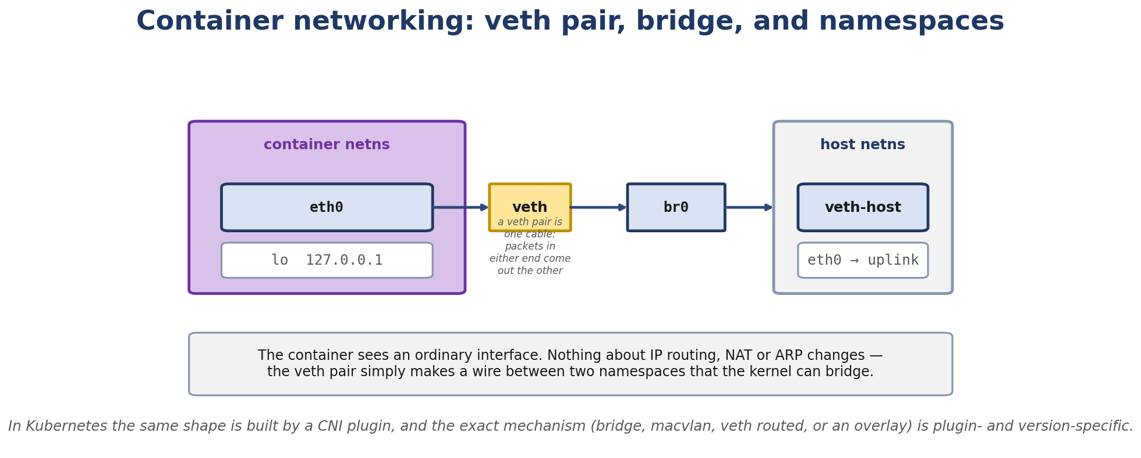
Figure 8.1. Container networking: a veth pair, a bridge, and two namespaces.
- Virtual network interfaces in Linux
- The Linux bridge (brctl-style commands with the new bridge utility)
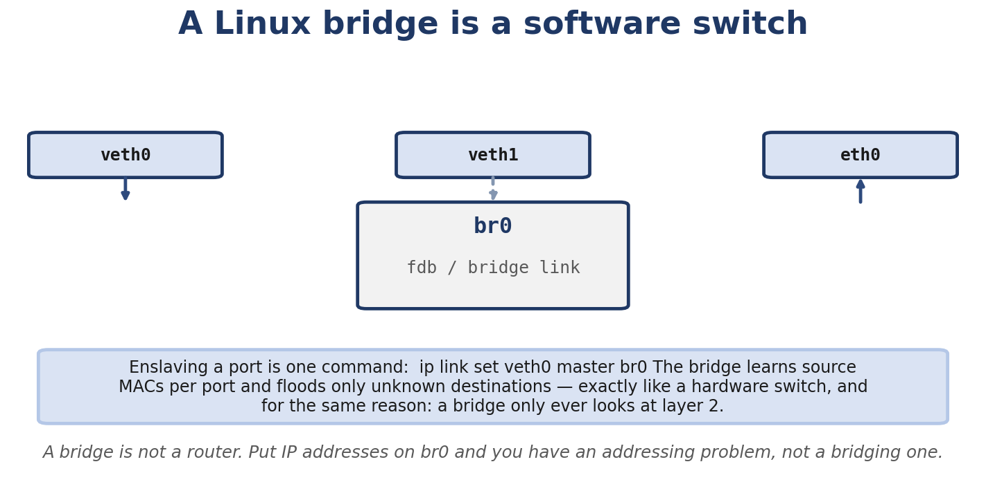
Figure 8.2. A Linux bridge is a software switch, and only ever looks at layer 2.
- VLAN subinterfaces and 802.1Q tagging
- TAP vs TUN
- Bonding (NIC teaming)
- VRF (Virtual Routing and Forwarding)
- Network namespaces
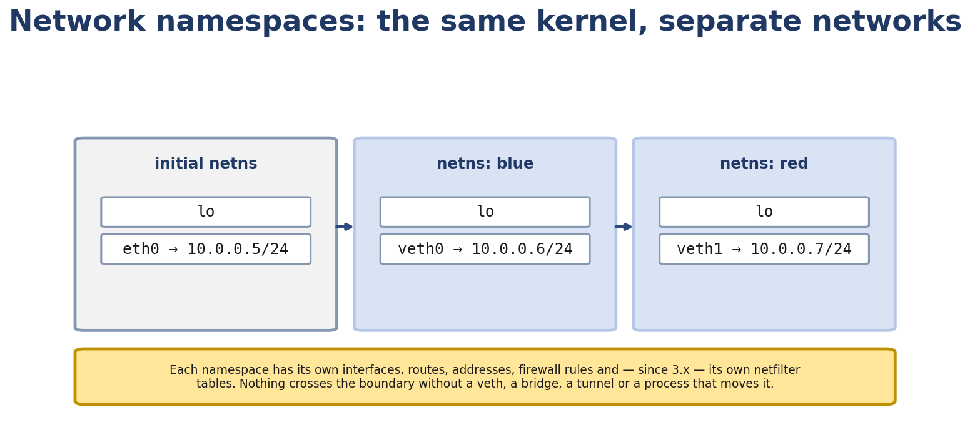
Figure 8.3. Network namespaces: the same kernel, with separate networks.
- How containers (Docker) and Kubernetes use these primitives

Real-Life Analogy - Buildings, Tunnels, and Switchboards
Reality check — where the analogy breaks. The analogy above is a pedagogical tool for building a mental model. It is not a precise description of the kernel mechanism. The real implementation differs from the analogy in ways your interviews and lab work will surface; always reason from the kernel source when precision matters.
Network namespaces are separate office buildings. Inside each building, the workers know only about their own internal network. To reach another building, you have to use the underground tunnel that connects them.
The tunnel connecting two buildings is a veth pair - a virtual cable that goes from one building’s wall to another. The two ends of the cable have different identities inside each building.
If you want to connect many buildings, you need a switchboard. The Linux bridge is a switchboard - it learns which “rooms” (MAC addresses) live in which building and forwards accordingly.
Sometimes a single physical cable carries traffic for multiple buildings (VLANs). The cable has color-coded tape on each segment; the bridge reads the color to know which building it’s for.
When buildings need multiple internet connections (for redundancy or bandwidth), they can bond them together - like combining multiple elevators into one logical elevator bank.

The Networking Concept

Virtual interfaces
Linux has many types of “interfaces” that aren’t physical NICs:
lo - loopback. Always there. veth - virtual ethernet. A pair of connected interfaces. bridge - a virtual switch. Multiple interfaces can be attached. vlan - a VLAN subinterface. Tagged traffic on a parent interface. bond - link aggregation. Multiple physical NICs combined. tun / tap - virtual point-to-point (TUN) or ethernet (TAP) device. vrf - separate routing table on a single interface. dummy - blackhole-ish interface for testing. ipvlan / macvlan - share a parent’s MAC or IP at different layer. wireguard - encrypted tunnel. vxlan - layer-2-over-UDP tunnel.
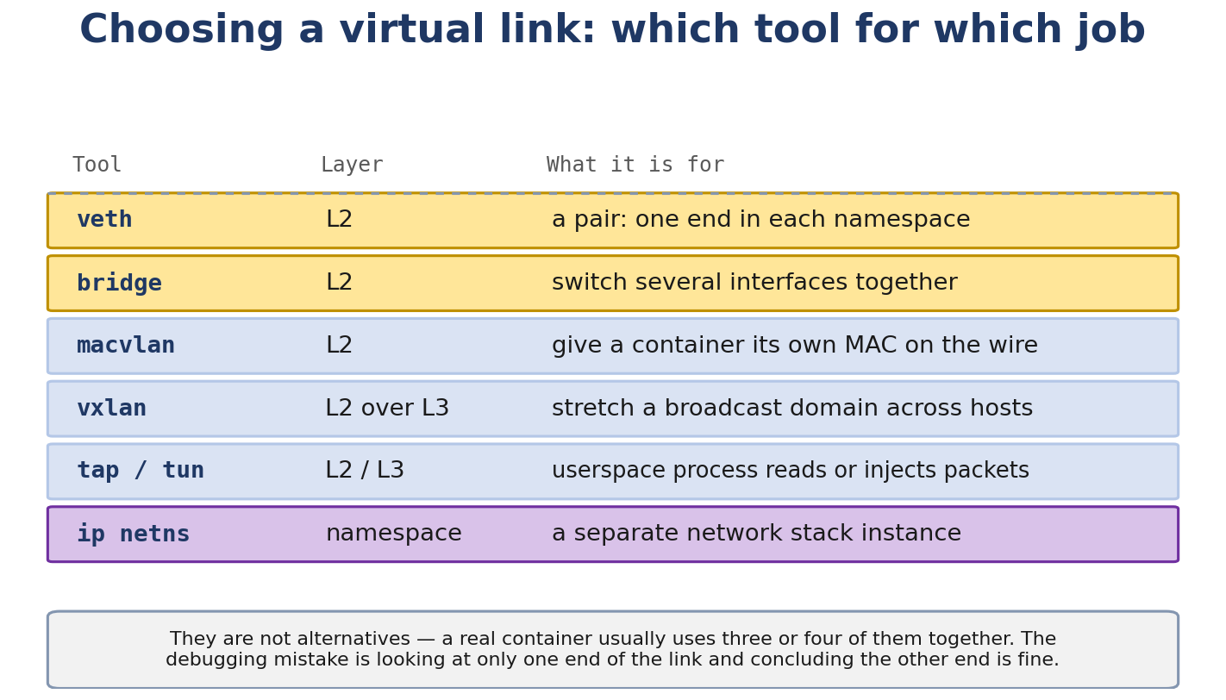
Figure 8.4. Choosing a virtual link: which tool answers which problem.

veth pairs
A veth pair is two virtual interfaces connected by a hidden bridge inside the kernel. Whatever goes into one end comes out the other. They’re typically used to connect two namespaces.
ip link add veth-a type veth peer name veth-b
Both ends have their own MAC, MTU, queue, and stats. The kernel moves packets between them with veth_xmit (essentially, the kernel re-injects the packet as if it came in on the peer end).
MTU is shared - setting MTU on one end changes both. (Setting it too low and traffic will silently drop due to too-long packets.)

Linux bridge
The Linux bridge is a software switch. You create one and attach interfaces:
ip link add br0 type bridge
ip link set eth0 master br0
Now eth0 is a “port” on the bridge. The bridge learns MAC addresses by watching incoming frames and builds a forwarding table (FDB). Frames between two bridge ports get forwarded through the bridge (not through IP routing).
bridge link show
bridge fdb show
bridge vlan show
The Linux bridge can also do:
STP (Spanning Tree Protocol) - prevents loops. brctl stp br0 on. VLAN-aware bridging - ports can be trunk or access for various VLANs. Filtering with ebtables - bridge-level firewall.
Modern kernels support per-port VLAN filtering and trunk/access modes. Configure with:
bridge vlan add dev eth0 vid 10 pvid untagged
bridge vlan add dev eth0 vid 20

VLAN subinterfaces
A VLAN subinterface tags outgoing traffic with an 802.1Q tag and removes the tag on incoming traffic.
ip link add link eth0 name eth0.10 type vlan id 10
Frames sent from eth0.10 will have a 4-byte VLAN tag inserted between the source MAC and EtherType. Frames arriving on eth0 with VLAN ID 10 are delivered to eth0.10.
The kernel does this in vlan_dev_hard_header (in net/8021q/vlan_dev.c):
return dev_hard_header(skb, vlan_dev_priv(dev)->real_dev,
ETH_P_8021Q, dst_addr, src_addr, len);
It calls the real device’s header_ops to build the outer Ethernet header, but uses ETH_P_8021Q (0x8100) as the EtherType. Then a 4-byte VLAN tag is inserted by vlan_insert_tag.
802.1Q tag layout:
+--------------------+---------+-----+
| TPID (0x8100) | PCP/DEI | VID |
+--------------------+---------+-----+
16 bits 4 bits 12 bits
VID is the VLAN ID (0-4095). PCP is priority (3 bits). DEI is drop eligibility.

TAP and TUN
TUN - virtual point-to-point device. Carries IP packets. Used by OpenVPN, WireGuard, etc. TAP - virtual ethernet device. Carries Ethernet frames. Used by QEMU, KVM, etc.
The kernel side of a TUN/TAP device is a struct net_device with TX/RX queues. The user-space side is a file descriptor; read() gets packets, write() sends packets.
ip tuntap add mode tun name tun0
ip addr add 10.0.0.1/24 dev tun0
ip link set tun0 up
A user-space process opens /dev/net/tun, gets an fd, and pumps packets.

Bonding
Bonding combines multiple physical NICs into one logical interface. Modes:
active-backup (mode 1) - one active, others standby. Failover only. balance-rr (mode 0) - round-robin. Outgoing packets alternate across slaves. No switch support needed. balance-xor (mode 2) - XOR hash. Needs switch support (EtherChannel). 802.3ad / LACP (mode 4) - Link Aggregation Control Protocol. Standard, switch support required. balance-tlb (mode 5) - transmit load balancing. No switch support. balance-alb (mode 6) - adaptive load balancing. Includes receive balancing via ARP.
ip link add bond0 type bond mode 802.3ad
ip link set eth0 master bond0
ip link set eth1 master bond0
ip link set bond0 up

VRF
VRF (Virtual Routing and Forwarding) lets one physical interface participate in multiple routing tables. It’s like having multiple “logical routers” sharing the same NIC.
ip link add vrf-red type vrf table 1001
ip link set eth0 master vrf-red
ip route add default via 192.168.1.1 dev eth0 table 1001
Now traffic that hits this VRF (e.g. from a socket with SO_BINDTODEVICE = vrf-red or via policy rule) uses table 1001. Other traffic uses the main table.
VRF is different from network namespaces: VRF isolates routing tables but shares the network interface and other kernel namespaces. Namespaces are more heavyweight.

Network namespaces
A network namespace is a full set of network state: interfaces, routes, firewall rules, sockets. Each namespace has its own struct net. Namespaces are isolated from each other - interfaces in ns-a are invisible from ns-b.
ip netns add ns-test
ip netns list
ip netns exec ns-test ip link show
Namespaces are referenced from struct sock (sk->sk_net), struct net_device (dev->nd_net), and struct sk_buff (skb->sk->sk_net or via dev). Each socket knows which namespace it belongs to. When the kernel processes a packet, it consults the namespace’s routing table, firewall, etc.
Switching namespace at runtime: a process can call unshare(CLONE_NEWNET) to create a new namespace for itself, or setns() to join an existing one.
unshare -n ip link show # shows only lo in the new namespace
Namespaces are the building block of container networking. Docker, Kubernetes, LXC all use them.

Docker networking
Docker has several network drivers:
bridge (default) — the container runtime creates a default bridge interface (commonly 'docker0' on legacy Docker; 'bridge' on newer default networks; or your CNI-provided bridge). The exact interface name and subnet are runtime- and CNI-specific. Each container gets a veth pair with one end in the container, the other attached to the bridge. NAT is used for external connectivity.
host - the container shares the host’s network namespace. No network isolation.
none - only lo. The container has no network.
overlay - multi-host networking using VXLAN tunnels between hosts.
macvlan - the container gets a separate MAC on the parent’s interface (no bridge, no NAT).

Kubernetes networking
Kubernetes imposes a flat networking model: every pod gets its own IP, and pods can communicate directly without NAT. Implementations:
CNI plugins (Container Network Interface) - bridge, ptp, calico, flannel, cilium. Each implements the model differently.
Pod-to-pod same-node: CNI creates a veth pair for each pod, attaches one end to a bridge (or similar), the other end is inside the pod’s netns.
Pod-to-pod cross-node: encapsulated in VXLAN (Flannel) or routed (Calico).
Services (ClusterIP): virtual IPs implemented with iptables/IPVS in kube-proxy. Connections to 10.96.0.1:80 are DNAT’d to a backing pod.
kube-proxy modes (Kubernetes-default behavior changed across versions — verify on your cluster): iptables (default through several releases), IPVS (an opt-in alternative, faster at scale), userspace (deprecated).
The pod’s “primary” interface is actually a veth pair where the pod end is inside the container’s netns and the host end is in the host’s netns (often named like cali... or cni...).

Follow the Packet - Container to Internet
A Docker container with IP 172.17.0.2 pings 8.8.8.8:
- Container’s eth0 is a veth. ICMP echo goes out, kernel forwards via veth to peer.
- Peer end is on docker0 bridge. Bridge has no specific destination, so it floods (or doesn’t forward because ICMP isn’t MAC-known).
- Wait - actually, ICMP goes to a destination IP that’s not on docker0’s subnet. So the bridge doesn’t forward; the packet is delivered to the host’s IP stack.
- The host receives the packet on its docker0 interface (the veth peer). It processes it locally - but actually, since 172.17.0.2 is not the host’s IP, and the destination is 8.8.8.8, the kernel routes the packet out the default interface (eth0).
- The MASQUERADE rule rewrites the source IP from 172.17.0.2 to the host’s external IP.
- Out eth0, to the gateway, to 8.8.8.8.
The reply comes back reversed: 8.8.8.8 → host's IP → un-MASQUERADE → 172.17.0.2 → docker0 → veth → container eth0.

Linux View

Create namespaces
sudo ip netns add red
sudo ip netns add blue

Create a veth pair
sudo ip link add veth-red type veth peer name veth-blue
sudo ip link set veth-red netns red
sudo ip link set veth-blue netns blue
sudo ip netns exec red ip addr add 10.0.0.1/24 dev veth-red
sudo ip netns exec red ip link set veth-red up
sudo ip netns exec blue ip addr add 10.0.0.2/24 dev veth-blue
sudo ip netns exec blue ip link set veth-blue up
sudo ip netns exec red ping 10.0.0.2

Create a bridge
sudo ip link add br0 type bridge
sudo ip link set veth-red master br0 # wait, can't, it's in a netns
Better: create the bridge in a namespace too, or use the host’s main namespace.
sudo ip link add br0 type bridge
sudo ip link set eth0 master br0 # add a physical interface as a port
ip link set br0 up

VLAN
sudo ip link add link eth0 name eth0.10 type vlan id 10
sudo ip addr add 192.168.10.1/24 dev eth0.10
sudo ip link set eth0.10 up

Bond
sudo ip link add bond0 type bond mode active-backup
sudo ip link set eth0 master bond0
sudo ip link set eth1 master bond0
sudo ip link set bond0 up
cat /proc/net/bonding/bond0

VRF
sudo ip link add vrf-red type vrf table 100
sudo ip link set eth0 master vrf-red
sudo ip route add default via 192.168.1.1 dev eth0 table 100
sudo ip rule add iif eth0 lookup 100

Kernel View
Key files:
drivers/net/veth.c - veth driver. Functions: veth_newlink, veth_xmit. net/bridge/ - bridge implementation. br.c, br_if.c, br_fdb.c, br_netlink.c. net/8021q/ - VLAN subinterfaces. vlan.c, vlan_dev.c. drivers/net/bonding/ - bonding. drivers/net/dummy.c - dummy device. drivers/net/tun.c - TUN/TAP. net/core/net_namespace.c - namespace creation. copy_net_ns, unregister_netdev_many.
Key functions:
veth_newlink / veth_xmit - peer relationship setup and TX. br_add_if / br_fdb_add - bridge port and FDB management. vlan_dev_real_dev - return the underlying device for a VLAN subif. copy_net_ns - create a new namespace.

Source Code Walkthrough

Excerpt 1: veth_newlink (drivers/net/veth.c, abbreviated)
static int veth_newlink(struct net_device *dev, struct rtnl_newlink_data *data)
{
...
/* The peer is the other end */
peer = rtnl_dev_get(net, data->peer_tb);
...
veth->peer = peer;
peer->peer = dev;
...
}
The two veth ends are linked via the peer pointer. When one end transmits (veth_xmit), it passes the skb to the peer as if the peer had received it from a NIC.

Excerpt 2: veth_xmit (drivers/net/veth.c, abbreviated)
static netdev_tx_t veth_xmit(struct sk_buff *skb, struct net_device *dev)
{
struct veth_priv *priv = netdev_priv(dev);
struct net_device *rcv = priv->peer;
...
/* Pass skb to peer as RX */
if (likely(netif_running(rcv))) {
napi_gro_receive(&priv->npapi, skb);
}
...
}
The sending end hands the skb to napi_gro_receive on the peer - the peer treats it as if it had been received from a NIC.

Excerpt 3: br_add_if (net/bridge/br_if.c, abbreviated)
int br_add_if(struct net_bridge *br, struct net_device *dev)
{
...
p = kzalloc(sizeof(*p), GFP_KERNEL);
...
p->br = br;
p->dev = dev;
...
list_add_tail_rcu(&p->list, &br->port_list);
...
}
Adds the device to the bridge’s port list. The bridge will now learn MAC addresses on this port and forward frames to it as appropriate.

Excerpt 4: copy_net_ns (net/core/net_namespace.c, abbreviated)
static struct net *copy_net_ns(unsigned long flags, struct net *old_net)
{
struct net *net;
...
net = net_alloc();
...
/* Copy each subsystem */
for_each_net_subsys(subsys) {
err = subsys->clone(net, old_net);
...
}
...
}
copy_net_ns is called when unshare(CLONE_NEWNET) or clone(CLONE_NEWNET) happens. It iterates through all registered “net subsystems” (pernet_ops list: dev, netfilter, ipv4, ipv6, etc.) and calls each subsystem’s clone method to copy its state.

Excerpt 5: vlan_dev_real_dev (net/8021q/vlan_dev.h)
static inline struct net_device *vlan_dev_real_dev(const struct net_device *dev)
{
return vlan_dev_priv(dev)->real_dev;
}
Returns the parent device for a VLAN subinterface. Used widely - e.g. when a route says “out eth0.10”, the kernel walks up to eth0 to actually transmit.

Hands-On Lab - Build a Four-NS Topology

Goal
You’ll build a topology with two connected namespaces, plus two more connected via VLAN trunk.

Setup
sudo ip netns add ns1
sudo ip netns add ns2
sudo ip netns add ns3
sudo ip netns add ns4

Step 1: Direct connection between ns1 and ns2
sudo ip link add veth1a type veth peer name veth1b
sudo ip link set veth1a netns ns1
sudo ip link set veth1b netns ns2
sudo ip netns exec ns1 ip addr add 192.168.10.1/24 dev veth1a
sudo ip netns exec ns1 ip link set veth1a up
sudo ip netns exec ns2 ip addr add 192.168.10.2/24 dev veth1b
sudo ip netns exec ns2 ip link set veth1b up
sudo ip netns exec ns1 ping -c1 192.168.10.2

Step 2: Trunk between ns3 and ns4 with VLANs
Use a single “physical cable” (veth pair) carrying VLAN 10 and VLAN 20.
sudo ip link add veth3 type veth peer name veth3-host
sudo ip link set veth3 netns ns3
sudo ip link set veth3-host up
sudo ip netns exec ns3 ip link add link veth3 name veth3.10 type vlan id 10
sudo ip netns exec ns3 ip addr add 192.168.10.1/24 dev veth3.10
sudo ip netns exec ns3 ip link set veth3 up
sudo ip netns exec ns3 ip link set veth3.10 up
# ns4 is on the host, accessing the host end of the veth as if it were a switch port
sudo ip link add link veth3-host name veth3-host.20 type vlan id 20
sudo ip addr add 192.168.20.2/24 dev veth3-host.20
sudo ip link set veth3-host.20 up
This demonstrates that the veth acts like a trunk carrying both VLAN 10 (ns3) and VLAN 20 (host).

Step 3: Use bridge link show
bridge link show
Should show all veth ends and bridge ports.

Step 4: Inspect with tcpdump
sudo tcpdump -nei veth3-host -e
sudo ip netns exec ns3 ping 192.168.10.255 # broadcast to see other end's MAC learn
You’ll see ARP and ICMP, with VLAN tags visible (use -vv).

Expected output
$ sudo ip netns exec ns1 ping -c1 192.168.10.2
PING 192.168.10.2 (192.168.10.2) 56(84) bytes of data.
64 bytes from 192.168.10.2: icmp_seq=1 ttl=64 time=0.052 ms
Sub-100 microsecond latency because veth is in-kernel.

Experiment
- Try sending a 2000-byte packet: sudo ip netns exec ns1 ping -s 2000 -c1 192.168.10.2. Without MTU adjustment, it will fail because the veth’s MTU is 1500 by default.
- Increase MTU on both ends: sudo ip netns exec ns1 ip link set veth1a mtu 9000 && sudo ip netns exec ns2 ip link set veth1b mtu 9000. Now 2000-byte packets work.
- Add a default route in ns1 and observe asymmetric behavior if ns2 doesn’t have a route back.

Break It
Set MTU asymmetrically:
sudo ip netns exec ns1 ip link set veth1a mtu 9000
sudo ip netns exec ns2 ip link set veth1b mtu 1500
sudo ip netns exec ns1 ping -s 8000 -c1 192.168.10.2
ns1 sends 8000-byte ICMP, ns2’s veth MTU is 1500, packets are dropped silently (or you get sendmsg: Message too long if you use a TCP socket). Diagnose with ip netns exec ns2 ip link show veth1b.

Debug It
Use the methodology:
- Is the interface up? ip link show
- Are IPs correct? ip addr
- Is there a route? ip route
- Does ARP resolve? ip neigh
- Does tcpdump show packets going out? On the source end.
- Does tcpdump show packets coming in? On the destination end.

Challenge
Build a topology with ns-router forwarding between ns1 (192.168.10.0/24) and ns2 (192.168.20.0/24). Configure IP forwarding in ns-router. Verify ping works across.

Solution
sudo ip netns add ns-router
sudo ip link add veth-r1 type veth peer name veth-r1host
sudo ip link add veth-r2 type veth peer name veth-r2host
sudo ip link set veth-r1host netns ns1
sudo ip link set veth-r2host netns ns2
sudo ip link set veth-r1 netns ns-router
sudo ip link set veth-r2 netns ns-router
sudo ip netns exec ns-router ip addr add 192.168.10.254/24 dev veth-r1
sudo ip netns exec ns-router ip addr add 192.168.20.254/24 dev veth-r2
sudo ip netns exec ns-router ip link set veth-r1 up
sudo ip netns exec ns-router ip link set veth-r2 up
sudo ip netns exec ns-router sysctl -w net.ipv4.ip_forward=1
sudo ip netns exec ns1 ip addr add 192.168.10.1/24 dev veth-r1host
sudo ip netns exec ns1 ip link set veth-r1host up
sudo ip netns exec ns1 ip route add default via 192.168.10.254
sudo ip netns exec ns2 ip addr add 192.168.20.1/24 dev veth-r2host
sudo ip netns exec ns2 ip link set veth-r2host up
sudo ip netns exec ns2 ip route add default via 192.168.20.254
sudo ip netns exec ns1 ping 192.168.20.1
This is the foundation of the Chapter 12 capstone project.

Interview Questions
Q8.1 (Beginner) - What is a veth pair?
A pair of virtual ethernet interfaces connected by an internal bridge in the kernel. Packets going into one end come out the other. Typically used to connect two network namespaces.
Q8.2 (Beginner) - What is the Linux bridge?
A software switch. Multiple interfaces can be attached as “ports.” The bridge learns MAC addresses per port and forwards frames accordingly. Operates at Layer 2.
Q8.3 (Beginner) - What is a VLAN?
A way to partition a single physical link into multiple logical Layer-2 segments. Each frame carries a 12-bit VLAN ID in an 802.1Q tag. Used for network segmentation, multi-tenancy, isolation.
Q8.4 (Intermediate) - How does a veth pair work internally?
The two ends are linked by peer pointers. When one end transmits (veth_xmit), the kernel passes the skb to the peer’s NAPI receive path (napi_gro_receive). The peer treats it as if received from a NIC.
Q8.5 (Intermediate) - Compare a bridge vs a router.
Bridge: Layer 2, MAC-based forwarding, transparent to IP. Router: Layer 3, IP-based forwarding, segments broadcast domains. In Linux, a bridge is a software switch; a host with IP forwarding enabled acts as a router.
Q8.6 (Intermediate) - What is the difference between TUN and TAP?
TUN: virtual point-to-point, carries IP packets. Used by OpenVPN, WireGuard. TAP: virtual ethernet, carries Ethernet frames. Used by QEMU/KVM. Both have a kernel side (a struct net_device) and a user-space side (a file descriptor for read/write).
Q8.7 (Intermediate) - How does Docker networking work?
Docker creates a docker0 bridge. Each container gets a veth pair; one end is inside the container, the other attached to docker0. The container has an IP from a private subnet (172.17.0.0/16 by default). NAT (MASQUERADE) is used for outbound. Other drivers: host, none, overlay (VXLAN), macvlan.
Q8.8 (Intermediate) - What is kube-proxy’s role in Kubernetes networking?
kube-proxy implements the Service abstraction (ClusterIP). It watches the API server for Service/Endpoint changes and programs iptables (or IPVS) rules on each node so that traffic to a Service IP is DNAT’d to a backing pod.
Reality check — Kubernetes networking is moving. The default kube-proxy mode depends on the Kubernetes version, the container runtime, and the cluster's CNI plugin: the iptables default has been replaced by the IPVS mode in many production clusters from Kubernetes 1.11+, and eBPF-based kube-proxy replacements (Cilium, Calico eBPF, Kube-Router) bypass iptables/IPVS entirely on newer kernels. The commands in this section target a typical managed-cluster / kubeadm deployment on Linux 4.19/5.x; verify against your own cluster.
Q8.9 (Advanced) - Compare VRF vs network namespaces.
VRF: lightweight routing-table isolation, same network namespace. Same interfaces, different routing tables. Useful for multi-tenant routing on a single host. Namespaces: full isolation. Different interfaces, different routing tables, different firewall rules, different processes. Heavier.
Q8.10 (Advanced) - How does Calico implement Kubernetes networking?
Calico uses BGP for routing between nodes (no overlay). Each pod gets a veth pair; the host end is a normal interface with an IP from a pod CIDR. The host runs a BGP daemon that advertises pod routes to other nodes. Result: pod-to-pod traffic is routed at Layer 3, no encapsulation.
Q8.11 (Advanced) - How does Flannel differ from Calico?
Flannel uses VXLAN overlays. Each pod gets an IP from a flat subnet. The host encapsulates pod traffic in VXLAN (UDP on port 4789) and sends it to the destination host. Simpler to set up, but adds 50-byte header overhead.
Q8.12 (Container) - How do you configure networking between two containers on different Docker hosts?
Several options: (1) Docker Swarm with overlay network, (2) direct VXLAN tunnel between hosts, (3) Weave, (4) host networking + port mapping, (5) shared network namespace. Each has different isolation and performance tradeoffs.
Q8.13 (Troubleshooting) - A container can ping its gateway but not external IPs. What do you check?
- Is IP forwarding enabled on the host? cat /proc/sys/net/ipv4/ip_forward. (2) Is NAT/MASQUERADE configured? iptables -t nat -L -nv. (3) Is the container’s default route correct? ip route inside the container. (4) Does the host have a route back? (5) Are there firewalls blocking?

Key Takeaways
Linux has many virtual interface types: veth, bridge, vlan, bond, vrf, tun/tap, macvlan, ipvlan. veth pairs connect namespaces (each end lives in its own namespace). Linux bridge is a software switch operating at Layer 2. VLAN subinterfaces tag/untag 802.1Q frames. Network namespaces provide full network isolation; they’re the foundation of container networking. Containers use veth pairs into a bridge; cross-host uses overlay (VXLAN) or routing (Calico).

Practice Challenges
- Build a multi-tenant setup. Two bridges, each with its own VLAN, on the same host.
- Test bond failover. With two physical NICs in active-backup, unplug one and watch failover.
- CNI hands-on. Install minikube or kind. Inspect the pod’s veth pair from the host. Look at the bridge CNI creates.
- Compare TAP vs TUN. Write a small program that opens /dev/net/tun and reads packets. Show the difference for TUN (IP packets) vs TAP (Ethernet frames).
- Read drivers/net/veth.c. Find veth_xmit. How does it know which peer to send to?
- Read net/bridge/br_if.c. Find br_add_if. What’s the locking?
- Kubernetes pod networking. Start a pod. kubectl exec - ip link show. See the veth pair inside.

Chapter 9 - Netfilter, nftables, Conntrack and NAT

What You Will Learn
nftables syntax: tables, chains, rules, sets, maps
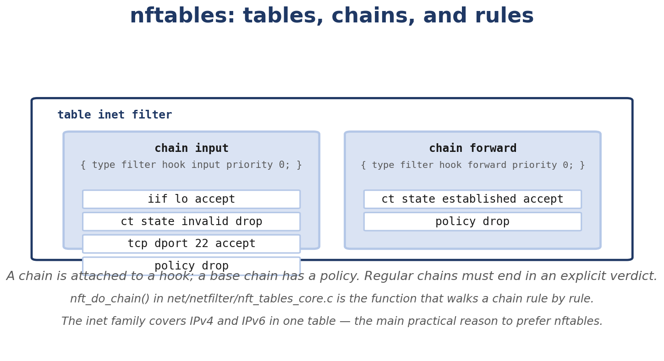
Figure 9.1. nftables tables, chains and rules, and where nft_do_chain() walks them.
- The five Netfilter hooks and where each one runs in the packet path
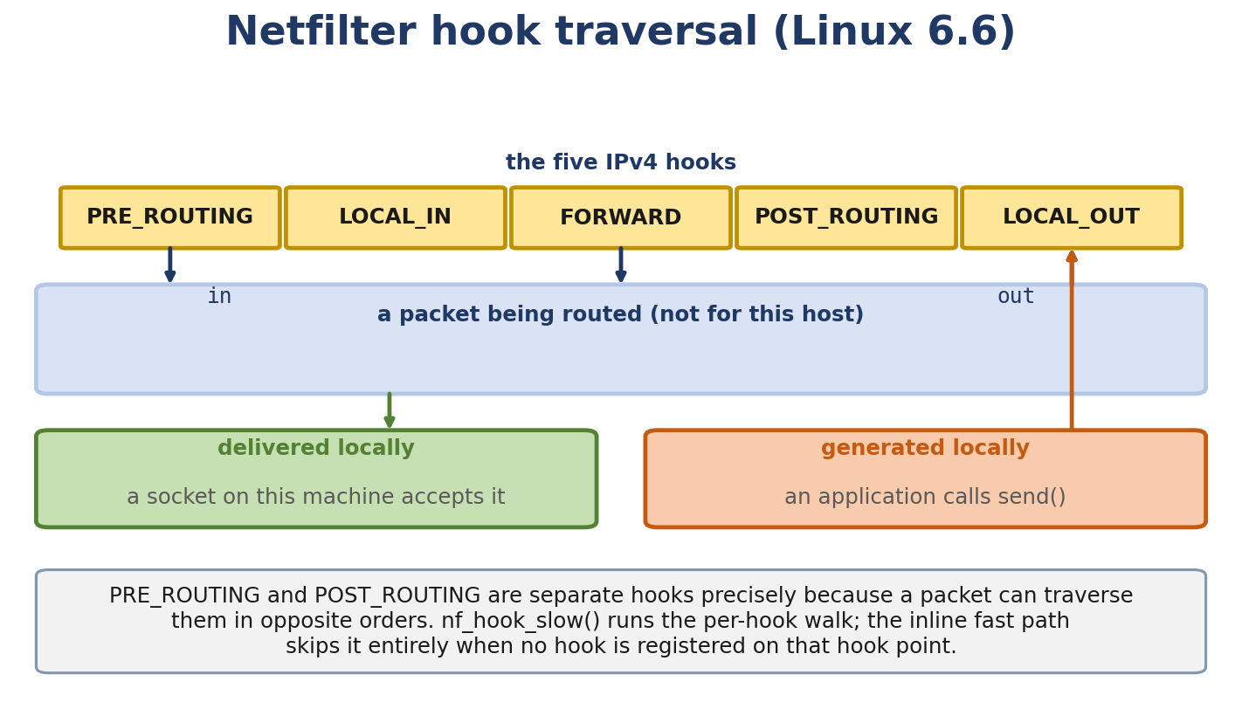
Figure 9.2. Netfilter hook traversal in Linux 6.6, for routed and locally-delivered packets.
- Conntrack: how the kernel tracks connections
- Stateful firewalls using the conntrack states
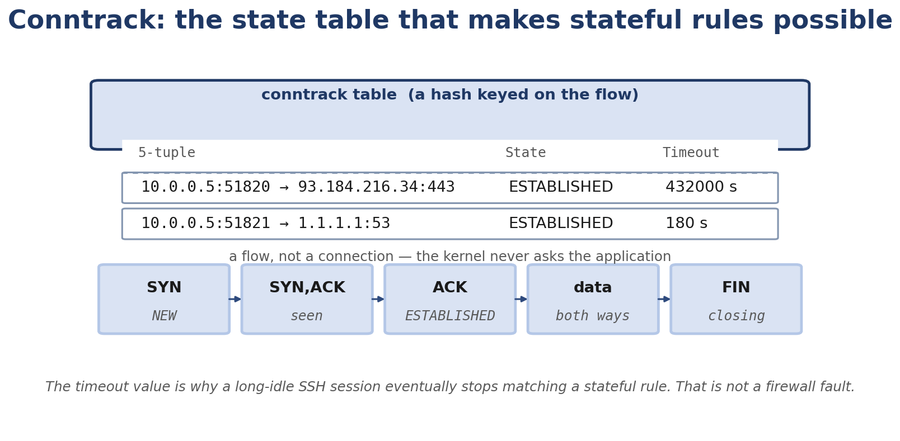
Figure 9.3. Conntrack: the flow state table behind every stateful firewall rule.
- SNAT, DNAT, masquerading, port forwarding
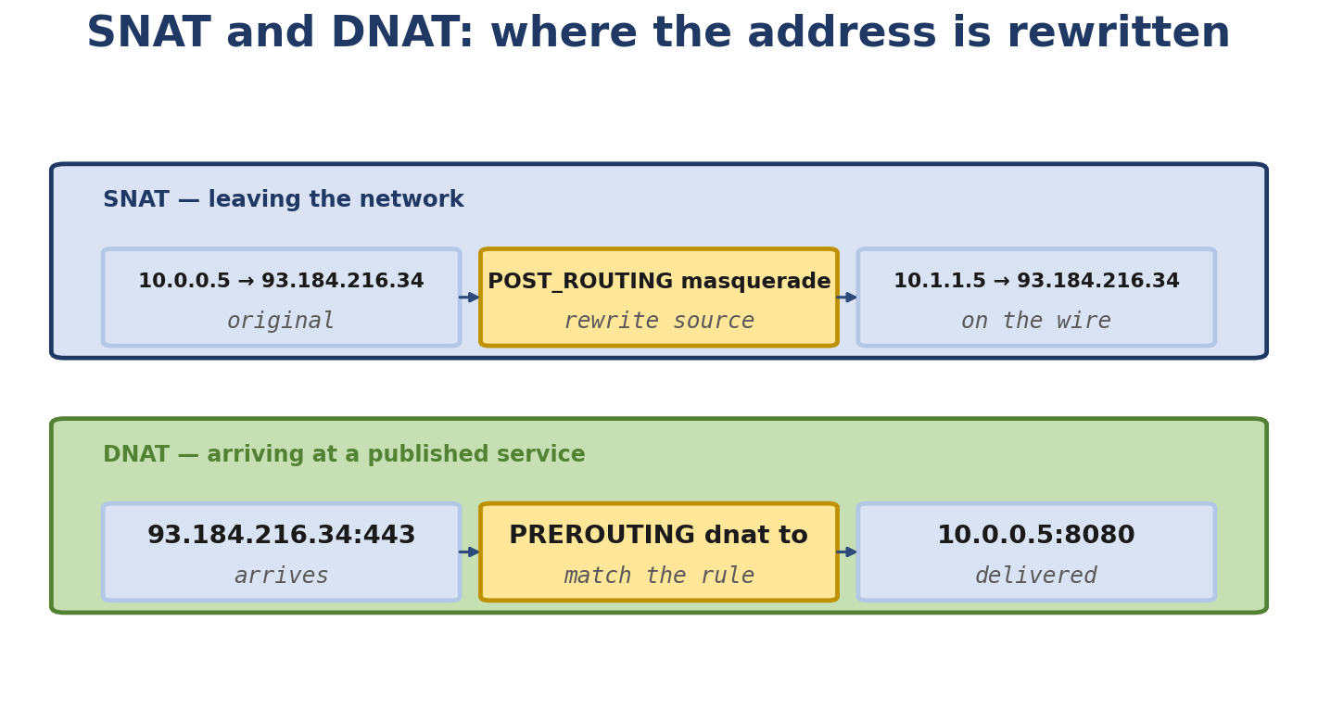
Figure 9.4. SNAT rewrites the source on the way out; DNAT rewrites the destination on the way in.
- How to build a Linux router with namespaces
- How to debug with nft, conntrack, tcpdump

Real-Life Analogy - Customs Checkpoints
Reality check — where the analogy breaks. The analogy above is a pedagogical tool for building a mental model. It is not a precise description of the kernel mechanism. The real implementation differs from the analogy in ways your interviews and lab work will surface; always reason from the kernel source when precision matters.
The postal system now has customs. When an envelope moves through the system, it passes through several customs checkpoints. Each checkpoint can inspect, stamp, or reject the envelope.
PREROUTING: before routing decision. Can rewrite destination. INPUT: delivered locally. Final checkpoint before delivery. FORWARD: routed (not local delivery, not local origin). Through traffic. OUTPUT (a.k.a. LOCAL_OUT in newer terminology): locally generated, before routing. POSTROUTING: just before the wire, after the routing decision. Can rewrite source. (Note: OUTPUT and POSTROUTING are SEPARATE Netfilter hooks, not the same one. OUTPUT fires before routing for locally generated packets; POSTROUTING fires after routing and right before the qdisc/driver.)
Each checkpoint has a queue of officers. Each officer (rule) inspects the envelope. If an officer decides “this is interesting, mark it,” they put a stamp on it (set a conntrack mark). If they decide “this is forbidden,” they put it in the rejected pile (DROP). If they decide “this needs to go somewhere else,” they rewrite the address (DNAT/SNAT).
Conntrack is the customs’ ledger: every envelope that passes is logged in a big book. When the reply comes back, the ledger says “ah, this is the response to envelope #1234” - so we know which state to apply (ESTABLISHED, RELATED, etc.).

The Networking Concept

The five Netfilter hooks
+--------+
| Ingress|
+--------+
|
v
[PREROUTING] ← hook 0
|
v
+---------------+
| Routing |
| Decision |
+---------------+
/ \
/ \
v v
[INPUT] [FORWARD] ← hooks 1, 2
| |
| v
| [POSTROUTING] ← hook 4
| |
v v
+------+ +------+
| Local| | Egress|
+------+ +------+
|
v
[OUTPUT] ← hook 3
|
v
[POSTROUTING] ← hook 4
|
v
+------+
| Egress|
+------+
Each hook is a point where modules can register callbacks. The kernel walks the list of registered callbacks for each hook and invokes each one. A callback can:
Accept the packet (NF_ACCEPT) Drop the packet (NF_DROP) Queue it for userspace (NF_QUEUE) Repeat the iteration (NF_REPEAT) Stolen (e.g. by AF_PACKET) - packet never continues.
The kernel iterates until every callback returns ACCEPT, or one returns DROP.

nftables
nftables is the modern replacement for iptables. It uses a unified syntax for IPv4, IPv6, ARP, and bridge filtering. Rules are organized in tables, which contain chains, which contain rules.

Tables
table ip filter { ... } # IPv4 filter
table ip6 filter { ... } # IPv6 filter
table inet filter { ... } # both IPv4 and IPv6
table ip nat { ... } # NAT table (different chains)
table bridge filter { ... }# bridge-layer
Each table has an address family (ip, ip6, inet, arp, bridge, netdev) and a name.

Chains
Chains are attached to hooks:
table ip filter {
chain input {
type filter hook input priority 0; policy accept;
...
}
chain forward {
type filter hook forward priority 0; policy drop;
...
}
chain output {
type filter hook output priority 0; policy accept;
...
}
}
The type filter hook input priority 0 says: this is a filter chain, attached to the input hook, with priority 0. Lower priority numbers run first.
Chain types:
filter - accept/drop nat - source/destination rewrite route - affect routing decision

Rules
chain input {
type filter hook input priority 0; policy drop;
# Accept established/related
ct state established,related accept
# Accept loopback
iif lo accept
# Allow SSH
tcp dport 22 accept
# Allow ICMP
ip protocol icmp accept
# Rate limit
ip protocol icmp limit rate 4/second accept
# Log and drop
log prefix "nft-drop: " drop
}

Sets and maps
# Set: a set of IP addresses
set blackhole {
type ipv4_addr
elements = { 1.2.3.4, 5.6.7.8 }
}
# Map: IP -> mark
set dnat-map {
type ipv4_addr : ipv4_addr
elements = { 192.168.1.10 : 10.0.0.10,
192.168.1.11 : 10.0.0.11 }
}
chain prerouting {
type nat hook prerouting priority -100;
ip daddr @blackhole drop
**WARNING:** the snippet shown here mixes the destination match and source-address map in a way that does not express the intended public-to-internal DNAT. The correct form for vmap-based DNAT is to map the public destination IP to the internal IP, leaving the source untouched. A working pattern is:
table ip nat { map dnat_map { type ipv4_addr : ipv4_addr elements = { 203.0.113.10 : 10.0.0.10, 203.0.113.11 : 10.0.0.11 } } chain prerouting { type nat hook prerouting priority -100; policy accept; ip daddr vmap @dnat_map dnat to ip daddr map @dnat_map } }
Verify every nftables snippet against the exact kernel/iproute2/nft version you are running before publishing.
}

Useful match expressions
iif <name> - input interface oif <name> - output interface ip saddr <addr> - source IPv4 ip daddr <addr> - destination IPv4 ip6 saddr/daddr - IPv6 tcp dport <port> - destination TCP port udp dport <port> - destination UDP port ct state <state> - conntrack state meta mark <mark> - packet mark meta nftrace set 1 - enable per-packet tracing

Verdict statements
accept drop reject (with reject with icmp type ... or tcp reset) queue (to NFQUEUE) return - return to caller chain jump <chain> - go to another chain goto <chain> - go but return after log prefix "..." - log with prefix

Conntrack
Conntrack is a subsystem that tracks “connections” - not just TCP connections, but pseudo-connections for UDP and ICMP. Each entry includes:
Tuple: (protocol, src_ip, src_port, dst_ip, dst_port) State: NEW, ESTABLISHED, RELATED, INVALID Timeout (decreases; entry is GC’d when it hits 0) Mark (a 32-bit value for your own use) Helper info (e.g. for FTP, the data connection is RELATED to the control)
States:
NEW - first packet seen. Conntrack allocates an entry but doesn’t know if the peer is real yet. ESTABLISHED - reply seen. Now both sides confirmed. NOTE: this conntrack state is NOT the same as the TCP state machine’s ESTABLISHED. Conntrack has its own independent state machine that tracks flow-level metadata across all transport protocols; a conntrack entry marked ESTABLISHED may correspond to a TCP socket still in SYN_SENT, or to a UDP flow whose first packet has been replied to. Treating them as identical is a common interview mistake. RELATED - a new connection that’s related to an existing one (e.g. FTP data connection, ICMP error related to a TCP connection). INVALID - packet doesn’t match any tracked state (e.g. out-of-window TCP, malformed).
Default timeouts (UDP: 30s, TCP established: 5 min, etc.). Configurable via nf_conntrack_* sysctls.
You can list entries:
$ sudo conntrack -L
tcp 6 431999 ESTABLISHED src=192.168.1.10 dst=93.184.216.34 sport=54321 dport=443 packets=12 bytes=1234 [UNREPLIED] src=93.184.216.34 dst=192.168.1.10 sport=443 dport=54321 packets=12 bytes=5678
Or watch events live:
$ sudo conntrack -E

NAT
NAT rewrites addresses as the packet passes through:
SNAT - source NAT. Rewrites source IP (and optionally port). Used to give outbound traffic a single public IP. DNAT - destination NAT. Rewrites destination IP (and optionally port). Used to forward external traffic to internal servers. MASQUERADE - like SNAT but the source IP is determined at packet time (the IP of the outgoing interface). Useful when the IP is dynamic (DHCP). REDIRECT - special DNAT that rewrites the destination to the local machine.
Where NAT hooks:
SNAT/MASQUERADE - POSTROUTING (after routing decision, before the wire). Reason: you need to know which interface the packet is going out (for MASQUERADE) and the destination needs to be unchanged (so the reply can be correctly unrouted). DNAT - PREROUTING (before routing decision). Reason: you need to change the destination BEFORE the routing table decides where the packet goes.
NAT chains use priority -100 (PREROUTING) and 100 (POSTROUTING) by convention - these run before/after the regular filter chains.
Example:
table ip nat {
chain prerouting {
type nat hook prerouting priority -100; policy accept;
tcp dport 80 dnat to 192.168.1.10:8080
}
chain postrouting {
type nat hook postrouting priority 100; policy accept;
ip saddr 192.168.0.0/16 oif eth0 masquerade
}
}

Stateful firewall
With conntrack, you can write rules that depend on the state of a connection:
table ip filter {
chain input {
type filter hook input priority 0; policy drop;
ct state established,related accept
ct state invalid drop
iif lo accept
tcp dport { 22, 80, 443 } accept
icmp type echo-request accept
}
}
This is the canonical “let established in, drop invalid, accept a few services” rule.

Follow the Packet - Inbound Web Request Through DNAT
External client (203.0.113.5) -> server (198.51.100.1) -> backend (10.0.0.10:8080)
1. Packet arrives at eth0 of server.
2. PREROUTING: DNAT rewrites dst from 198.51.100.1:80 to 10.0.0.10:8080. Conntrack records this.
3. Routing decision: dst 10.0.0.10 is internal. Route to internal interface.
4. FORWARD: filter rules applied (e.g. accept based on ESTABLISHED).
5. POSTROUTING: nothing (no SNAT here). Conntrack has the original destination saved.
6. Packet forwarded to 10.0.0.10:8080.
Reply:
1. Backend replies src=10.0.0.10:8080, dst=203.0.113.5.
2. Routing decision: dst is external.
3. POSTROUTING: SNAT rewrites src to 198.51.100.1 (so the reply matches what the client expects).
4. FORWARD: filter accept.
5. Packet sent to client.
Client side:
- Sees a "connection" to 198.51.100.1:80.
- Server translates both directions transparently.

Linux View

nft commands
$ sudo nft list ruleset # inspect host rules only
# The lab router uses its own network namespace:
$ sudo ip netns exec ns-router nft list ruleset
$ sudo ip netns exec ns-router nft flush ruleset
$ sudo ip netns exec ns-router nft monitor
$ sudo ip netns exec ns-router nft -i
Example session:
$ sudo nft add table ip filter
$ sudo nft 'add chain ip filter input { type filter hook input priority 0; policy drop; }'
$ sudo nft 'add rule ip filter input ct state established,related accept'
$ sudo nft 'add rule ip filter input iif lo accept'
$ sudo nft 'add rule ip filter input tcp dport 22 accept'
$ sudo nft list ruleset

conntrack
$ sudo conntrack -L # list entries
$ sudo conntrack -E # watch events
$ sudo conntrack -S # statistics
$ sudo conntrack -D -s 10.0.0.0/8 # delete entries from a subnet
WARNING on conntrack -F (full flush): sudo conntrack -F flushes the ENTIRE conntrack table on this host, destroying tracking state for every flow that traverses the box. This is rarely what you want on a production host. Prefer targeted deletion (as shown above) with conntrack -D -s <src> or conntrack -d -p tcp --dport <port>. If you must flush everything (e.g. as a last-resort recovery step), do so during a maintenance window and document the action.

Translate iptables to nft
For old habits, there’s iptables-translate:
$ iptables-translate -A INPUT -p tcp --dport 22 -j ACCEPT
nft add rule ip filter input tcp dport 22 accept

Kernel parameters
$ sudo sysctl -a | grep nf_conntrack
net.netfilter.nf_conntrack_max = 65536
net.netfilter.nf_conntrack_tcp_timeout_established = 432000
...

Kernel View
Key files:
net/netfilter/core.c - hook iteration. net/netfilter/nf_conntrack_core.c - conntrack table. net/netfilter/nf_nat_core.c - NAT logic. net/netfilter/nftables/ - nftables implementation. net/ipv4/netfilter/ - IPv4-specific netfilter (e.g. iptables compatibility).
Key functions:
In Linux 6.6, nf_hook_slow() walks the registered Netfilter hooks. An accepted packet continues to the next hook. A drop frees the skb with a drop reason. A queued packet is passed to nf_queue(). Function names and call paths change across kernel versions, so check the source for the version you are reading.

Source Code Walkthrough

Excerpt 1: nf_hook_slow (net/netfilter/core.c, Linux 6.6, abbreviated)
int nf_hook_slow(struct sk_buff *skb,
struct nf_hook_state *state,
const struct nf_hook_entries *e,
unsigned int s)
{
unsigned int verdict;
int ret;
for (; s < e->num_hook_entries; s++) {
verdict = nf_hook_entry_hookfn(&e->hooks[s], skb, state);
switch (verdict & NF_VERDICT_MASK) {
case NF_ACCEPT:
break;
case NF_DROP:
kfree_skb_reason(skb, SKB_DROP_REASON_NETFILTER_DROP);
ret = NF_DROP_GETERR(verdict);
return ret ? ret : -EPERM;
case NF_QUEUE:
ret = nf_queue(skb, state, s, verdict);
if (ret == 1)
continue;
return ret;
default:
return 0;
}
}
return 1;
}
Simple iteration. Each hook returns a verdict; non-ACCEPT short-circuits.

Excerpt 2: nf_conntrack_in (net/netfilter/nf_conntrack_core.c, abbreviated)
unsigned int nf_conntrack_in(struct sk_buff *skb, const struct nf_hook_state *state)
{
enum ip_conntrack_info ctinfo;
struct nf_conn *ct;
ct = nf_ct_get(skb, &ctinfo);
if (ct) {
/* Already tracked */
nf_ct_refresh(ct, skb, ctinfo);
return NF_ACCEPT;
}
/* New connection */
ct = resolve_normal_ct(skb, state, &ctinfo);
...
return NF_ACCEPT;
}
If the packet already has a conntrack (it’s a reply or part of an established flow), refresh the entry’s timeout. Otherwise, create a new entry.

Excerpt 3: nf_nat_ipv4_fn (Linux 6.6 source location; verify before quoting)
unsigned int nf_nat_ipv4_fn(void *priv, struct sk_buff *skb,
const struct nf_hook_state *state)
{
struct nf_conn *ct = nf_ct_get(skb, &ctinfo);
enum nf_nat_manip_type manip = HOOK2MANIP(state->hook);
...
if (nf_nat_initialized(ct, manip)) {
/* Already NAT'd */
...
} else {
/* Apply NAT rules */
ret = nf_nat_rule_find(skb, ct, state, manip);
...
}
...
}
The manip tells us if we’re doing source or destination rewrite based on the hook (POSTROUTING = source, PREROUTING = destination).

Excerpt 4: nft_do_chain (net/netfilter/nft_tables_core.c — nf_tables_core.c in modern trees; abbreviated)
static unsigned int nft_do_chain(struct sk_buff *skb, int verdict,
const struct nf_hook_state *state,
struct nft_chain *chain)
{
...
while (nft_rule_is_active(rule) && (verdict & NF_VERDICT_MASK) < NF_STOP) {
verdict = nft_rule_eval(rule, skb, state);
if (verdict != NF_ACCEPT) {
...
return verdict;
}
...
}
...
}
Walk through the rules. Each rule evaluates its expressions. If verdict is non-ACCEPT, exit immediately.

Hands-On Lab - Build a Linux Router with Firewall and NAT

Goal
Build a router that: Has two interfaces (internal and external). Routes packets between them. Has conntrack-based stateful firewall. Performs MASQUERADE for outbound traffic. Performs DNAT to publish an internal HTTP service.

Setup
Three namespaces:
sudo ip netns add ns-client
sudo ip netns add ns-router
sudo ip netns add ns-server
sudo ip netns add ns-ext # represents "the internet"
sudo ip link add veth-c type veth peer name veth-cr
sudo ip link add veth-s type veth peer name veth-sr
sudo ip link add veth-re type veth peer name veth-e
sudo ip link set veth-c netns ns-client
sudo ip link set veth-cr netns ns-router
sudo ip link set veth-sr netns ns-router
sudo ip link set veth-s netns ns-server
sudo ip link set veth-re netns ns-router
sudo ip link set veth-e netns ns-ext
sudo ip netns exec ns-client ip addr add 192.168.10.1/24 dev veth-c
sudo ip netns exec ns-client ip link set veth-c up
sudo ip netns exec ns-client ip route add default via 192.168.10.254
sudo ip netns exec ns-router ip addr add 192.168.10.254/24 dev veth-cr
sudo ip netns exec ns-router ip addr add 192.168.20.254/24 dev veth-sr
sudo ip netns exec ns-router ip addr add 203.0.113.1/24 dev veth-re
sudo ip netns exec ns-router ip link set veth-cr up
sudo ip netns exec ns-router ip link set veth-sr up
sudo ip netns exec ns-router ip link set veth-re up
sudo ip netns exec ns-router sysctl -w net.ipv4.ip_forward=1
sudo ip netns exec ns-server ip addr add 192.168.20.1/24 dev veth-s
sudo ip netns exec ns-server ip link set veth-s up
sudo ip netns exec ns-server ip route add default via 192.168.20.254
sudo ip netns exec ns-ext ip addr add 203.0.113.2/24 dev veth-e
sudo ip netns exec ns-ext ip link set veth-e up
sudo ip netns exec ns-ext ip route add default via 203.0.113.1

Commands
Start a netcat HTTP-ish server in ns-server:
sudo ip netns exec ns-server nc -l -p 8080
Add nftables rules in ns-router:
sudo ip netns exec ns-router nft flush ruleset
sudo ip netns exec ns-router nft add table ip filter
sudo ip netns exec ns-router nft 'add chain ip filter input { type filter hook input priority 0; policy drop; }'
sudo ip netns exec ns-router nft 'add chain ip filter forward { type filter hook forward priority 0; policy drop; }'
sudo ip netns exec ns-router nft 'add rule ip filter input ct state established,related accept'
sudo ip netns exec ns-router nft 'add rule ip filter input iif lo accept'
sudo ip netns exec ns-router nft 'add rule ip filter input tcp dport 22 accept'
sudo ip netns exec ns-router nft 'add rule ip filter forward ct state established,related accept'
sudo ip netns exec ns-router nft 'add rule ip filter forward iif veth-re oif veth-sr ct state new accept'
# NAT
sudo ip netns exec ns-router nft add table ip nat
sudo ip netns exec ns-router nft 'add chain ip nat postrouting { type nat hook postrouting priority 100; }'
sudo ip netns exec ns-router nft 'add rule ip nat postrouting oif veth-re ip saddr 192.168.0.0/16 masquerade'
sudo ip netns exec ns-router nft 'add chain ip nat prerouting { type nat hook prerouting priority -100; }'
sudo ip netns exec ns-router nft 'add rule ip nat prerouting iif veth-re tcp dport 80 dnat to 192.168.20.1:8080'

Expected output
$ sudo ip netns exec ns-ext nc 203.0.113.1 80 < /etc/hostname
[response from ns-server]
The DNAT rewrites 203.0.113.1:80 to 192.168.20.1:8080. MASQUERADE rewrites the source IP back to 203.0.113.1 when going out veth-re.

Experiment
- Verify conntrack:
- sudo ip netns exec ns-router conntrack -L
- You’ll see entries for both the client-to-router and the internal forwarded flows.
- Watch live:
- sudo ip netns exec ns-router conntrack -E
- Generate some traffic; you’ll see [NEW], [UPDATE] events.
- Watch NAT:
- sudo ip netns exec ns-router nft monitor

Break It
Block outgoing ICMP:
sudo ip netns exec ns-router nft 'add rule ip filter forward ip protocol icmp drop'
sudo ip netns exec ns-client ping -c1 203.0.113.2
Fails. Diagnose: tcpdump shows SYN/ACK/etc. forwarded but ping dropped. nft monitor shows the drop rule firing.

Debug It
Imagine the DNAT doesn’t work - the external client gets connection refused.
- conntrack -E - does the entry appear? If yes, conntrack is recording.
- tcpdump -ni veth-re - does the external request arrive?
- nft list ruleset - are the rules actually loaded?
- iptables -t nat -L (legacy) - any conflicting rules?

Challenge
Add a rate limit: only 4 ICMP packets per second allowed from internal clients to external.

Solution
sudo ip netns exec ns-router nft 'add rule ip filter forward ip protocol icmp limit rate 4/second accept'
sudo ip netns exec ns-router nft 'add rule ip filter forward ip protocol icmp drop'

Interview Questions
Q9.1 (Beginner) - What are the five Netfilter hooks?
PREROUTING (before routing decision), INPUT (delivered locally), FORWARD (routed, not local), OUTPUT (locally generated, before routing), POSTROUTING (just before wire).
Q9.2 (Beginner) - What is conntrack?
The kernel’s connection tracking subsystem. Maintains a table of “connections” (TCP, UDP, ICMP pseudo-connections). Each entry has a state (NEW, ESTABLISHED, RELATED, INVALID) and a timeout.
Q9.3 (Beginner) - What is NAT?
Network Address Translation. Rewriting of source or destination IP/port as packets traverse the firewall. Used for sharing one public IP among many internal hosts (SNAT/MASQUERADE) or for publishing internal services (DNAT).
Q9.4 (Intermediate) - Why is SNAT in POSTROUTING and DNAT in PREROUTING?
SNAT rewrites source AFTER routing (because the route decision was based on the original destination, which shouldn’t change). DNAT rewrites destination BEFORE routing (because the new destination needs to be routed correctly).
Q9.5 (Intermediate) - What’s the difference between SNAT and MASQUERADE?
SNAT uses a fixed source IP (you specify it). MASQUERADE uses the IP of the outgoing interface (determined at packet time). Use MASQUERADE when the IP is dynamic (e.g. DHCP).
Q9.6 (Intermediate) - What is the RELATED state used for?
When a new connection is related to an existing one (e.g. FTP data connection is RELATED to the FTP control; an ICMP error is RELATED to the TCP connection that triggered it). The kernel uses helper modules to detect these.
Q9.7 (Intermediate) - What’s the difference between nftables and iptables?
nftables uses a unified syntax for IPv4/IPv6/ARP/bridge, has sets/maps for performance, and is more efficient (one ruleset for all families). iptables is family-specific, has separate binaries for each (iptables, ip6tables, arptables, ebtables). Under the hood, modern iptables uses nftables (xtables-translation).
Q9.8 (Advanced) - How does NAT interact with conntrack?
Conntrack records the original tuple. When a NAT’d reply comes back, the kernel uses the saved original tuple to identify it as RELATED to the original connection, and reverses the NAT automatically.
Q9.9 (Advanced) - Why does conntrack sometimes need a “helper” for protocols like FTP?
FTP uses a control connection (port 21) and dynamically negotiates a data connection (random port). The firewall can’t know which data port to allow without inspecting the control traffic. Helper modules (like nf_conntrack_ftp) parse the control traffic and pre-create conntrack entries for the data connection.
Q9.10 (Advanced) - Explain a SYN flood scenario through this firewall.
A SYN flood sends thousands of SYNs. Each creates a NEW conntrack entry. The conntrack table fills up (default max 65536). New connections are refused (or, if nf_conntrack_tcp_loose=1, they replace old entries). With nf_conntrack_tcp_loose=0, the server stops accepting NEW connections.
Q9.11 (Kernel) - Where does nf_conntrack_in run?
At the NF_INET_PRE_ROUTING hook (for incoming packets) and NF_INET_LOCAL_OUT (for outgoing). It’s invoked before the routing decision so that conntrack can mark packets early.
Q9.12 (Kernel) - What is the role of nf_ct_refresh?
Called when a packet matches an existing conntrack entry. Resets the entry’s timeout to the per-protocol default (or to a custom value passed). This is how the entry stays alive as long as traffic flows.

Key Takeaways
Netfilter has five hooks; nftables attaches chains to hooks. Conntrack tracks connections across protocols (TCP, UDP, ICMP). Stateful firewalls use conntrack states (NEW, ESTABLISHED, RELATED, INVALID). NAT requires PREROUTING (DNAT) or POSTROUTING (SNAT). MASQUERADE for dynamic IPs, SNAT for static. Use nft for modern config; iptables still works but uses xtables-translation internally.

Practice Challenges
- Build the lab above and watch conntrack. Use conntrack -E while traffic flows.
- Test the rate limit. Use hping3 - flood or similar to see the limit kick in.
- FTP through conntrack helper. Configure nf_conntrack_ftp and verify passive-mode FTP works.
- Read nftables source. The chain evaluator lives in net/netfilter/nft_tables_core.c (nf_tables_core.c in current trees). Start by grepping nft_do_chain. nf_nat_ipv4_fn() lives in the IPv4 NAT module.
- Read nf_conntrack_core.c. Find nf_conntrack_in. Understand the resolve path.
- Replace iptables with nft. Take an existing iptables rule and translate to nft with iptables-translate.
- Test conntrack exhaustion. Use a script to open thousands of connections, watch conntrack_max.

Chapter 10 - Linux Network Debugging: Find Where the Packet Died

What You Will Learn
12+ realistic debugging case studies using a strict template
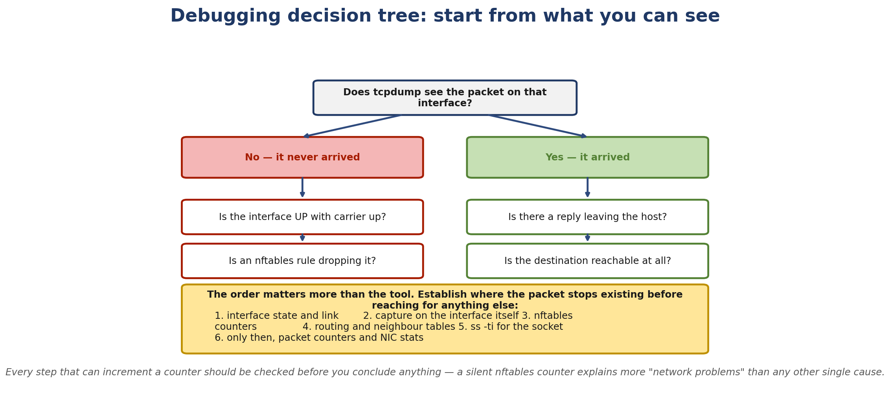
Figure 10.1. A debugging order of operations: establish where the packet stops existing before reaching for anything else.
- A systematic methodology for debugging any network problem
- The 11-step layer-by-layer mental model
- Tool coverage: ping, traceroute, tracepath, ip, ss, tcpdump, tshark, Wireshark, ethtool, ip neigh, ip route, ip rule, nstat, sar, conntrack, dmesg, journalctl
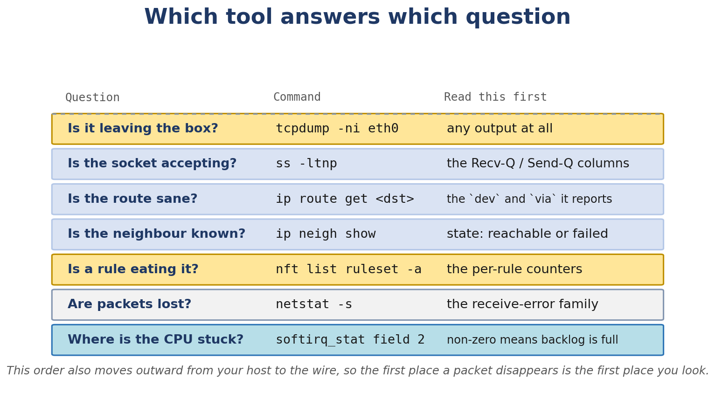
Figure 10.2. Which diagnostic tool answers which question.
- Kernel-level debugging: ftrace, perf, trace-cmd, bpftrace, bpftool, dropwatch

Real-Life Analogy - Tracing a Missing Package
Reality check — where the analogy breaks. The analogy above is a pedagogical tool for building a mental model. It is not a precise description of the kernel mechanism. The real implementation differs from the analogy in ways your interviews and lab work will surface; always reason from the kernel source when precision matters.
When a package doesn’t arrive, an experienced delivery person starts at one end and works through the chain. They don’t randomly try things. They go step by step.
- Was the package given to the post office? (Did the app generate traffic?)
- Did the clerk accept it? (Did the kernel accept it?)
- Did the clerk stamp it correctly? (Did TCP/UDP process it?)
- Did the sorter pick the right truck? (Did routing choose the right path?)
- Did the customs officer accept it? (Did the firewall allow it?)
- Did the truck driver load it? (Did the driver transmit?)
- Did the truck leave the dock? (Did the NIC transmit?)
- Was the road clear? (Was the remote machine reachable?)
This is the discipline. Walk the layers. Use the right tool at each layer.

The Networking Concept

The 11-step mental model
Application
↓
1. Did the application generate traffic?
→ strace, lsof, /proc/PID/io
2. Did the socket send it?
→ ss -tnp, netstat
↓
3. Did TCP/UDP process it?
→ ss -tin, tcpdump, Wireshark
↓
4. Did routing pick the right interface?
→ ip route get, ip rule show
↓
5. Did neighbor resolution succeed?
→ ip neigh show
↓
6. Did the firewall allow it?
→ nft list ruleset, iptables -L, conntrack -L
↓
7. Did the packet reach the interface?
→ tcpdump -ni <interface>
↓
8. Did the driver transmit?
→ ethtool -S <interface>
↓
9. Did the NIC transmit?
→ ethtool --include-statistics
↓
10. Did the remote machine receive?
→ remote tcpdump, ping from remote
↓
11. Did the reply return?
→ tcpdump on both ends
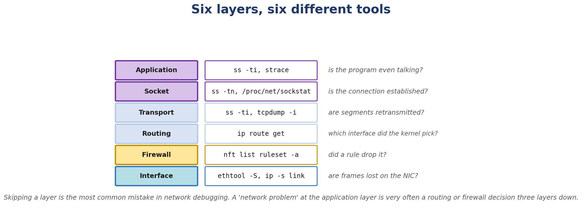
Figure 10.3. Six layers, six different tools. Skipping a layer is the most common debugging mistake.

Tool reference

Connectivity testing
ping <dst> - ICMP echo. Tests basic reachability. ping6 <dst> - IPv6 variant. traceroute -n <dst> - show hops with TTL. tracepath <dst> - similar to traceroute but doesn’t need root. mtr <dst> - continuous traceroute with statistics.

State inspection
ip link - interfaces. ip addr - IP addresses. ip route / ip route get <dst> - routing. ip rule - policy routing. ip neigh - neighbor cache. ip netns - namespaces. ss -tnp - TCP connections. ss -ltnp - listening sockets. ss -unp - UDP. ss -tin - TCP internals (cwnd, retrans, rtt). ss -m - memory (buffer sizes). ss -s - summary. netstat - legacy alternative. nstat - detailed kernel network stats (counters since last reset). sar -n DEV - per-device throughput over time. sar -n TCP - TCP counters over time. sar -n EDEV - per-device errors.

Packet capture
tcpdump -ni any -c 10 - capture 10 packets on all interfaces. tcpdump -ni eth0 -c 10 'host 1.2.3.4' - with filter. tcpdump -w /tmp/cap.pcap - save to file. tshark - wireshark CLI. Wireshark - GUI; can decode thousands of protocols.

Driver / hardware
ethtool <iface> - basic info. ethtool -S <iface> - driver stats (rx_packets, tx_packets, drops, errors). ethtool -i <iface> - driver info. ethtool -l <iface> - queue count. ethtool -g <iface> - ring sizes. ethtool -k <iface> - offloads. ethtool -K <iface> <feature> on/off - toggle offloads. ethtool -x <iface> - RSS hash indirection.

Firewall / NAT
nft list ruleset - all rules. nft monitor - live events. conntrack -L - connection tracking table. conntrack -E - live events. conntrack -S - statistics. iptables -L -nv - legacy iptables (translates to nft under the hood). iptables -t nat -L -nv - NAT table.

Logs
dmesg - kernel ring buffer. dmesg -w - follow. journalctl -k - kernel messages. journalctl -u <service> - specific service.

Kernel tracing
ftrace - built-in tracer. trace-cmd record -e <events> to capture. perf record/report/top - sampling profiler. bpftrace -e '...' - BPF scripting. bpftool prog show - list loaded BPF programs. bpftool map show - list BPF maps. dropwatch -l kas - kernel drop reasons.

Drop reasons
Linux 5.17 added the SKB_DROP_REASON_* values, which record why an skb was dropped:
SKB_DROP_REASON_NOT_SPECIFIED
SKB_DROP_REASON_NO_SOCKET
SKB_DROP_REASON_SOCKET_RCVBUFF
SKB_DROP_REASON_PROTO_MEM
SKB_DROP_REASON_TCP_FASTOPEN_NO_COOKIE
SKB_DROP_REASON_TCP_FASTOPEN_PASSIVE_NO_FDATA
SKB_DROP_REASON_TCP_RESET
...
Use dropwatch to see them in real time, or bpftrace to query them.

Case Studies

Case 1 - Ping works but TCP fails
Problem. User reports: “I can ping google.com, but I can’t load the website.”
Initial observation.
$ ping -c3 8.8.8.8
PING 8.8.8.8 (8.8.8.8) 56(84) bytes of data.
64 bytes from 8.8.8.8: icmp_seq=1 ttl=118 time=12.3 ms
64 bytes from 8.8.8.8: icmp_seq=2 ttl=118 time=12.5 ms
64 bytes from 8.8.8.8: icmp_seq=3 ttl=118 time=12.4 ms
$ curl -v https://google.com
* Trying 142.250.190.78:443...
* connect to 142.250.190.78 port 443 failed: Connection timed out
* Closing connection 0
curl: (28) Failed to connect to google.com port 443 after 129651 ms: Timeout
Hypothesis.
ICMP allowed, TCP blocked somewhere. Or: routing works for ICMP, but TCP is going somewhere weird.
Investigation.
$ sudo nft list ruleset
table ip filter {
chain input {
type filter hook input priority 0; policy drop;
...
}
}
(No related rule, so default is drop.) The firewall has policy drop for input but only allows certain services. Outbound TCP isn’t allowed.
$ sudo iptables -L INPUT -nv
Chain INPUT (policy DROP 0 packets, 0 bytes)
pkts bytes target prot opt in out source destination
12 1008 ACCEPT all -- lo * 0.0.0.0/0 0.0.0.0/0
3 252 ACCEPT icmp -- * * 0.0.0.0/0 0.0.0.0/0
Confirmed: only ICMP and loopback are allowed.
Root cause. Firewall policy drops outbound TCP. (Even though it’s INPUT chain - note the INPUT chain processes both inbound and locally-generated traffic.)
Fix.
$ sudo iptables -I INPUT 1 -m state --state ESTABLISHED,RELATED -j ACCEPT
Or in nft:
sudo nft 'add rule ip filter input ct state established,related accept'
Verification.
$ curl -v https://google.com
* Connected to google.com (142.250.190.78) port 443
...
Engineering lesson. Stateful firewalls need explicit ESTABLISHED,RELATED rules. Without them, replies to outbound traffic are dropped.

Case 2 - TCP handshake never completes
Problem. curl https://internal-server hangs in “Trying to connect” for 60+ seconds.
Initial observation.
$ curl -v https://internal-server
* Trying 10.0.0.5:443...
* connect to 10.0.0.5 port 443 failed: Connection timed out
Investigation.
$ ss -tnp dst 10.0.0.5
State Recv-Q Send-Q Local:Port Peer:Port
SYN-SENT 0 1 192.168.1.10:54321 10.0.0.5:443 users:(("curl",pid=1234,fd=3))
SYN-SENT - kernel sent SYN, no SYN-ACK.
$ sudo tcpdump -ni any -c 5 'host 10.0.0.5 and tcp'
15:00:00.000 IP 192.168.1.10.54321 > 10.0.0.5.443: Flags [S], seq 1000, win 64240
(repeated - same SYN, retransmitted)
No SYN-ACK ever returned.
$ sudo nft list ruleset
... rule allowing tcp dport 443 ...
But:
$ sudo iptables -I FORWARD -p tcp -d 10.0.0.5 --dport 443 -j DROP
There’s a legacy iptables rule shadowing the nftables rule.
Root cause. Legacy iptables rule dropping the forwarded TCP traffic.
Fix. Remove the legacy rule:
$ sudo iptables -D FORWARD -p tcp -d 10.0.0.5 --dport 443 -j DROP
Verification.
$ curl -v https://internal-server
* Connected to internal-server (10.0.0.5) port 443
Engineering lesson. Don’t run iptables and nftables simultaneously - they can interact unpredictably. Pick one. (Modern nftables has iptables compatibility, but mixing raw iptables with native nft is messy.)

Case 3 - Connection refused
Problem. telnet server 22 returns “Connection refused” immediately.
Initial observation.
$ telnet server 22
Trying 10.0.0.5...
telnet: Unable to connect to remote host: Connection refused
The server actively refused - got a RST.
Investigation.
$ ss -tnp dst 10.0.0.5:22
SYN-SENT 0 1 192.168.1.10:54321 10.0.0.5:22
Kernel sent SYN, got RST back.
$ sudo tcpdump -ni any -c 4 'host 10.0.0.5 and port 22'
15:00:00.000 IP 192.168.1.10.54321 > 10.0.0.5.22: Flags [S]
15:00:00.001 IP 10.0.0.5.22 > 192.168.1.10.54321: Flags [R.]
Got an RST.
Root cause. Either no process is listening on port 22 on the server, or the kernel actively rejected (e.g. iptables -I INPUT -p tcp - dport 22 -j REJECT).
$ ssh server 'ss -ltnp | grep :22'
ssh: Connection refused
Can’t even SSH to check. So:
$ sudo nmap -sS -p22 server
PORT STATE SERVICE
22/tcp closed ssh
Closed = port has no listener.
Fix. Start the SSH server, or fix whatever is supposed to listen on port 22.
Verification. telnet server 22 connects.
Engineering lesson. “Connection refused” means RST - the kernel (or a RST-emitting rule) actively rejected. Different from “timeout” (no response).

Case 4 - Connection timeout (asymmetric routing + rp_filter)
Problem. Server is reachable from one client but not another, even though the IP routing looks correct.
Investigation.
$ sudo tcpdump -ni eth0 -c 4 'host 10.0.0.5'
... only requests, no replies ...
Server’s tcpdump shows the SYN arriving but no SYN-ACK going out.
$ sudo sysctl net.ipv4.conf.all.rp_filter
net.ipv4.conf.all.rp_filter = 1
Root cause. Strict rp_filter: server receives SYN on eth0 from a source IP whose route would go out a different interface. Kernel drops the packet as spoofed.
Fix.
$ sudo sysctl -w net.ipv4.conf.eth0.rp_filter=2
Mode 2 is loose - drop only if source is unreachable, not if route lookup disagrees.
Verification. Server starts replying.
Engineering lesson. rp_filter is a useful anti-spoofing tool but breaks asymmetric routing. Use mode 2 when you need flexibility.

Case 5 - Connection reset mid-stream
Problem. Established TCP connection suddenly gets reset.
Investigation.
$ sudo tcpdump -ni any -c 4 'host server'
... FIN or RST mid-stream ...
Could be:
Peer process crashed. iptables -I INPUT -p tcp - dport 80 -j REJECT - reject-with tcp-reset. TCP timeout - peer not reachable, kernel gives up. NAT table full.
Root cause. conntrack -S shows dropping=0 so it’s not conntrack. Check dmesg for kernel warnings.
Fix. Depends on root cause.

Case 6 - Packets leave but don’t return
Problem. ping 8.8.8.8 shows 0% received.
Investigation.
$ sudo tcpdump -ni eth0 -c 4 'host 8.8.8.8'
... requests go out, no replies ...
Outgoing works. Reply path broken.
$ ip route get 8.8.8.8 from <some-internal-ip>
If you have multiple IPs and asymmetric routing: outgoing interface differs from incoming interface expected for the reply.
$ sudo tcpdump -ni eth1 -c 4 'host 8.8.8.8'
... replies arriving on eth1 ...
The reply comes back on a different interface than outgoing.
Root cause. Asymmetric routing + default rp_filter = drops.
Fix. Same as Case 4.

Case 7 - Large packets fail
Problem. ping 8.8.8.8 works for small packets, fails for -s 2000.
Investigation.
$ ping -M do -s 1500 8.8.8.8
PING 8.8.8.8 (8.8.8.8) 1500(1528) bytes of data.
^C
--- 8.8.8.8 ping statistics ---
1 packets transmitted, 0 received, 100% packet loss
ping -M do sets DF. With size 1500, total IP packet is 1528 (1500 + 8 ICMP + 20 IP). Larger than typical MTU.
$ sudo tcpdump -ni eth0 -c 4 'host 8.8.8.8'
... SYN/SYN-ACK/ACK handshake works ...
... but no ICMP echo reply for large packet ...
The handshake works at MTU 1500 because TCP MSS is 1460. But ICMP doesn’t have MSS - it’s 1500.
Root cause. Path MTU < 1500. Probably a tunnel with smaller MTU.
Verification.
$ tracepath 8.8.8.8
1?: [LOCALHOST] pmtu 1500
1: 192.168.1.1 0.412ms
1: 192.168.1.1 0.398ms pmtu 1480
2: ...
PMTU is 1480. So 1500-byte ICMP packets are too big.
Fix. Reduce outgoing packet size. Or fix PMTUD.

Case 8 - DNS works but app doesn’t
Problem. nslookup google.com works, but curl https://google.com fails.
Investigation.
$ nslookup google.com
Server: 8.8.8.8
Address: 142.250.190.78
DNS resolves.
$ curl https://google.com
curl: (6) Could not resolve host: google.com
But curl can’t resolve.
Root cause. /etc/nsswitch.conf order or /etc/resolv.conf issue.
$ cat /etc/nsswitch.conf | grep hosts
hosts: files dns
$ cat /etc/resolv.conf
nameserver 127.0.0.1
The nameserver is 127.0.0.1 but no local resolver is running.
Fix.
$ sudo systemctl start systemd-resolved
$ sudo ln -sf /run/systemd/resolve/resolv.conf /etc/resolv.conf

Case 9 - Localhost works, remote fails
Problem. ping 127.0.0.1 works; ping 192.168.1.5 fails.
Investigation.
$ ip route
default via 192.168.1.1 dev eth0
192.168.1.0/24 dev eth0
But:
$ sudo tcpdump -ni eth0 -c 4 'icmp'
... nothing ...
No traffic going out.
$ ip link show eth0
eth0: <NO-CARRIER,BROADCAST,MULTICAST,UP> mtu 1500
NO-CARRIER - no link. Cable unplugged or switch port down.
Fix. Plug the cable.

Case 10 - High packet loss
Problem. iperf3 -c server shows 5% packet loss.
Investigation.
$ ethtool -S eth0 | grep -E 'rx_|drop|miss'
rx_packets: 1000000
rx_missed: 50000
50k packets missed. ethtool -S statistics are driver/NIC-specific. rx_missed, rx_no_buffer, rx_dropped, and similar names may indicate receive-side resource pressure, but their exact meaning depends on the driver. Check your driver documentation; for example, Intel NICs use rx_dropped differently than Mellanox. The example here uses Intel-style names and the typical meaning - ring full or buffer shortage - but always verify against the driver.
$ cat /proc/net/softnet_stat | head
01adbe44 00000000 ...
The first column is packets processed. If non-zero, packets are being processed. If zero, softirq is stuck.
$ mpstat -P ALL 1
CPU saturation: one core at 100% while others idle.
Root cause. Single CPU handling all RX. Driver queues pinned to one core. Increase IRQ affinity.
Fix.
$ sudo ethtool -L eth0 combined 4
$ sudo systemctl set_irq_affinity ...

Case 11 - High latency
Problem. ping shows 200 ms latency to a normally-fast server.
Investigation.
$ ping -c5 server
64 bytes from server: icmp_seq=1 ttl=64 time=210 ms
64 bytes from server: icmp_seq=2 ttl=64 time=210 ms
Consistent 210 ms. Probably bufferbloat.
$ tc -s qdisc show dev eth0
qdisc fq_codel ...
backlog 1234567b 1234p
qdisc has 1MB of backlog. The link is full - packets are queuing.
Root cause. A bulk upload is filling the link, causing latency for ICMP. The default qdisc (typically fq_codel or fq on modern Ethernet) is usually well-tuned for this; if your distro is using a fifo or pfifo_fast default the symptom matches.
Fix. Switch to fq_codel (already there) but check that the bottleneck rate is correctly set. Or use cake.

Case 12 - Drops inside the host
Problem. Performance test shows 30% drops, but the NIC reports no misses.
Investigation.
$ sudo tc -s qdisc show dev eth0
qdisc fq_codel ...
Sent 1000000 bytes 1000 pkt
(dropped 300, overlimits 0 requeues 0)
backlog 0b 0p
300 packets dropped by qdisc - qdisc queue was full.
Root cause. Application reads slowly; kernel can’t queue more.
Fix. Increase socket buffer sizes, or rate-limit the sender.

Linux View

dropwatch
$ sudo dropwatch -l kas
Live drop reasons. Press Ctrl-C to stop.

bpftrace for drops
$ sudo bpftrace -e 'kprobe:kfree_skb_reason /arg0/ { @[arg1] = count(); }'
Note: arg1 is the enum skb_drop_reason (kernel 5.17+).

nstat
$ nstat
TcpActiveOpens 12 0.0
TcpPassiveOpens 45 0.0
TcpEstabResets 2 0.0
TcpInSegs 12345 0.0
TcpOutSegs 23456 0.0
TcpRetransSegs 3 0.0
TcpCurrEstab 5
...
Compare two snapshots to see what’s changing.

Kernel View
Key files:
net/core/drop_monitor.c - kernel drop monitoring infrastructure. include/linux/skbuff.h - enum skb_drop_reason (kernel 5.17+). net/ipv4/route.c - ip_route_input_noref (rp_filter).
Key functions:
kfree_skb_ reason(skb, reason) - drop with reason. drop_monitor - kprobe-based monitoring. trace_kfree_skb - tracepoint.

Source Code Walkthrough

Excerpt 1: kfree_skb_reason (net/core/skbuff.c, abbreviated)
void kfree_skb_ reason(struct sk_buff *skb, enum skb_drop_reason reason)
{
if (!skb_unref(skb))
return;
/* Emit tracepoint with reason */
trace_kfree_skb(skb, __builtin_return_address(0), reason);
/* Drop count for owning socket */
if (skb->sk)
skb->sk->sk_drops++;
__kfree_skb(skb);
}

Excerpt 2: ip_route_input and rp_filter (net/ipv4/route.c, abbreviated)
static int ip_route_input_slow(struct sk_buff *skb, __be32 daddr, __be32 saddr,
u8 tos, u8 protocol, struct net_device *dev)
{
...
if (IN_DEV_OR_NET(in_dev, rp_filter)) {
err = fib_validate_source(skb, saddr, daddr, tos, 0, dev, &res, &itag);
if (err < 0) {
...
goto drop;
}
}
...
}

Excerpt 3: dev_xmit_complete (net/core/dev.c, abbreviated)
void dev_xmit_complete(struct sk_buff *skb)
{
...
/* Update per-queue stats */
txq->tx_packets++;
txq->tx_bytes += skb->len;
...
}
Called by drivers after TX completion to update per-queue stats. Important for tc -s qdisc show accuracy.

Hands-On Lab - Build a Bug, Find It, Fix It

Goal
You’ll reproduce 3 of the case-study failures and diagnose them.

Setup
Use the topology from Chapter 9 (ns-client, ns-router, ns-server, ns-ext).

Fault 1 - Drop outbound TCP in ns-router
sudo ip netns exec ns-router nft 'add rule ip filter forward ip protocol tcp drop'
Then from ns-client: sudo ip netns exec ns-client nc -w2 server 80 < /etc/hostname. Fails. Diagnose with tcpdump, conntrack, nft monitor.

Fault 2 - Block ICMP
sudo ip netns exec ns-router nft 'add rule ip filter input ip protocol icmp drop'
Then from ns-client: ping the router. Fails. Diagnose.

Fault 3 - Wrong route in ns-server
sudo ip netns exec ns-server ip route del default via 192.168.20.254
sudo ip netns exec ns-server ip route add default via 192.168.20.1 # wrong gateway (itself)
Now ns-server can’t reach ns-client. Diagnose with ip route get.

Challenge
Without running, predict: if you tcpdump -ni any -c 1 'host 8.8.8.8', what do you see during a ping 8.8.8.8? What if rp_filter is strict and the reply arrives on a different interface?

Solution
You see ICMP echo request and reply, plus possibly ARP for the gateway. With strict rp_filter and asymmetric reply path, you see only the request - the reply is dropped silently.

Interview Questions
Q10.1 (Beginner) - Describe the 11-step debugging methodology.
Application, socket, TCP/UDP, routing, firewall, interface, driver, NIC, wire, remote, reply. Use the right tool at each layer.
Q10.2 (Beginner) - What’s the difference between “connection refused” and “connection timed out”?
Refused: kernel got RST. No listener or active rejection. Timeout: kernel sent SYN but got no SYN-ACK. Could be: firewall drop, routing issue, remote down, NIC problem.
Q10.3 (Intermediate) - What tool would you use to see why packets are being dropped inside the host?
dropwatch -l kas for live drop reasons. sudo bpftrace -e 'kprobe:kfree_skb_reason /arg0/ { @[arg1] = count(); }' for a histogram of reasons.
Q10.4 (Intermediate) - How do you verify that packets are actually leaving the NIC?
ethtool -S <iface> shows tx_packets. tcpdump -ni <iface> shows packets on the wire. ping from a remote machine confirms end-to-end.
Q10.5 (Intermediate) - What’s the difference between dropwatch and ftrace?
dropwatch focuses on packet drops with reasons. ftrace is a general tracing framework - you can trace any kernel function with trace-cmd or perf.
Q10.6 (Advanced) - How would you debug a transient issue that only happens under load?
Use continuous tracing: bpftrace -e 'kprobe:kfree_skb_reason /arg0/ { @[arg1] = count(); }' interval:5:10 for periodic reports. Or keep a bounded packet-capture ring: `sudo tcpdump -ni "$IFACE" -C 100 -W 10 -w /tmp/cap.pcap`. It keeps up to ten files of about 100 MB each, then overwrites the oldest file. Look at the buffer after the issue.
Q10.7 (Advanced) - How do you know if a packet loss is on the wire vs in the host?
Compare ethtool -S counters (NIC received X) with tcpdump counters (kernel saw X). If they differ, drops are in the host. If tcpdump shows fewer than the application sent, drops are in the queue (qdisc or socket buffer).
Q10.8 (Troubleshooting) - A TCP connection is slow. Walk through your debugging.
- ping - basic reachability, latency.
- mtr - per-hop latency, loss.
- ss -tin - connection state, cwnd, retransmits.
- tcpdump -w capture - analyze with Wireshark (throughput, retransmits, window size).
- iperf3 to bypass application - is the application the bottleneck?

Key Takeaways
Use the 11-step methodology: walk every layer, use the right tool at each layer. Tools exist at every level: ping (basic), ss (socket state), tcpdump (wire), nft/conntrack (firewall), ethtool (driver), bpftrace/dropwatch (kernel). “Connection refused” vs “timeout” vs “RST mid-stream” each have different causes. Drop reasons (kernel 5.17+) tell you exactly why the kernel dropped a packet.

Practice Challenges
- Reproduce every case study. For each, build it in your namespaces, then diagnose.
- Run dropwatch during heavy load. Generate load, watch reasons.
- Use bpftrace to find the most-dropped reason.
- Compare tcpdump and ethtool counters. Generate load; verify they agree.
- Read the drop_reason enum. grep -A100 "enum skb_drop_reason" include/linux/skbuff.h. See all the reasons.
- Build a histogram of time spent inside dev_queue_xmit() with a matching kprobe and kretprobe. This measures kernel function time, not wire or round-trip latency.
- Try trace-cmd end-to-end. Capture a full ping from user to wire, identify every function in between.

Chapter 11 - Linux Network Performance and High-Speed Networking

What You Will Learn
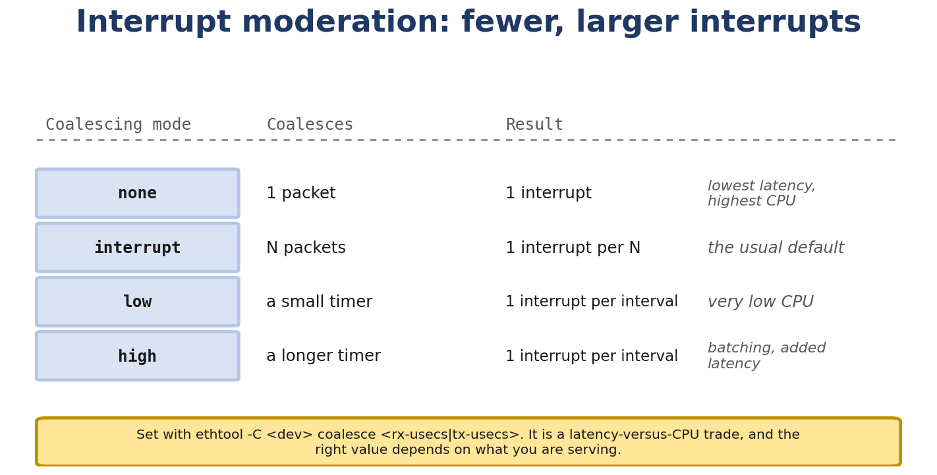
Figure 11.1. Interrupt coalescing: fewer, larger interrupts, and what that costs in latency.
qdisc and traffic control with tc
- Bandwidth, throughput, PPS, latency, jitter - what they really mean
- CPU cost of networking: interrupts, softirq, syscall overhead
- Memory, cache, NUMA effects
- Lock contention and how it limits scaling
- RX/TX queue count, IRQ affinity, multi-queue
- Offloads: GRO, GSO, TSO, LRO, checksum, VLAN, RSS
- RPS, RFS, XPS
- How to measure and tune

Real-Life Analogy - Highway Engineering
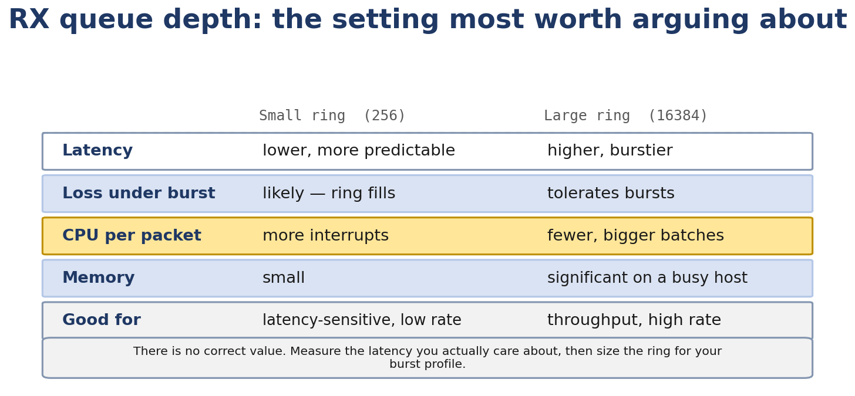
Figure 11.2. RX queue depth is a latency-versus-burst trade, not a performance setting.
Reality check — where the analogy breaks. The analogy above is a pedagogical tool for building a mental model. It is not a precise description of the kernel mechanism. The real implementation differs from the analogy in ways your interviews and lab work will surface; always reason from the kernel source when precision matters.
A highway has: A maximum capacity (bandwidth) A traffic rate (throughput) Travel time (latency) Variation in travel time (jitter)
Performance comes from: Number of lanes (RX/TX queues, multi-queue) Smart traffic lights (qdisc, fq_codel, BBR) Good merge design (RSS, RPS, RFS, XPS) Removing traffic lights where possible (offloads: TSO, checksum) Carpooling (GRO - multiple small packets into one)
You can have a 10-lane highway, but if all lanes feed into one toll booth, throughput is limited by the booth.

The Networking Concept

Bandwidth vs throughput vs PPS
Bandwidth - the link’s rated capacity (e.g. 10 Gbps). Throughput - actual achieved rate. Lower than bandwidth due to overhead, retransmits, CPU limits. PPS - packets per second. Matters for small-packet workloads. Limited by CPU.
For a single TCP stream over 10 Gbps you might see roughly 5-9 Gbps in *illustrative* test conditions (single TCP socket, modern x86, kernel TCP defaults, tuned NIC offloads, low-loss RTT). Real-world throughput depends heavily on CPU, NIC, offload state, congestion control, IRQ affinity, and workload — verify on your own stack rather than expecting these numbers.. PPS is usually 1-5 Mpps per core.

Latency vs jitter
Latency - time for one packet to traverse. Jitter - variation in latency across packets.
For voice/video, jitter matters more than average latency (a 100 ms average with 10 ms jitter is bad; a 50 ms average with 1 ms jitter is good).

CPU cost model
Networking has multiple CPU costs:
IRQ - interrupting the CPU to handle an event. ~1 microsecond each, but disruptive. Softirq - running the NAPI poll in softirq context. Cannot block, but can do more work than IRQ. Syscall - user space calling the kernel (read/write/send/recv). ~1 microsecond. Copy - moving data between user and kernel space. Depends on size; ~10 GB/s with memcpy. Locking - taking spinlocks or mutexes. Contention can serialize CPUs.
For high throughput, you want to:
Spread IRQs across CPUs (IRQ affinity). Batch packet processing (NAPI). Offload work to hardware (TSO, checksum, RSS). Avoid unnecessary copies (zero-copy, splice).

Memory and cache
Packets flow through kernel memory. Important things:
sk_buff cache - kernel pre-allocates skbs in a slab cache for fast allocation. Data buffer - allocated from kernel heap, but with specific size classes. NUMA effects - on multi-socket systems, memory local to a CPU is faster than remote. The driver should allocate from the local node.
Check NUMA topology:
$ numactl --hardware
available: 2 nodes (0-1)
node 0 cpus: 0 1 2 3 4 5
node 1 cpus: 6 7 8 9 10 11
node 0 size: 32768 MB
node 1 size: 32768 MB
node 0 free: 12345 MB
node 1 free: 23456 MB
node distances:
node 0 1
0: 10 20
1: 20 10
Cross-node memory access is 2x slower (in this case).

Lock contention
Networking has several locks that can be contended:
neighbor cache lock - protects the ARP/ND table. With many CPUs doing ARP lookups, this serializes. qdisc lock - protects the qdisc queue. Single qdisc lock = bottleneck. Socket lock - each socket has a lock. Multi-listener with SO_REUSEPORT distributes the load. xhci lock, netdev lock, etc.
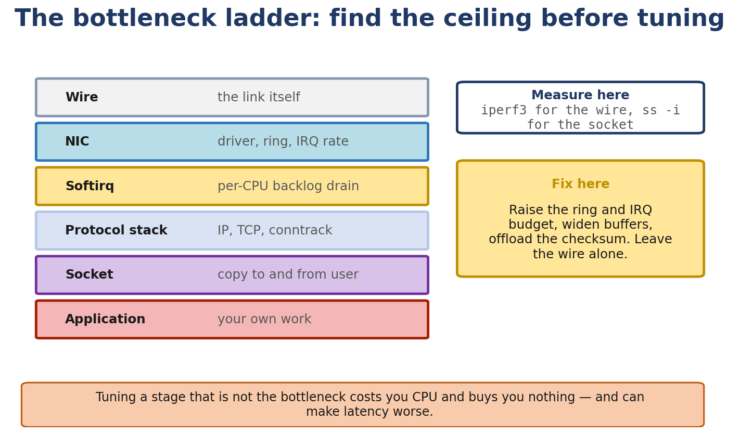
Figure 11.3. The bottleneck ladder: measure where the ceiling is before tuning anything.
Check for lock contention with perf lock contention -a or cat /proc/lockdep.

RX/TX queues and multi-queue
Modern NICs have multiple queues. Each queue is an independent ring with its own IRQ.
RX queues receive packets. The NIC uses RSS to distribute packets across queues. TX queues send packets. The driver (or XPS) picks a queue.
Single-queue is the default; multi-queue is opt-in:
$ ethtool -l eth0
Channel parameters for eth0:
Pre-set maximums:
RX: 0
TX: 0
Other: 1
Combined: 8
Current hardware settings:
RX: 0
TX: 0
Other: 1
Combined: 1
Set combined to N:
$ sudo ethtool -L eth0 combined 4

IRQ affinity
Each IRQ can be pinned to specific CPUs. For multi-queue NICs, distribute:
$ cat /proc/irq/24/smp_affinity
ff
$ echo 01 > /proc/irq/24/smp_affinity # pin IRQ 24 to CPU 0
$ echo 02 > /proc/irq/25/smp_affinity # pin IRQ 25 to CPU 1
...
Or use systemd’s irqbalance to do it automatically. (Often irqbalance does the right thing - but verify with cat /proc/interrupts.)

Offloads

GRO
Generic Receive Offload. Combines multiple incoming TCP segments into one skb. Default on. Saves CPU.
$ ethtool -k eth0 | grep generic-receive-offload
generic-receive-offload: on

GSO
Generic Segmentation Offload. Defers segmentation. If the driver supports TSO, GSO is bypassed for TCP. For UDP/non-TCP, GSO segments in software just before the driver.

TSO
TCP Segmentation Offload. The NIC’s hardware does the segmentation. Requires driver support.
$ ethtool -k eth0 | grep tcp-segmentation
tcp-segmentation-offload: on

LRO
Large Receive Offload. Driver-side aggregation. Largely deprecated in favor of GRO.

Checksum offload
The NIC computes/verifies checksums. Huge CPU saving.
$ ethtool -k eth0 | grep -E 'checksum|vlan'
tx-checksumming: on
rx-checksumming: on
tcp-checksumming: on
udp-checksumming: on

VLAN offload
The NIC inserts/removes 802.1Q tags.
$ ethtool -k eth0 | grep vlan
tx-vlan-offload: on
rx-vlan-offload: on

RSS
Receive Side Scaling. The NIC distributes incoming packets across RX queues based on a hash. Different connections land on different queues, processed by different CPUs.
$ ethtool -x eth0

RPS, RFS, XPS
These are software mechanisms for distributing work across CPUs, complementing hardware RSS.

RPS - Receive Packet Steering
Software RSS. When a packet arrives on a single RX queue, RPS distributes it across CPUs based on a hash. Useful when the NIC has only one queue but multiple CPUs.
echo 7 > /sys/class/net/eth0/queues/rx-0/rps_cpus # use CPUs 0-2

RFS - Receive Flow Steering
RPS + flow-aware CPU pinning. If the destination socket is on CPU 3, RFS steers packets to CPU 3. Better cache locality.
echo 4096 > /sys/class/net/eth0/queues/rx-0/rps_flow_cnt

XPS - Transmit Packet Steering
For TX queues, XPS determines which queue to use based on the sending CPU. Prevents head-of-line blocking.
echo 01 > /sys/class/net/eth0/queues/tx-0/xps_cpus
echo 02 > /sys/class/net/eth0/queues/tx-1/xps_cpus

qdisc and traffic control
Every interface has a qdisc (queuing discipline). Default varies by distribution:
pfifo_fast - three-band priority FIFO. Legacy default. fq - flow-based fair-queuing scheduler with pacing support. Used as a default on many modern distros. fq_codel - flow queuing combined with CoDel’s active queue management to control queue delay. Common modern default; helps fight bufferbloat. cake - common application keeplied even more recent. tbf - token bucket filter. Rate limit. htb - hierarchical token bucket. Bandwidth shaping.
View:
$ tc qdisc show dev eth0
Replace:
$ sudo tc qdisc replace dev eth0 root fq_codel
Add a rate limit:
$ sudo tc qdisc add dev eth0 root tbf rate 100mbit burst 32kbit latency 400ms

Follow the Packet - A 64-byte UDP Flood
A minimum Ethernet frame is 64 bytes, including its frame check sequence. Add 8 bytes for the preamble and start marker, plus 12 bytes for the inter-frame gap: 84 bytes of wire time. At 1 Gb/s, 1,000,000,000 / (84 × 8) is about 1.488 million packets per second. This is the wire-rate limit, not a promise about CPU forwarding speed.
For 10 Gbps: ~14.4 Mpps wire rate (64-byte packets). The per-core PPS ceiling depends on the driver and packet path; on typical modern x86, software forwarding yields roughly 1-3 Mpps per core, so line-rate forwarding at 14 Mpps typically needs multi-core software forwarding or hardware offload. CPU bound, not bandwidth bound.
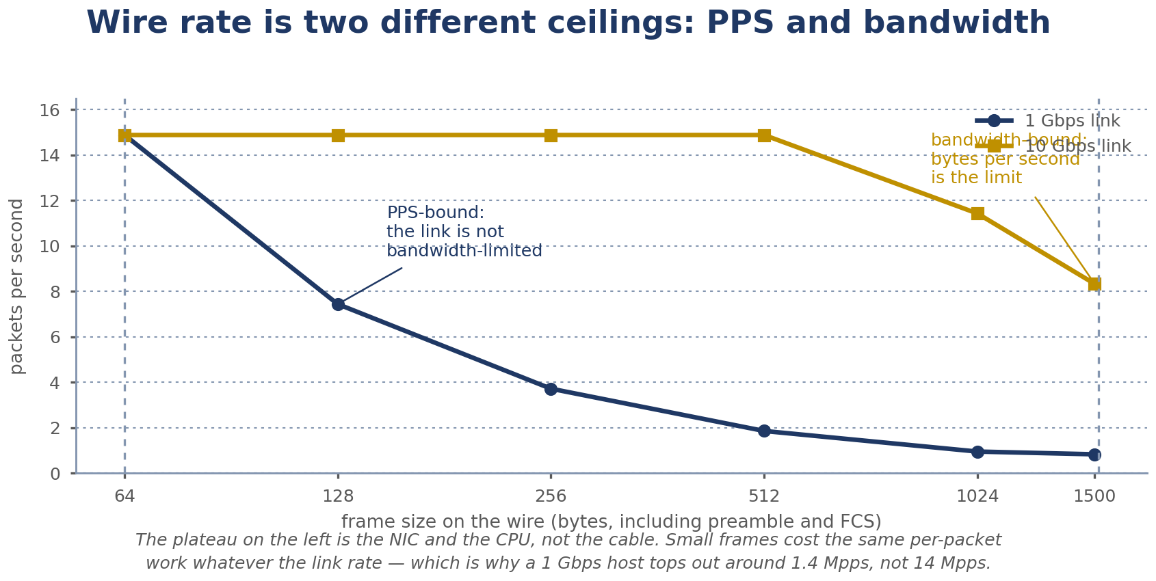
Figure 11.4. Wire rate has two ceilings: packets per second and bits per second. Which one binds depends on frame size.
This is why PPS is often the real bottleneck.

Linux View

iperf3
The standard tool for throughput testing.
# Server
$ iperf3 -s
# Client
$ iperf3 -c <server-ip> -t 30 -P 4
-P 4 uses 4 parallel streams. -R for reverse. -u for UDP. -w 4M for window size.

sar
$ sar -n DEV 1
Linux 5.x ...
...
02:30:00 PM IFACE rxpck/s txpck/s rxkB/s txkB/s rxcmp/s txcmp/s rxmcst/s %ifutil
02:30:01 PM eth0 12345.00 12340.00 1234.00 1234.00 0.00 0.00 0.00 12.34
02:30:01 PM lo 0.00 0.00 0.00 0.00 0.00 0.00 0.00 0.00

mpstat
$ mpstat -P ALL 1
Per-CPU utilization. If one core is at 100% while others are idle, that’s the bottleneck.

perf
$ sudo perf top -e 'kprobe:*' -g
Live profiling of kernel functions.

numactl
$ numactl --cpunodebind 0 --membind 0 ./my_app
Pin the process to node 0 (CPUs and memory).

pktgen
Kernel module for high-rate packet generation. Useful for PPS testing.
# Load
sudo modprobe pktgen
# Configure (example)
echo "add_device eth0" > /proc/net/pktgen/kpktgend_0
echo "count 1000000" > /proc/net/pktgen/eth0
echo "clone_skb 0" > /proc/net/pktgen/eth0
echo "pkt_size 60" > /proc/net/pktgen/eth0
echo "dst 192.168.1.5" > /proc/net/pktgen/eth0
echo "start" > /proc/net/pktgen/pgctrl

Kernel View
Key files:
net/core/dev.c - device layer. net/sched/sch_fq_codel.c - fq_codel qdisc. net/sched/sch_fq.c - fq qdisc. net/sched/sch_tbf.c - tbf qdisc. net/sched/sch_htb.c - htb qdisc. include/linux/netdevice.h - XPS, RPS, RFS hooks.
Key functions:
netdev_pick_tx - choose TX queue. get_rps_cpu - RPS CPU selection. napi_schedule - schedule NAPI. fq_enqueue - fq qdisc enqueue.

Source Code Walkthrough

Excerpt 1: netdev_pick_tx (net/core/dev.c, abbreviated)
u16 netdev_pick_tx(struct sk_buff *skb, struct net_device *dev,
struct net_device *sb_dev)
{
...
queue_index = skb_tx_hash(dev, skb);
if (dev->real_num_tx_queues > 1) {
/* Try XPS first */
if (xps_ok)
queue_index = xps_map[cpu];
else
queue_index = skb_tx_hash(dev, skb);
}
...
}
XPS (Transmit Packet Steering) determines the queue based on the sending CPU. If XPS is not configured, falls back to a hash of the 4-tuple.

Excerpt 2: get_rps_cpu (net/core/net-sysfs.c, abbreviated)
static int get_rps_cpu(struct net_device *dev, struct sk_buff *skb,
struct rps_dev_flow **rflowp)
{
...
/* Hash the 4-tuple */
hash = skb_get_hash(skb);
if (!hash)
hash = (__force u32)skb->protocol;
/* Look up the flow */
flow = &flow_table[hash & (size - 1)];
cpu = flow->cpu;
return cpu;
}
RPS computes a hash of the packet, looks up the flow table, returns the CPU. The packet is then sent to that CPU’s backlog queue via enqueue_to_backlog.

Excerpt 3: fq_enqueue (net/sched/sch_fq.c, abbreviated)
static int fq_enqueue(struct sk_buff *skb, struct Qdisc *qdisc, struct sk_buff **to_free)
{
struct fq_sched_data *q = qdisc_priv(qdisc);
...
/* Hash to a flow */
idx = q->flows_cnt;
skb_flow_dissect(skb, &keys, 0);
idx = fq_flow_idx(keys);
/* Limit memory per flow */
if (fq_flow_queue_is_full(flow))
return qdisc_drop(skb, qdisc, to_free);
...
}
fq_codel hashes packets to flows (one per 5-tuple). Each flow has its own queue. fq_codel drops from the worst offender when memory is full.

Hands-On Lab - Tune a veth Pair

Goal
Measure baseline performance and observe the effect of various tunings.

Setup
Two namespaces, veth pair, iperf3.
sudo ip netns add ns-a
sudo ip netns add ns-b
sudo ip link add veth-a type veth peer name veth-b
sudo ip link set veth-a netns ns-a
sudo ip link set veth-b netns ns-b
sudo ip netns exec ns-a ip addr add 10.0.0.1/24 dev veth-a
sudo ip netns exec ns-a ip link set veth-a up
sudo ip netns exec ns-b ip addr add 10.0.0.2/24 dev veth-b
sudo ip netns exec ns-b ip link set veth-b up

Commands
Lab 1 - baseline:
# Server in ns-b:
sudo ip netns exec ns-b iperf3 -s
# Client in ns-a:
sudo ip netns exec ns-a iperf3 -c 10.0.0.2 -t 10
Note the throughput. For a veth pair, expect very high (kernel in-memory, no NIC).
Lab 2 - multi-queue:
sudo ip netns exec ns-a ethtool -L veth-a combined 4
Re-run iperf3. Probably no difference for veth (single CPU socket).
Lab 3 - toggle offloads:
sudo ip netns exec ns-a ethtool -K veth-a tso off gso off gro off
Re-run iperf3. Watch CPU usage with mpstat -P ALL 1. CPU goes up significantly.
Lab 4 - different qdisc:
sudo ip netns exec ns-a tc qdisc replace dev veth-a root fq
sudo ip netns exec ns-a tc qdisc replace dev veth-a root fq_codel
Re-run iperf3. Throughput similar; latency under load may differ.
Lab 5 - UDP PPS:
sudo ip netns exec ns-b iperf3 -s
sudo ip netns exec ns-a iperf3 -c 10.0.0.2 -u -l 64 -b 1G -t 10
For 64-byte UDP, throughput in bps is much lower than for TCP because of PPS limits.

Expected output
$ sudo ip netns exec ns-a iperf3 -c 10.0.0.2 -t 10
Connecting to host 10.0.0.2, port 5201
[ 5] local 10.0.0.1 port 54321 connected to 10.0.0.2 port 5201
[ ID] Interval Transfer Bitrate
[ 5] 0.00-10.00 sec ... GBytes ... Gbits/sec
For a veth, expect 10-50 Gbits/sec (it’s all in-kernel, limited by CPU).

Experiment
Compare with and without offloads:
# With offloads
iperf3 -c ... -t 10 # record throughput
ethtool -K veth-a tso off gso off
iperf3 -c ... -t 10 # record throughput
Offloads make a huge difference for large transfers.

Break It
Force CPU contention:
# Add CPU stress
sudo apt install -y stress-ng
sudo stress-ng --cpu 4 --timeout 30 &
iperf3 -c ... -t 30 # watch throughput drop

Debug It
If throughput is low:
- mpstat -P ALL 1 - find the saturated CPU.
- perf top - see what kernel is busy doing.
- ethtool -S <iface> | grep drop - check for drops.

Challenge
Find the optimal RPS/RFS setting for a single-queue NIC. Hint: use rps_cpus and rps_flow_cnt sysfs entries.

Solution sketch
# 4 CPUs
echo 0f > /sys/class/net/eth0/queues/rx-0/rps_cpus
echo 4096 > /sys/class/net/eth0/queues/rx-0/rps_flow_cnt
Then check with cat /proc/softirqs and mpstat to see distribution.

Interview Questions
Q11.1 (Beginner) - What’s the difference between bandwidth and throughput?
Bandwidth is the rated capacity of the link. Throughput is what you actually achieve. Throughput is always lower due to overhead, retransmits, CPU limits, contention.
Q11.2 (Beginner) - What is PPS, and why does it matter?
Packets per second (PPS) matters when frames are small. A minimum Ethernet frame is 64 bytes, including its frame check sequence. The wire uses another 8 bytes for the preamble and start marker, plus 12 bytes for the inter-frame gap, so each frame takes 84 bytes of wire time. At 1 Gb/s, that is about 1.488 million packets per second. Dividing by 64 gives about 1.95 million frames per second only when the preamble, start marker, and gap are not counted. Here, 64 bytes means an Ethernet frame, not an IP payload. The CPU rate depends on the hardware and work done per packet.
Q11.3 (Intermediate) - What is IRQ affinity, and why does it matter?
The mapping of IRQs to CPUs. With multi-queue NICs, distributing IRQs across CPUs lets multiple cores handle packets in parallel. With single-queue + RPS, you can do the same in software.
Q11.4 (Intermediate) - Compare RPS, RFS, and XPS.
RPS: software RSS, distributes RX across CPUs. RFS: RPS + flow-aware, directs to the CPU running the application (cache locality). XPS: TX-side, directs to a queue based on the sending CPU.
Q11.5 (Intermediate) - Why is disabling TSO bad for large transfers?
TSO offloads TCP segmentation to the NIC. Without it, the kernel segments in software, which is much slower. For 1 MB transfers, TSO can save milliseconds of CPU time per send.
Q11.6 (Intermediate) - What is NUMA, and how does it affect networking?
Non-Uniform Memory Access. On multi-socket systems, memory attached to one CPU is faster to access than memory attached to another. For networking, the driver should allocate buffers on the local node. Cross-node DMA is slower.
Q11.7 (Advanced) - What is the difference between fq and fq_codel?
fq is a flow-based fair-queuing scheduler with pacing support. fq_codel combines fq’s flow queuing with CoDel (Controlled Delay) active queue management
Q11.8 (Advanced) - How does the kernel decide which qdisc to use?
When you create an interface, the kernel uses default_qdisc (settable via sysctl net.core.default_qdisc). The default depends on the kernel version and distribution; modern distros commonly ship fq or fq_codel, but always verify on the running system with tc qdisc show dev <iface>. The qdisc is attached to the interface’s qdisc field in net_device.
Q11.9 (Advanced) - What’s the maximum PPS for a single core?
Depends on workload and hardware, but typically 1-5 Mpps for simple forwarding. With zero-copy and modern hardware, can be higher.
Q11.10 (Performance) - How do you find a CPU bottleneck in networking?
mpstat -P ALL 1 - find the saturated CPU. perf top - see what’s running. cat /proc/softirqs - see if NET_RX is dominating.
Q11.11 (Performance) - How do you find a queue bottleneck?
tc -s qdisc show dev <iface> - look for backlog and drops. ethtool -S <iface> - look at rx_missed and per-queue stats. If qdisc has backlog growing, the consumer is too slow.

Key Takeaways
For high throughput: many queues, IRQ affinity, offloads, fq_codel, BBR. For low latency: minimal queueing, fq_codel or cake, modern CC. For high PPS: small per-packet CPU cost, batch processing, RSS/RPS. NUMA matters on multi-socket servers. Offloads save CPU but can hide issues (e.g. drops in NIC firmware). Measure first; tune second.

Practice Challenges
- Baseline test. Run iperf3 between two VMs, record throughput.
- Toggle every offload. Watch throughput change.
- Test NUMA. If you have a multi-socket machine, pin the iperf3 client to node 0 vs node 1, observe.
- Use pktgen. Inject 1 Mpps; find the saturation point.
- Read sch_fq_codel.c. Find the codel algorithm. Understand the “sojourn time” calculation.
- Compare congestion controls. Try cubic vs BBR. Different throughput, different latency.
- Build a multi-queue setup. Use 4 queues, distribute IRQs, run iperf3 with 4 parallel streams.

Chapter 12 - eBPF, XDP, AF_XDP and the Final Capstone Project

What You Will Learn
- BPF history and the move to eBPF
- The verifier - what it does and why
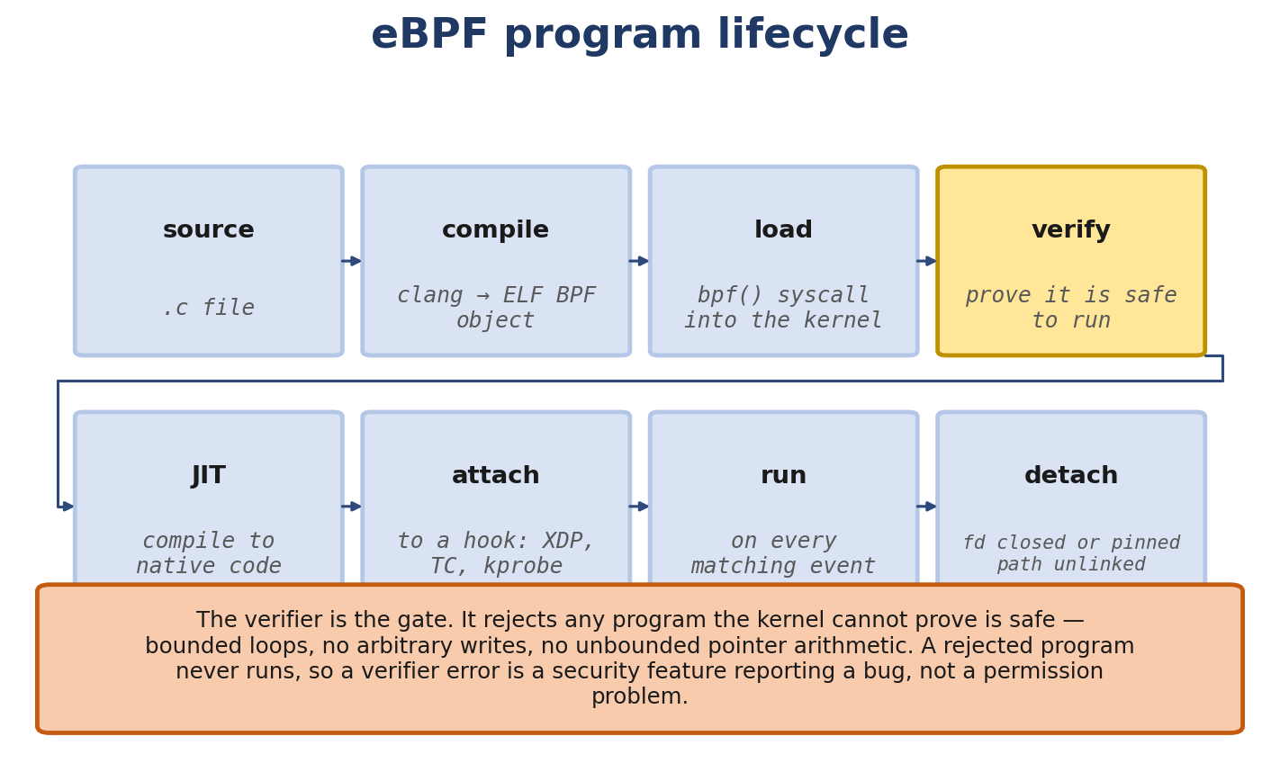
Figure 12.1. The eBPF program lifecycle, and the verifier that gates every load.
- BPF program types: kprobe, tracepoint, XDP, TC, socket, cgroup
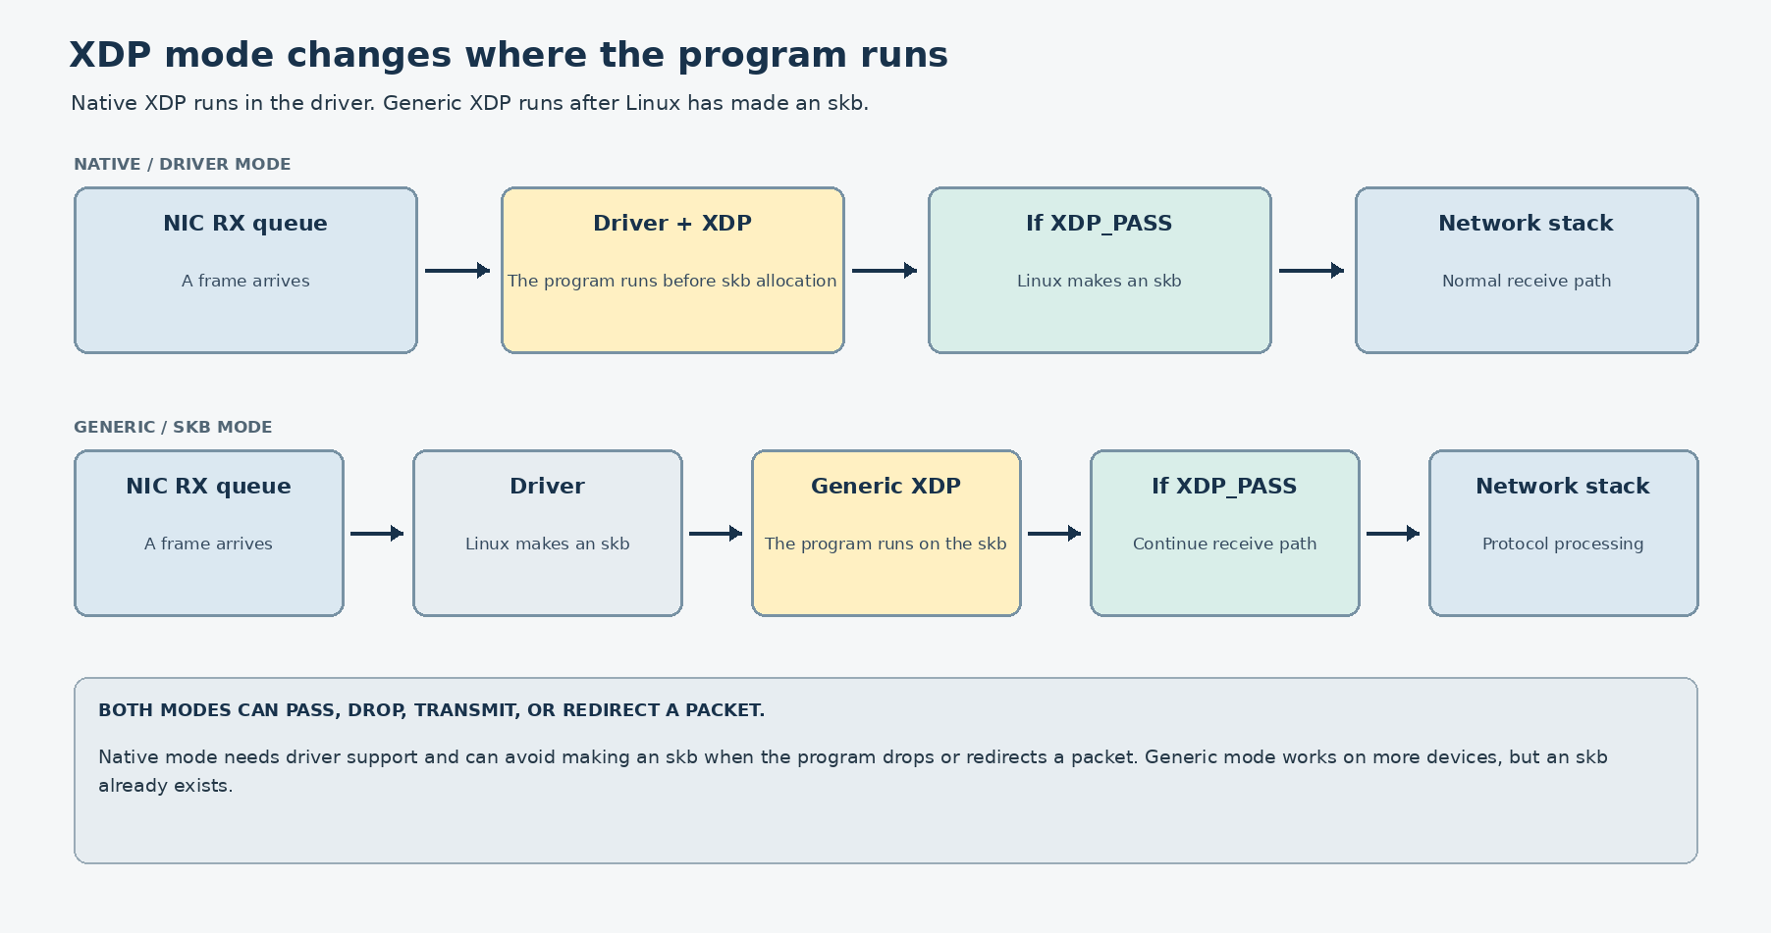
Figure 12.2. Native XDP runs before skb allocation; generic XDP runs after.
- BPF maps: hash, array, ringbuf, perf, LPM trie, devmap, cpumap, XSKMAP
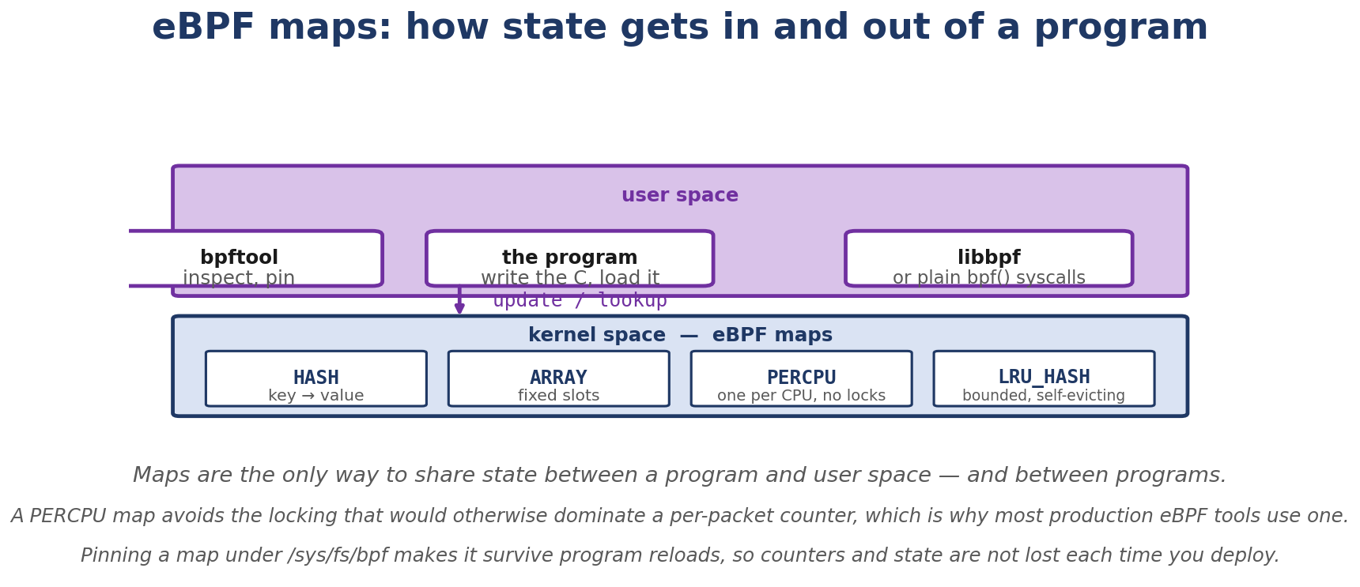
Figure 12.3. eBPF maps: how state gets in and out of a running program.
- BPF helpers
- CO-RE and libbpf
- XDP modes: driver, generic, offload
- XDP actions: DROP, PASS, TX, REDIRECT
- AF_XDP and zero-copy
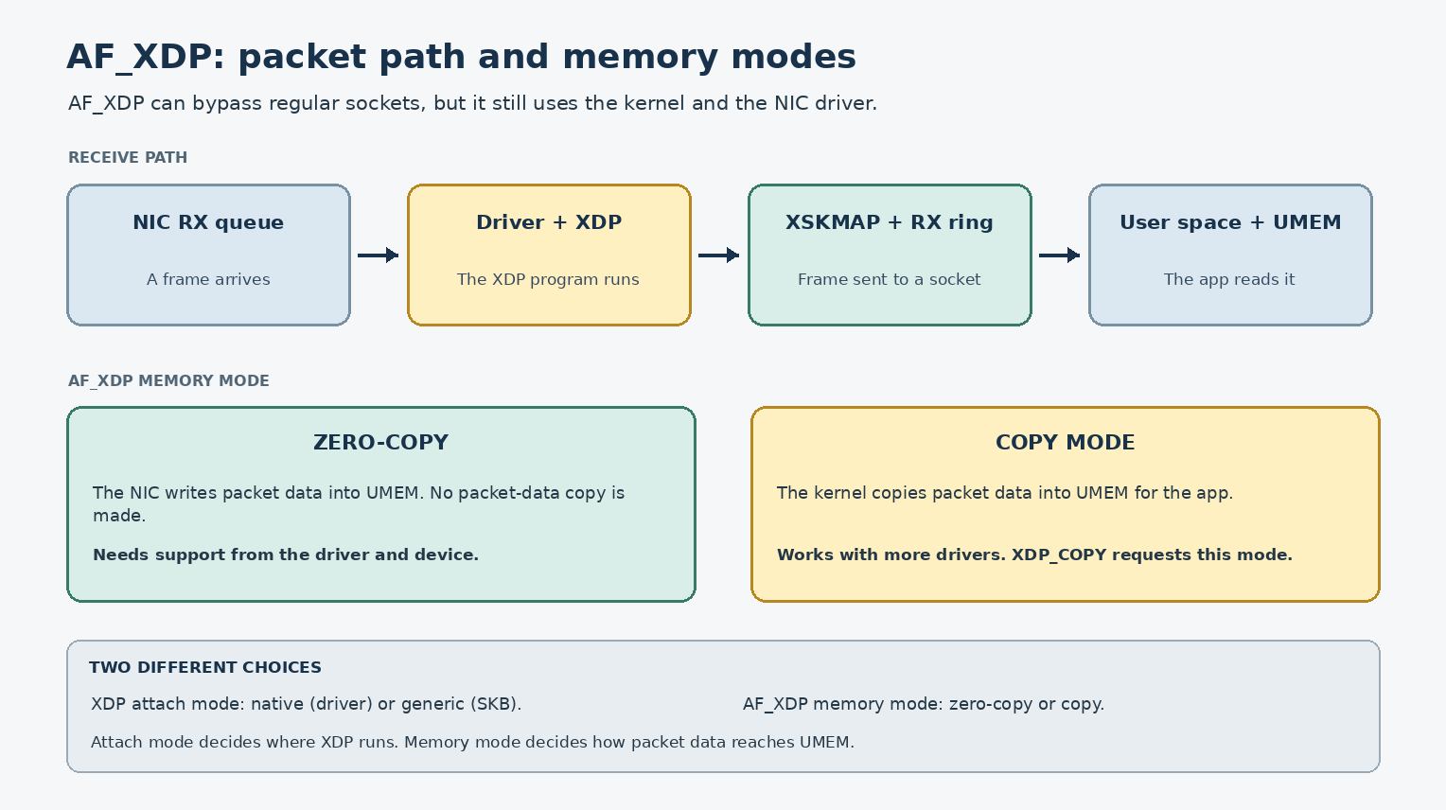
Figure 12.4. AF_XDP packet path, with XDP attach mode and memory mode shown as separate choices.
- Six hands-on eBPF/XDP mini-projects
- The Final Capstone Project: build a complete instrumented network

Real-Life Analogy - The Programmable Inspector
Reality check — where the analogy breaks. The analogy above is a pedagogical tool for building a mental model. It is not a precise description of the kernel mechanism. The real implementation differs from the analogy in ways your interviews and lab work will surface; always reason from the kernel source when precision matters.
Imagine the postal system. There’s a checkpoint at every stage. By default, the checkpoint just looks at the address and forwards. But what if you could install a small robot at any checkpoint to inspect the envelope and make decisions?
eBPF is that robot. You write a small program in C (or BPF assembly), the kernel’s verifier checks that it can’t crash or hang the system, and the kernel JIT-compiles it to native code. Then it’s installed at a hook point (a kprobe, tracepoint, XDP, TC, etc.) and runs whenever a packet (or any kernel event) hits that hook.
XDP is the most powerful: the robot meets the packet before the rest of the stack even knows about it. It can DROP the packet, PASS it to the kernel, TX it back out, or REDIRECT it to another CPU or another interface.

The Networking Concept

BPF history
Classic BPF (cBPF): introduced in 1992. Used for packet filtering (e.g. tcpdump). Limited to a few operations, no loops, no maps. The kernel interpreter ran the bytecode.
Extended BPF (eBPF): introduced in 2014 (kernel 3.18). General-purpose in-kernel virtual machine. Maps (key-value stores), helpers (kernel functions callable from BPF), JIT compilation to native code, hooks everywhere in the kernel.

The verifier
Before a BPF program runs, the verifier simulates every possible execution path. It checks:
The verifier checks every instruction the program can reach. It checks memory access, pointer use, control flow, and stack use. It rejects unreachable instructions and loops it cannot prove will finish within a limit. Bounded loops are allowed on supported kernels.
If the verifier rejects, the program can’t be loaded. This is what makes BPF safe - buggy programs can’t crash the kernel.

Program types
Different program types attach to different hooks:
BPF_PROG_TYPE_KPROBE - attach to a kernel function entry/exit. See every call. BPF_PROG_TYPE_TRACEPOINT - attach to a static tracepoint (more stable than kprobes). BPF_PROG_TYPE_XDP - run on every RX packet, before the kernel stack. BPF_PROG_TYPE_SCHED_CLS / BPF_PROG_TYPE_SCHED_ACT - TC classifier/action. BPF_PROG_TYPE_SOCKET_FILTER - classic BPF, attached to a socket. BPF_PROG_TYPE_CGROUP_SKB - egress/ingress of a cgroup. BPF_PROG_TYPE_CGROUP_SOCK_OPS - socket events in a cgroup. BPF_PROG_TYPE_SK_MSG - socket message-level hooks. BPF_PROG_TYPE_LSM - Linux Security Module hooks.

Map types
Maps are key-value stores shared between BPF programs and user space:
BPF_MAP_TYPE_HASH - generic hash table. BPF_MAP_TYPE_ARRAY - fixed-size array. BPF_MAP_TYPE_PERCPU_HASH / BPF_MAP_TYPE_LRU_PERCPU_HASH - per-CPU variants, no contention. BPF_MAP_TYPE_RINGBUF - efficient ring buffer for events to user space. BPF_MAP_TYPE_PERF_EVENT_ARRAY - perf events. BPF_MAP_TYPE_LPM_TRIE - longest-prefix match (for IP routing). BPF_MAP_TYPE_DEVMAP - XDP_REDIRECT to another interface. BPF_MAP_TYPE_CPUMAP - XDP_REDIRECT to another CPU. BPF_MAP_TYPE_XSKMAP - AF_XDP socket map.

Helpers
BPF programs can call kernel functions (helpers). Examples:
bpf_map_lookup_elem(map, key) - look up in a map. bpf_map_update_elem(map, key, value, flags) - update. bpf_probe_read(dst, size, src) - read kernel memory safely. bpf_get_smp_processor_id() - current CPU. bpf_redirect(ifindex, flags) - XDP redirect to another interface. bpf_xdp_adjust_head(ctx, delta) - adjust headroom (XDP). bpf_skb_store_bytes(skb, offset, from, len, flags) - write into skb. bpf_csum_diff(from, from_size, to, to_size, seed) - checksum diff. bpf_trace_printk(fmt, fmt_size, ...) - debug print (slow, don’t use in production). bpf_ringbuf_output(ringbuf, data, size, flags) - efficient event output.

CO-RE
CO-RE (Compile Once, Run Everywhere) lets you compile a BPF program on one kernel and run it on others, despite struct layout differences. It works by:
BTF (BPF Type Format) embedded in the kernel - describes struct layouts. BPF program records the “type” of each field access (not the offset). At load time, the loader patches offsets based on the target kernel’s BTF.
Requires pahole to generate BTF at compile time, and libbpf to load.

XDP modes
[Linux 6.6, driver-dependent] Three modes:
Native/driver XDP - runs in the NIC driver, before skb creation. Fastest. Requires driver support (e1000, i40e, mlx5, virtio_net, etc. - check the XDP_FEATURES netlink attribute for current capability flags). Generic XDP - runs after skb creation, in the RX path. Universal (any driver). Slower than native. In the kernel’s two-mode taxonomy this is “XDP_SKB” mode. Offloaded XDP - runs on the NIC itself. Limited programs. Rare.
XDP mode depends on the network device and kernel version. Linux 6.6 veth supports native (driver) and generic (skb-based) XDP. Native XDP runs before an skb is made; generic XDP runs after. Check the device capabilities instead of assuming a mode.
$ ip link set dev eth0 xdp obj prog.o sec xdp # native (driver-supported)
$ ip link set dev eth0 xdp generic obj prog.o sec xdp # force generic
$ ip link set dev eth0 xdp off # remove

XDP actions
#include <linux/bpf.h>
#include <linux/if_ether.h>
#include <linux/ip.h>
#include <bpf/bpf_helpers.h>
SEC("xdp")
int my_prog(struct xdp_md *ctx)
{
void *data = (void *)(long)ctx->data;
void *data_end = (void *)(long)ctx->data_end;
struct ethhdr *eth = data;
if ((void *)(eth + 1) > data_end)
return XDP_ABORTED;
if (eth->h_proto != __constant_htons(ETH_P_IP))
return XDP_PASS;
struct iphdr *iph = (void *)(eth + 1);
if ((void *)(iph + 1) > data_end)
return XDP_ABORTED;
return XDP_PASS;
}
Actions:
XDP_PASS - pass to the kernel stack. XDP_DROP - drop the packet. XDP_TX - transmit back out the same interface. XDP_REDIRECT - redirect to another interface or CPU. XDP_ABORTED - drop (with trace message). Like XDP_DROP but indicates a programming error.

AF_XDP
AF_XDP is a socket API for moving packets between XDP and user space. It has copy and zero-copy modes. By default, the kernel tries zero-copy and can fall back to copy mode if the driver does not support zero-copy. You can request a mode with XDP_COPY or XDP_ZEROCOPY; the request fails if that mode is not available. Zero-copy also needs packets to reach the queue used by the socket. AF_XDP bypasses the regular socket path, but it still uses the kernel and the driver.
Setup:
struct xsk_socket *xsk;
struct xsk_ring_cons rx_ring;
struct xsk_ring_prod tx_ring;
struct xsk_ring_cons comp_ring;
struct xsk_ring_prod fill_ring;
xsk_socket__create(&xsk, "eth0", 0, &umem, &rx_ring, &tx_ring,
&fill_ring, &comp_ring, NULL);
The user-space program fills descriptors in the fill ring (giving buffers to the kernel for RX), receives packets from the rx ring, and sends packets via the tx ring.
Used for high-performance packet processing (DPDK alternative, eXpress Data Path).

Socket filters
Classic BPF programs attached to a socket:
SEC("socket")
int my_filter(struct __sk_buff *skb)
{
/* Drop UDP */
if (skb->protocol == ETH_P_IP) {
struct iphdr *iph = (void *)(long)skb->data + ETH_HLEN;
if (iph + 1 <= (void *)(long)skb->data_end) {
if (iph->protocol == IPPROTO_UDP)
return 0; // drop
}
}
return skb->len; // pass
}
Attach:
bpftool prog load filter.o /sys/fs/bpf/filter
# classic/eBPF socket filters attach via the socket API:
setsockopt(sock, SOL_SOCKET, SO_ATTACH_BPF, &prog_fd, sizeof(prog_fd))
# bpftool prog attach PROG ATTACH_TYPE [MAP] does not take a 'socket id'

cgroup networking
BPF programs can attach to cgroups, applying to all sockets/processes in that cgroup:
BPF_CGROUP_INET_INGRESS - incoming connections. BPF_CGROUP_INET_EGRESS - outgoing connections. BPF_CGROUP_SOCK_OPS - socket state changes.
Useful for container-level policies (e.g. “containers in this cgroup can only use HTTP”).

Follow the Packet - Where Programs Hook
Wire
|
v
NIC
|
v
Driver (NAPI start)
|
v
[XDP] ← eBPF can run here (XDP_DROP, XDP_TX, XDP_REDIRECT, XDP_PASS)
|
v
[TC ingress] ← eBPF can run here (clsact)
|
v
[Netfilter PREROUTING]
|
v
[IP stack]
|
v
[Netfilter INPUT]
|
v
[Socket filter] ← eBPF can run here (BPF_PROG_TYPE_SOCKET_FILTER)
|
v
Application
|
v
[Socket filter / sendmsg]
|
v
[Netfilter OUTPUT]
|
v
[Netfilter POSTROUTING]
|
v
[TC egress] ← eBPF can run here (clsact)
|
v
Driver (TX)
|
v
NIC
|
v
Wire

Linux View

bpftool
# End-to-end bpftool / ip workflow (Linux 6.6, bpftool v6.x):
$ sudo bpftool prog loadall foo.o /sys/fs/bpf/foo
$ sudo bpftool net attach xdp pinned /sys/fs/bpf/foo/xdp_prog dev eth0
$ sudo bpftool prog show
$ sudo bpftool prog tracelog
$ sudo bpftool prog dump xlated id 1
$ sudo bpftool prog dump jited id 1 # only if JIT is enabled
$ ping 8.8.8.8
# Remove the attachment before cleaning up the pinned files.
$ sudo bpftool net detach xdp dev eth0
$ sudo rm -rf /sys/fs/bpf/foo
# Alternative, for the same object:
$ sudo ip link set dev eth0 xdp obj foo.o sec xdp

bpftrace
A scripting language for eBPF:
$ sudo bpftrace -e 'kprobe:dev_queue_xmit { @[comm] = count(); }'
$ sudo bpftrace -l # list probes
$ sudo bpftrace -e 'tracepoint:skb:kfree_skb { @[args->reason] = count(); }'

Kernel View
Key files:
kernel/bpf/verifier.c - the verifier. kernel/bpf/core.c - interpreter and JIT. net/core/filter.c - socket filter and TC BPF. net/core/dev.c - XDP entry point. drivers/net/virtio_net.c - XDP support in virtio-net. include/uapi/linux/bpf.h - BPF UAPI. include/linux/bpf.h - internal BPF definitions.
Key functions:
bpf_prog_run - run a BPF program. bpf_map_* - map operations. bpf_check - verifier entry.

Source Code Walkthrough

Excerpt 1: bpf_prog_run (kernel/bpf/core.c, abbreviated)
static unsigned int bpf_prog_run(const struct bpf_prog *prog, void *ctx)
{
...
return prog->bpf_func(ctx, prog->insnsi);
}
bpf_func is the JIT-compiled native code. For interpreted mode, it’s __bpf_prog_run.

Excerpt 2: XDP program skeleton
#include <linux/bpf.h>
#include <bpf/bpf_helpers.h>
SEC("xdp")
int xdp_drop_udp(struct xdp_md *ctx)
{
void *data = (void *)(long)ctx->data;
void *data_end = (void *)(long)ctx->data_end;
struct ethhdr *eth = data;
if ((void *)(eth + 1) > data_end)
return XDP_ABORTED;
if (eth->h_proto != __constant_htons(ETH_P_IP))
return XDP_PASS;
struct iphdr *iph = (void *)(eth + 1);
if ((void *)(iph + 1) > data_end)
return XDP_ABORTED;
if (iph->protocol == IPPROTO_UDP)
return XDP_DROP;
return XDP_PASS;
}
char _license[] SEC("license") = "GPL";
Compile:
clang -O2 -target bpf -c prog.c -o prog.o

Excerpt 3: TC BPF program skeleton
struct {
__uint(type, BPF_MAP_TYPE_ARRAY);
__uint(max_entries, 1);
__type(key, __u32);
__type(value, __u64);
} packet_count SEC(".maps");
SEC("tc")
int tc_count_packets(struct __sk_buff *skb)
{
__u32 key = 0;
__u64 *count = bpf_map_lookup_elem(&packet_count, &key);
if (count)
__sync_fetch_and_add(count, 1);
return TC_ACT_OK;
}
(Note: in modern libbpf with BTF, you use BTF-defined maps; the old-style bpf_map_def is deprecated.)

Hands-On Lab - Six Mini-Projects

Mini-Project 1: BPF packet counter
A simple program that counts packets on a per-CPU basis.
// count_packets.c
#include <linux/bpf.h>
#include <bpf/bpf_helpers.h>
struct {
__uint(type, BPF_MAP_TYPE_PERCPU_ARRAY);
__uint(max_entries, 1);
__type(key, __u32);
__type(value, __u64);
} pkt_count SEC(".maps");
SEC("xdp")
int count_packets(struct xdp_md *ctx)
{
__u32 key = 0;
__u64 *count = bpf_map_lookup_elem(&pkt_count, &key);
if (count)
__sync_fetch_and_add(count, 1);
return XDP_PASS;
}
char _license[] SEC("license") = "GPL";
clang -O2 -target bpf -c count_packets.c -o count_packets.o
[Linux 6.6, iproute2/bpftool version-dependent] The modern idioms are:

Load a program from an ELF object and pin it by name:
sudo bpftool prog loadall count_packets.o /sys/fs/bpf/cp

Attach the pinned XDP program to an interface:
sudo bpftool net attach xdp pinned /sys/fs/bpf/cp/xdp_prog dev eth0

Or, more simply, attach in one step from an ELF object:
sudo bpftool net attach xdp obj count_packets.o sec xdp dev eth0 # or: sudo ip link set dev eth0 xdp obj count_packets.o sec xdp

Or use iproute2 (also widely used):
sudo ip link set dev eth0 xdp obj count_packets.o sec xdp
Always check the bpftool/iproute2 versions you have (`bpftool version`, `ip -V`) and refer to that version's man page; the syntax has evolved. # 2 = eth0
# Generate traffic
ping 8.8.8.8
# Read counter
sudo bpftool map dump pinned /sys/fs/bpf/cp
key: 00 00 00 00 value: 12
# Detach
sudo bpftool net detach xdp dev eth0

Mini-Project 2: Interface monitor
Count skb packets entering the TX path, grouped by device, once per second. This counts calls to dev_queue_xmit(); it does not prove that a frame reached the wire.
sudo bpftrace -e '
kprobe:dev_queue_xmit {
$skb = (struct sk_buff *)arg0;
if ($skb->dev) {
@tx[str($skb->dev->name)] = count();
}
}
interval:s:1 {
print(@tx);
clear(@tx);
}'

Mini-Project 3: TCP connection monitor
sudo bpftrace -e '
tracepoint:sock:inet_sock_set_state {
$sk = (struct sock *)args->skaddr;
printf("%s %s:%d -> %s:%d state %d -> %d\n",
comm, $sk->__sk_common.skc_rcv_saddr,
$sk->__sk_common.skc_num,
$sk->__sk_common.skc_daddr,
$sk->__sk_common.skc_dport,
args->oldstate, args->newstate);
}
'

Mini-Project 4: Drop monitor
sudo bpftrace -e '
kprobe:kfree_skb_reason /arg0/ {
$skb = (struct sk_buff *)arg0;
@[comm, $skb->protocol] = count();
}'

Mini-Project 5: Latency histogram
sudo bpftrace -e '
kprobe:dev_queue_xmit {
@start[tid] = nsecs;
}
kretprobe:dev_queue_xmit /@start[tid]/ {
@lat = hist(nsecs - @start[tid]);
@count = count();
delete(@start[tid]);
}

Mini-Project 6: XDP_DROP on a veth
XDP program that drops 50% of packets from a specific source IP:
// drop_xdp.c - 50% XDP drop, complete and compilable (Linux 6.6, libbpf, clang >= 14)
#include <linux/bpf.h>
#include <linux/if_ether.h>
#include <linux/ip.h>
#include <bpf/bpf_helpers.h>
// 1. Declare every map BEFORE referencing it.
// PERCPU avoids the lock — each CPU tracks its own counter, the
// reader sums across CPUs.
struct {
__uint(type, BPF_MAP_TYPE_PERCPU_ARRAY);
__uint(max_entries, 1);
__type(key, __u32);
__type(value, __u64);
} drop_count SEC(".maps");
// 2. The program.
SEC("xdp")
int drop_prog(struct xdp_md *ctx)
{
void *data = (void *)(long)ctx->data;
void *data_end = (void *)(long)ctx->data_end;
// minimal bounds check — the only mandatory verifier step
if (data + sizeof(struct ethhdr) > data_end)
return XDP_PASS;
// 3. Increment the per-CPU counter atomically. __sync_fetch_and_add
// is the portable C way to do an atomic add without explicit
// atomics in BPF; the verifier accepts it on __u64.
__u32 key = 0;
__u64 *cnt = bpf_map_lookup_elem(&drop_count, &key);
if (cnt) __sync_fetch_and_add(cnt, 1);
// 4. Drop every other packet deterministically — that gives the 50%.
// Without the random source the verifier rejects nondeterminism.
if (bpf_get_prandom_u32() & 1)
return XDP_DROP;
return XDP_PASS;
}
char _license[] SEC("license") = "GPL";
$ clang -O2 -g -target bpf -Wall \
-I/usr/include/x86_64-linux-gnu \
-c drop_xdp.c -o drop_xdp.o
# Pin and attach (always detach before exiting — see the runbook above):
$ sudo bpftool prog loadall drop_xdp.o /sys/fs/bpf/drop_xdp
$ sudo ip link set dev veth-a xdp pinned /sys/fs/bpf/drop_xdp/drop_prog
# Observe the per-CPU counter (sum across CPUs):
$ sudo bpftool map dump pinned /sys/fs/bpf/drop_xdp/drop_count | tail -n +2 \
| awk '{s+=$2} END {print "total dropped:", s}'
# Teardown (do this before you reboot or you will leave the XDP hook attached):
$ sudo ip link set dev veth-a xdp off
$ sudo rm -rf /sys/fs/bpf/drop_xdp

Final Capstone Project - Build a Mini Linux Network

Topology
Linux Host
|
+-------------------+-------------------+
| |
ns-client ns-router
veth-c0 | veth-r0 (192.168.10.0/24) veth-r1 | veth-s0 (192.168.20.0/24)
| |
+-- [optional bridge] --+ +-- ns-server
|
veth-ob0 (192.168.99.0/24) - observer
|
ns-observer

Goals
Build a network that exercises every concept from the book:
- Ethernet, ARP - basic connectivity.
- IP, Routing - multi-subnet via L3 router.
- TCP, UDP - at least one of each.
- Firewall, NAT - nftables on the router.
- Packet capture - tcpdump on every link.
- Packet drops - bpftrace drop monitor.
- Performance testing - iperf3.
- Kernel observation - ftrace / bpftrace.
- eBPF monitoring - observability tool.

Step 1 - Setup
sudo ip netns add ns-client
sudo ip netns add ns-router
sudo ip netns add ns-server
sudo ip netns add ns-observer
sudo ip link add veth-c0 type veth peer name veth-r0
sudo ip link add veth-r1 type veth peer name veth-s0
sudo ip link add veth-r2 type veth peer name veth-ob0
sudo ip link set veth-c0 netns ns-client
sudo ip link set veth-r0 netns ns-router
sudo ip link set veth-r1 netns ns-router
sudo ip link set veth-s0 netns ns-server
sudo ip link set veth-r2 netns ns-router
sudo ip link set veth-ob0 netns ns-observer
sudo ip netns exec ns-client ip addr add 192.168.10.1/24 dev veth-c0
sudo ip netns exec ns-client ip link set veth-c0 up
sudo ip netns exec ns-client ip route add default via 192.168.10.254
sudo ip netns exec ns-router ip addr add 192.168.10.254/24 dev veth-r0
sudo ip netns exec ns-router ip addr add 192.168.20.254/24 dev veth-r1
sudo ip netns exec ns-router ip addr add 192.168.99.254/24 dev veth-r2
sudo ip netns exec ns-router ip link set veth-r0 up
sudo ip netns exec ns-router ip link set veth-r1 up
sudo ip netns exec ns-router ip link set veth-r2 up
sudo ip netns exec ns-router sysctl -w net.ipv4.ip_forward=1
sudo ip netns exec ns-server ip addr add 192.168.20.1/24 dev veth-s0
sudo ip netns exec ns-server ip link set veth-s0 up
sudo ip netns exec ns-server ip route add default via 192.168.20.254
sudo ip netns exec ns-observer ip addr add 192.168.99.1/24 dev veth-ob0
sudo ip netns exec ns-observer ip link set veth-ob0 up
sudo ip netns exec ns-observer ip route add default via 192.168.99.254

Step 2 - Configure the firewall and NAT
In ns-router:
sudo ip netns exec ns-router nft flush ruleset
sudo ip netns exec ns-router nft add table ip filter
sudo ip netns exec ns-router nft 'add chain ip filter input { type filter hook input priority 0; policy drop; }'
sudo ip netns exec ns-router nft 'add chain ip filter forward { type filter hook forward priority 0; policy drop; }'
sudo ip netns exec ns-router nft 'add rule ip filter input ct state established,related accept'
sudo ip netns exec ns-router nft 'add rule ip filter input iif lo accept'
sudo ip netns exec ns-router nft 'add rule ip filter input ip protocol icmp accept'
sudo ip netns exec ns-router nft 'add rule ip filter forward ct state established,related accept'
sudo ip netns exec ns-router nft 'add rule ip filter forward iif veth-r0 oif veth-r1 accept'
sudo ip netns exec ns-router nft 'add rule ip filter forward iif veth-r1 oif veth-r0 accept'
# NAT
sudo ip netns exec ns-router nft add table ip nat
sudo ip netns exec ns-router nft 'add chain ip nat postrouting { type nat hook postrouting priority 100; }'
sudo ip netns exec ns-router nft 'add rule ip nat postrouting ip saddr 192.168.10.0/24 oif veth-r1 masquerade'

Step 3 - Start a service in ns-server
# In ns-server, start a netcat listener
sudo ip netns exec ns-server nc -l -p 8080

Step 4 - Capture on every link
In four terminals, one per link:
sudo ip netns exec ns-client tcpdump -ni veth-c0 -w /tmp/cap-client.pcap
sudo ip netns exec ns-router tcpdump -ni veth-r0 -w /tmp/cap-router-r0.pcap
sudo ip netns exec ns-router tcpdump -ni veth-r1 -w /tmp/cap-router-r1.pcap
sudo ip netns exec ns-server tcpdump -ni veth-s0 -w /tmp/cap-server.pcap
Capture on ns-observer to see packets sent to or from that interface. It will not show unrelated unicast traffic between other hosts. To see that traffic, capture on a router in the path or use a switch mirror port.

Step 5 - Run traffic
From ns-client:
sudo ip netns exec ns-client curl http://192.168.20.1:8080
# (well, nc just echoes - but you can do something useful here)
Or run iperf3:
# In ns-server
sudo ip netns exec ns-server iperf3 -s
# In ns-client
sudo ip netns exec ns-client iperf3 -c 192.168.20.1 -t 30

Step 6 - Watch conntrack and NAT
In ns-router:
sudo ip netns exec ns-router conntrack -E
Watch the entries appear and update.

Step 7 - Inject loss
In ns-router:
sudo ip netns exec ns-router tc qdisc add dev veth-r1 root netem loss 10%
Re-run iperf3. Watch throughput drop, retransmits climb.

Step 8 - Drop monitoring with bpftrace
In ns-router:
sudo bpftrace -e '
kprobe:kfree_skb_reason /arg0/ {
@[arg1] = count();
}
interval:s:5 {
print(@);
clear(@);
}
'

Step 9 - eBPF observability tool
Build a small BPF program that monitors:
Packet counts per interface. Drop reasons. Latency (dev_queue_xmit → netif_receive_skb for veth-r0, round trip).
Combine with a bpftrace one-liner:
sudo bpftrace -e '
kprobe:dev_queue_xmit {
@start[tid] = nsecs;
}
kretprobe:dev_queue_xmit /@start[tid]/ {
@lat = hist(nsecs - @start[tid]);
@count = count();
delete(@start[tid]);
}
interval:s:1 {
printf("dev_queue_xmit calls/s: %d\n", @count);
print(@lat);
clear(@lat);
clear(@count);
}

Step 10 - Final mystery fault
Introduce a fault and let the reader diagnose. For example:
Remove a route: sudo ip netns exec ns-router ip route del 192.168.20.0/24 dev veth-r1 - packets from ns-client reach router but no reply. Misconfigure NAT: remove the MASQUERADE rule - replies don’t come back. Block a port: add an nftables rule dropping tcp 8080.

Deliverable checklist
The reader should be able to confirm:
[ ] All four namespaces can ping each other. [ ] TCP and UDP traffic flows client → server and back. [ ] nftables firewall logs show accepted/dropped packets. [ ] conntrack shows entries for both client-to-server flows. [ ] iperf3 throughput matches expectations. [ ] Drop injection causes observable drops in bpftrace. [ ] XDP drop monitor works (if implemented). [ ] Final mystery fault diagnosed using the methodology.

Wrap-up: setup.sh and teardown.sh
Encourage the reader to write a single setup.sh and teardown.sh that builds and tears down the entire environment. This becomes their personal networking playground.

Interview Questions
Q12.1 (Beginner) - What is eBPF?
eBPF (extended Berkeley packet filter) is a programmable system in Linux. A verifier checks each program before it can run. The kernel can interpret it or compile it to machine code with a just-in-time (JIT) compiler when JIT is enabled and supported. Programs can attach to XDP, traffic control, tracing, sockets, cgroups, and security hooks. Maps share data; helper functions provide approved kernel operations.
Q12.2 (Beginner) - What is the verifier?
The verifier checks a BPF program before the kernel accepts it. It checks memory access, pointers, control flow, and bounded work. A program can run in the interpreter or use a JIT compiler when JIT is enabled and supported.
Q12.3 (Intermediate) - What is XDP?
Express Data Path. A hook in the NIC driver (or generic mode) that runs BPF programs on every received packet before the kernel network stack processes it. XDP programs can DROP, PASS, TX, or REDIRECT packets at line rate.
Q12.4 (Intermediate) - Compare XDP driver mode vs generic mode.
Driver mode: runs in the NIC driver, before skb creation. Fastest. Requires driver support. Generic mode: runs after skb creation, in the RX path. Universal (any driver). Slower. Driver mode is the production choice when available.
Q12.5 (Intermediate) - What is AF_XDP?
A socket API for packets from XDP to user space. It can copy packet data or use zero-copy when the driver supports it.
Q12.6 (Intermediate) - What is CO-RE?
Compile Once, Run Everywhere. A [Linux 5.x+] CO-RE (Compile Once, Run Everywhere) uses BTF (BPF Type Format) information. At compile time, the BPF program is built against the BTF of your local kernel/headers, and the loader (libbpf) records the types and access patterns. At load time on the target kernel, libbpf reads the target’s /sys/kernel/btf/vmlinux and performs relocations against the target’s actual struct layouts - rewriting offsets so the program matches the running kernel’s structures without recompilation. The tool that emits BTF in your ELF is pahole (used during build); the kernel itself generates BTF if CONFIG_DEBUG_INFO_BTF=y is set, and many distros ship vmlinux BTF files. pahole is therefore a build-time helper for emitting BTF into BPF object files, not a runtime requirement. At load time, the loader patches offsets using the target kernel’s BTF (BPF Type Format). Allows the same compiled BPF object to work on different kernel versions.
Q12.7 (Advanced) - How does BPF communicate with user space?
Maps (key-value stores) and ring buffers. BPF programs write events into maps; user space reads them. For high-throughput events, ringbuf is preferred. For per-event sampling, perf event array works. Maps can also be used for configuration (user space writes, BPF reads).
Q12.8 (Advanced) - How do you write a BPF program that handles missing helpers on older kernels?
Use bpf_core_enum_value_exists and bpf_core_field_exists (CO-RE helpers) to check at load time. Or use #ifdef based on the kernel version. For production code, check at runtime and fall back.
Q12.9 (eBPF internals) - Walk through what happens when an XDP program is loaded.
- bpftool prog load foo.o /sys/fs/bpf/foo is called.
- The kernel parses the ELF, finds the SEC("xdp") section.
- The verifier runs through every instruction, simulating execution.
- If verification passes, the kernel accepts the program. It may use the interpreter or a JIT compiler, depending on kernel settings and CPU support.
- The compiled code is stored in the kernel.
- Use either `bpftool net attach xdp id PROG_ID dev IFACE` or `bpftool net attach xdp pinned FILE dev IFACE` to attach an XDP program to a network device. The exact attach syntax depends on the installed iproute2/bpftool version; keep the command form consistent in the same lab and check `bpftool version` and `ip -V` before you rely on it.
- From that point, every packet triggers the program.
Q12.10 (eBPF internals) - How does the verifier handle loops?
Verifiable loops must have a constant or bounded trip count. The verifier analyzes each branch and ensures the program terminates. Unbounded loops are rejected. Helper functions and BPF-to-BPF function calls are also bounded.
Q12.11 (Troubleshooting) - A BPF program fails to load with “permission denied”. What do you check?
- Are you root? (2) Is kernel.unprivileged_bpf_disabled=1? Need CAP_BPF or CAP_SYS_ADMIN. (3) Is the program type allowed for unprivileged users? (4) Is the BTF available in the kernel?
Q12.12 (Troubleshooting) - A BPF program loads but doesn’t see any events. What do you check?
- Is the program attached to the right hook? (2) Is the event source generating events? (3) Are your map lookups correct? (4) Use bpftool prog tracelog to see trace_printk output.

Key Takeaways
eBPF is a programming system inside the Linux kernel. The verifier checks each program before it runs. The kernel may interpret the program or use a just-in-time (JIT) compiler when JIT is enabled and supported. Programs can attach to places such as XDP, traffic control, tracing, sockets, and cgroups. Maps hold data shared with user space or other programs; helper functions give programs approved kernel services.

Practice Challenges
- Complete all six mini-projects.
- Build the capstone project end-to-end. Run it; verify every checklist item.
- Modify the capstone. Add a new namespace. Add a new service. Add a new firewall rule.
- Write a BPF program that implements a custom load balancer (e.g. XDP chooses backend based on source IP hash).
- Try libbpf-bootstrap. https://github.com/libbpf/libbpf-bootstrap has examples.
- Read kernel/bpf/verifier.c. Find the loop-bounding logic.
- Use bpftrace for everyday debugging. Replace your old tcpdump + grep workflows.

Afterword - Where to Go From Here
You have the foundation. To deepen:
Kernel source: read net/ipv4/tcp.c, net/core/dev.c, kernel/bpf/verifier.c. Advanced networking: dive into the Linux kernel’s BPF docs (https://www.kernel.org/doc/html/latest/networking/), cilium/ebpf papers. Performance: Brendan Gregg’s “Systems Performance” and the “BPF Performance Tools” book. Tools: perf, bpftrace, bpftool, Wireshark, ethtool - these are your everyday companions.
The most important thing: keep tracing packets. Every time something doesn’t work, walk the layer model. You’ll be surprised how often a 30-second tcpdump reveals the answer.
Welcome to the network engineer’s view of the world.

Appendix A - Common Linux Networking Pitfalls
This appendix collects the most common mistakes engineers make when debugging Linux networking, organized by layer. Use it as a checklist when something is broken.

Layer 1: Application
Symptom: “My app can’t reach the server.” - Check the application logs first. The error message usually tells you which syscall failed and why. - strace -e trace=network,read,write -p <pid> shows exactly what the application is doing. - lsof -p <pid> shows open file descriptors and which are sockets. - For Python: python3 -X dev enables ResourceWarning. For Go: net/http logs connection failures.
Symptom: “The app says it connected but no data flows.” - The TCP handshake might complete but the application reads no data. Check ss -tin 'sport = :<port>' for cwnd and rtt. - recv might be blocking on a socket with no data ready. Confirm with non-blocking mode and epoll.

Layer 2: Sockets
Symptom: “bind: Address already in use” - Another process holds the port. ss -ltnp | grep :<port> shows who. - For restarting servers quickly, set SO_REUSEADDR before bind. - For multiple processes sharing a port, set SO_REUSEPORT (kernel 3.9+).
Symptom: “Too many open files” - Per-process FD limit hit. Check ulimit -n. - System-wide limit: cat /proc/sys/fs/file-max. - For network servers, increase both: ulimit -n 65535 in the systemd unit, and /etc/security/limits.conf.
Symptom: “Connection reset by peer” - The peer sent RST. Either no listener or active rejection. - ss -tnp '( dport = :<port> )' shows if there’s a half-open SYN-SENT. - tcpdump shows SYN, SYN-ACK, RST.

Layer 3: Routing
Symptom: “Network is unreachable” - The kernel has no route for the destination. ip route get <dst> shows what it would do. - Usually missing default route: ip route add default via <gateway> dev <iface>.
Symptom: “Asymmetric routing” - Outgoing traffic goes out one interface; replies come back on another. - Often the issue is asymmetric routing + rp_filter=1. Solution: sysctl -w net.ipv4.conf.<iface>.rp_filter=2 for loose mode.
Symptom: “Packets go out the wrong interface” - More specific route exists. ip route get <dst> shows what the kernel picks. - Longest prefix match wins. A /32 beats a /24.

Layer 4: Firewall
Symptom: “Ping works, TCP fails” - Firewall allows ICMP but not TCP. nft list ruleset to inspect. - Common cause: missing ct state established,related accept in INPUT chain.
Symptom: “Connection refused” with no listener - The peer sent RST. Either no process is listening or a rule rejected with REJECT. - nft list ruleset for REJECT rules; ss -ltnp for the listener.
Symptom: “Conntrack table full” - nf_conntrack_max reached. Default 65536. Increase via sysctl. - For servers under attack, lower timeouts: nf_conntrack_tcp_timeout_established.

Layer 5: Neighbor / ARP
Symptom: “Destination Host Unreachable” - ARP failed. ip neigh show shows no entry or FAILED state. - tcpdump -nei <iface> arp shows ARP requests but no replies. Usually the peer is on a different subnet.
Symptom: “ARP flapping” - Two hosts claim the same IP. Both send gratuitous ARP. - Look for IP conflicts in DHCP logs; check the network for rogue devices.

Layer 6: Interface / Driver / NIC
Symptom: “NO-CARRIER on the interface” - Physical link is down. Check cable, switch port, NIC lights. - For virtual interfaces (veth, bridge), check the peer end.
Symptom: “rx_missed climbs” - The NIC is receiving packets faster than the driver can process. - Increase ring buffer size: ethtool -G <iface> rx 4096. - Increase NAPI budget: sysctl net.core.netdev_budget (kernel 5.x+).
Symptom: “Driver crashes under load” - Check dmesg for backtraces. Often firmware issues. - ethtool --show-firmware <iface> shows the loaded firmware version.

Layer 7: Application Protocol
Symptom: “TLS handshake fails” - Old TLS version mismatch. openssl s_client -connect <host>:<port> shows the negotiation. - Cipher suite mismatch (e.g. server requires TLS 1.3 but client is 1.2).
Symptom: “DNS works but app cannot resolve” - /etc/nsswitch.conf order issue. The application uses a different resolver than getent. - For containers, check /etc/resolv.conf and whether systemd-resolved is running.

Appendix B - Glossary
ACK — TCP acknowledgment. The receiver sends an ACK with the next expected sequence number to confirm receipt.
AF_INET — Address family for IPv4. Use AF_INET6 for IPv6, AF_UNIX for local sockets.
ARP — Address Resolution Protocol. Maps an IPv4 address to a MAC address on the local segment.
AS — Autonomous System. A network or set of networks under a single administrative domain.
BPF / eBPF — Berkeley Packet Filter / extended BPF. An in-kernel virtual machine that runs sandboxed programs.
Bridge — A Layer-2 device that forwards frames based on MAC addresses. Linux bridge is a software switch.
Checksum offload — Letting the NIC compute or verify TCP/UDP/IP checksums instead of the CPU.
CIDR — Classless Inter-Domain Routing. Address notation like 192.168.1.0/24 where /24 is the prefix length.
Conntrack — The connection tracking subsystem in netfilter. Tracks stateful connections.
Cubic — Linux TCP congestion control algorithm. Verify on the running system with 'sysctl net.ipv4.tcp_congestion_control'; the kernel default and distro overrides vary.
DSCP — Differentiated Services Code Point. Used in IPv4 ToS and IPv6 Traffic Class for QoS.
DMA — Direct Memory Access. NIC transfers data to/from host memory without CPU involvement.
EtherType — 16-bit field in the Ethernet header indicating the protocol encapsulated (0x0800 = IPv4).
FIB — Forwarding Information Base. The kernel’s routing table structure.
GRO — Generic Receive Offload. Combines multiple incoming packets into one large skb.
GSO — Generic Segmentation Offload. Defers segmentation to the device.
ICMP — Internet Control Message Protocol. Used for ping, traceroute, error messages.
IRQ — Interrupt Request. Hardware signal to the CPU. Modern NICs use MSI-X.
LRO — Large Receive Offload. Driver-side aggregation (largely deprecated in favor of GRO).
MAC — Media Access Control. The 48-bit hardware address of a network interface.
MSS — Maximum Segment Size. The largest TCP payload, typically MTU - 40 (IPv4 + TCP headers).
MTU — Maximum Transmission Unit. Largest packet size on a link, typically 1500 for Ethernet.
NAPI — New API. Modern packet receive mechanism using interrupts and polling.
NAT — Network Address Translation. Rewriting source or destination addresses.
ND — Neighbor Discovery. IPv6 protocol that replaces ARP.
Nftables — Modern Linux firewall framework (replaces iptables).
NUMA — Non-Uniform Memory Access. Multi-socket systems have local and remote memory.
PCIe — Peripheral Component Interconnect Express. The bus modern NICs use.
PMTUD — Path MTU Discovery. Process of finding the smallest MTU along a path.
Qdisc — Queuing discipline. Per-interface packet scheduler (fq_codel, fq, pfifo_fast, etc.).
RPS — Receive Packet Steering. Software RSS, distributes RX across CPUs.
RFS — Receive Flow Steering. RPS + flow-aware CPU pinning.
RSS — Receive Side Scaling. Hardware hash → RX queue assignment.
RTT — Round-trip time. Time for a packet to reach the peer and back.
RX / TX — Receive / transmit.
SIIT — Stateless IP/ICMP Translation (RFC 6145). Used in IPv6 transition.
SLAAC — Stateless Address Autoconfiguration. IPv6 address assignment from router advertisements.
SO_REUSEADDR / SO_REUSEPORT — Socket options for port reuse.
- SO_REUSEADDR controls address/port rebinding semantics for bind(). From socket(7): it “indicates that the rules used in validating addresses supplied in a bind() call should allow reuse of local addresses. For AF_INET sockets this means that a socket may bind, except when there is an active listening socket bound to the address.” Concretely: it allows a socket to bind to an address/port with another socket in a non-LISTEN state (commonly TIME_WAIT). It does NOT delete TIME_WAIT entries or change TIME_WAIT duration. Whether “restarting a server would fail for ~60s” depends on the exact local/remote address matrix; see the socket(7) table.
- SO_REUSEPORT (Linux 3.9+) lets multiple sockets bind to the same address/port combination, each with the option set. The kernel load-balances incoming connections across the group (default: 4-tuple hash). Since Linux 4.5/4.6 (UDP/TCP), an eBPF program can be attached via SO_ATTACH_REUSEPORT_EBPF (setsockopt) for custom selection; since Linux 4.19, BPF_MAP_TYPE_REUSEPORT_SOCKARRAY + BPF_PROG_TYPE_SK_REUSEPORT allow BPF-driven selection from a map. Primary use: multi-process / multi-thread listener scaling for performance.
Active closers (clients) reusing outbound 5-tuples should look at net.ipv4.tcp_tw_reuse=1 (a separate Linux-specific timestamp-gated mechanism), not at SO_REUSEADDR.
TCP — Transmission Control Protocol. Reliable, ordered, connection-oriented transport.
TOS / DSCP — Type of Service / Differentiated Services Code Point. QoS marking.
TSO — TCP Segmentation Offload. NIC performs TCP segmentation in hardware.
TTL — Time To Live. IPv4 field decremented at each hop; packet dropped at 0.
UDP — User Datagram Protocol. Connectionless, unreliable, datagram transport.
VLAN — Virtual LAN. 802.1Q tagging to partition a single physical link.
VRF — Virtual Routing and Forwarding. Multiple routing tables on one host.
Veth — Virtual ethernet. A pair of connected virtual interfaces.
XDP — Express Data Path. BPF hook in the NIC driver for fast packet processing.
XPS — Transmit Packet Steering. CPU → TX queue mapping.

Appendix C - Tool Reference
This appendix lists each major tool used in the book, with a one-line description and the chapters where it appears.

Diagnostic Tools
ping — ICMP echo. Tests reachability and latency. Used: Chapters 1, 10.
traceroute — Shows hops with TTL. Used: Chapter 3, 10.
tracepath — Like traceroute without root. Used: Chapter 3.
mtr — Continuous traceroute with statistics. Used: Chapter 10.
tcpdump — Packet capture. Used: throughout, especially Chapters 1, 5, 10.
tshark — Wireshark CLI. Used: Chapter 10.
Wireshark — GUI packet analyzer. Used: Chapters 5, 10.
iperf3 — TCP/UDP throughput testing. Used: Chapter 11.
ethtool — Driver/NIC info and stats. Used: Chapters 7, 10, 11.

State Inspection
ip — Address, route, link, rule, neighbor. Used: throughout, especially Chapters 1-3, 8.
ss — Socket statistics (replaces netstat). Used: Chapters 4, 5.
ip neigh — Neighbor cache. Used: Chapter 2.
conntrack — Connection tracking. Used: Chapter 9.
nft — Netfilter/firewall rules. Used: Chapter 9.
sar — System activity reporter. Network stats: -n DEV, -n TCP, -n EDEV. Used: Chapters 10, 11.
nstat — Network statistics counters. Used: Chapter 10.
mpstat — Per-CPU utilization. Used: Chapter 11.
numactl — NUMA topology. Used: Chapter 11.
pktgen — High-rate packet generation. Used: Chapter 11.
bpftool — BPF program/map management. Used: Chapter 12.
bpftrace — High-level BPF scripting. Used: Chapter 10, 12.
dropwatch — Monitor packet drops with reasons. Used: Chapter 10.
trace-cmd / perf — Kernel tracing. Used: Chapter 10.
strace — Syscall tracing for user-space programs. Used: Chapter 4.
lsof — Open file descriptors. Used: Chapter 4.

Kernel Source Locations
net/ipv4/ — IPv4, TCP, UDP, ICMP, ARP.
net/ipv6/ — IPv6, ICMPv6, NDP.
net/core/ — Sk_buff, device layer, neighbour cache, sockets.
net/netfilter/ — Conntrack, nftables, NAT.
net/bridge/ — Linux bridge.
net/8021q/ — VLAN.
net/sched/ — Qdisc implementations.
include/linux/skbuff.h — struct sk_buff.
include/net/sock.h — struct sock.
include/linux/netdevice.h — struct net_device.
include/uapi/linux/bpf.h — BPF UAPI.
drivers/net/ — Device drivers.
drivers/net/veth.c — Veth pair.
drivers/net/tun.c — TUN/TAP.
drivers/net/virtio_net.c — Virtio-net.

Appendix D - Reading the Linux Network Source
This appendix is a brief tour of how to navigate the Linux kernel source for networking topics. It complements the source walkthroughs in each chapter.

Setting Up the Source
To follow along, you need the kernel source. On Ubuntu:
sudo apt install -y linux-source
cd /usr/src/linux-source-$(uname -r)
tar xf linux-source-*.tar.xz
cd linux-source-*/
Or, browse the latest source online at https://elixir.bootlin.com/linux/latest/source/net/.

Useful Search Patterns
To find a function definition:
grep -RIn "^int tcp_sendmsg" net/
To find all callers of a function:
grep -RIn "tcp_sendmsg(" net/ drivers/ include/
To find struct definitions:
grep -RIn "^struct sk_buff {" include/
To find field references:
git grep "sk_buff->protocol"

Source Tree Tour for Networking
Start at the application. The syscall enters via:
- net/socket.c — __sys_socket, __sys_bind, __sys_listen, __sys_connect, __sys_accept, __sys_sendmsg, __sys_recvmsg.
The syscall dispatches to family-specific code:
- net/ipv4/af_inet.c — inet_create, inet_bind, inet_stream_connect, inet_accept, inet_sendmsg, inet_recvmsg.
The protocol layer:
- net/ipv4/tcp.c — TCP state, sendmsg, recvmsg.
- net/ipv4/tcp_input.c — TCP RX, ACK processing, state transitions.
- net/ipv4/tcp_output.c — TCP TX, segment construction.
- net/ipv4/tcp_timer.c — Retransmission, keepalive, TIME_WAIT.
- net/ipv4/udp.c — UDP sendmsg, recvmsg.
The network layer:
- net/ipv4/ip_input.c — IPv4 packet reception.
- net/ipv4/ip_output.c — IPv4 packet transmission.
- net/ipv4/route.c — Routing decisions.
- net/ipv4/fib_trie.c — The FIB trie structure.
- net/ipv4/icmp.c — ICMP handling.
The device layer:
- net/core/dev.c — The heart: dev_queue_xmit, netif_receive_skb, __netif_receive_skb_core, napi_schedule.
- net/core/skbuff.c — Sk_buff allocation, freeing, mutation.
- net/core/neighbour.c — ARP / ND table.
Netfilter:
- net/netfilter/core.c — Hook iteration.
- net/netfilter/nf_conntrack_core.c — Conntrack.
- net/netfilter/nf_nat_core.c — NAT.
- net/netfilter/nftables/ — Nftables implementation.
Drivers:
- drivers/net/ethernet/intel/ — Intel NICs.
- drivers/net/virtio_net.c — Virtio-net (VMs).
- drivers/net/veth.c — Veth pair.
- drivers/net/loopback.c — Loopback.
- drivers/net/tun.c — TUN/TAP.
- drivers/net/bonding/ — Bonding.

Reading Strategy
When you encounter an unfamiliar function, follow this strategy:
- Find the declaration. Look in include/ for the function signature.
- Find the definition. Use grep on ^<return_type> function_name.
- Find the callers. This tells you who calls it and from where.
- Read the callers. They reveal the context.
- Read the function body. Focus on the major branches, not every line.
- Trace one packet end to end. Pick a single syscall or packet and follow it from the application to the NIC.
The goal is to build a mental model. You don’t need to read every line; you need to know enough to know where to look when something breaks.

Appendix E - Performance Tuning Recipes
Reality check — apply tuning recipes only after measuring. Do not blindly copy tuning knobs (ethtool -K, sysctl -w) into production: offloads and buffer sizes interact with the driver, the firmware, and the workload in ways that depend on the specific NIC and CPU generation. Profile with the methodology in Chapter 10 before, during, and after each change; roll back if a single-number metric regresses.
This appendix collects common performance tuning recipes. Each is a starting point; the right tuning depends on your workload.

Recipe: Maximize Single-Stream Throughput on a 10 Gbps NIC
# 1. Verify the link
ethtool <iface> | grep Speed
# Should show 10000 Mb/s
# 2. Check for errors
ethtool -S <iface> | grep -E 'err|drop|miss'
# 3. Enable all offloads
ethtool -K <iface> tso on gso on gro on \
rx-checksumming on tx-checksumming on \
rx-vlan-offload on tx-vlan-offload on
# 4. Use fq_codel (Linux default)
tc qdisc replace dev <iface> root fq_codel
# 5. Increase socket buffers
sysctl -w net.ipv4.tcp_rmem='4096 87380 6291456'
sysctl -w net.ipv4.tcp_wmem='4096 65536 6291456'
sysctl -w net.core.rmem_max=12582912
sysctl -w net.core.wmem_max=12582912
# 6. Use BBR
sysctl -w net.ipv4.tcp_congestion_control=bbr # verify with 'sysctl net.ipv4.tcp_congestion_control' first; CUBIC is the typical default, BBR is opt-in
# 7. Test
iperf3 -c <server> -t 30
Expected: 8-9 Gbps on a single stream.

Recipe: Maximize PPS (Small Packets)
# 1. Multi-queue NIC
ethtool -L <iface> combined 8
# 2. RSS hash on all relevant fields
ethtool -x <iface>
# 3. Increase ring buffers
ethtool -G <iface> rx 4096 tx 4096
# 4. IRQ affinity (distribute across cores)
# IRQ numbers and CPU numbers are different. Do not shift by the IRQ number.
# Use irqbalance, or map queue IRQs to online CPUs with smp_affinity_list.
cat /sys/devices/system/cpu/online
grep <iface> /proc/interrupts
# 5. Use UDP for high PPS tests (TCP overhead)
iperf3 -c <server> -u -l 64 -b 0 -t 30
# -l 64 sets UDP data size, not Ethernet frame size.

Recipe: Minimize Latency (Avoid Bufferbloat)
# 1. Replace default qdisc with cake
tc qdisc replace dev <iface> root cake bandwidth <link-rate>
# 2. Or use fq_codel (also good)
tc qdisc replace dev <iface> root fq_codel
# 3. Reduce TCP buffers if needed
sysctl -w net.ipv4.tcp_rmem='4096 87380 2097152'
sysctl -w net.ipv4.tcp_wmem='4096 65536 2097152'
# 4. Test
ping -c 100 <peer>
# Should show sub-millisecond latency when the link is idle

Recipe: Isolate the Bottleneck
When throughput is lower than expected:
# 1. CPU-bound?
mpstat -P ALL 1
# If one core is at 100%, that's the bottleneck.
# 2. Network-bound?
sar -n DEV 1
# If %ifutil is near 100%, the link is saturated.
# 3. Memory-bound?
sar -r 1
# If %memused is high and si/so are non-zero, swap is happening.
# 4. Lock-bound?
cat /proc/net/softnet_stat
# If columns are uneven, softirq is uneven (one CPU handling more).
# 5. Interrupt-bound?
cat /proc/interrupts
# If one CPU is handling all IRQs, that's the bottleneck.
Apply the appropriate fix (more queues, RPS, RSS, offloads, etc.).

Appendix F - Common Interview Answers
This appendix provides longer-form answers to common interview questions for quick reference. Each answer is condensed from the relevant chapter.

Q: How does a packet travel from one host to another?
A: The application calls send() which enters the kernel via syscall. The kernel constructs a struct sk_buff with the data. The transport layer (TCP or UDP) builds its header and calls the IP layer. IP looks up the route (ip_route_output), encapsulates in an Ethernet frame, and queues to the qdisc. The driver DMA-maps the data, writes TX descriptors, and signals the NIC. The NIC transmits the bits. On the receiver, the NIC receives the bits, DMA-writes to a buffer, raises an IRQ. The driver’s NAPI poll dequeues, allocates an sk_buff, and calls netif_receive_skb_core. The packet flows up: IP, TCP/UDP, socket. The application calls recv() and gets the data.

Q: How does TCP ensure reliability?
A: Sequence numbers identify every byte. Cumulative ACKs acknowledge everything up to a point. SACK allows non-contiguous acknowledgment of received ranges. The receive window controls flow control. The congestion window (managed by whichever algorithm the running kernel/distribution has configured - typically cubic or bbr; check with sysctl net.ipv4.tcp_congestion_control and ss -tin) controls how much can be in flight. Retransmission is triggered either by a retransmission timeout (RTO) or, in the classic fast-retransmit path, by three duplicate ACKs. Modern Linux adds other loss-recovery mechanisms (TLP, RACK-style heuristics) that can fire before the 3-DUPACK threshold.
Note on FACK: the historical Linux behavior where FACK is implicitly enabled alongside SACK has evolved across kernel versions. Do not assume a static “SACK-on implies FACK-on” rule on Linux 6.6 - verify against the kernel and configuration you are running. Timeout doubles on each failure. Fast recovery drops cwnd after fast retransmit, then ramps up.

Q: What’s the difference between TCP and UDP?
A: TCP is connection-oriented with a three-way handshake, sequence numbers, ACKs, flow control, congestion control, and a four-way close. UDP is connectionless - each sendto is one packet with no setup, no acknowledgment, no ordering, no retransmission. UDP is used when latency matters more than reliability (DNS, video, gaming) or when the application implements its own reliability (QUIC).

Q: How does NAT work?
A: NAT rewrites IP addresses as packets traverse the firewall. SNAT (source NAT) rewrites source addresses in POSTROUTING - used to share a public IP among many internal hosts. DNAT (destination NAT) rewrites destination addresses in PREROUTING - used to publish internal services. Conntrack records the original tuple so the reply can be correctly unrouted. MASQUERADE is like SNAT but uses the outgoing interface’s IP at packet time, useful when the IP is dynamic.

Q: How does Linux decide which route to use?
A: The kernel maintains a trie of routes (the fib_trie). For each outgoing packet, the lookup walks from the longest possible prefix toward shorter ones, returning the first match. This is “longest prefix match.” Multiple tables can exist (policy routing), and ip rule determines which table to consult first based on source, destination, mark, or other criteria.

Q: What is NAPI?
A: The polling RX framework (the NAPI acronym originally came from 'New API' in Linux 2.4 but is no longer authoritative). It replaces one-IRQ-per-packet with burst polling. The driver raises an IRQ for the first packet in a burst, then disables the IRQ and schedules NAPI. The kernel polls the driver's napi->poll callback until it returns the budget as work_done.

Q: How do you debug “ping works, TCP fails”?
A: Apply the layer model. Is the TCP application generating traffic? Check via strace or ss -tnp. Is the kernel sending the SYN? Check via ss -tin. Is there a firewall dropping it? nft list ruleset or iptables -L. Is the route correct? ip route get <dst>. Does ARP resolve? ip neigh. Does tcpdump show the SYN on the wire? If yes, the problem is somewhere between the wire and the receiving socket. If no, the problem is local.

Q: What is sk_buff?
A: The kernel’s representation of a packet. Holds a pointer to the data buffer plus metadata: head/data/tail/end pointers, length, protocol, owning socket, owning device, headroom for adding headers, tailroom for appending data. The sk_buff moves through the kernel stack with data being added/removed in place via skb_push, skb_put, skb_pull, skb_trim. Cloning allows multiple skbs to share a single data buffer.

Q: What is XDP?
Express Data Path (XDP) runs a BPF program on received packets. Native XDP runs in a supporting driver before an skb is made. Generic XDP runs later, after an skb exists. XDP can pass, drop, transmit, or redirect a packet. Native XDP can reduce packet-processing work, but speed depends on the driver, hardware, and workload.

Appendix G - Notes on Kernel Versions
Throughout the book, specific kernel APIs are referenced. Kernel APIs evolve. This appendix notes version dependencies that may matter to readers running older or newer kernels.

Kernel 4.x
- Fib_trie replaced fib_hash (2.6.x, but 4.x is when most distros adopted).
- RFS, XPS added in 3.x; widely deployed by 4.x.
- TSO/GRO/GSO mature.

Kernel 5.x
- 5.0 (March 2019): XDP redirect support, AF_XDP initial.
- 5.17 (March 2022): Added skb drop-reason support, including SKB_DROP_REASON_* values.
- 5.10 (December 2020, LTS): BPF skeletons, CO-RE maturing. Default in many distros.
- 5.15 (October 2021, LTS): BPF token, bpf_loop helper.
- 5.18+: skb_drop_reason refactor. Some enum values renamed.

Kernel 6.x
- 6.0 (October 2022): Big improvement to BPF linked lists, kfuncs.
- 6.1 (December 2022, LTS): BPF exceptions, kfuncs for many kernel subsystems.
- 6.2 (February 2023): Memory allocation kfuncs.
- 6.6 (October 2023, LTS): The reference kernel for this book.

What This Means for the Reader
BPF features depend on the kernel version and configuration. The skb drop-reason API used in this book needs Linux 5.17 or later. Check the version notes before you run a lab.
If you’re running a kernel newer than 6.6, the code in this book should still work. New BPF features may have been added but the basics (programs, maps, helpers, XDP, AF_XDP) remain compatible.
For production systems, prefer an LTS kernel (5.10, 5.15, 6.1, 6.6). These get long-term security updates.

Appendix H - Recommended Reading Order
This book is designed to be read cover to cover, but readers coming from different backgrounds may want to skip ahead.

If you are new to networking
Read Chapters 1-5 in order, then jump to Chapters 10 (Debugging) and 12 (Capstone). Come back to Chapters 6-9 when you need kernel depth.

If you know networking but not Linux
Read Chapters 1 (basics), 4 (sockets), 8 (namespaces/bridges), 9 (nftables), 10 (debugging), 11 (performance). Skip the kernel chapters initially.

If you know Linux but not networking
Read Chapters 1-3 (foundations), 5 (TCP/UDP), 8 (virtualization), 9 (firewall). The kernel chapters (6-7) can come later.

If you know kernel development but not networking
Skim Chapters 1-3, focus on Chapter 6 (sk_buff), Chapter 7 (TX/RX path), Chapter 9 (Netfilter), Chapter 12 (eBPF/XDP).

If you are preparing for interviews
Read all chapters. Pay special attention to:
- Chapter 1: OSI model, encapsulation.
- Chapter 4: socket syscalls, blocking vs non-blocking, epoll.
- Chapter 5: TCP state machine, retransmission, congestion control.
- Chapter 6: sk_buff, struct sock, napi_struct.
- Chapter 7: full TX/RX path.
- Chapter 9: Netfilter hooks, conntrack, NAT.
- Chapter 12: eBPF, XDP, AF_XDP.
After reading, write out the answers to the interview questions without looking. Repeat until you can answer them all cold.

If you are debugging a production issue
Go to Chapter 10. Run the layer-by-layer methodology. Use the case studies as templates for your own debugging. Skip to Chapter 12 if you need kernel-level tracing.

Appendix I - Acknowledgments and Contributions
This book builds on the work of countless engineers in the Linux kernel community. Some deserve specific acknowledgment.
The kernel network maintainers over the years:
- David S. Miller (maintainer of net/ for many years)
- Jakub Kicinski (current net maintainer)
- Eric Dumazet (major contributor to TCP, qdisc, net/core)
- Paolo Abeni (net maintainer, BPF networking)
- Daniel Borkmann (BPF networking)
- Alexei Starovoitov (eBPF architect)
Tool authors:
- Daniel Borkmann and others (bpftrace)
- Brendan Gregg (perf, bpftrace documentation, systems performance insights)
- The tcpdump/Wireshark teams
Documentation sources:
- The Linux kernel’s Documentation/networking/
- The Cilium project’s BPF documentation (https://docs.cilium.io/en/latest/bpf/)
- RFCs for protocol specifications
The readers of earlier drafts who provided feedback.
The author thanks all of you.

Appendix J - Notation and Conventions
Throughout this book, the following notation and conventions are used.

Commands
Shell commands are shown as they should be typed. sudo is used when needed; the user is assumed to be in a sudoers group. Output is shown with realistic values; actual values on your system may differ.

Code Blocks
C code, kernel excerpts, and configuration snippets are shown in monospace:
struct sk_buff *skb = alloc_skb(len, GFP_KERNEL);
The line numbers are not included; refer to the kernel source for exact line numbers.

File Paths
Linux paths use the standard conventions: /etc/, /proc/, /sys/, /usr/, /var/.

Network Notation
- 192.168.1.0/24 means the network 192.168.1.0 with prefix length 24.
- 2001:db8::/32 is an IPv6 prefix.
- eth0, lo, veth-a are interface names.
- 192.168.1.10:8080 is an IP plus port (host:port).
- TCP flags are abbreviated: S (SYN), A (ACK), P (PSH), F (FIN), R (RST), U (URG).

Cross-References
References to other chapters use the format “Chapter X” or “Section Y.Z of Chapter X.” Page references use the page number, but in a digital format the linked section is preferred.

Glossary of Abbreviations
The abbreviations used throughout are defined in Appendix B (Glossary). If you encounter an unfamiliar abbreviation, refer there first.

Extra Content - Deep Dives
This section contains additional deep-dive material that augments the main chapters. It’s organized by topic and is referenced from the relevant chapters.

Deep Dive: TCP Buffer Sizing
The TCP receive buffer holds data that has arrived from the peer but not yet been read by the application. The send buffer holds data that the application has written but not yet been acknowledged. Both are critical for throughput.
Linux autotunes these buffers by default. The relevant sysctls are:
- net.ipv4.tcp_rmem: minimum, default, maximum receive buffer size (in bytes).
- net.ipv4.tcp_wmem: minimum, default, maximum send buffer size.
- net.core.rmem_max: maximum receive buffer for any socket.
- net.core.wmem_max: maximum send buffer for any socket.
Default values on a typical Linux 6.x system:
net.ipv4.tcp_rmem = 4096 131072 6291456
net.ipv4.tcp_wmem = 4096 16384 4194304
net.core.rmem_max = 212992
net.core.wmem_max = 212992
The autotuner increases the buffer when needed (when the application is slow to read). It never exceeds tcp_rmem[2] or tcp_wmem[2].
For high-bandwidth, high-latency links, the buffer must be large enough to hold the bandwidth-delay product:
buffer >= bandwidth * RTT
For a 10 Gbps link with 50 ms RTT:
buffer >= 10e9 bits/sec * 0.050 sec = 500e6 bits = 62.5 MB
So you’d want tcp_rmem[2] to be at least 62.5 MB. The default 6 MB is far too small for this case.
To increase:
sysctl -w net.ipv4.tcp_rmem='4096 131072 134217728'
sysctl -w net.ipv4.tcp_wmem='4096 16384 134217728'
sysctl -w net.core.rmem_max=134217728
sysctl -w net.core.wmem_max=134217728
After this, single-stream throughput on a 10 Gbps link with high latency should reach the link capacity.
To verify the autotuner is working, look at ss -tin:
$ ss -tin
ESTAB 0 0 192.168.1.10:54321 142.250.190.78:443
cubic wscale:7,7 rto:204 rtt:11.5/2.5 ato:40 mss:1388 ...
rcv_space:14600 rcv_ssthresh:64000 ...
rcv_space is the current receive buffer size; rcv_ssthresh is the slow-start threshold for the receive window. These are dynamically adjusted.
For applications that know they need a specific buffer size, SO_RCVBUF and SO_SNDBUF override the autotuner:
int bufsize = 4 * 1024 * 1024; // 4 MB
setsockopt(fd, SOL_SOCKET, SO_RCVBUF, &bufsize, sizeof(bufsize));
setsockopt(fd, SOL_SOCKET, SO_SNDBUF, &bufsize, sizeof(bufsize));
But this disables autotuning. Only do this if you know what you’re doing.

Deep Dive: PMTUD Scenarios
This section explores common PMTUD (Path MTU Discovery) scenarios, including the dreaded “PMTUD blackhole.”

Normal PMTUD
Host A (1500-byte MTU) sends a 1500-byte packet to Host B through a tunnel with 1400-byte MTU.
- Host A sends with DF set, total 1500 bytes.
- Tunnel router receives. Its outgoing interface MTU is 1400. Packet is too big.
- Tunnel router drops the packet and sends ICMP Type 3 Code 4 (“Fragmentation Needed”) to Host A, including MTU=1400.
- Host A receives the ICMP, records the path MTU as 1400.
- Host A’s next packet to Host B is 1400 bytes (with appropriate header accounting).
- Packet goes through.

PMTUD Blackhole
The same setup, but a firewall between Host A and the tunnel router blocks ICMP Type 3 Code 4.
- Host A sends 1500-byte packet with DF.
- Tunnel router drops it and sends ICMP.
- Firewall blocks the ICMP.
- Host A never learns that 1400 is the path MTU.
- Host A keeps sending 1500-byte packets.
- They all get silently dropped at the tunnel.
- Large transfers fail. Small transfers work (because TCP MSS clamps them).
Diagnosis:
$ ping -M do -s 1472 8.8.8.8 # works
$ ping -M do -s 1473 8.8.8.8 # fails
The packet is being silently dropped. traceroute to the destination may show incomplete hops.
Mitigation:
- Lower the MSS via TCP: iptables -t mangle -A POSTROUTING -p tcp --tcp-flags SYN,RST SYN -j TCPMSS --clamp-mss-to-pmtu (modern: use iptables or nft).
- Fix the firewall to allow ICMP Fragmentation Needed.
- Set the interface MTU to match the path MTU on the source host.

MSS Clamping
When PMTUD doesn’t work, MSS clamping prevents the issue by advertising a smaller MSS in the TCP SYN. The peer then never sends a segment larger than the MSS.
Linux uses the path MTU to determine MSS, but if PMTUD is broken, you can manually set it:
iptables -t mangle -A POSTROUTING -p tcp --tcp-flags SYN,RST SYN \
-j TCPMSS --set-mss 1380
This sets the MSS to 1380 bytes (slightly less than 1400-byte path MTU minus headers). Both directions of the SYN are clamped.
In nftables:
table inet mangle {
chain postrouting {
type filter hook postrouting priority -150; policy accept;
tcp flags syn,rst tcp option maxseg size set 1380
}
}

Deep Dive: TCP Congestion Control Internals
This section explains how the Linux kernel’s congestion control algorithms work under the hood.

Cubic
Cubic is the default for many Linux distributions. It’s named after the cubic function it uses to compute cwnd as a function of time since the last loss event:
W(t) = C * (t - K)^3 + W_max
Where: - W(t) is the cwnd at time t since the last loss event. - C is a scaling constant (typically 0.4). - K is the time it would take for the current cwnd to reach W_max (the cwnd at the last loss event) under slow start. - W_max is the cwnd at the last loss event.
The cubic function grows quickly when far from W_max, then slowly when near W_max, then quickly again when probing for more bandwidth.
After a loss event: - ssthresh is set to cwnd * 0.7 (multiplicative decrease). - cwnd is reduced to ssthresh. - The cubic function resumes.
The advantage over Reno (which uses AIMD - additive increase, multiplicative decrease) is that cubic’s growth function is faster at probing, leading to higher throughput on high-bandwidth, high-latency links.

BBR
BBR (Bottleneck Bandwidth and Round-trip propagation time) is a model-based congestion control. It does not use loss as the primary signal; instead, it estimates the bottleneck bandwidth and the round-trip propagation time, then operates at the bandwidth-delay product.
BBR’s operation:
- Probe RTT phase: periodically reduce inflight to measure RTT without queueing delay.
- Probe BW phase: send at 1.25x estimated bottleneck bandwidth for short periods to probe for more capacity.
- Cruise phase: operate at estimated bandwidth-delay product.
Advantages of BBR: - Lower queueing delay (less bufferbloat). - Higher throughput on some paths (especially those with shallow buffers). - More predictable performance.
Disadvantages: - Can be unfair to other flows on shared bottlenecks. - Can cause retransmissions if it overshoots. - More complex to debug.
To switch to BBR:
sysctl -w net.ipv4.tcp_congestion_control=bbr # verify the previous value with 'sysctl net.ipv4.tcp_congestion_control' first; BBR is opt-in
Verify with ss -tin (look for bbr in the output).

Hybrid Slow Start
Modern Linux kernels use Hybrid Slow Start (hystart) instead of classic slow start. Instead of doubling cwnd per RTT until ssthresh, hystart uses a delay-based heuristic to detect when queueing delay starts and exits slow start earlier.
This prevents the classic “slow start overshoot” where cwnd grows past the bottleneck capacity before loss is detected.

Forward Acknowledgment (FACK)
FACK is a TCP loss recovery algorithm that uses forward acknowledgments to better estimate the number of outstanding bytes. It allows more accurate cwnd management during loss recovery.
FACK is enabled by default when SACK is enabled. Look for fackets_seen in ss -tin output.

Early Retransmit
When a small number of packets are lost, the sender may not receive enough duplicate ACKs to trigger fast retransmit. Early Retransmit detects this and retransmits after fewer duplicate ACKs.
Enabled by default in modern kernels.

Tail Loss Probe
When the very last few packets of a flow are lost, the sender has no way to know whether they’re lost or just delayed. Tail Loss Probe sends a probe packet to elicit an ACK.
Enabled by default.

Deep Dive: NIC Architecture
This section explains how modern NICs work at the hardware level.

The Basic NIC
A NIC (Network Interface Card) is a PCIe device with:
- One or more ports (1G, 10G, 25G, 100G copper or fiber).
- Internal memory (typically 16-256 MB for high-end NICs).
- A processor (often ARM-based, running firmware).
- DMA engines for moving data to/from host memory.
- Interrupt generation (MSI-X for modern NICs).
When a packet arrives:
- The PHY (physical layer chip) converts the electrical/optical signal to digital bits.
- The MAC (in the NIC) checks the frame’s FCS (note: ordinary host packet captures do not always include the Ethernet FCS) and validates it.
- The NIC writes the frame to a buffer in host memory via DMA.
- The NIC writes a descriptor to the RX ring.
- The NIC raises an MSI-X interrupt.

Multi-Queue NICs
Modern NICs have multiple RX and TX queues, each with its own ring and interrupt.
NIC
|
+-- RX Queue 0 (IRQ 0)
| |
| RX Ring 0 (descriptors in host memory)
|
+-- RX Queue 1 (IRQ 1)
| |
| RX Queue 1
|
+-- TX Queue 0 (IRQ 2)
| |
| TX Queue 0
|
...
Multiple queues allow:
- RSS: NIC distributes incoming packets across queues based on a hash.
- XPS: Driver selects TX queue based on the sending CPU.
- Multiple CPUs handle packets in parallel.

Flow Director (Intel-specific)
Intel’s i40e and ice NICs have a feature called Flow Director (FD) that allows the NIC to direct specific flows to specific queues and even to specific CPUs via interrupts.
FD is configured via ethtool --config-ntuple. Rules look like:
# Direct all TCP from 192.168.1.10 to queue 3
ethtool --config-ntuple eth0 flow-type tcp4 src-ip 192.168.1.10 action 3

SmartNICs and Offloads
Some NICs (especially “SmartNICs” like Mellanox ConnectX-5/6, Intel Columbiaville, Netronome Agilio) have substantial processing capability. They can:
- Run eBPF programs on the NIC itself (XDP offload).
- Implement TC filters in firmware.
- Run a full Linux instance on the NIC (e.g. Mellanox BlueField).
- Perform encryption/decryption in hardware (IPsec, TLS).
For the Linux host, these NICs appear as normal PCIe devices, but they offload significant processing from the host CPU.

RDMA
Remote Direct Memory Access (RDMA) allows a NIC to read/write host memory directly without involving the CPU. Used for high-performance storage (NVMe-over-Fabrics), GPU-to-GPU communication, and HPC workloads.
Linux supports RDMA via the rdma kernel subsystem and libibverbs/librdmacm user-space libraries. The kernel’s networking stack doesn’t directly use RDMA; it’s a separate infrastructure.
But there’s overlap: Soft-RoCE (software RDMA over Ethernet) allows RDMA-like semantics over standard Ethernet. And iWARP does RDMA over TCP.

Deep Dive: Network Namespaces Internals
This section explains how network namespaces work at the kernel level.

The struct net
Each network namespace is represented by struct net in the kernel:
struct net {
refcount_t passive_refcnt;
refcount_t refcnt;
spinlock_t rules_mod_lock;
unsigned int dev_base_seq;
int ifindex;
spinlock_t nsid_lock;
atomic_t fnhe_genid;
struct list_head list;
struct list_head exit_list;
struct llist_node cleanup_list;
struct user_namespace *user_ns;
struct ucounts *ucounts;
struct net *net;
/* ... many more fields ... */
};
The struct net contains (or points to) all per-namespace state:
- Devices (dev_base_head).
- Routing tables.
- Firewall rules.
- Socket table.
- TCP/UDP control blocks.
- Network namespaces ID (nsid).
- init_net is the initial namespace (PID 1’s network namespace).

Per-Namespace Subsystems
Each subsystem that needs per-namespace state registers a struct pernet_operations:
struct pernet_operations {
struct list_head list;
int (*init)(struct net *net); // Called on namespace creation
void (*exit)(struct net *net); // Called on namespace deletion
void (*exit_batch)(struct list_head *net_exit_list);
size_t size;
...
};
Subsystems registered include:
- net_dev_init (devices)
- netlink_init (netlink sockets)
- fib_trie_init (routing)
- tcp_net_init (TCP)
- udp_net_init (UDP)
- nf_net_init (netfilter)
- And many more.
When a namespace is created (unshare(CLONE_NEWNET) or clone(CLONE_NEWNET)), the kernel walks the pernet_operations list and calls each subsystem’s init method.

Cross-Namespace Communication
Even though namespaces are isolated, some communication mechanisms cross them:
- Unix domain sockets: stay within a namespace.
- Abstract Unix sockets: visible across namespaces if they share network namespace.
- Netlink: netlink sockets are per-namespace.
- TCP/UDP: only cross namespaces via routing.
- Tunnels: a tunnel device in one namespace can be configured to terminate in another via the “external” flag.

Init Net and Netns Mounts
Each process has a /proc/<pid>/ns/net symlink to its namespace. The kernel’s init namespace is mounted by default.
You can see your current namespace:
$ readlink /proc/self/ns/net
net:[4026531992]
To enter another namespace:
$ sudo nsenter --net=/proc/<pid>/ns/net
$ readlink /proc/self/ns/net
net:[4026531992]
Same inode, same namespace.

Deep Dive: Kernel Source Tree for BPF
This section points you to the key kernel source files for understanding BPF.

Core BPF Implementation
- kernel/bpf/verifier.c: the verifier. Tracks state through every instruction, validates memory access, ensures bounded loops. ~10,000 lines.
- kernel/bpf/core.c: BPF interpreter and JIT abstraction. Maps BPF instructions to native code.
- kernel/bpf/disasm.c: BPF disassembler.
- kernel/bpf/syscall.c: BPF syscall entry points. Program loading, map creation, etc.
- kernel/bpf/map_in_map.c: map-in-map support.
- kernel/bpf/btf.c: BTF (BPF Type Format) handling.

BPF Helpers
- kernel/bpf/core.c: helper dispatch table.
- net/core/filter.c: socket filter helpers (bpf_skb_store_bytes, bpf_l4_csum_replace, etc.).
- include/uapi/linux/bpf.h: helper function IDs.

Program Types
- net/core/filter.c: socket filters and TC BPF.
- net/core/dev.c: XDP entry point (xdp_do_generic_redirect, etc.).
- kernel/trace/bpf_trace.c: kprobe and tracepoint programs.
- kernel/bpf/cgroup.c: cgroup-bpf programs.

JIT Compilers
- arch/x86/net/bpf_jit_comp.c: x86-64 JIT.
- arch/arm64/net/bpf_jit_comp.c: arm64 JIT.
- kernel/bpf/core.c: generic JIT framework.

BPF Testing
- tools/testing/selftests/bpf/: BPF test programs. Hundreds of test cases.
- tools/lib/bpf/: libbpf source.
- tools/bpf/bpftool/: bpftool source.
To build BPF programs:
$ sudo apt install -y build-essential clang llvm libbpf-dev
$ clang -O2 -target bpf -c prog.c -o prog.o
This produces a BPF ELF object. To load it:
$ sudo bpftool prog load prog.o /sys/fs/bpf/prog
$ sudo bpftool net attach xdp pinned /sys/fs/bpf/prog dev eth0
# Equivalent helper form:
$ sudo ip link set dev eth0 xdp obj prog.o sec xdp

Deep Dive: Modern NIC Drivers
This section lists major modern NIC drivers and their characteristics.

Intel
- e1000e: legacy 1 Gbps. Mature, simple. Use for older hardware.
- igb: newer 1 Gbps. Supports multiple queues, MSI-X.
- ixgbe: 10 Gbps. Multi-queue, XDP support (driver mode).
- i40e: 10/25/40 Gbps. Full XDP driver mode, Flow Director.
- ice: 25/50/100 Gbps. Newer than i40e, similar features.
- ixgbevf / iavf: SR-IOV virtual function drivers.

Mellanox
- mlx4_core / mlx4_en: ConnectX-3, 40/56 Gbps. Mature.
- mlx5_core / mlx5e: ConnectX-4/5/6, up to 200 Gbps. RDMA, XDP, hardware offloads.

Broadcom
- bnx2x: legacy 10 Gbps.
- bnxt_en: newer, supports up to 100 Gbps.

Realtek
- r8169: common consumer 1 Gbps. Limited offload support.

Virtual
- virtio_net: virtio paravirtualized NIC for VMs. Excellent performance with vhost-net.
- veth: virtual ethernet pair (used for namespaces).
- tun / tap: TUN/TAP devices.

Selecting a Driver for Performance
For best performance:
- Use kernel-supported drivers (in-tree).
- Enable MSI-X (almost always enabled by default).
- Enable multi-queue and RSS.
- Match IRQ affinity to CPU topology.
- Use BBR or appropriate congestion control.
- Tune socket buffers based on bandwidth-delay product.

Deep Dive: Tuning Specific Workloads
This section provides workload-specific tuning recipes.

High-Throughput File Transfer (HTTP, FTP, etc.)
For sustained throughput:
# TCP buffers for high bandwidth-delay product
sysctl -w net.ipv4.tcp_rmem='4096 131072 134217728'
sysctl -w net.ipv4.tcp_wmem='4096 16384 134217728'
# Use BBR
sysctl -w net.ipv4.tcp_congestion_control=bbr # verify with 'sysctl net.ipv4.tcp_congestion_control' first; CUBIC is the typical default, BBR is opt-in
# Increase socket backlog
sysctl -w net.core.somaxconn=4096
# Enable TCP window scaling (default on)
sysctl -w net.ipv4.tcp_window_scaling=1

Low-Latency Trading
For sub-millisecond latency:
# Reduce qdisc to fq_codel (good for low latency)
tc qdisc replace dev <iface> root fq_codel
# Increase IRQ affinity to specific cores
echo 1 > /proc/irq/<eth0-tx-rx-0>/smp_affinity
# Disable busy waiting on client side
# Use blocking I/O with epoll edge-triggered
# Consider busy polling (kernel 4.9+)
sysctl -w net.core.busy_poll=50
sysctl -w net.core.busy_read=50
# Use SO_BUSY_POLL on individual sockets

Many Concurrent Connections (C10K and beyond)
For servers handling many simultaneous connections:
# Increase file descriptor limits
ulimit -n 65535
# Use SO_REUSEPORT for multiple workers
# (setsockopt SO_REUSEPORT before bind)
# Use epoll edge-triggered
# (EPOLLIN | EPOLLET)
# Consider io_uring for async I/O
# Tune socket buffers (smaller, since memory is per-connection)
sysctl -w net.ipv4.tcp_rmem='4096 131072 262144'
sysctl -w net.ipv4.tcp_wmem='4096 16384 65536'

High PPS (Packets Per Second)
For packet processors handling small packets at high rates:
# Multi-queue NIC
ethtool -L <iface> combined 8
# Large ring buffers
ethtool -G <iface> rx 4096 tx 4096
# Distribute IRQs across cores
# IRQ numbers and CPU numbers are different. Do not shift by the IRQ number.
# Use irqbalance, or map queue IRQs to online CPUs with smp_affinity_list.
cat /sys/devices/system/cpu/online
grep <iface> /proc/interrupts
# Enable RSS hash on 4-tuple
ethtool -x <iface>
# Use busy polling
sysctl -w net.core.busy_poll=50

Deep Dive: Routing Protocols
This section briefly introduces routing protocols that Linux supports.

Static Routes
The simplest. Configured manually.
ip route add 10.0.0.0/8 via 192.168.1.1 dev eth0
Pros: simple, no overhead. Cons: doesn’t adapt to topology changes.

Quagga / FRRouting
Open-source routing daemons that speak BGP, OSPF, RIP, IS-IS. Linux can run them as user-space processes.
# Install
sudo apt install frr
# Configure OSPF
vtysh
configure terminal
router ospf
network 192.168.1.0/24 area 0
exit
write memory
The daemon exchanges routes with peers and programs the kernel via netlink.

Bird
Another routing daemon, popular in European ISPs. Supports BGP, OSPF, BFD, RPKI.

Babel
A distance-vector protocol designed for mesh networks. Used in community networks and some Linux-based routers.

Policy Routing with Multiple Tables
Already covered in Chapter 3. Recap:
echo "200 vpn" >> /etc/iproute2/rt_tables
ip route add default via 10.8.0.1 dev tun0 table vpn
ip rule add from 192.168.50.10 lookup vpn priority 100
ip rule add lookup main priority 32766

Segment Routing (SRv6, MPLS)
Linux supports MPLS and SRv6 for advanced traffic engineering. Requires specialized kernel features and configuration.
For MPLS:
sudo modprobe mpls_router
sudo modprobe mpls_iptunnel
Configuration is via iproute2:
ip route add 10.0.0.0/24 via 192.168.1.1 dev eth0 mpls 100
For SRv6, the kernel has support in net/ipv6/seg6.c and related files.

Deep Dive: Time-Sensitive Networking (TSN)
TSN is a set of IEEE standards for deterministic Ethernet. Used in industrial automation, automotive, and audio/video production.
Linux TSN support includes:
- IEEE 802.1Qbv: Time-Aware Shaper (TAS). Schedule transmission based on time.
- IEEE 802.1Qbu: Frame Preemption. Allow high-priority frames to interrupt low-priority ones.
- IEEE 802.1Qcr: Asynchronous Traffic Shaping (ATS).
- IEEE 802.1AS: Time synchronization (gPTP).
- IEEE 802.1CB: Frame Replication and Elimination for Redundancy (FRER).
Linux supports these via:
- tc qdisc for scheduling (Qdisc for TSN: taprio).
- ethtool -K <iface> <feature> for offloads.
- phc2sys for time synchronization.
- Various kernel config options.
Example: time-aware shaping.
# Configure taprio qdisc
tc qdisc replace dev eth0 parent root handle 100 taprio \
num_tc 3 \
map 2 2 1 0 2 2 2 2 2 2 2 2 2 2 2 2 \
queues 1@0 1@1 1@2 \
base-time 0 \
sched-entry S 01 300000 \
sched-entry S 02 200000 \
sched-entry S 04 500000 \
cycle-time 1000000 \
flags 2
This is advanced. Most readers won’t need TSN. But it’s worth knowing Linux supports it.

Deep Dive: Linux Kernel Hardening for Networking
This section lists kernel hardening settings relevant to networking.

Disable Source Routing
Source routing lets the sender specify the path. It’s rarely useful and often abused by attackers.
sysctl -w net.ipv4.conf.all.accept_source_route=0
sysctl -w net.ipv4.conf.default.accept_source_route=0

Enable Reverse-Path Filtering
sysctl -w net.ipv4.conf.all.rp_filter=1
sysctl -w net.ipv4.conf.default.rp_filter=1

Disable ICMP Redirect Acceptance
ICMP redirects tell the kernel to use a different gateway. Disable unless you specifically need them.
sysctl -w net.ipv4.conf.all.accept_redirects=0
sysctl -w net.ipv4.conf.default.accept_redirects=0
sysctl -w net.ipv4.conf.all.secure_redirects=0
sysctl -w net.ipv4.conf.default.secure_redirects=0
sysctl -w net.ipv6.conf.all.accept_redirects=0
sysctl -w net.ipv6.conf.default.accept_redirects=0

Disable Send Redirects
sysctl -w net.ipv4.conf.all.send_redirects=0
sysctl -w net.ipv4.conf.default.send_redirects=0

Enable SYN Cookies
SYN cookies prevent SYN flood attacks.
sysctl -w net.ipv4.tcp_syncookies=1

Disable IP Forwarding (if not a router)
If this machine is not a router, disable forwarding.
sysctl -w net.ipv4.ip_forward=0
sysctl -w net.ipv6.conf.all.forwarding=0

Enable Kernel Address Space Layout Randomization (KASLR)
Already enabled by default.

BPF Hardening
Disable unprivileged BPF:
sysctl -w kernel.unprivileged_bpf_disabled=1
Disable JIT for security-sensitive environments (slower, but harder to exploit):
sysctl -w net.core.bpf_jit_harden=2

Summary of Hardening Settings
A reasonable hardening config:
# /etc/sysctl.d/99-network-hardening.conf
# Source routing
net.ipv4.conf.all.accept_source_route = 0
net.ipv4.conf.default.accept_source_route = 0
net.ipv6.conf.all.accept_source_route = 0
net.ipv6.conf.default.accept_source_route = 0
# Redirects
net.ipv4.conf.all.accept_redirects = 0
net.ipv4.conf.default.accept_redirects = 0
net.ipv6.conf.all.accept_redirects = 0
net.ipv6.conf.default.accept_redirects = 0
net.ipv4.conf.all.secure_redirects = 0
net.ipv4.conf.default.secure_redirects = 0
net.ipv4.conf.all.send_redirects = 0
net.ipv4.conf.default.send_redirects = 0
# Reverse-path filtering
net.ipv4.conf.all.rp_filter = 1
net.ipv4.conf.default.rp_filter = 1
# SYN cookies
net.ipv4.tcp_syncookies = 1
# Don't forward (if not a router)
net.ipv4.ip_forward = 0
net.ipv6.conf.all.forwarding = 0
# BPF hardening
kernel.unprivileged_bpf_disabled = 1
net.core.bpf_jit_harden = 2
Apply with sudo sysctl -p /etc/sysctl.d/99-network-hardening.conf.

Deep Dive: Network Troubleshooting with bpftrace
This section provides more advanced bpftrace scripts for debugging.

Trace TCP retransmissions with details
sudo bpftrace -e '
kprobe:__tcp_retransmit_skb {
$sk = (struct sock *)arg0;
$tp = (struct tcp_sock *)arg0;
printf("retrans: %s:%d -> %s:%d seq=%u\n",
$sk->__sk_common.skc_rcv_saddr,
$sk->__sk_common.skc_num,
$sk->__sk_common.skc_daddr,
$sk->__sk_common.skc_dport,
$tp->snd_nxt);
}
'

Trace XDP actions
sudo bpftrace -e '
kprobe:bpf_prog_run_xdp {
$ctx = (struct xdp_md *)arg0;
@[comm, arg1] = count();
}
'

Measure socket buffer pressure
sudo bpftrace -e '
kprobe:sock_def_readable /arg0/ {
$sk = (struct sock *)arg0;
@[$sk->sk_socket->file->f_inode->i_ino] = count();
}
'

Watch qdisc enqueue/dequeue
sudo bpftrace -e '
kprobe:__dev_queue_xmit {
$skb = (struct sk_buff *)arg0;
@enqueue[$skb->dev->name] = count();
}
kprobe:netif_receive_skb {
$skb = (struct sk_buff *)arg0;
@dequeue[$skb->dev->name] = count();
}
interval:s:5 {
print(@enqueue);
print(@dequeue);
clear(@enqueue);
clear(@dequeue);
}
'

Trace NAPI poll latency
sudo bpftrace -e '
kprobe:napi_poll {
@start[tid] = nsecs;
}
kretprobe:napi_poll /@start[tid]/ {
@lat = hist(nsecs - @start[tid]);
delete(@start[tid]);
}
'

Trace TCP accept rate per second
sudo bpftrace -e '
kprobe:inet_csk_accept {
@accept = count();
}
interval:s:1 {
printf("accepts/sec: %d\n", @accept);
clear(@accept);
}
'

Watch for unusual TCP flags
sudo bpftrace -e '
tracepoint:tcp:tcp_set_state {
if (args->newstate == 7 /* CLOSE */) {
$sk = (struct sock *)args->skaddr;
@[$sk->__sk_common.skc_daddr] = count();
}
}
'

Trace conntrack table modifications
sudo bpftrace -e '
kprobe:nf_conntrack_hash_insert {
@new = count();
}
kprobe:nf_conntrack_confirm {
@confirmed = count();
}
interval:s:1 {
printf("new: %d, confirmed: %d\n", @new, @confirmed);
clear(@new);
clear(@confirmed);
}
'

Deep Dive: Container Networking in Practice
This section walks through container networking with detailed examples.

Docker Default Bridge
When you run docker run ..., Docker:
- Creates a veth pair.
- One end goes inside the container (named eth0).
- attached to the runtime's default bridge (interface name and subnet are runtime / CNI / rootless specific).
- The container gets an IP from a private subnet (172.17.0.0/16 by default).
- NAT (MASQUERADE) is configured so the container can reach the outside.
Inspect:
docker network ls
docker network inspect bridge
Look at: - Subnet: the private subnet. - Gateway: the host-side gateway for the bridge. - Containers: which containers are connected.

Docker User-Defined Bridge
For production, use a user-defined bridge:
docker network create --driver bridge --subnet 192.168.100.0/24 mynet
docker run --network mynet --name web nginx
docker run --network mynet --name db postgres
Containers on the same user-defined bridge can resolve each other by name (via Docker’s built-in DNS).

Docker Host Networking
For maximum performance, use --network host:
docker run --network host --name web nginx
The container shares the host’s network namespace. No veth, no NAT, no bridge. Direct host network access.

Docker Macvlan
For when you want each container to have its own MAC on the physical network:
docker network create -d macvlan \
--subnet=192.168.1.0/24 \
--gateway=192.168.1.1 \
-o parent=eth0 mymacvlan
docker run --network mymacvlan --name web nginx
The container appears as a separate host on the network. Useful for legacy applications that expect to be on the LAN directly.

Kubernetes CNI Plugins
Kubernetes uses CNI (Container Network Interface) plugins for pod networking. Common ones:
- Calico: Uses BGP for routing. No overlay.
- Flannel: Uses VXLAN overlay. Simpler.
- Cilium: Uses eBPF for high performance. Modern.
- Weave: Mesh network with encryption.
- Multus: Allows multiple interfaces per pod.
Each CNI implements the CNI spec:
- When a pod is created, kubelet calls the CNI plugin.
- The plugin creates a veth pair, attaches one end to the host bridge (or other infra), puts the other end in the pod’s netns.
- The plugin assigns an IP (usually from a CIDR allocated to the node).
- The plugin sets up routes so pods can reach each other.

Service Networking (kube-proxy)
Kubernetes Services are implemented by kube-proxy. There are three modes:
iptables mode (default):
kube-proxy watches for Service/Endpoint changes and programs iptables rules. Each Service IP has a chain; traffic to the IP is DNAT’d to a backend pod’s IP.
IPVS mode:
IPVS uses per-service hash-backed virtual-server entries (per-packet lookup is effectively O(1) per service). The actual kube-proxy recommendation (iptables vs IPVS vs eBPF-based replacements) depends on your Kubernetes version and CNI plugin; verify on the cluster you operate.
Userspace mode (deprecated):
kube-proxy itself proxies the traffic. Old, slow, deprecated.
To check which mode is in use:
kubectl -n kube-system get configmap kube-proxy -o yaml | grep mode

Network Policies
Kubernetes Network Policies are firewall rules for pods. Implemented by the CNI plugin (Calico, Cilium, etc.).
Example:
apiVersion: networking.k8s.io/v1
kind: NetworkPolicy
metadata:
name: allow-web-to-db
spec:
podSelector:
matchLabels:
app: db
ingress:
- from:
- podSelector:
matchLabels:
app: web
ports:
- port: 5432
This allows only pods with app=web to connect to pods with app=db on port 5432.

Deep Dive: Cloud Networking
This section briefly covers Linux in cloud environments.

AWS
EC2 instances have an elastic network interface (ENI). Linux sees it as eth0. The instance’s IP is a private IP within the VPC.
For high-performance networking, use Enhanced Networking with the ena driver:
$ ethtool -i eth0 | grep driver
driver: ena
$ ethtool -k eth0 | grep -E 'tcp|scatter'
ena supports TSO, GSO, scatter-gather, and high packet rates.
For SR-IOV, attach an EFA (Elastic Fabric Adapter). Linux sees it as an RDMA device.

GCP
Compute Engine instances use the gve driver for newer instances, virtio_net for older. Like AWS, the guest sees a virtual NIC.
For high-performance, use Tier 1 networking with Google’s Andromeda fabric.

Azure
Azure instances use the mana driver (Microsoft Azure Network Adapter) for high-performance, or hv_netvsc (Hyper-V synthetic) for compatibility.

Kubernetes Networking on Cloud
Cloud Kubernetes (EKS, GKE, AKS) uses the cloud provider’s networking underneath:
- EKS: AWS VPC CNI. Pods get IPs from the VPC subnet.
- GKE: GKE native (uses VPC).
- AKS: Azure CNI Overlay or Node Subnet.
The trade-off is between flat networking (pods have routable IPs, easy debugging, no overlay overhead) and IP address conservation (overlay networks with smaller per-node pod CIDRs).

Deep Dive: eBPF for Observability
This section expands on Chapter 12 with more advanced bpftrace patterns.

Connect Time Tracking
sudo bpftrace -e '
kprobe:tcp_v4_connect {
@start[tid] = nsecs;
}
kretprobe:tcp_v4_connect /@start[tid]/ {
@latency = hist(nsecs - @start[tid]);
delete(@start[tid]);
}
'

Packet Path Tracking
sudo bpftrace -e '
kprobe:dev_queue_xmit {
@start[tid] = nsecs;
}
kretprobe:dev_queue_xmit /@start[tid]/ {
$lat = nsecs - @start[tid];
@devq_xmit_lat = hist($lat);
delete(@start[tid]);
}
'

Drop Reason Histogram
sudo bpftrace -e '
kprobe:kfree_skb_reason /arg0/ {
@[arg1] = count();
}
interval:s:10 {
print(@);
clear(@);
}
'

Softirq CPU Distribution
sudo bpftrace -e '
kprobe:net_rx_action {
@start = nsecs;
@count[tid] = count();
}
interval:s:1 {
print(@count);
clear(@count);
}
'

TCP Window Size Tracking
sudo bpftrace -e '
kprobe:tcp_sendmsg {
$sk = (struct sock *)arg0;
$tp = (struct tcp_sock *)arg0;
@snd_cwnd = lhist($tp->snd_cwnd, 0, 100, 10);
}
'

Per-Process Network Usage
sudo bpftrace -e '
kprobe:tcp_sendmsg {
$sk = (struct sock *)arg0;
@bytes_sent[comm] = sum(arg2);
}
interval:s:5 {
print(@bytes_sent);
clear(@bytes_sent);
}
'

Inspect per-interface drop counters
# Counter names and meanings vary by driver.
sudo ethtool -S eth0 | grep -iE 'drop|miss|discard|error'

Deep Dive: Future Directions
This section briefly mentions emerging directions in Linux networking.

eBPF Everywhere
eBPF is expanding beyond networking into:
- Security: LSM hooks, seccomp filters, audit.
- Tracing: perf, bpftrace.
- Storage: XDP-style processing for block devices (in development).
Linux 6.x kernels continue to add new BPF program types, helpers, and kfuncs.

io_uring
io_uring is a Linux I/O mechanism that allows user-space to submit I/O operations without syscall overhead. For networking, it can be used with TCP sockets (since 6.0).
io_uring for networking:
- Submit multiple recvmsg/sendmsg with one syscall.
- Receive completions via shared ring buffer.
- Lower overhead than traditional event loops.
This is in active development. The TCP and io_uring integration is improving.

Multipath TCP (MPTCP)
MPTCP allows a single TCP connection to use multiple paths. Linux has supported MPTCP since kernel 5.6 (with patches), and it’s been upstreamed in stages.
Use cases: mobile devices that want to use Wi-Fi and cellular simultaneously; data centers that want to use multiple network paths for resilience.

Time-Sensitive Networking (TSN)
Already covered above. Linux continues to improve TSN support for industrial and automotive use cases.

SmartNIC Offload
SmartNICs are getting smarter. Offloading more kernel networking to NICs is an active area. Kernel APIs are evolving to make this easier.

Quantum-Resistant Cryptography
Linux is adding post-quantum cryptographic algorithms to IPsec and TLS. This will eventually affect kernel networking performance and configuration.

Summary
Linux networking continues to evolve. The patterns taught in this book (the layer model, the debugging methodology, the source walkthroughs) apply to future developments. The specific APIs and tools will change; the understanding doesn’t.

Closing Notes
You have reached the end of this book. You understand:
- The OSI and TCP/IP models and how Linux implements them.
- How packets travel from applications to the wire and back.
- How sockets, sk_buffs, and queues work.
- How the kernel routes, fires, queues, and transmits packets.
- How to debug network issues systematically.
- How to tune for performance.
- How to extend the kernel with eBPF and XDP.
The rest is practice. Read more kernel source. Run more experiments. Trace more packets. Build more tools. The more you do, the more these patterns become second nature.
Welcome to the network engineer’s view of the world. Go make the network faster, more reliable, and easier to understand.

Appendix K - Network Protocol Reference
This appendix provides detailed reference information for the major application protocols that ride on top of TCP and UDP. Knowing how these protocols work helps you debug them.

HTTP/HTTPS
Default ports: HTTP 80, HTTPS 443.
Layer: TCP (HTTP/3 uses QUIC, which is over UDP).

Request format
GET /path HTTP/1.1
Host: www.example.com
User-Agent: curl/7.68.0
Accept: */*

Response format
HTTP/1.1 200 OK
Content-Type: text/html
Content-Length: 1234
Connection: keep-alive
<html>...</html>

HTTP methods
- GET: retrieve a resource.
- POST: submit data to a resource.
- PUT: replace a resource.
- DELETE: delete a resource.
- HEAD: like GET but no body.
- OPTIONS: discover supported methods.
- PATCH: partial update.

HTTP status codes
- 1xx: informational.
- 2xx: success.
- 3xx: redirection.
- 4xx: client error.
- 5xx: server error.
Common ones: 200 (OK), 301 (Moved Permanently), 302 (Found), 304 (Not Modified), 400 (Bad Request), 401 (Unauthorized), 403 (Forbidden), 404 (Not Found), 500 (Internal Server Error), 502 (Bad Gateway), 503 (Service Unavailable), 504 (Gateway Timeout).

HTTP versions
- HTTP/1.0: one request per connection.
- HTTP/1.1: keep-alive by default, pipelining, chunked encoding, virtual hosts.
- HTTP/2: binary framing, multiplexing, header compression (HPACK), server push (now deprecated).
- HTTP/3: QUIC-based, no head-of-line blocking.

HTTPS
HTTPS is HTTP over TLS. The TLS handshake establishes encryption before any HTTP traffic.
Modern TLS versions: TLS 1.2 (still widely used), TLS 1.3 (latest, faster handshake).
Default port 443.

Debugging HTTP
curl -v https://example.com # show request/response headers
curl -k https://self-signed.example # ignore certificate errors
curl --resolve www.example.com:443:1.2.3.4 https://www.example.com # bypass DNS
curl -H "Authorization: Bearer ..." https://api.example.com # add header
wget --debug https://example.com # show extensive debug output
mitmproxy --mode transparent # intercept HTTP

Common HTTP problems
“Connection refused”: server not running, wrong port, firewall. “Connection reset”: server killed the connection (RST). “Timeout”: server didn’t respond in time. Could be slow, overloaded, or network issue. “SSL handshake failed”: TLS version mismatch, certificate invalid, cipher mismatch. “502 Bad Gateway”: server is a proxy, and the upstream is down. “503 Service Unavailable”: server is overloaded or in maintenance. “504 Gateway Timeout”: server is a proxy, and the upstream timed out.

HTTP/2 and HTTP/3
HTTP/2 multiplexes multiple requests over a single TCP connection. Each request/response is broken into binary frames with a stream ID.
HTTP/3 runs over QUIC (UDP). QUIC avoids TCP’s head-of-line blocking and integrates TLS 1.3.
Debugging:
curl --http2 https://example.com -v # force HTTP/2
curl --http3 https://example.com -v # force HTTP/3

DNS
Default port: 53 (UDP for queries, TCP for large responses, AXFR).
Layer: UDP (mostly) and TCP.

Query format
DNS uses a binary protocol. A typical query for example.com A:
Header: id, flags (RD=1), qdcount=1
Question: example.com, type=A, class=IN

Response format
Header: id, flags (QR=1, AA=1, RD=1, RA=1), qdcount=1, ancount=1
Question: example.com, type=A, class=IN
Answer: example.com, type=A, class=IN, ttl=300, rdlength=4, rdata=93.184.216.34

Record types
- A: IPv4 address.
- AAAA: IPv6 address.
- CNAME: canonical name (alias).
- MX: mail server.
- NS: authoritative name server.
- PTR: reverse lookup.
- SOA: start of authority.
- TXT: arbitrary text (used for SPF, DKIM, domain verification).
- SRV: service location.
- CAA: certification authority authorization.

Resolution process
- Application calls getaddrinfo("example.com").
- Resolver (often systemd-resolved or glibc) sends query to configured nameserver (e.g. 8.8.8.8).
- Nameserver either:
  - Has the answer cached, or
  - Queries authoritative server for the domain.
- Response comes back, cached per TTL.
- Application gets the IP.

Debugging DNS
dig example.com # A record
dig example.com AAAA # AAAA record
dig example.com MX # MX records
dig @8.8.8.8 example.com # use specific nameserver
dig +trace example.com # trace from root
dig -x 8.8.8.8 # reverse lookup
nslookup example.com # alternative tool
host example.com # simple tool

Common DNS problems
“server can’t find example.com”: NXDOMAIN. Domain doesn’t exist or no record of that type.
“connection timed out”: nameserver unreachable. Check /etc/resolv.conf.
“no servers could be reached”: firewall blocking port 53.
“SERVFAIL”: nameserver error. Often misconfigured zone.
Slow DNS: high latency to nameserver, or DNSSEC validation failing.

DNS over HTTPS (DoH) and DNS over TLS (DoT)
Modern privacy-respecting DNS:
- DoH: DNS over HTTPS (port 443).
- DoT: DNS over TLS (port 853).
systemd-resolved supports both:
# /etc/systemd/resolved.conf
DNSOverTLS=yes
DNS=1.1.1.1

TLS
Default port: 443 (HTTPS), 993 (IMAPS), 995 (POP3S), etc.
TLS is a complex protocol. This section covers the practical debugging aspects.

TLS 1.3 handshake
- Client sends ClientHello with supported versions, cipher suites, key share.
- Server sends ServerHello with selected version, cipher, key share.
- Server sends Certificate, CertificateVerify, Finished.
- Client sends Finished.
- Application data can now flow.
The handshake is 1 round trip for the basic case (or 0 round trips with TLS 1.3 + 0-RTT, which has replay concerns).

TLS 1.2 handshake
- ClientHello.
- ServerHello, Certificate, ServerHelloDone.
- ClientKeyExchange, ChangeCipherSpec, Finished.
- ChangeCipherSpec, Finished.
This is 2 round trips.

Cipher suites
A cipher suite specifies: - Key exchange: ECDHE, DHE, RSA. - Authentication: RSA, ECDSA. - Bulk encryption: AES-GCM, ChaCha20-Poly1305. - MAC: implicit (AEAD).
Modern TLS 1.3 cipher suites (preferred):
- TLS_AES_256_GCM_SHA384
- TLS_CHACHA20_POLY1305_SHA256
- TLS_AES_128_GCM_SHA256
Legacy TLS 1.2 cipher suites (avoid if possible):
- TLS_ECDHE_RSA_WITH_AES_256_GCM_SHA384
- TLS_ECDHE_RSA_WITH_CHACHA20_POLY1305_SHA256
- TLS_ECDHE_RSA_WITH_AES_128_GCM_SHA256

Debugging TLS
openssl s_client -connect example.com:443 -tls1_3 # force TLS 1.3
openssl s_client -connect example.com:443 -tls1_2 # force TLS 1.2
openssl s_client -connect example.com:443 -cipher 'ECDHE-RSA-AES256-GCM-SHA384' # force cipher
openssl s_client -connect example.com:443 -servername example.com # SNI
curl -v https://example.com # show TLS details

Common TLS problems
“certificate verify failed”: CA bundle not installed, expired cert, hostname mismatch.
“handshake failure”: no shared cipher suite. Server requires a cipher the client doesn’t support.
“protocol version”: server requires TLS version the client doesn’t support.
“sslv3 alert handshake failure”: similar to handshake failure.
“certificate has expired”: cert past notAfter. Renew.
“self signed certificate”: not signed by a trusted CA. For internal use only.

SSH
Default port: 22.
Layer: TCP.

SSH protocol layers
- Transport layer: SSH-TRANS. Provides authentication, confidentiality, integrity.
- User auth layer: SSH-USERAUTH. Authenticates the user.
- Connection layer: SSH-CONNECT. Multiplexes multiple channels over a single connection.

Connection process
- TCP connect to port 22.
- Server sends its version string: SSH-2.0-OpenSSH_8.9p1.
- Client sends its version.
- Key exchange (e.g. Curve25519).
- Server authentication (host key).
- User authentication (password, publickey, etc.).
- Session established.
- Channels opened (shell, exec, port-forward, etc.).

Debugging SSH
ssh -v user@host # verbose
ssh -vvv user@host # very verbose
ssh -p 2222 user@host # different port
ssh -i ~/.ssh/id_rsa user@host # specific key
ssh -o StrictHostKeyChecking=no # skip host key check
ssh -L 8080:localhost:80 user@host # local port forward
ssh -R 8080:localhost:80 user@host # remote port forward
ssh -D 1080 user@host # SOCKS proxy

Common SSH problems
“Connection refused”: sshd not running, wrong port, firewall.
“Permission denied (publickey)”: key not authorized. Check ~/.ssh/authorized_keys.
“Host key verification failed”: server’s host key changed (or new server). Update ~/.ssh/known_hosts.
“Connection timed out”: network issue. Check firewall.
“Too many authentication failures”: server has MaxAuthTries limit and we’ve exceeded it.

SSH key types
- RSA: legacy. 2048-bit minimum, prefer 4096.
- ECDSA: elliptic curve. 256, 384, 521 bits.
- Ed25519: modern elliptic curve. Recommended.
To generate:
ssh-keygen -t ed25519 -C "user@example.com"

HTTPS in Detail
Since HTTPS is the dominant protocol today, this section provides extra detail.

TLS in HTTP/2
HTTP/2 requires TLS 1.2 or later. ALPN (Application-Layer Protocol Negotiation) is used to negotiate h2 vs http/1.1 within the TLS handshake.

Certificate chain
A typical TLS server certificate chain:
Root CA (DigiCert, Let's Encrypt, etc.)
|
+-- Intermediate CA (signs server certs)
|
+-- Server certificate (your server)
The server sends the intermediate and the server cert. The client has the root in its trust store and verifies the chain.

OCSP Stapling
Online Certificate Status Protocol (OCSP) lets a client check if a cert is revoked. Stapling means the server periodically fetches its own OCSP response and includes it in the TLS handshake, so clients don’t have to make a separate query.

Certificate Transparency
Certificate Transparency (CT) requires CAs to log every cert they issue to public logs. Browsers check logs to detect mis-issued certs.

TLS 1.3 0-RTT
TLS 1.3 allows 0-RTT data: the client can send application data in the first flight, using a session ticket from a previous connection. This trades some security (replay risk) for latency.
Servers can reject 0-RTT data if they don’t accept the trade-off.

HTTP/3 and QUIC
QUIC is a transport protocol built on UDP. HTTP/3 runs over QUIC.
QUIC features:
- Built-in encryption (TLS 1.3).
- Multiple streams over a single connection (no TCP head-of-line blocking).
- Connection migration (e.g. Wi-Fi to cellular).
- 0-RTT handshake.

QUIC in Linux
Linux kernel support for QUIC is limited. Most QUIC implementations run in user space (e.g. Chromium’s quiche, Cloudflare’s quiche, ngtcp2).
Kernel UDP socket is used; QUIC runs above it.

Debugging QUIC
curl --http3 https://example.com -v # force HTTP/3
For deeper inspection, use Wireshark with the QUIC dissector.

DHCP
Default port: 67 (server), 68 (client).
Layer: UDP.

Process
- Client broadcasts DHCP Discover (src 0.0.0.0:68, dst 255.255.255.255:67).
- Server(s) respond with DHCP Offer (your IP, lease time, options).
- Client broadcasts DHCP Request (choosing one server).
- Server confirms with DHCP ACK.
The four messages are DORA: Discover, Offer, Request, ACK.

DHCP options
- 1: Subnet Mask.
- 3: Router.
- 6: Domain Name Server.
- 15: Domain Name.
- 51: IP Address Lease Time.
- 53: DHCP Message Type.
- 54: Server Identifier.
- 58: Renewal Time (T1).
- 59: Rebinding Time (T2).

Debugging DHCP
# Capture DHCP traffic
sudo tcpdump -ni eth0 -vv port 67 or port 68
# Release and renew
sudo dhclient -r eth0 # release
sudo dhclient eth0 # renew
# View current lease
cat /var/lib/dhcp/dhclient.leases

Common DHCP problems
No IP assigned: server unreachable, no DHCP server on segment, firewall blocking. Wrong IP: server config wrong, stale lease. No DNS: option 6 not set on server.

ARP
(Already covered in detail in Chapter 2, but here for completeness.)
Layer: Link layer (between Layer 2 and Layer 3).
Default use: IP-to-MAC resolution on local segment.

Packet types
- ARP Request: “Who has IP X? Tell Y.”
- ARP Reply: “IP X is at MAC Y.”
- Gratuitous ARP: “I have IP Z, my MAC is W.” (for announcing changes)
- RARP: “Who am I?” (reverse; deprecated)

ICMP
(Already covered in detail in earlier chapters, but here for completeness.)
Common types and codes:
- 0/0: Echo Reply.
- 3/0: Destination Unreachable - Network.
- 3/1: Destination Unreachable - Host.
- 3/2: Destination Unreachable - Protocol.
- 3/3: Destination Unreachable - Port.
- 3/4: Destination Unreachable - Fragmentation Needed (DF set).
- 5/0: Redirect (for network).
- 5/1: Redirect (for host).
- 8/0: Echo Request.
- 9/0: Router Advertisement.
- 10/0: Router Solicitation.
- 11/0: Time Exceeded.
- 12/0: Parameter Problem.

Debugging ICMP
ping -c 4 8.8.8.8 # basic ping
ping -c 4 -s 1000 8.8.8.8 # bigger payload
ping -c 4 -W 2 8.8.8.8 # 2-second timeout
ping -c 4 -t 64 8.8.8.8 # specific TTL
traceroute 8.8.8.8 # show all hops
mtr 8.8.8.8 # continuous traceroute

Common ICMP problems
No reply: filtering, asymmetric routing, peer down.
High latency: bufferbloat, congestion, distance.
Packet loss: lossy link, congestion, queue drops.

Appendix L - Practical Labs Index
This appendix lists the hands-on labs in the book and groups them by skill level. Use this index to find a lab that matches what you’re trying to learn.

Foundational Labs
These labs require only basic Linux familiarity.
- Chapter 1: Trace your first packet with tcpdump.
- Chapter 2: Watch ARP happen.
- Chapter 3: Predict the next hop with ip route get.
- Chapter 4: Build a TCP echo server in C.
- Chapter 5: Watch TCP and UDP side by side.
- Chapter 8: Build a four-namespace topology.

Intermediate Labs
These labs require comfort with command-line tools and basic C.
- Chapter 4: Build a UDP probe.
- Chapter 4: Convert the blocking server to epoll edge-triggered.
- Chapter 6: Inspect an skb at runtime with bpftrace.
- Chapter 7: Measure dev_queue_xmit latency.
- Chapter 9: Build a Linux router with firewall and NAT.

Advanced Labs
These labs require familiarity with kernel internals and tracing tools.
- Chapter 7: Trace the full TX/RX path with ftrace.
- Chapter 9: Inject asymmetric conntrack timeout.
- Chapter 10: Reproduce 12 debugging case studies.
- Chapter 11: Tune a veth pair, see the difference.
- Chapter 12: Six eBPF/XDP mini-projects.
- Chapter 12: Build the final capstone network.

Lab Patterns
All labs in this book follow the same pattern:
- Goal: what you will learn.
- Setup: required environment.
- Commands: exact commands to run.
- Expected Output: what success looks like.
- Explanation: why the output looks that way.
- Experiment: change something and observe.
- Break It: introduce a failure.
- Debug It: apply the methodology.
- Challenge: solve without the answer.
- Solution: detailed walkthrough.
This pattern trains both understanding and reflexes.

Recommended Lab Sequence
If you’re new to Linux networking, do the labs in chapter order. The labs build on each other.
If you’re experienced but new to Linux, do Chapter 1-3, then jump to Chapter 8 (namespaces and bridges), then Chapter 9 (firewall), then Chapter 10 (debugging).
If you’re preparing for interviews, do the labs in any order. The interview questions at the end of each chapter reinforce the same concepts.

Lab Environment
All labs work on a single Ubuntu 22.04 (or later) VM. You don’t need multiple physical machines. Network namespaces replace physical hosts.
Minimum requirements:
- 2 GB RAM (more is better for some labs).
- 10 GB free disk.
- Root access (sudo).
- Internet connection (for installing packages, though most labs work offline after install).

Setting Up Once
Run this once at the start:
sudo apt update
sudo apt install -y iproute2 tcpdump traceroute mtr iperf3 \
nftables conntrack ethtool \
bpftrace linux-headers-$(uname -r) \
clang llvm strace lsof netcat-openbsd \
dnsutils iproute2-doc
sudo apt install -y libnl-3-dev libnl-genl-3-dev # for some advanced bpf
Verify:
sudo ip link
sudo ip addr
sudo ip route
sudo ping -c 1 8.8.8.8
sudo tcpdump -ni any -c 1
If all these work, you’re ready for the labs.

Cleanup
Many labs create namespaces, veth pairs, and iptables rules. To clean up:
# List namespaces, then delete only names created by this lab.
sudo ip netns list
sudo ip netns del ns-client
sudo ip netns del ns-router
sudo ip netns del ns-server
sudo ip netns del ns-observer
# Deleting a namespace also removes its veth links, nftables rules, and conntrack state.
# Do not use "ip -all netns delete" or flush the host firewall/conntrack table.
A more aggressive cleanup:
# Lab firewall rules live in the lab namespaces and disappear when those
# namespaces are deleted. Do not flush host nftables or restart host networking.

Lab Time Estimates
Lab | Estimated Time
Chapter 1 lab | 15 minutes
Chapter 2 lab | 20 minutes
Chapter 3 lab | 30 minutes
Chapter 4 lab (TCP echo) | 45 minutes
Chapter 4 lab (UDP probe) | 30 minutes
Chapter 4 lab (epoll) | 60 minutes
Chapter 5 lab | 30 minutes
Chapter 6 lab | 45 minutes
Chapter 7 lab | 60 minutes
Chapter 8 lab | 45 minutes
Chapter 9 lab | 60 minutes
Chapter 10 lab (any case) | 30 minutes
Chapter 11 lab | 45 minutes
Chapter 12 lab (any mini-project) | 30-60 minutes
Chapter 12 capstone | 120+ minutes
Total: roughly 12-15 hours of focused lab time.

Lab Tips
- Take notes. Record what you ran and what happened. Future you will thank you.
- Save your work. Snapshot VMs before major labs. Use version control for your lab scripts.
- Break things intentionally. The “Break It” sections are where the learning happens.
- Read error messages carefully. Kernel errors often tell you exactly what’s wrong.
- Use grep liberally. When you’re not sure, grep the kernel source.
- Save packet captures. A tcpdump -w /tmp/cap.pcap is invaluable for later analysis.
- Compare against the expected output. If yours doesn’t match, that’s the lesson.

Common Lab Pitfalls
- Forgetting sudo. Most lab commands need root.
- Wrong namespace. Always check ip netns exec <name> ... if running inside a namespace.
- Asymmetric MTU. Match MTU on both ends of veth pairs.
- iptables vs nftables confusion. Pick one per lab.
- Stale state. Restart services or flush state between attempts.

Beyond the Labs
Once you’ve done the labs in this book:
- Build your own home network monitoring tool with bpftrace.
- Write a custom eBPF program that does something specific to your work.
- Try tracing a real production issue (in a safe environment).
- Read the kernel source for a feature you use every day.
- Contribute a patch to a tool you depend on (tcpdump, iproute2, etc.).
The skills in this book transfer. Apply them to whatever problem you face next.

Appendix M - Reference Workflows
This appendix provides step-by-step workflows for common real-world tasks. Each workflow is a sequence of commands with explanations of what each step does.

Workflow 1: Diagnose a Slow Application
When users report an application is slow, follow this workflow.
Step 1: Confirm the problem. Get specific symptoms:
- Is it slow all the time or intermittently?
- Is it slow for one user or all users?
- Are there error messages?
- Did something change recently (deploy, kernel update, config change)?
Step 2: Check basic connectivity.
ping <server>
traceroute <server>
mtr <server>
If network is the issue, fix it first. If not, continue.
Step 3: Check the application server.
ssh user@<server>
top # what's using CPU?
free -h # memory
df -h # disk
Look for resource exhaustion.
Step 4: Check the application process.
ps aux | grep <app>
ss -tnp | grep <pid>
Is the process running? Are its sockets healthy?
Step 5: Check system-level network stats.
sar -n DEV 1 # per-interface throughput
sar -n TCP 1 # TCP counters
nstat # delta since last check
Look for retransmits, drops, errors.
Step 6: Capture packets during the slow period.
sudo tcpdump -ni <iface> -w /tmp/cap.pcap host <server>
After capturing, analyze:
tshark -r /tmp/cap.pcap -Y 'tcp.analysis.retransmission' -T fields -e frame.number
Count retransmissions. Look for patterns.
Step 7: Trace kernel function calls.
sudo perf record -e 'net:*' -a -g -- sleep 30
sudo perf report
Find hot functions in the network stack.
Step 8: Check application-level metrics.
Application logs, response times, error rates. The application may have metrics endpoints (Prometheus, etc.).
Step 9: Form a hypothesis and test.
Based on evidence:
- High retransmits + low throughput: network quality issue.
- High CPU in softirq: increase RSS/RPS.
- High drops in tc -s qdisc: qdisc full, increase buffer or shape traffic.
- High application time: application bottleneck, not network.
Step 10: Fix and verify.
Apply the fix. Run the workflow again to confirm.

Workflow 2: Add a New Service to a Multi-Tenant Cluster
When deploying a new service that needs network isolation:
Step 1: Plan the network.
- Choose a subnet (e.g. 10.20.0.0/24).
- Decide isolation strategy: namespace, VLAN, VRF, security group.
Step 2: Create namespaces.
sudo ip netns add service-new
Step 3: Create veth pair.
sudo ip link add veth-new-host type veth peer name veth-new-ns
sudo ip link set veth-new-ns netns service-new
Step 4: Configure addresses.
sudo ip addr add 10.20.0.1/24 dev veth-new-host
sudo ip link set veth-new-host up
sudo ip netns exec service-new ip addr add 10.20.0.2/24 dev veth-new-ns
sudo ip netns exec service-new ip link set veth-new-ns up
sudo ip netns exec service-new ip link set lo up
Step 5: Add routes.
sudo ip netns exec service-new ip route add default via 10.20.0.1
Step 6: Configure firewall.
If the service needs to reach the outside:
sudo ip netns exec service-new nft add table ip filter
sudo ip netns exec service-new nft 'add chain ip filter output { type filter hook output priority 0; policy accept; }'
# etc.
Step 7: Attach to a bridge (if needed).
sudo ip link set veth-new-host master br0
Step 8: Test.
sudo ip netns exec service-new ping 10.20.0.1
sudo ip netns exec service-new ping 8.8.8.8
Step 9: Configure any NAT or port forwarding.
If external traffic needs to reach the service:
# DNAT
sudo nft add table ip nat
sudo nft 'add chain ip nat prerouting { type nat hook prerouting priority -100; }'
sudo nft 'add rule ip nat prerouting tcp dport 8080 dnat to 10.20.0.2:80'
Step 10: Document.
Add to your runbook:
- Namespace name: service-new.
- veth pair: veth-new-host <-> veth-new-ns.
- Subnet: 10.20.0.0/24.
- Firewall rules: list.
- Owner: which team.

Workflow 3: Investigate Packet Loss
When you see packet loss between two hosts:
Step 1: Confirm the loss.
ping -c 100 <dst>
# Loss shows as "X% packet loss"
Step 2: Check basic connectivity.
ip route get <dst>
ip neigh show
ping <gateway>
If you can’t reach the gateway, problem is local.
Step 3: Look at counters.
ip -s link show <iface>
# Look at RX/TX errors, drops, dropped
ethtool -S <iface> | grep -E 'err|drop|miss|fifo'
# Look at rx_dropped, tx_dropped, rx_missed, etc.
Step 4: Use mtr for continuous diagnosis.
mtr -r -c 100 <dst>
mtr shows loss per hop. If loss appears at a specific hop, the problem is between that hop and the next.
Step 5: Check for duplex mismatch.
ethtool <iface> | grep -E 'Speed|Duplex'
If one side is full duplex and the other is half, you’ll see errors. Force both to the same setting.
Step 6: Check for buffer pressure.
tc -s qdisc show dev <iface>
# Look at backlog, drops, overlimits
If qdisc is full, traffic is being dropped because the link is saturated.
Step 7: Check for SFP/cable issues.
For fiber:
ethtool -m <iface>
# Show DOM (Digital Optical Monitoring) data
# Look at RX power, TX power
If RX power is low, the fiber might be damaged or dirty.
Step 8: Capture and analyze.
sudo tcpdump -ni <iface> -w /tmp/cap.pcap host <dst>
Look for retransmissions, out-of-order segments, etc.
Step 9: Check for offload issues.
Some offloads can cause problems:
sudo ethtool -K <iface> gro off
sudo ethtool -K <iface> tso off
If the problem goes away, the offload is the culprit.
Step 10: Escalate if needed.
If the problem is upstream (beyond your control), document what you’ve found and escalate to the network team.

Workflow 4: Profile Network Performance
When you need to understand where time is being spent:
Step 1: Establish baseline.
iperf3 -c <server> -t 30
# Get baseline throughput
Step 2: Test with various packet sizes.
iperf3 -c <server> -l 64 # small packets
iperf3 -c <server> -l 1400 # large packets
Small packets stress PPS. Large packets stress bandwidth.
Step 3: Test UDP for raw throughput.
iperf3 -c <server> -u -b 0 # UDP at maximum rate
Look at packet loss and jitter.
Step 4: Profile CPU.
mpstat -P ALL 1
# During iperf3, watch per-CPU utilization
One core at 100% = CPU bottleneck.
Step 5: Profile with perf.
sudo perf record -g -a -- iperf3 -c <server> -t 10
sudo perf report
See what kernel functions dominate.
Step 6: Profile with bpftrace.
sudo bpftrace -e '
kprobe:dev_queue_xmit { @start[tid] = nsecs; }
kretprobe:dev_queue_xmit /@start[tid]/ {
@lat = hist(nsecs - @start[tid]);
delete(@start[tid]);
}
'
See TX latency distribution.
Step 7: Profile RSS distribution.
cat /proc/net/softnet_stat
# Per-CPU columns
If one column has all the work, RSS is misconfigured.
Step 8: Try offload toggles.
ethtool -K <iface> tso off # disable TSO
iperf3 -c <server> -t 30 # retest
If throughput drops significantly with TSO off, the NIC needs TSO.
Step 9: Profile with pktgen for PPS.
# Load pktgen (if available)
sudo modprobe pktgen
# Configure
echo "add_device eth0" > /proc/net/pktgen/kpktgend_0
echo "pkt_size 60" > /proc/net/pktgen/eth0
echo "count 10000000" > /proc/net/pktgen/eth0
echo "start" > /proc/net/pktgen/pgctrl
Watch mpstat to see how high PPS goes before CPU saturates.
Step 10: Compare against expectations.
- 10 Gbps single stream: example test conditions (single TCP socket on a quiet 10 Gbps link, modern x86, tuned offloads, BBR or CUBIC, modest RTT) may reach several Gbps up to near line rate. Real-world throughput varies with CPU, NIC, RSS, IRQ affinity, congestion control, socket buffers, MTU, and workload — treat this as an example, not an expectation.
- 10 Gbps with 64-byte packets: ~14 Mpps is the wire rate. Achieving it on a forwarding box typically requires multi-core software forwarding with tuned NIC offloads, or hardware-accelerated forwarding; the exact core count depends on the driver, NIC generation, and packet path. Treat as an upper-bound example, not a universal expected value.
- 1 Gbps small packets: ~1.4 Mpps line-rate for 64-byte frames at 1 Gbps (excluding CPU cost — forwarding every packet at that PPS takes one modern x86 core or more), fits in 1-2 cores.
If you’re significantly below, tune and retest.

Workflow 5: Capture a Complete Network Session
When you need to record and analyze a session for debugging or learning:
Step 1: Set up the capture.
sudo tcpdump -ni <iface> -w /tmp/session.pcap -s 0
# -s 0: capture full packets (default is 96 bytes)
Step 2: Trigger the session.
curl -v https://example.com
# or whatever action
Step 3: Stop the capture.
Ctrl-C tcpdump.
Step 4: Inspect with tshark.
tshark -r /tmp/session.pcap -c 20 # first 20 packets
tshark -r /tmp/session.pcap -Y 'tcp.analysis.retransmission'
tshark -r /tmp/session.pcap -Y 'dns'
Step 5: Open in Wireshark for visual analysis.
wireshark /tmp/session.pcap &
Wireshark features:
- Follow TCP Stream (right-click a TCP packet).
- TCP Conversation Equivalence.
- I/O graphs.
- Expert info.
- Protocol-specific dissectors.
Step 6: Annotate.
In Wireshark, add comments to packets (right-click -> Add Comment). Save the annotated capture.
Step 7: Save the capture.
The capture file is gold for later. Store it in your incident response archive.

Workflow 6: Set Up a Linux Router
When you need a Linux host to act as a router:
Step 1: Enable forwarding.
sudo sysctl -w net.ipv4.ip_forward=1
sudo sysctl -w net.ipv6.conf.all.forwarding=1
Make persistent in /etc/sysctl.d/:
# /etc/sysctl.d/99-router.conf
net.ipv4.ip_forward = 1
net.ipv6.conf.all.forwarding = 1
Step 2: Configure interfaces.
Assume eth0 is internal (192.168.10.0/24) and eth1 is external.
sudo ip addr add 192.168.10.254/24 dev eth0
sudo ip addr add <external-ip>/<prefix> dev eth1
sudo ip link set eth0 up
sudo ip link set eth1 up
Step 3: Configure firewall.
sudo ip netns exec ns-router nft flush ruleset
sudo ip netns exec ns-router nft add table ip filter
sudo ip netns exec ns-router nft 'add chain ip filter forward { type filter hook forward priority 0; policy drop; }'
sudo ip netns exec ns-router nft 'add rule ip filter forward ct state established,related accept'
sudo ip netns exec ns-router nft 'add rule ip filter forward iif eth0 oif eth1 ct state new accept'
Step 4: Configure NAT (if internal hosts need external access).
sudo nft add table ip nat
sudo nft 'add chain ip nat postrouting { type nat hook postrouting priority 100; }'
sudo nft 'add rule ip nat postrouting oif eth1 ip saddr 192.168.10.0/24 masquerade'
Step 5: Verify.
sudo ip route
sudo ip neigh
sudo nft list ruleset
ping 8.8.8.8 # from this host
# Test from an internal host
Step 6: Make persistent.
For Debian/Ubuntu, edit /etc/network/interfaces. For RHEL/CentOS, edit /etc/sysconfig/network-scripts/. For systemd-networkd, edit the network files.

Workflow 7: Add a Network Monitor
To watch network traffic in real time:
Step 1: Capture continuously.
IFACE=eth0
sudo tcpdump -ni "$IFACE" -G 3600 -W 24 \
-w '/tmp/monitor-%Y%m%d%H%M%S.pcap' \
-z /usr/local/bin/rotate.sh
# Saves 24 hourly files, then stops. Remove -z if no post-rotate script is needed.
Step 2: Real-time statistics.
sudo watch -n 1 'ip -s link show <iface>'
Step 3: Continuous tracing with bpftrace.
sudo bpftrace -e '
kprobe:dev_queue_xmit { @tx[str(arg0->dev->name)] = count(); }
kprobe:netif_receive_skb { @rx[str(arg0->dev->name)] = count(); }
kprobe:kfree_skb_reason /arg0/ { @drop[arg1] = count(); }
interval:s:5 {
print(@tx);
print(@rx);
print(@drop);
clear(@tx);
clear(@rx);
clear(@drop);
}
'
Step 4: Long-term trend capture.
# /usr/local/bin/rotate.sh
#!/bin/bash
mv /tmp/monitor.pcap /tmp/monitor-$(date +%Y%m%d-%H%M%S).pcap
gzip /tmp/monitor-*.pcap
Step 5: Alert on anomalies.
Use a cron job or systemd timer to check for unusual drops:
*/5 * * * * /usr/local/bin/check-network.sh
The script can compare current nstat output to baseline and alert.

Workflow 8: Debug a Container Network Problem
When a container can’t reach the network:
Step 1: Check the container.
docker exec <container> ip addr
docker exec <container> ip route
If no IP, the container wasn’t started with --network.
Step 2: Check the host-side veth.
ip link show type veth
ip -d link show <veth-host-end>
Find the veth that’s in the host (peer of the container’s eth0).
Step 3: Check the bridge.
ip link show master docker0 # or bridge name
brctl show docker0
Verify the container’s veth is attached.
Step 4: Check iptables/nftables.
sudo iptables -t nat -L -n
sudo nft list ruleset
Look for MASQUERADE for the bridge’s subnet.
Step 5: Check sysctls.
sudo sysctl net.ipv4.ip_forward
# Should be 1
Step 6: Reproduce in a namespace.
Create a namespace mimicking the container:
sudo ip netns add test-container
sudo ip link add veth-test type veth peer name veth-test-host
sudo ip link set veth-test netns test-container
sudo ip netns exec test-container ip addr add 172.17.0.100/16 dev veth-test
sudo ip netns exec test-container ip link set veth-test up
sudo ip netns exec test-container ip link set lo up
sudo ip netns exec test-container ip route add default via 172.17.0.1
sudo ip link set veth-test-host master docker0
sudo ip link set veth-test-host up
sudo ip netns exec test-container ping 8.8.8.8
If this works, the issue is specific to your container’s config. If it fails, the issue is the bridge or NAT.
Step 7: Try with –network host.
docker run --network host --rm -it alpine ping 8.8.8.8
If this works, the issue is in the bridge/NAT path. If it fails, the issue is on the host’s network.
Step 8: Check Docker daemon logs.
sudo journalctl -u docker --since "10 minutes ago"
Look for errors during container creation.

Workflow 9: Build a Custom eBPF Tool
When you need a custom observability tool:
Step 1: Define the question.
What do you want to know? Example: “What’s the distribution of TCP retransmissions per second?”
Step 2: Identify the kprobe/tracepoint.
For TCP retransmits:
sudo bpftrace -l 'tracepoint:tcp:tcp_retransmit*'
Step 3: Write the script.
#!/usr/bin/env bpftrace
tracepoint:tcp:tcp_retransmit_skb {
@retrans[comm] = count();
}
interval:s:1 {
print(@retrans);
clear(@retrans);
}
Step 4: Test.
Save as retrans.bt, run with sudo bpftrace retrans.bt.
Step 5: Add to your toolbox.
Save the script in ~/bpf-scripts/. Add documentation about what it does and when to use it.
Step 6: Iterate.
As you use the tool, refine it. Add filters, more counters, output formatting.

Workflow 10: Migrate from iptables to nftables
When you have an existing iptables setup and want to modernize:
Step 1: Translate.
sudo iptables-save > /tmp/iptables.rules
sudo iptables-translate -f /tmp/iptables.rules > /tmp/nftables-translated.nft
Or use iptables-restore-translate:
sudo iptables-restore-translate -f /tmp/iptables.rules
This prints the nftables equivalent to stdout.
Step 2: Review.
The translation isn’t always perfect. Review manually:
- Custom chains may need restructuring.
- Some iptables modules may not have nftables equivalents.
- Match expressions may need adjustment.
Step 3: Test in staging.
Load the translated ruleset in a test environment. Verify behavior matches.
Step 4: Migrate.
In production:
# Host firewall change: use a maintenance window and keep console access.
# Put "flush ruleset" at the top of the new file so nft applies one batch.
sudo iptables-save > /tmp/old.rules.bak
sudo nft -c -f /tmp/nftables-final.nft # check without applying
sudo nft -f /tmp/nftables-final.nft
Step 5: Verify.
Test all critical flows. Watch logs.
Step 6: Remove legacy.
sudo update-alternatives --set iptables /usr/sbin/iptables-nft
Or remove iptables entirely if not needed.
Step 7: Document.
Update your runbook to reference nftables syntax. Train the team.

Appendix N - Performance Benchmarking Methodology
This appendix covers how to design and run benchmarks that give meaningful results. Many networking “optimizations” don’t actually help, and some even hurt, because the benchmark methodology is flawed.

What is a Benchmark?
A benchmark is a controlled experiment that measures a system’s behavior under specific conditions. For networking, benchmarks measure:
- Throughput: how much data per second.
- Latency: how long for a packet to traverse.
- Jitter: variation in latency.
- Packet loss: percentage of packets that don’t arrive.

Common Benchmark Mistakes

Mistake 1: Not controlling variables
If you change two things at once, you don’t know which helped. Change one thing, measure, change another.

Mistake 2: Warm-up
The first few seconds of a network test are unreliable (TCP slow start, caches filling, etc.). Discard the first 5-10 seconds.
iperf3 -c <server> -t 30 # raw
iperf3 -c <server> -t 30 -O 10 # discard first 10 seconds

Mistake 3: Too short
A 1-second test averages over too little. 30-60 seconds is reasonable.

Mistake 4: Wrong test for the workload
iperf3 measures bulk transfer. It doesn’t measure web server latency. Pick the right tool.

Mistake 5: Not enough iterations
One run can be noisy. Run 3-5 times and average.
for i in 1 2 3 4 5; do
iperf3 -c <server> -t 30
done

Mistake 6: Ignoring the network under test
The network between two hosts has its own characteristics. A “10 Gbps” benchmark over a 100 Mbps link is testing the link, not the host.

Mistake 7: Misinterpreting results
A “2x improvement” might be from cache effects, not the change you made. Verify by re-running after restoring the original.

Benchmark Templates

Throughput Template (TCP)
# On server:
iperf3 -s
# On client:
iperf3 -c <server> -t 30 -O 5 -P 4
# -t 30: a randomized interval around the default base_reachable_time of 30 s (typically 15-45 s)
# -O 5: discard first 5 seconds
# -P 4: 4 parallel streams
# Run 5 times:
for i in 1 2 3 4 5; do
echo "Run $i:"
iperf3 -c <server> -t 30 -O 5 -P 4
done

Latency Template
# One-way latency (if both sides have clocks synced)
ping -c 100 -i 0.1 <server> # 100 pings, 100ms apart
# Round-trip latency
ping -c 100 -i 0.1 <server>
# TCP latency (with controlled load)
# Use iperf3 -J for JSON output
iperf3 -c <server> -t 10 -J | jq '.end.streams[0].sender.tcp_rtt'

Packet Loss Template
# Send at controlled rate, measure loss
iperf3 -c <server> -u -b 1G -t 30 -l 64
# Look at "Lost/Total Datagrams" in output

CPU Impact Template
# Measure CPU during benchmark
iperf3 -c <server> -t 30 -O 5 &
IPERF_PID=$!
mpstat -P ALL 1 30 > /tmp/cpu-during.txt
wait $IPERF_PID
# Analyze
awk '{sum += $4} END {print "average %usr:", sum/NR}' /tmp/cpu-during.txt

Memory Impact Template
# Measure memory during benchmark
iperf3 -c <server> -t 30 -O 5 &
IPERF_PID=$!
while ps -p $IPERF_PID > /dev/null; do
free -m | grep Mem
sleep 1
done
wait $IPERF_PID

Comparing Configurations
To compare A vs B:
- Baseline: measure A 5 times, record results.
- Apply B’s change.
- Measure B 5 times, record results.
- Compare averages and standard deviations.
- If B is significantly better (>10% improvement), keep it. Otherwise, revert.
Be skeptical of marginal improvements. A 2% throughput gain might be measurement noise.

Reproducibility
To ensure reproducibility:
- Use the same hardware.
- Use the same kernel version.
- Use the same workload.
- Use the same tool version.
- Document everything.
If a result is hard to reproduce, it’s probably not real.

What Good Looks Like
A good benchmark:
- Has a clear hypothesis.
- Controls all variables except one.
- Runs long enough for stable results.
- Reports mean, median, and standard deviation.
- Is repeatable.
- Compares against a baseline.

Common Benchmark Tools
- iperf3: TCP/UDP throughput.
- netperf: TCP/UDP throughput with detailed statistics.
- mtr: Continuous traceroute with statistics.
- ttcp: TCP throughput.
- iperf2: Older iperf, still widely used.
- wrk / wrk2: HTTP load testing.
- ab (Apache Bench): HTTP load testing, basic.
- siege: HTTP load testing.
- flent: Network bufferbloat testing.
- packetdrill: TCP behavior testing (Google).
- moon-gen: UDP packet generation.
- pktgen: Kernel module for packet generation.
For specific use cases, choose the right tool.

Beyond Throughput
Real applications care about:
- p99 latency: the 99th percentile of response times.
- Tail latency: the worst-case latency.
- Throughput under latency constraints: throughput when latency must be below a threshold.
These are different from “max throughput.” A configuration that achieves 9 Gbps but has 100 ms p99 latency is bad for interactive workloads.
Use tools like flent, wrk2, or custom scripts to measure these.

Summary
Benchmarking is methodology. Measure carefully, control variables, run long enough, verify results, and be skeptical. The most important skill is knowing when a result is real vs noise.
ewpage

Appendix O - Selected Kernel Source Walkthroughs
[Reference implementation: Linux 6.6 LTS] This appendix provides extended source code walkthroughs for engineers who want to deepen their understanding of the Linux network stack. Each walkthrough traces a specific operation from entry to completion.
Version-qualification conventions used throughout this book:
- [Linux 6.6] - verified against the 6.6 LTS kernel source tree.
- [Linux 6.x] - generic modern-Linux behavior; details may vary across minor versions.
- [Distribution-dependent] - behavior depends on the distro (Ubuntu, RHEL, etc.).
- [Driver-dependent] - behavior depends on the network driver in use.
- [Hardware-dependent] - depends on NIC firmware/features.
Source excerpts in this appendix are either direct excerpts from the Linux 6.6 source tree or are labeled Illustrative pseudocode. Anything that looks like a bug in real source is almost certainly pseudocode - check the surrounding label.

Walkthrough: Tracing tcp_sendmsg() End to End
This walkthrough follows a single send() syscall from user space all the way to the wire.

User space
ssize_t send(int sockfd, const void *buf, size_t len, int flags);
The C library wrapper translates send into sendmsg which becomes the syscall:
sendmsg(fd, &msg, flags)
This is syscall 46 on x86-64.

Kernel entry
The syscall handler is __sys_sendmsg in net/socket.c.
int __sys_sendmsg(int fd, struct user_msghdr __user *msg, unsigned flags)
{
...
sock = sockfd_lookup_light(fd, &err, &fput_needed);
...
__sys_sendmsg_sock(sock, msg, flags);
}
sockfd_lookup_light translates the fd to a struct socket. __sys_sendmsg_sock does the actual work.

Socket layer
static int __sys_sendmsg_sock(struct socket *sock, struct user_msghdr __user *msg,
unsigned flags)
{
...
err = sock_sendmsg(sock, &msg_sys);
...
}
sock_sendmsg is the BSD socket entry. It dispatches to sock->ops->sendmsg.

Protocol layer
For TCP over IPv4, sock->ops is inet_stream_ops. Its sendmsg is inet_sendmsg. inet_sendmsg calls sk->sk_prot->sendmsg which is tcp_sendmsg for TCP.
int tcp_sendmsg(struct sock *sk, struct msghdr *msg, size_t size)
{
...
while (msg_data_left(msg)) {
// Allocate skb if needed
skb = sk_stream_alloc_skb(sk, ..., sk->sk_allocation);
// Copy user data into skb
skb_add_data_nocache(skb, &msg->msg_iter, copy);
// Push TCP header and send
tcp_push(sk, flags, mss_now, tp->nonagle, size_goal);
}
}
Key operations: - Allocate a struct sk_buff with enough headroom for TCP + IP + Ethernet headers. - Copy user data into the skb’s data area (or reference it for zero-copy). - Push a TCP header in front of the data (skb_push(skb, sizeof(struct tcphdr))). - Hand to IP via tcp_transmit_skb -> __tcp_transmit_skb.

TCP transmit
static int __tcp_transmit_skb(struct sock *sk, struct sk_buff *skb, int clone_it,
gfp_t gfp, u32 rcv_nxt)
{
...
// Build TCP header
th = (struct tcphdr *)skb->data;
th->source = inet->inet_sport;
th->dest = inet->inet_dport;
th->seq = htonl(tcb->seq);
th->ack_seq = htonl(rcv_nxt);
...
// Compute checksum (or offload)
if (skb->ip_summed == CHECKSUM_PARTIAL) {
th->check = ~tcp_v4_check(len, inet->inet_saddr, inet->inet_daddr, 0);
}
// Send to IP
err = ip_queue_xmit(sk, skb);
...
}
TCP header is constructed in the skb’s data area. Checksum is computed or marked for offload. Then handed to IP.

IP layer
int ip_queue_xmit(struct sock *sk, struct sk_buff *skb, struct flowi4 *fl4)
{
...
// Push IP header
skb_push(skb, sizeof(struct iphdr));
skb_reset_network_header(skb);
// Fill IP header
iph = ip_hdr(skb);
iph->version = 4;
iph->ihl = 5;
iph->ttl = ip4_dst_hoplimit(&rt->dst);
iph->protocol = sk->sk_protocol;
iph->saddr = fl4->saddr;
iph->daddr = fl4->daddr;
iph->tot_len = htons(skb->len);
// Send to device
err = ip_local_out(net, sk, skb);
...
}
The simplified transmit path is: ip_local_out() -> NF_INET_LOCAL_OUT -> ip_output() -> NF_INET_POST_ROUTING -> output/MTU checks -> ip_finish_output2() -> neighbor resolution -> dev_queue_xmit() -> qdisc -> driver ndo_start_xmit() -> DMA -> NIC. This is a simplified view, not the whole kernel state machine: packet handling varies by protocol, routing, offloads, tunnel state, and kernel version.

Device layer
int ip_local_out(struct net *net, struct sock *sk, struct sk_buff *skb)
{
int err;
err = __ip_local_out(net, sk, skb);
if (likely(err == 1))
err = ip_finish_output2(net, sk, skb);
return err;
}
static int __ip_local_out(struct net *net, struct sock *sk, struct sk_buff *skb)
{
int err;
err = nf_hook(NF_INET_LOCAL_OUT, net, sk, skb, NULL, skb_dst(skb)->dev,
ip_finish_output);
...
}
Netfilter runs on the local transmit path at the relevant hooks. The exact chain depends on the packet type, route, and configured hooks, but the important point is: the path is not simply “IP header then straight to the device.” The stack performs local-output checks, routing and output decisions, then uses the neighbor layer to resolve the next-hop link address before the packet can be handed to the driver.

Queueing
int dev_queue_xmit(struct sk_buff *skb)
{
...
q = rcu_dereference_bh(txq->qdisc);
if (q) {
rc = q->enqueue(skb, q, &to_free);
}
...
}
The skb is enqueued in the qdisc (default fq_codel or fq). The qdisc decides when to actually send.

Driver transmit
Eventually the qdisc calls dev_hard_start_xmit, which calls the driver’s ndo_start_xmit:
static netdev_tx_t driver_start_xmit(struct sk_buff *skb, struct net_device *dev)
{
...
// DMA-map the skb's data
dma_addr = dma_map_single(dev->dev.parent, skb->data, skb->len, DMA_TO_DEVICE);
// Write TX descriptor
tx_desc->addr = dma_addr;
tx_desc->len = skb->len;
// Doorbell: tell the NIC there's a new packet
writel(tx_desc_index, dev->base_addr + REG_TX_DOORBELL);
...
}
The driver DMA-maps the skb’s data, writes a TX descriptor, and signals the NIC. The NIC reads the data via DMA and transmits it on the wire.

Summary
Path from send() to wire:
send(fd, buf, len, 0)
-> __sys_sendmsg
-> sock_sendmsg
-> inet_sendmsg
-> tcp_sendmsg
-> tcp_push -> __tcp_transmit_skb
-> ip_queue_xmit
-> ip_local_out
-> NF_INET_LOCAL_OUT
-> ip_output
-> NF_INET_POST_ROUTING
-> ip_finish_output2
-> neighbor resolution / dev_queue_xmit
-> qdisc_enqueue
-> dev_hard_start_xmit
-> driver ndo_start_xmit
-> DMA mapping, descriptor write, doorbell
-> NIC transmits
Each step is short. The kernel’s elegance is in chaining them together.

Walkthrough: Tracing netif_receive_skb() End to End
This walkthrough follows a packet from the NIC interrupt to the application.

Driver interrupt
When a packet arrives, the NIC raises an MSI-X interrupt. The driver’s ISR runs:
static irqreturn_t driver_interrupt(int irq, void *dev_id)
{
struct driver_priv *priv = dev_id;
// Acknowledge the interrupt
// Schedule NAPI
napi_schedule(&priv->napi);
return IRQ_HANDLED;
}
The ISR is short. It just schedules NAPI to do the real work in softirq context.

NAPI softirq
When the softirq fires, net_rx_action runs:
static __latent_entropy void net_rx_action(struct softirq_action *h)
{
struct softnet_data *sd = this_cpu_ptr(&softnet_data);
...
while (!list_empty(&sd->poll_list)) {
struct napi_struct *n = list_first_entry(&sd->poll_list, struct napi_struct, poll_list);
budget = napi_poll(n, budget);
...
}
}
For each NAPI on the per-CPU list, it calls napi_poll with a budget.

Driver poll
The driver’s poll function processes RX ring entries:
static int driver_poll(struct napi_struct *napi, int budget)
{
struct driver_priv *priv = container_of(napi, struct driver_priv, napi);
int work_done = 0;
// Process completed RX descriptors
while (work_done < budget) {
struct rx_desc *desc = &priv->rx_ring[priv->next_to_clean];
if (!(desc->status & RX_DONE))
break;
// Allocate skb for the received packet
struct sk_buff *skb = build_skb(desc->addr, desc->len);
// Pass to GRO
napi_gro_receive(&priv->napi, skb);
// Refill descriptor
desc->addr = dma_map_single(...);
priv->next_to_clean = (priv->next_to_clean + 1) % RX_RING_SIZE;
work_done++;
}
if (work_done < budget) {
napi_complete_done(napi, work_done);
// Re-enable IRQ
}
return work_done;
}
For each completed RX descriptor, the driver allocates an skb, calls napi_gro_receive, and refills the descriptor with a new DMA buffer.

GRO
static void napi_gro_receive(struct napi_struct *napi, struct sk_buff *skb)
{
...
if (netif_elide_gro(&dev_net(dev)->gro_normal_batch))
goto gro_normal;
skb_gro_reset_offset(skb);
gro_normal:
gro_list_prepare(skb);
napi->gro_count++;
list_add_tail(&skb->list, &napi->gro_list);
...
if (unlikely(napi->gro_count >= MAX_GRO_NORMAL_BATCH)) {
napi_gro_flush(napi, HZ);
}
}
GRO accumulates packets on a per-NAPI list. When the list is full or NAPI completes, it flushes.
On flush, GRO attempts to coalesce packets with similar headers (same 5-tuple, contiguous sequence numbers) into one larger skb. This reduces CPU work for the upper layers.

Protocol demux
static int __netif_receive_skb_core(struct sk_buff *skb, bool pfmemalloc)
{
...
// Set the protocol
skb_reset_mac_header(skb);
skb->protocol = eth_type_trans(skb, dev);
// Deliver to packet taps
list_for_each_entry_rcu(ptype, &ptype_all, list) {
if (!ptype->dev || ptype->dev == skb->dev)
deliver_skb(skb, ptype, skb->dev);
}
// Protocol demux
ptype = __rcu_dereference(inet_ptype_base[skb->protocol]);
if (ptype)
ptype->func(skb, skb->dev, ptype, skb->data);
...
}
For IPv4, inet_ptype_base[ETH_P_IP] is ip_packet_type and its func is ip_rcv. So packets are dispatched to ip_rcv.

IP receive
static int ip_rcv(struct sk_buff *skb, struct net_device *dev,
struct packet_type *pt, struct net_device *orig_dev)
{
...
// Netfilter
return NF_HOOK(NF_INET_PRE_ROUTING, ..., ip_rcv_finish);
}
static int ip_rcv_finish(struct net *net, struct sock *sk, struct sk_buff *skb)
{
...
// Lookup route
err = ip_route_input_noref(skb, iph->daddr, iph->saddr, iph->tos, dev);
// Local delivery or forwarding
if (rt->dst.input == ip_local_deliver) {
return ip_local_deliver(net, sk, skb);
}
...
}
Netfilter NF_INET_PRE_ROUTING is called. Then route lookup. If local, deliver to ip_local_deliver.

Local delivery
static int ip_local_deliver(struct net *net, struct sock *sk, struct sk_buff *skb)
{
...
// Netfilter
return NF_HOOK(NF_INET_LOCAL_IN, ..., ip_local_deliver_finish);
}
static int ip_local_deliver_finish(struct net *net, struct sock *sk, struct sk_buff *skb)
{
...
// Protocol demux
ipprot = rcu_dereference(inet_protos[iph->protocol]);
if (ipprot) {
ret = ipprot->handler(skb);
}
...
}
Netfilter NF_INET_LOCAL_IN. Then protocol dispatch. For TCP, inet_protos[IPPROTO_TCP]->handler is tcp_v4_rcv.

TCP receive
int tcp_v4_rcv(struct sk_buff *skb)
{
...
// Lookup the socket
sk = __inet_lookup_skb(&tcp_hashinfo, skb, __tcp_hdrlen(th), th->source,
th->dest, skb->skb_iif);
if (sk) {
// Deliver to socket
ret = tcp_v4_do_rcv(sk, skb);
} else {
// No socket: send RST
...
}
return ret;
}
Find the socket by 4-tuple. Deliver to tcp_v4_do_rcv.

Socket delivery
static int tcp_v4_do_rcv(struct sock *sk, struct sk_buff *skb)
{
...
// State machine
if (sk->sk_state == TCP_ESTABLISHED) {
// Fast path
tcp_rcv_established(sk, skb);
} else {
// Slow path (state transitions)
tcp_rcv_state_process(sk, skb);
}
...
}
If ESTABLISHED, fast path. Otherwise, slow path with state machine.

TCP data path
void tcp_rcv_established(struct sock *sk, struct sk_buff *skb)
{
...
// Process ACK
tcp_ack(sk, skb, 0);
// Copy data to receive queue
if (tcp_receive_window(skb) > 0) {
...
skb_queue_tail(&sk->sk_receive_queue, skb);
...
}
// Wake up waiters
sk_data_ready(sk);
...
}
Process ACKs (update cwnd, RTT, etc.). Copy payload to receive queue. Wake up any blocked recv() calls.

User space
User space is blocked on recv() waiting for data. When sk_data_ready wakes the wait queue, the task becomes runnable. The scheduler picks it up. The recv() syscall completes and returns the data.

Walkthrough: Tracing nf_conntrack_in() End to End
This walkthrough follows a packet through conntrack.

Packet arrival
A packet arrives at nf_conntrack_in, called from the Netfilter PRE_ROUTING hook:
unsigned int nf_conntrack_in(struct sk_buff *skb, const struct nf_hook_state *state)
{
enum ip_conntrack_info ctinfo;
struct nf_conn *ct;
ct = nf_ct_get(skb, &ctinfo);
if (ct) {
// Already tracked
nf_ct_refresh(ct, skb, ctinfo);
return NF_ACCEPT;
}
// New connection
ct = resolve_normal_ct(skb, state, &ctinfo);
return NF_ACCEPT;
}

Looking up existing entry
static inline struct nf_conn *nf_ct_get(const struct sk_buff *skb,
enum ip_conntrack_info *info)
{
return nf_ct_get_noinfo(skb);
}
static inline struct nf_conn *nf_ct_get_noinfo(const struct sk_buff *skb)
{
return (void *)(skb->_nfct & NFCT_PTRMASK);
}
The connection tracking entry is stored in skb->_nfct. If non-NULL, the packet already has a tracked entry.

Resolving new connection
static struct nf_conn *resolve_normal_ct(struct sk_buff *skb,
const struct nf_hook_state *state,
enum ip_conntrack_info *ctinfo)
{
struct nf_conn *tmpl, *ct;
// Get the tuple (5-tuple)
if (!nf_ct_get_tuplepr(skb, skb_network_offset(skb),
state->pf, &orig_tuple))
return NULL;
// Look up by tuple
ct = nf_conntrack_find_get(state->net, &orig_tuple);
if (ct) {
// Found existing entry
...
}
// Not found: create new entry
ct = nf_conntrack_alloc(state->net, &orig_tuple, ...);
...
return ct;
}
The tuple is extracted from the packet. Lookup in the conntrack hash table. If not found, allocate a new entry.

Tuple extraction
bool nf_ct_get_tuplepr(const struct sk_buff *skb, unsigned int nhoff,
u_int8_t l3num, struct nf_conntrack_tuple *tuple)
{
// Call the protocol-specific tuple extractor
return __nf_ct_get_tuple(skb, nhoff, l3num, tuple);
}
For IPv4 TCP:
nf_conntrack_in()
-> resolve_normal_ct()
-> nf_ct_get_tuple()
-> nf_conntrack_handle_packet()
-> nf_conntrack_tcp_packet() [TCP state tracking]

Hash lookup
struct nf_conn *nf_conntrack_find_get(struct net *net,
const struct nf_conntrack_tuple *tuple)
{
struct nf_conntrack_tuple_hash *h;
struct nf_conn *ct;
h = ___nf_conntrack_find(net, tuple, &ct);
if (h) {
nf_conntrack_get(&ct->ct_general);
return ct;
}
return NULL;
}
Hash on the tuple, look up in the pernet conntrack table.

State transition
For TCP, the conntrack state machine tracks connection state:
static noinline_for_stack enum nf_conntrack_confirm
nf_ct_resolve_clash(struct sk_buff *skb, ...)
{
...
// Update state based on packet flags
if (test_bit(IPS_SEEN_REPLY_BIT, &ct->status)) {
ct->status |= IPS_ASSURED;
...
}
...
}
If we’ve seen a reply (the SYN-ACK for a SYN, the ACK for a SYN-ACK, etc.), the entry is marked ASSURED, meaning it’s a confirmed bidirectional flow.

Storing in skb
The conntrack entry is stored back in the skb:
static inline void nf_ct_set(struct sk_buff *skb, struct nf_conn *ct,
enum ip_conntrack_info info)
{
skb->_nfct = (unsigned long)ct | info;
}
Now subsequent hooks can find it.

Timeout refresh
static inline bool nf_ct_refresh(struct nf_conn *ct,
struct sk_buff *skb,
enum ip_conntrack_info info)
{
// Update timeout based on current state
timeout = nf_ct_timeouts[ct->timeout_state];
...
if (refresh_timeout) {
WRITE_ONCE(ct->timeout, jiffies + timeout * HZ);
}
...
}
The entry’s timeout is reset to the per-state default. Entries that aren’t refreshed are eventually GC’d.

Walkthrough: Tracing tcp_v4_connect() End to End
This walkthrough follows a TCP connection setup from the application’s connect() to the kernel sending the SYN.

User space
int connect(int sockfd, const struct sockaddr *addr, socklen_t addrlen);
The libc wrapper calls sys_connect syscall.

Kernel entry
int __sys_connect(int fd, struct sockaddr __user *uservaddr, int addrlen)
{
...
sock = sockfd_lookup_light(fd, &err, &fput_needed);
...
err = sock->ops->connect(sock, (struct sockaddr *)&address, addrlen);
...
}
sock->ops->connect is inet_stream_connect for TCP.

inet_stream_connect
static int inet_stream_connect(struct socket *sock, struct sockaddr *uaddr,
int addr_len, int flags)
{
...
err = sk->sk_prot->connect(sk, uaddr, addr_len);
if (err < 0)
goto out;
sock->state = SS_CONNECTING;
...
timeo = sock_sndtimeo(sk, flags & O_NONBLOCK);
if (!timeo || !inet_wait_for_connect(sk, timeo, writebias))
goto out;
...
}
sk->sk_prot->connect is tcp_v4_connect for TCP. Then wait for connection to complete (or fail, depending on flags).

tcp_v4_connect
int tcp_v4_connect(struct sock *sk, struct sockaddr *uaddr, int addr_len)
{
...
// Set destination address
inet_sk_state_load(sk);
// Lookup route
rt = ip_route_connect(...);
// Set source address if not set
if (!inet->inet_saddr)
inet->inet_saddr = inet_select_addr(sk->sk_socket->sk_route_caps,
rt->dst.dev, RT_SCOPE_LINK);
// Initialize sequence number (random)
tp->write_seq = secure_tcp_seq(inet->inet_saddr, inet->inet_daddr,
inet->inet_sport, usin->sin_port);
inet->inet_id = tp->write_seq ^ jiffies;
// Build and send SYN
/* Illustrative pseudocode. NOT a direct excerpt from Linux 6.6.
In the real kernel, tcp_v4_connect() in net/ipv4/tcp_ipv4.c
delegates to tcp_connect() in net/ipv4/tcp_output.c, which
builds the SYN skb, calls tcp_transmit_skb(), and transitions
the socket to TCP_SYN_SENT. tcp_make_synack() is unrelated -
it is used by the passive (server) side to build a SYN+ACK. */
skb = tcp_make_synack(...);
err = tcp_connect(sk);
return 0;
}
Route lookup, source address selection, random ISN, then send SYN.

tcp_connect
int tcp_connect(struct sock *sk)
{
...
// Build the SYN skb
skb = sk_stream_alloc_skb(sk, 0, sk->sk_allocation, false);
// Allocate TCP options (MSS, window scale, etc.)
tcp_options_write(skb, NULL, NULL, NULL);
// Push TCP header
skb_push(skb, sizeof(struct tcphdr));
// Send the SYN
err = tcp_transmit_skb(sk, skb, 1, GFP_KERNEL);
// Update state to SYN_SENT
inet_csk(sk)->icsk_retransmits = 0;
inet_csk(sk)->icsk_rto = TCP_TIMEOUT_INIT;
tp->retrans_stamp = tcp_time_stamp(sk);
...
TCP_SET_STATE(sk, TCP_SYN_SENT);
...
}
Allocate skb, build SYN, send it, transition to SYN_SENT.

Summary
Path from connect() to SYN:
connect(fd, addr, len)
-> __sys_connect
-> inet_stream_connect
-> tcp_v4_connect
-> tcp_connect
-> tcp_transmit_skb
-> ip_queue_xmit (path same as send)
The SYN goes out like any other TCP segment. The application blocks (in blocking mode) waiting for the handshake to complete.

Walkthrough: Tracing XDP on a veth
This walkthrough follows a packet through XDP on a veth pair.

Setup
You have XDP attached to a veth:
sudo ip link set dev veth-a xdp obj prog.o sec xdp

Packet arrival
A packet arrives at veth-a’s peer end (in another namespace). The kernel “receives” it from the peer, which is logically like an NIC receiving it from the wire.

XDP entry
In net/core/dev.c:
static int netif_receive_skb_internal(struct sk_buff *skb)
{
...
// Run XDP if attached
ret = do_xdp_generic(skb, &xdp);
if (ret != XDP_PASS) {
// XDP program made a decision
switch (ret) {
case XDP_TX:
// Transmit back
...
case XDP_REDIRECT:
// Redirect
...
case XDP_DROP:
kfree_skb (skb);
return NET_RX_DROP;
...
}
}
...
}
do_xdp_generic is called for generic XDP (which veth uses). The XDP program runs, returns an action.

XDP program
SEC("xdp")
int my_xdp_prog(struct xdp_md *ctx)
{
void *data = (void *)(long)ctx->data;
void *data_end = (void *)(long)ctx->data_end;
// Parse headers
struct ethhdr *eth = data;
if ((void *)(eth + 1) > data_end)
return XDP_ABORTED;
// Decision logic
if (some_condition)
return XDP_DROP;
return XDP_PASS;
}
The program has direct access to the packet data via ctx->data and ctx->data_end. It returns an action.

Actions
- XDP_PASS: continue normal processing. The packet goes through the rest of the stack.
- XDP_DROP: drop the packet immediately. No skb is created (in native XDP).
- XDP_TX: transmit back out the same interface.
- XDP_REDIRECT: redirect to another interface or CPU.
- XDP_ABORTED: drop with a trace message (for debugging).

Generic vs Native XDP
For veth, generic XDP is used (driver XDP would be for physical NICs). Generic XDP runs after an skb is created, slightly slower than native XDP. But it works on any interface.

Why XDP is Fast
For native XDP on real NICs:
- Runs in the NIC driver, before skb creation.
- Direct access to packet data (no skb metadata overhead).
- Bypasses the entire network stack if DROP or REDIRECT.
- Can drop packets at line rate.
For DDoS mitigation, XDP is the fastest way: drop unwanted traffic before it costs CPU cycles.

Summary of Walkthroughs
Each walkthrough traces a specific operation from user space or hardware, through the kernel, to its destination. The pattern is the same:
- Find the entry point (syscall, IRQ, softirq).
- As a packet travels through a Linux host, it is touched by every layer of the network stack. An application writes bytes to a socket; the socket layer hands the bytes to the transport layer (TCP or UDP); TCP segments the stream and passes it to IP, which routes it through Netfilter and the neighbour subsystem to a network device. The device driver DMAs the packet onto a NIC, and the NIC puts the bytes on the wire. On the way back in, the same path runs in reverse: DMA into a ring, NAPI batching, GRO, Netfilter, routing, transport, socket. The chapters in this book follow that path top to bottom, with the Linux 6.6 source as the ground truth.
Lab | Estimated Time
Chapter 1 lab | 15 minutes
Chapter 2 lab | 20 minutes
Chapter 3 lab | 30 minutes
Chapter 4 lab (TCP echo) | 45 minutes
Chapter 4 lab (UDP probe) | 30 minutes
Chapter 4 lab (epoll) | 60 minutes
Chapter 5 lab | 30 minutes
Chapter 6 lab | 45 minutes
Chapter 7 lab | 60 minutes
Chapter 8 lab | 45 minutes
Chapter 9 lab | 60 minutes
Chapter 10 lab (any case) | 30 minutes
Chapter 11 lab | 45 minutes
Chapter 12 lab (any mini-project) | 30-60 minutes
Chapter 12 capstone | 120+ minutes

Index
A complete alphabetical index of major topics. Use this for quick lookup.

A
- accept (syscall): Chapter 4
- ACK (TCP): Chapter 5
- ARP: Chapters 2, 3
- AF_XDP: Chapter 12
- AS: not covered

B
- bandwidth: Chapters 1, 11
- bind (syscall): Chapter 4
- bridge: Chapter 8
- BPF / eBPF: Chapter 12
- bonding: Chapter 8

C
- C10K problem: implied in Chapter 4 (epoll)
- C struct sk_buff: Chapter 6
- cgroup-bpf: Chapter 12
- checksum offload: Chapters 7, 11
- cgroup: Chapter 12
- CO-RE: Chapter 12
- connect (syscall): Chapter 4
- conntrack: Chapters 9, 10
- congestion control: Chapters 5, 11
- containers: Chapter 8
- Cubic: Chapter 11

D
- dmesg: Chapter 10
- DMA: Chapter 7
- DNAT: Chapter 9
- dropwatch: Chapter 10
- drivers/net: Chapter 7

E
- eBPF: Chapter 12
- encapsulation: Chapter 1
- epoll: Chapter 4
- EtherType: Chapters 1, 2
- ethtool: Chapters 7, 10

F
- fib_trie: Chapter 3
- fragmentation: Chapters 3, 7
- fq_codel: Chapter 11

G
- GRO: Chapters 7, 11
- GSO: Chapters 7, 11
- gateway: Chapter 3

H
- headroom (skb): Chapter 6
- hostname: Chapter 1
- HTB: Chapter 11

I
- ICMP: Chapters 1, 3, 5
- ip command: throughout
- ip rule: Chapter 3
- ip route: Chapters 1, 3
- iperf3: Chapter 11
- IRQ affinity: Chapters 7, 11
- iptables: Chapter 9
- IPv4 / IPv6: Chapters 1, 2, 3
- ISO/OSI: Chapter 1

J
- jitter: Chapter 1

K
- K8s (Kubernetes): Chapter 8
- kernel source tree: Chapters 6, Appendix D

L
- LACP: Chapter 8
- libbpf: Chapter 12
- LRO: Chapters 7, 11

M
- MAC address: Chapters 1, 2
- MASQUERADE: Chapter 9
- mpstat: Chapter 11
- mtr: Chapter 10
- MTU: Chapters 1, 3
- MSI-X: Chapter 7

N
- NAPI: Chapters 6, 7, 11
- namespace: Chapter 8
- NAT: Chapter 9
- NDP: Chapter 2
- nftables: Chapter 9
- NIC: Chapters 1, 7
- NUMA: Chapter 11

O
- OSI model: Chapter 1
- offload: Chapters 7, 11

P
- packet: Chapter 1
- perf: Chapters 10, 11
- PMTUD: Chapter 3
- policy routing: Chapter 3
- PPS: Chapter 11
- prefix length: Chapter 3

Q
- qdisc: Chapters 7, 11
- queue: Chapter 11

R
- recv (syscall): Chapter 4
- ring buffer: Chapters 7, 11
- routing table: Chapter 3
- RPS / RFS / XPS: Chapter 11
- RSS: Chapters 7, 11

S
- send (syscall): Chapter 4
- sk_buff: Chapter 6
- SNAT: Chapter 9
- socket: Chapters 4, 6
- struct sock: Chapter 6
- struct net_device: Chapter 6
- strace: Chapter 4

T
- TAP / TUN: Chapter 8
- TCP: Chapter 5
- TCP_NODELAY: Chapter 4
- TCP_NODELAY: Chapter 4
- TIME_WAIT: Chapter 5
- TSO: Chapters 7, 11
- TTL: Chapter 3
- throughput: Chapters 1, 11
- TX ring: Chapter 7

U
- UDP: Chapter 5
- unicast / broadcast / multicast: Chapter 1

V
- VLAN: Chapters 2, 8
- veth: Chapter 8
- VRF: Chapter 8

W
- Wireshark: Chapters 5, 10

X
- XDP: Chapter 12
- XPS: Chapter 11

Z
- zero-copy: Chapter 12

